AIRCRAFT PRE-FIRE PLAN

AIRCRAFT TYPE: DC-4 Airliner / C-54A, D, E, & G Reference:

AIRCRAFT DESCRIPTION: A popular airtanker, the DC-4 has been acquired both military surplus and from airlines. It is a little slower than most other air tankers, but can operate from shorter and less weight restricted airports. The DC-4 is considerably smaller than the DC-7 and DC-6 and has round cabin windows. The round windows and three blade propellers can identify it. The “Super” DC-4 is a stock model that has been converted to operate with larger engines. Tanker 15 has one longitudinal or constant flow door.

Length (ft) | Wing Span (ft) | Turn Radius (ft) | Cruise Speed (Kts/mph) | Range Loaded (St. miles) | Gross Weight  (lbs.) | Contract Op. Wt. (lbs.) | Retardant Load | Number Gates | ICS Type
93 | 118 | 86 | 178 / 205 | 1100 | 65,000 | 63,000 | 2000 | 4 to 8 | 2

AIRCRAFT DIAGRAM
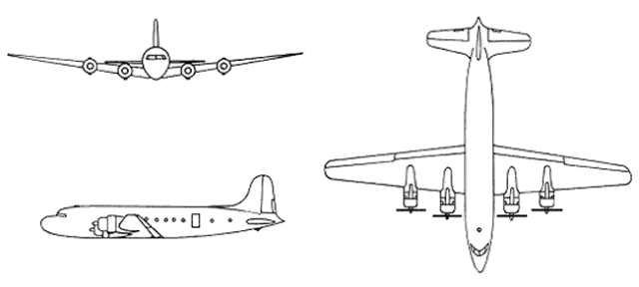

HAZARDS
- 3,720 gallons / 24924 pounds of av-gas on-board (fully loaded), located in wings and fuselage. Fuel load is generally only 1000 gallons / 6700 pounds.
- Two batteries located aft of nose wheel well.
- Propeller danger zone 25 feet
- Engine exhaust:1500 feet.
- Pneumatic system pressurized to 3000 psi.
- Normal floor height for cargo door from ground is 8 feet, 10 inches.
- Do not attempt to cut into the fuselage over the cockpit – area contains main electrical distribution location.

APPROACH TO ENTRY POINT: (Engines running 80%+)
- Approach directly from the left side, aft of the wings, avoiding the propellers for a ten-foot radius.

PRE-DESIGNATED RESCUEMAN ACTIONS
- GAIN ENTRY
a. Normal entry –
I. Rotate aft cargo door external handle, located on left aft fuselage, COUNTER-CLOCKWISE and PULL doors outward.
II. Rotate forward right crew door handle, located forward right fuselage, CLOCKWISE and PUSH door inward. NOTE: If collapsed nose gear occurs enter through main door. Height requires a 12-foot ladder.
b. Emergency entry –
I. Rotate crew forward door handle, located right forward fuselage, CLOCKWISE and PUSH door inward.
II. PULL astrodome external release ring, located top forward fuselage, and PUSH astrodome inward, if equipped.
III. PULL cargo doors emergency hinge pin release cable, located left aft fuselage, to release cargo doors.
IV. Overwing hatches “pop” handle out and rotate down. Push hatch in and let fall to floor.
v. Four (4) emergency exits located over wings. Two are located at the center of the wing, two are located just aft of the flap.
c. Cut-In –
I. Along marked areas.
II. Around aft cargo door.
III. Top of fuselage over aft cargo area.
- ENGINE SHUTDOWN
a. Normal Shutdown -
I. Retard throttles, located on control pedestal, to full aft position.
II. Place mixture controls, located on control pedestal, to aft IDLE CUT-OFF. Wait for engines to stop.
III. Place master ignition switches, located upper instrument panel, to OFF position.
IV. Place master battery switch, located pilot’s overhead panel, to OFF position.
3. AIRCREW EXTRACTION
a. Release lap belts and remove shoulder harness restraint straps. NOTE: If seat tracks are not damaged during crash landing use adjustable seat control handle to retract seat to aft position.

OTHER FACTORS
- Special tools/equipment: 12-foot ladder, Power rescue saw and crash axe.
- Engines will generate a large amount of smoke when starting.
- Extra fuel in the exhaust stack may ignite and immediately burn itself out.
- Can fly with one engine shutdown.
- If asked to rotate prop, rotate clockwise when looking at prop. NOTE: Fire fighters should avoid doing this!
- Location of switches and equipment and emergency shutdown procedures may vary for individual aircraft. Crews should be briefed prior to aircraft dispatch.

COMMUNICATIONS PLAN: National Air Tanker Frequency – 123.975. This is the frequency used by all air tanker bases, air tankers and air tanker support aircraft during fire fighting operations.

AIR TANKER CALL-SIGNS:
14, 15, 65, 119, 151, 152, 160, 161.

