AIRCRAFT PRE-FIRE PLAN

AIRCRAFT TYPE: DC-6 Airliner / C-118 Liftmaster Reference: T.O. 00-105E-9, Boeing Info.

AIRCRAFT DESCRIPTION: This airtanker was first used in 1971 and about ten have been converted since then. There are not many currently in service. Most had tanks constructed to hold three thousand gallons, but were usually downloaded to meet performance requirements. The airplane has been a very satisfactory airtanker. The DC-6 looks similar to the DC-7 as it has the same wingspan and square windows but is about one foot shorter in length and has smaller engines. It has either no windows or two windows forward of the wing and a three bladed prop.

Length (ft) | Wing Span (ft) | Turn Radius (ft) | Cruise Speed (Kts/mph) | Range Loaded (St. miles) | Gross Weight  (lbs.) | Contract Op. Wt. (lbs.) | Retardant Load | Number Gates | ICS Type
111 | 118 | 85 | 208 / 240 | 1300 | 92,200 | 86,200 | 2400 | 6 to 8 | 2

AIRCRAFT DIAGRAM
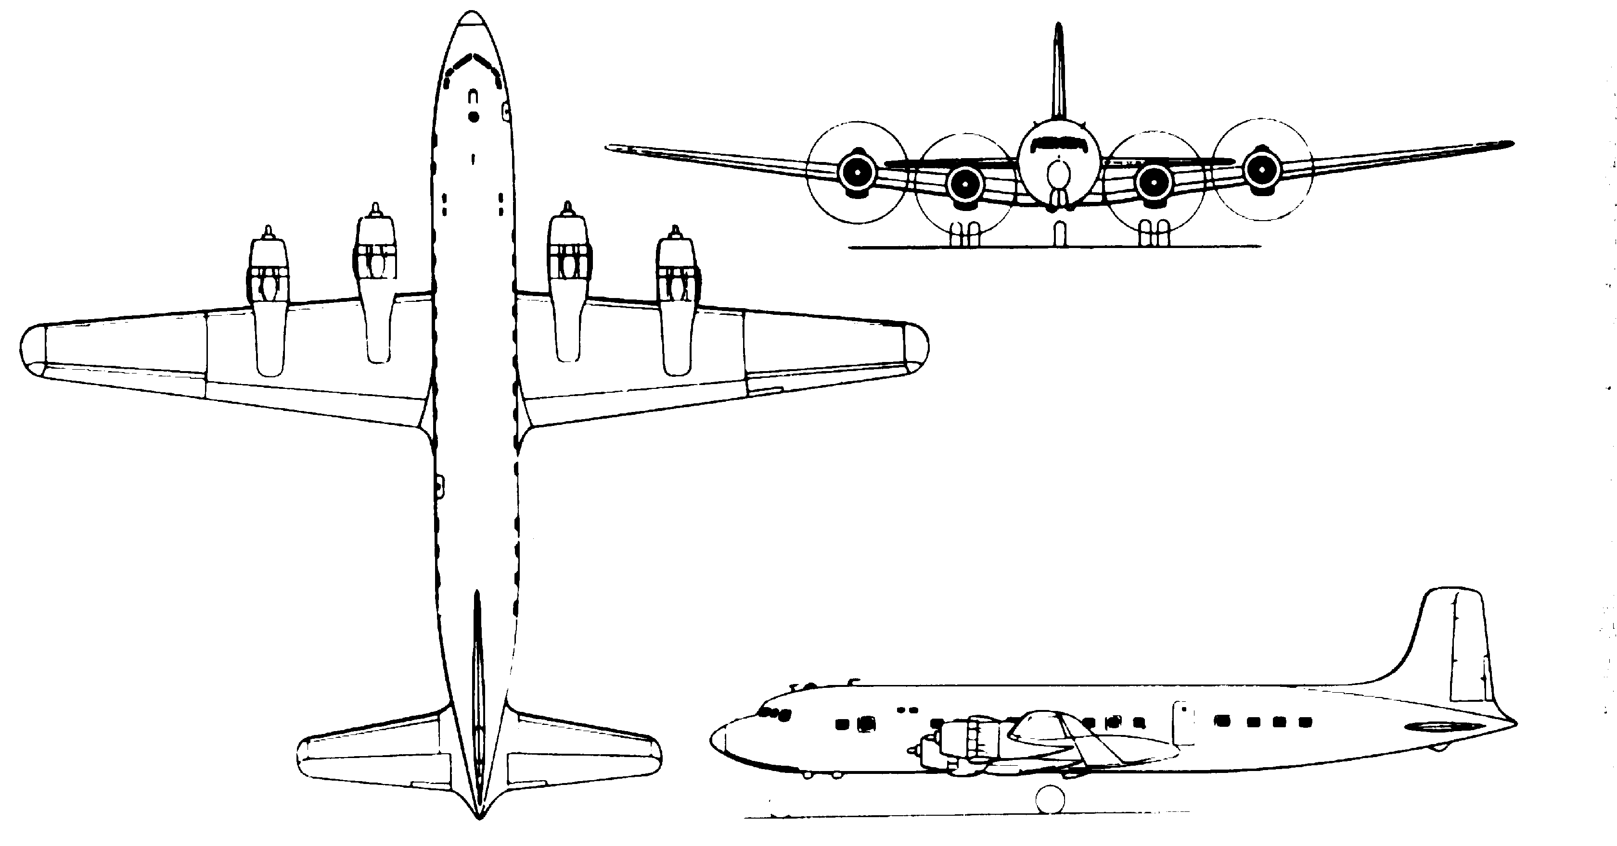

HAZARDS
- 5404 gallons / 36206.8 pounds of jet fuel on-board (fully loaded), located in wings and fuselage.
- 1 oxygen cylinder near cockpit or two in the over wing area.
- Two batteries located in nose.
- Propeller danger zone 25 feet
- Engine exhaust 1500 feet.
- Do not attempt to cut into the fuselage over the cockpit – area contains main electrical distribution location.

APPROACH TO ENTRY POINT: (Engines running 80%+)
- Approach directly from the nose, avoiding the propellers for a ten-foot radius.

PRE-DESIGNATED RESCUEMAN ACTIONS
- GAIN ENTRY
a. Normal entry –
I. Rotate external control handle located on passenger entrance door left side of fuselage, UP to open passenger entrance door outward.
II. Rotate external control handle, located on crew entrance door forward right side of fuselage UP to open crew entrance door outward.
b. Emergency entry – PULL handle on emergency exits, located over each wing, OUT and PULL hatch outward.
c. Cut-in –
I. Cut-in areas are located at normal and emergency entrances on aircraft and at cargo compartment windows and doors.
II. Top of fuselage.
- ENGINE SHUTDOWN
a. Emergency Shutdown -
I. PULL engine emergency T-handles, located on main fire control panel, FULL OUT.
b. Normal Shutdown -
I. Retard throttles, located on control pedestal, to CLOSED position.
II. Place mixture control levers, located on control pedestal, to CLOSED position.
III. Place ignition switches, located on forward overhead panel to OFF position.
IV. Place master battery/generator switches cutoff bar, located forward overhead panel, to OFF position.
3. AIRCREW EXTRACTION
a. Unlatch lap belt and remove shoulder harness from crewmember(s). NOTE: If seat tracks are not damaged during crash landing, use adjustable seat control to retract seat to aft position in removing crewmember(s).

OTHER FACTORS
- Special tools/equipment: Power rescue saw and crash axe.
- Engines will generate a large amount of smoke when starting.
- Extra fuel in the exhaust stack may ignite and immediately burn itself out.
- Location of switches and equipment and emergency procedures may vary for individual aircraft. Crews should be briefed prior to aircraft dispatch.

COMMUNICATIONS PLAN: National Air Tanker Frequency – 123.975. All air tanker bases, air tankers and air tanker support aircraft during fire fighting operations, use this frequency.

AIR TANKER CALL-SIGNS: 68

