AIRCRAFT PRE-FIRE PLAN

AIRCRAFT TYPE: de Havilland DHC-2 Beaver / U-6 Reference: T.O. 00-105E-9

AIRCRAFT DESCRIPTION: The Forest Service owns and operates Beavers in and around the many lake areas of Minnesota. They are used for aerial photography, seeding, fish stocking, and personnel movement. On wildfires they are used for water dropping. They can fill their water tank by scooping from lakes and can inject foam into the tank. This aircraft does not meet the Interagency Airtanker Board criteria for an airtanker. It is not technically an airtanker.

Length (ft) | Wing Span (ft) | Turn Radius (ft) | Cruise Speed (Kts/mph) | Range Loaded (St. miles) | Gross Weight  (lbs.) | Contract Op. Wt. (lbs.) | Retardant Load | Number Gates | ICS Type
30 | 48 | NA | 100 / 115 | 500 | 5100 | NA | 125 | 1 | NA

AIRCRAFT DIAGRAM
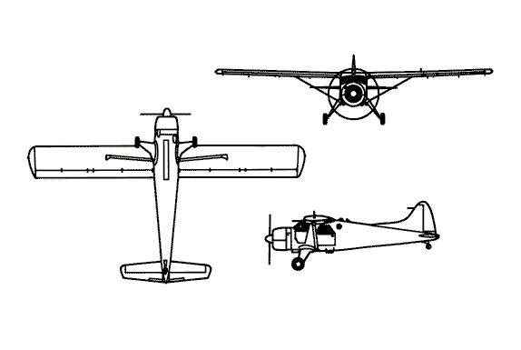

HAZARDS
- 111 gallons / 743.7 pounds of aviation gasoline on-board (fully loaded), located in wing tips and underside of fuselage.
- One battery located in aft cabin area.
- Propeller danger zone 25 feet

APPROACH TO ENTRY POINT: (Engines running 80%+)
- Approach directly from the side, avoiding the propeller for a ten-foot radius.

PRE-DESIGNATED RESCUEMAN ACTIONS
- GAIN ENTRY
a. Normal entry –
I. Flight compartment doors (two), located on each side of fuselage
II. Cabin compartment doors (two) located aft of flight compartment doors on each side of fuselage.
b. Emergency entry –
I. Break window in flight compartment and pull jettison door lever, located forward of left and right fuselage doors, and pull aft, pull door outwards.
II. Break window in cabin compartment and pull jettison door lever, located forward of left and right fuselage doors, forward or aft, pull door outward.
c. Cut-In – Cut in doors and windows as required.
- ENGINE SHUTDOWN
a. Retard mixture and throttle levers, located on upper center console, to CLOSED position.
b. Place fuel and oil emergency shut-off lever, located on lower control pedestal, down to CLOSED position.
c. Turn ignition switch, located on left side of forward console, to OFF position.
d. Push battery master switch, located on left forward console, down to OFF position.
3. AIRCREW EXTRACTION
a. Unlatch lap belts and remove shoulder harness from crewmember(s).

OTHER FACTORS
- Special tools/equipment: Power rescue saw and crash axe.
- Location of switches and equipment and emergency shutdown procedures may vary for individual aircraft. Crews should be briefed prior to aircraft dispatch.
- Aircraft skin penetration points for engine are located 6 inches forward of cockpit firewall along aircraft centerline and near tail on the fuselage at panel F.S. 113, 5 inches below centerline.

COMMUNICATIONS PLAN: National Air Tanker frequency – 123.975. All air tanker bases, air tankers, and air tanker support aircraft use this frequency during fire fighting operations.

