AIRCRAFT PRE-FIRE PLAN

AIRCRAFT TYPE: de Havilland DHC-6 Twin Otter/UV-18 Reference: Era Aviation / T.O. 00-105E-9

AIRCRAFT DESCRIPTION: This turbine-powered aircraft has excellent short field takeoff and landing capability. At one time it was the airplane of choice for small commuter airlines transporting up to nineteen passengers. It is well suited for agency operations at unimproved backcountry airfields and is often used to transport passengers, paracargo and smokejumpers. It is unpressurized and slow, but very stable, maneuverable, and has good endurance for longer flights. The aircraft systems and maintenance required are relatively simple. The landing gear does not retract.

Length (ft) | Wing Span (ft) | Cruise Speed (Kts/mph) | Range (St. miles) | Payload | Number of Pax Seats
52 | 65 | 148/170 | 450 | 3000 | 15-19 (8 jumpers)

AIRCRAFT DIAGRAM
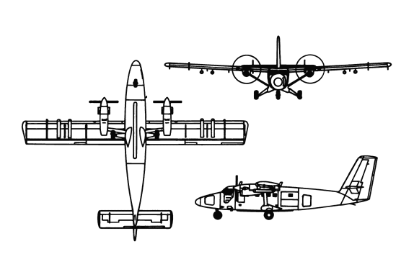

HAZARDS

380 gallons / 2546 pounds of Jet A located under floor of passenger / smokejumper section. (Aircraft N320EA has 44 gallon wing tanks mounted on the outboard tips of each wing.

Oxygen: Two locations – Two – 1800 PSI cylinders mounted in ceiling of aft baggage compartment for passengers. The emergency shutoff is also located here. One - 1800 PSI cylinder mounted in nose for pilot and co-pilot. Emergency shutoff is located on console.

Battery: rear baggage compartment.
4. 6 gallons of hydraulic fluid, system pressurized to 1575 psi.

5. Turbo propellers: Two 8’6” diameter blades.

Aircraft materials: Skin is aluminum, cabin floor is low-density aluminum, tail section is high strength aluminum alloys, and windscreen/windows is acrylic plastics.

Radar hazard in nose cone.

APPROACH TO ENTRY POINT: (Engines running 80%+)
- Approach directly from the nose, avoiding the propellers for a ten-foot radius.

PRE-DESIGNATED RESCUEMAN ACTIONS
- GAIN ENTRY
a. Normal entry
I. The cabin can be entered through the main entry door, located on the right aft side of the fuselage, by rotating the unlock handle counterclockwise.
II. The cabin can be entered through the paratroop door or airstair door or an optional double cargo door, located on the left aft side of the fuselage, by rotating the unlock clockwise.
III. Crew entry can be entered through the cockpit doors, located on either side of the fuselage, by rotating the unlock handle clockwise for the left door and counterclockwise for the right.
b. Emergency entry – WARNING! Do not use cockpit doors or emergency exits if engines are operating. Rotating blades can injure or cause death if contact is made.
I. Locate unlock handle on main entry door, or passenger/paratroop door, or cargo door. Rotate unlock handle in appropriate fashion and enter.
II. Emergency exits are located just aft of cockpit doors.
c. CUT-IN – By using a 25’ ladder, access the top of the fuselage and cut a hole between the main entry and passenger/paratroop or cargo doors.
- ENGINE SHUTDOWN
a. Retard engine fuel levers, located on right side of overhead console, AFT to full OFF position.
b. Retard propeller levers, located forward center of overhead console, to CENTER position, push in to clear stop or detent, then AFT to FEATHER position.
c. Pull master switch, located on left forward corner of overhead console, OUT to OFF position.
3. AIRCREW EXTRACTION
a. Unfasten seat belts from crew and passengers or paratroopers, and remove from aircraft.

OTHER FACTORS
- Special tools/equipment: Power rescue saw, 25’ foot ladder and crash axe.
- Location of switches and equipment and emergency shutdown procedures may vary for individual aircraft. Crews should be briefed prior to aircraft dispatch.

COMMUNICATIONS PLAN: National Air Tanker frequency – 123.975. This is the frequency used by all air tanker bases, air tankers, air tanker support aircraft during fire fighting operations.

