AIRCRAFT PRE-FIRE PLAN

AIRCRAFT TYPE: ER-2 Reference: Lockheed Rescue and Fire Fighting Info. and US Air Force Technical Order 00-105E-9

DESCRIPTION: NASA has been using two ER-2 Airborne Science aircraft as flying laboratories. The aircraft collect information about our surroundings, including earth resources, celestial observations, atmospheric chemistry and dynamics and oceanic processes. The aircraft are also used for electronic sensor research and development, satellite calibration and satellite data validation. The ER-2 is 30% larger than the U-2C. The single engine aircraft carries only a pilot. It is occasionally used to map burn areas utilizing its infrared cameras. This information aids fire planners in deciding how best to attack the fire.

Length (ft) | Wing Span (ft) | Cruise Speed (mph) | Range (St. miles) | Payload | Number of Pax Seats
62' 9" | 103 | 430 | 6,250 | ? | 1

AIRCRAFT DIAGRAM
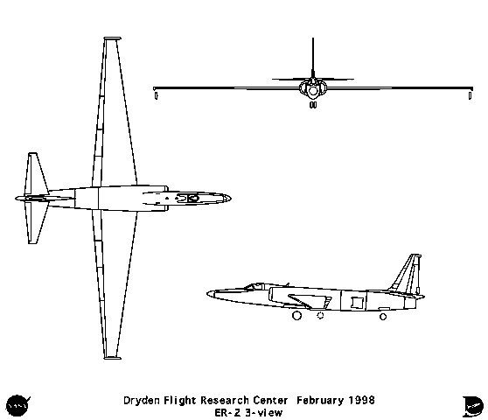

HAZARDS:
- Aircraft has an ejection seat – pilot wears a full-pressure suit.
- 2950 gallons of special high-altitude jet fuel (JPTS) on-board (fully loaded), located in wings.
- 2 Crew oxygen cylinders located aft of cockpit.
- 2 Batteries located aft of cockpit in fuselage.
- Avoid front of engines for 25 feet– ingestion hazard. Avoid rear of engine for 50 feet – high exhaust speeds.
- Turbine engine disintegration hazard aft of wing.
- Wheels are equipped with fusible plugs designed to melt and deflate the tire when the temperature is excessive. Use of Halon is preferred if tires are pressurized, but dry chemical, fog or foam is acceptable. If all tires are deflated any fire extinguishing agent may be used. WARNING! Approach landing gear from forward or aft when fighting a wheel fire as wheels and tires may explode.
- Hydrazine: Tank located between the engine and fuselage on the right side. WARNING! Hydrazine is considered toxic.

APPROACH TO ENTRY POINT: (Engines running 80%+)
- Approach directly from the side, avoiding the front on the engine.

PRE-DESIGNATED RESCUEMAN ACTIONS
- GAIN ENTRY – WARNING! If engine is running, personnel approaching airplane must use a lifeline between the crash truck and themselves to reduce the hazard of injury from engine intake suction. Personnel must remain on lifeline until engine has been shut-off.
- a. Normal entry –
I. Insert ½-inch extension into socket opening located on right side of fuselage behind canopy.
II. Lift right edge to open canopy until hold open prop latch engages.
b. Emergency entry –
I. Press latch and remove canopy jettison T-handle access door, located on left forward side of fuselage below canopy.
II. Grasp canopy jettison T-handle and pull outward approximately seven feet to jettison canopy.
c. Cut-in – Cut-in around canopy frame as required.
2. ENGINE SHUTDOWN
a. NORMAL / EMERGENCY SHUTDOWN I. Pull throttle, left side, aft to OFF.
II. Position fuel shutoff switch, located aft of throttle, to OFF.
III. Position battery switch, located lower right side of instrument panel, to OFF.
IV. Position oxygen system, located left side, to OFF.
3. AIRCREW EXTRACTION WARNING! Aircraft is equipped with an ejection seat
a. Cut ballistic line, located over pilot’s right shoulder.
b. Shut off oxygen system. Move helmet safety latch up, push down baler bar and press in on baler bar release to unlatch. Lift baler over top of helmet to open helmet visor.
c. Pull scramble handle, located on lower seat near pilot’s right thigh.
d. Pull survival kit handle, located near scramble handle. Remove crewmember.

OTHER FACTORS:
- Special tools/equipment: Power rescue saw, 24-foot extension ladder.
- Skin Penetration Points: “Q” bay under cockpit. “E” Bay aft of cockpit, Engine aft of wing.
- Locations of switches and equipment and emergency procedures may vary for individual aircraft. Crews should be briefed prior to aircraft dispatch.

COMMUNICATIONS PLAN: National Air Tanker Base Frequency – 123.975. This is the frequency used by all air tanker bases, air tankers and air tanker support aircraft during fire fighting operations.

