AIRCRAFT PRE-FIRE PLAN

AIRCRAFT TYPE: Fokker F-27 Reference: FedEx Crash Chart

AIRCRAFT DESCRIPTION: the F-27 was designed as a commuter aircraft and is also used extensively for airfreight. The Canadians have adapted this aircraft for airtanker work. Canadian airtankers may be used in the U.S. under special agreements when specific criteria have been met.

Length (ft) | Wing Span (ft) | Turn Radius (ft) | Cruise Speed (Kts/mph) | Range Loaded (St. miles) | Gross Weight  (lbs.) | Contract Op. Wt. (lbs.) | Retardant Load | Number Gates | ICS Type
83 | 95 | 64 | 240 / 276 | 500 | 45,000 | NA | 1600 | 8 | 3

AIRCRAFT DIAGRAM:
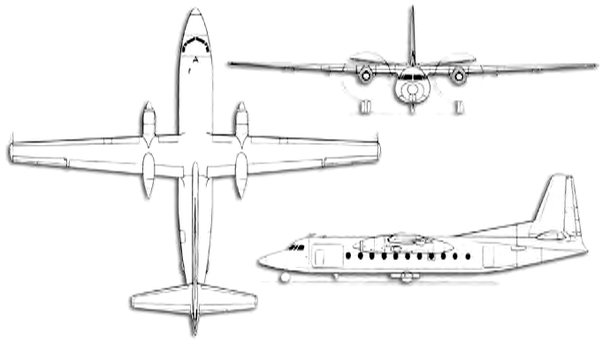

HAZARDS:
- Up to 4455.5 pounds / 65 gallons of jet fuel on-board (fully loaded), located in wings.
- Battery is located in the nose area of the aircraft.
- Fire extinguisher located between pilot seats.
- Propeller – Maintain 10 feet of separation from moving propeller.
- Carries one 1800-psi oxygen cylinder located near the co-pilot’s seat.
6. Engine Oil - .66 gallons
7. Gear box oil – 0.64

APPROACH TO ENTRY POINT: (Engines running 80%+)
- First-in crew should attempt to establish a rescue path to the crew door (right and left side, forward), or maintain a rescue path to the exit primarily being used by occupants for egress. CAUTION: avoid propeller for ten-foot radius. Approach directly from the nose, avoiding the propellers for a ten-foot radius.

PRE-DESIGNATED RESCUEMAN ACTIONS:
- GAIN ENTRY
a. Main cabin door – Located left side, raft of wing. Lift handle and turn. PUSH door inward. Move door upwards. Use grip, slide door to the right. If door won’t slide, PUSH red knob.
b. Right side main cabin door – Lift handle and turn. Push door inwards and upwards.
c. Cargo door: PULL handle and PULL cargo door. OR Lift handle and turn. Push door upwards.
d. Under wing hatches (2 each side) – Press button and push window in. NOTE: 2nd emergency window is optional.
- ENGINE SHUTDOWN
a. Pull high pressure cut off all the way aft.
3. AIRCREW EXTRACTION
a. Unlatch lap belt and remove shoulder harness from crewmember(s). If seat track is not damaged during crash landing, use adjustable seat control to move seat in aft position when removing crewmembers.

OTHER FACTORS:
1. Special tools/equipment: Power rescue saw and crash axe.
- Base of passenger door is maximum 3 feet off of ground with aircraft on its wheels.
- Location of switches and equipment and emergency shutdown procedures may vary for individual aircraft. Crews should be briefed prior to aircraft dispatch.

COMMUNICATIONS PLAN: National Air Tanker Base Frequency – 123.975. All air tanker bases, air tankers and air tanker support aircraft monitor this frequency during fire fighting operations.

