AIRCRAFT PRE-FIRE PLAN

AIRCRAFT TYPE: Kaman H-43 Huskie Reference: “Old” T.O. 00-105E-9

AIRCRAFT DESCRIPTION: These helicopters are very rare. They were first built in 1953 with a recip engine. Later versions had turbine engines installed. Kaman’s have two intermeshing main rotors and no tail rotor. The main rotors droop very close to ground level and are extremely hazardous to ground personnel when the helicopter is idling. Kaman’s are used for petroleum exploration, logging, and occasionally for fire fighting. They were originally designed as a crash rescue helicopter for the US Air Force.

Length (ft) | Rotor Dia. (ft) | Bucket Size (gals) | 1.5 Hour Fuel Load (gallons) | Fuel Consumption (gal/hrs) | Cruise Speed (Kts/mph) | Typical Equip. Wt. (lbs.) | Fixed Wt. Reduction (lbs.) | Pax Seats | ICS Type
25 | 47 | 324 |  | 85 | 85 / 98 | 4300 | N/A | N/A | 1

AIRCRAFT DIAGRAM
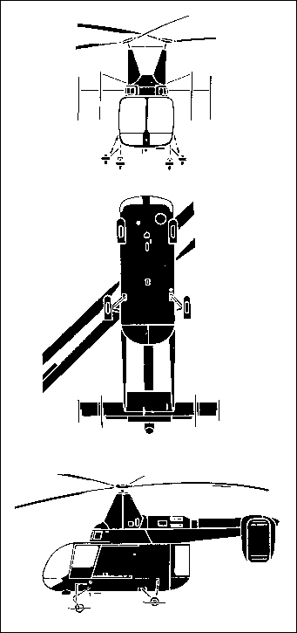

HAZARDS:
- 350 gallons / 2345 pounds of jet fuel on-board (fully loaded), located in fuselage, under passenger compartment.
- Rotors dip very close to the ground.
- One battery located in nose.

APPROACH TO ENTRY POINT: (Engines running 80%+)
1. Approach directly from the side, exercising extreme caution around rotors, which can dip very close to the ground.

PRE-DESIGNATED RESCUEMAN ACTIONS:
- GAIN ENTRY
a. Normal entry
I. Rotate exterior knob, located on forward cockpit doors, one each side of fuselage, aft and slide door aft.
II. Rotate exterior knob, located on cargo compartment door right fuselage, to aft position, slide door aft.
III. Rotate exterior handle, located on aft clamshell doors right of aft clamshell, clockwise, open door outward. NOTE: Left clamshell door has interior release handle located top center where aft doors join together.
b. Emergency entry
I. Cut or break window.
c. Forcible Entry/Cut-in
I. Cut cabin enclosure as required.
2. ENGINE SHUTDOWN
a. Rotate throttle, located on power control handle left side of pilot’s seat, clockwise to CUT-OFF position.
b. Push in fuel and oil switches, located on upper center console, to OFF position.
c. Push in battery switch, located on center console, to OFF position.
d. Push auxiliary fuel switch, located on center console, to OFF position.
3. AIRCREW EXTRACTION
a. Unlatch lap belts and remove shoulder harness restraint straps.

OTHER FACTORS:
- Special tools/equipment: Power rescue saw and crash axe.
- Location of switches and equipment and emergency shutdown procedures may vary for individual aircraft. Crews should be briefed prior to helicopter dispatch.

COMMUNICATIONS PLAN: National Air Tanker Frequency – 123.975. This is the frequency used by all air tanker bases, air tankers, and air tanker support aircraft during fire fighting operations.

