AIRCRAFT PRE-FIRE PLAN

AIRCRAFT TYPE: Hughes 500D / OH-6 Reference: Interagency Helicopter Operations Guide

AIRCRAFT DESCRIPTION: The 500D is a common helicopter. Originally a Hughes Aircraft, its current manufacturer is McDonald Douglas. The 500D and E have T-tails and the C has a V-tail. Military variants include the OH-6A. The latest versions are NOTARs. Instead of a tail rotor, NOTARs control yaw with exhaust vented through the tail boom. MD 500s are very maneuverable in confined areas and have great visibility for longline work. Plentiful parts and service make them economical to operate. The three seats in back are to small for average size people and there is no baggage compartment so cargo must be carried in external baskets or strapped inside.

Model | Length (feet) | Rotor Diameter (feet) | Bucket Size (gals) | 1.5 Hour Fuel Load (gals) | Fuel Consumption (gals / hr) | Cruise Speed  (kts / mph) | Typical Equipment wt. (lbs) | Fixed Wt. Reduction (lbs) | PAX Seats | ICS Type
500C | 31 | 26 | 96-108 | 35 | 23 | 124 mph | 1450 | 110 | 4 | 3
500D | 31 | 26 | 96-108 | 44 | 29 | 120 / 138 | 1600 | 120 | 4 | 3

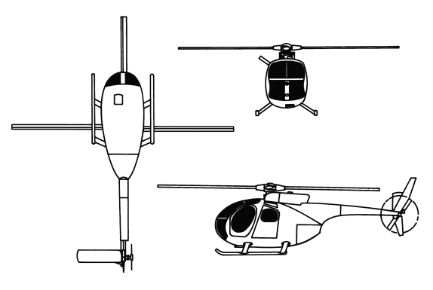
AIRCRAFT DIAGRAM:

HAZARDS
- Rotor blades.
- 61.5 gallons / 412 pounds of fuel.

APPROACH TO ENTRY POINT: (Engines running 80%+)
1. Approach from side of aircraft to avoid main rotor blades. WARNING! Rotor blades can dip several feet. Firefighters should remain in a crouching position as they approach.

PRE-DESIGNATED RESCUEMAN ACTIONS:
- GAINING ENTRY
a. NORMAL ENTRY
I. Open any of the four doors by rotating external door release handle.
b. EMERGENCY ENTRY
I. Emergency entrances may be gained through cabin doors and cargo / passenger doors.
II. Rotate external door release handle and open door.
III. If doors fail to open, leave handle in the open position and break glass to gain access to door jettison handle, pull to jettison door.
c. CUT-IN
I. Cut cabin enclosure as required.
- ENGINE SHUTDOWN
a. EMERGENCY SHUTDOWN
I. Rotate throttle control located on pilot and co-pilot collective levers, to FUEL CUT-OFF position.
II. Place battery switch, located on electrical control console, to OFF position.
3. AIRCREW EXTRACTION
a. Unlatch lap belts and remove shoulder harness from crewmember(s).

OTHER FACTORS:
- Special tools/equipment: Power rescue saw and crash axe.
- Location of switches and equipment and emergency shutdown procedures may vary for individual aircraft. Crews should be briefed prior to helicopter dispatch.

COMMUNICATIONS PLAN: National Air Tanker frequency – 123.975. This is the frequency used by all air tanker bases, air tankers, and air tanker support aircraft during fire fighting operations.

