AIRCRAFT PRE-FIRE PLAN

AIRCRAFT TYPE: Kaman K-Max “Aerial Truck” Reference: Kaman Aerospace

AIRCRAFT DESCRIPTION: The K-Max has been specifically designed, manufactured and successfully tested for the repetitive lift and torque loading requirements of external load operations. It is easily recognized by it’s two side-by-side intermeshing counter rotating main rotors. It flies with a crew of one.

Length (ft) | Rotor Dia. (ft) | Bucket Size (gals) | 1.5 Hour Fuel Load (gallons) | Fuel Consumption (gal/hrs) | Cruise Speed (Kts/mph) | Typical Equip. Wt. (lbs.) | Fixed Wt. Reduction (lbs.) | Pax Seats | ICS Type
52 | 48’ 4” |  | 106 |  | 185 / | 10,984 |  | 0

AIRCRAFT DIAGRAM
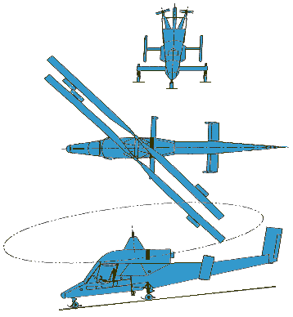

HAZARDS:
- 228 gallons / 1527 pounds of jet fuel on-board (fully loaded), located in wings and fuselage.
- One battery located in the nose compartment.
- Inlet suction danger area is 4 feet.
- Turbine blade failure
- Engine exhaust – 12 feet.
- APU exhaust – 12 feet.
- Rotor minimum ground clearance – Main = 10 feet 11 inches. Tail = 15 feet 10 inches. (The main rotor disc diameter is 84 feet 4 inches and the tail rotor disc diameter is 51 feet.)
- Pneumatic system pressurized to 3000 psi.
- Engine Oil – 13 gallons
- Hydraulic fluid – 5.77 gallons.
- Transmission fluid – 9 gallons.

APPROACH TO ENTRY POINT: (Engines running 80%+)
1. Approach directly from the side, exercising extreme caution around rotors, which can dip to within four feet of the ground.

PRE-DESIGNATED RESCUEMAN ACTIONS:
- GAIN ENTRY
The pilot access has two doors, one located on each side of the aircraft. The windows are plexiglass and the doors can be removed by opening the latch and lifting the door off of the hinge.
2. ENGINE SHUTDOWN
a. Rotate the throttle, located on the collective stick, to the OFF position.
b. Place the fuel switch, located on the left side of the cockpit instrument panel, to the OFF position.
c. Place the battery switch, located on the left side of the cockpit instrument panel, to the OFF position.
3. AIRCREW EXTRACTION
a. Release lap belt and shoulder harness and remove crew member.

OTHER FACTORS:
- Special tools/equipment: Power rescue saw and crash axe.
- Location of switches and equipment and emergency shutdown procedures may vary for individual aircraft. Crews should be briefed prior to helicopter dispatch.

COMMUNICATIONS PLAN: National Air Tanker Frequency – 123.975. This is the frequency used by all air tanker bases, air tankers, and air tanker support aircraft during fire fighting operations.

