AIRCRAFT PRE-FIRE PLAN

AIRCRAFT TYPE: Boeing KC-97 Reference: T.O. 00-105E-9

AIRCRAFT DESCRIPTION: One KC-97 is currently in the airtanker inventory. The State of Alaska has contracted it in recent years. The aircraft was originally designed as a military transport, but its primary use was as an airborne refueler. This aircraft can also be used for cargo transport after removing the retardant tanks. The KC-97 can be identified by the round glass cockpit nose area, square windows, mid wing, four engines and four blade propeller.

Length (ft) | Wing Span (ft) | Turn Radius (ft) | Cruise Speed (Kts/mph) | Range Loaded (St. miles) | Gross Weight  (lbs.) | Contract Op. Wt. (lbs.) | Retardant Load | Number Gates | ICS Type
118 | 141 | 85 | 217 / 250 | 1500 | 187,000 | 125,548 | 4500 | 16 | 1

AIRCRAFT DIAGRAM:

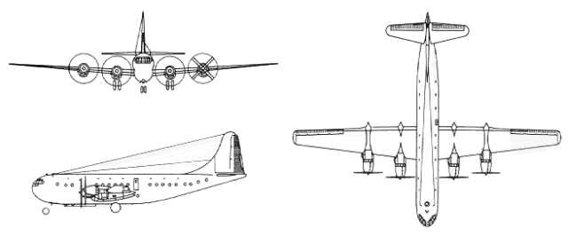

HAZARDS:
- 7790 gallons / 52193 pounds of aviation gas on-board (fully loaded), located in wings and fuselage.
- 10 oxygen cylinders in various locations. (3 fixed and 7 portable cylinders)
- One battery located in forward fuselage.
- Propeller danger zone 25 feet

APPROACH TO ENTRY POINT: (Engines running 80%+)
- Approach directly from the left side, avoiding the propellers for a ten-foot radius.

PRE-DESIGNATED RESCUEMAN ACTIONS:
- GAIN ENTRY
a. Normal entry – PUSH in flush type door and squeeze trigger to release door outward. Entrance doors located, one forward and one aft on left side of fuselage
b. Emergency entry – PULL emergency escape hatch release handles, located over wing and forward of rear cargo door on each side of aircraft, and push in escape hatches. Total of four escape hatches.
c. Cut-in –Cut-in areas as marked on fuselage.
- ENGINE SHUTDOWN
a. Emergency Shutdown –
I. PULL power package fire gang bar switches (six places) located on overhead panel to the downward position.
II. On L model, PULL emergency shutoff T-handles, located top and center on pilot’s instrument panel.
b. Normal Shutdown -
I. Retard throttles and mixture control lever, located on center control panel, to CLOSED (aft) position.
II. Place master switch, located on left side of engineers’ overhead panel, to OFF position.
III. Place battery switch, located on right side of master switch to OFF position.
IV. Place APU engine switch, located on APU control panel, to OFF position.
3. AIRCREW EXTRACTION
a. Unlatch lap belt and remove shoulder harness from crewmember(s). NOTE: If seat tracks are not damaged during crash landing use adjustable seat controls to move seats to aft position in removing crewmember(s).

OTHER FACTORS:
- Special tools/equipment: Power rescue saw and crash axe.
- Location of switches and equipment and emergency shutdown procedures may vary for individual aircraft. Crews should be briefed prior to aircraft dispatch.

COMMUNICATIONS PLAN: National Air Tanker frequency – 123.975. This is the frequency used by air tanker bases, air tankers, and air tanker support aircraft during fire fighting operations.

AIR TANKER CALL-SIGNS: Tanker 97

