AIRCRAFT PRE-FIRE PLAN

AIRCRAFT TYPE: MD-80 Series Reference: Boeing Rescue and Fire Fighting Info.

AIRCRAFT DESCRIPTION: The MD-80 is a large transport jet that ay be contracted by natural resources agencies for fire crew transportation and cargo delivery. The MD-80 resembles the DC-9, but is larger and can carry more fuel and passengers. Boeing is building a follow-on model called the Boeing 717. Some of the following information may also pertain to the DC-9 and the US Air Force’s C-9.

AIRCRAFT DIAGRAM

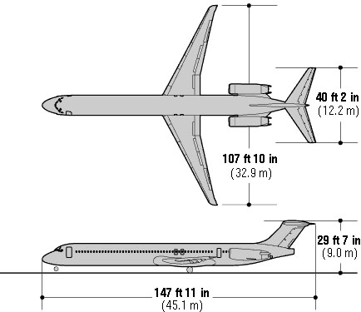

HAZARDS:
- 7778 gallons / 52,112.6 pounds of jet fuel on-board (fully loaded), located in wings and fuselage. Can also be located in auxiliary tanks in baggage compartment.
- Oxygen cylinders in various locations throughout aircraft.
- Auxiliary Power Unit (APU) is located in tail. Control panel located left side tail. APU exhaust duct located right side tail.
- Battery located in electrical compartment below flight deck.
- Avoid front of engines – ingestion hazard, rear of engine – high exhaust speeds.
- Wheels are equipped with fusible plugs designed to melt and deflate the tire when the temperature is excessive. WARNING! Approach landing gear truck from forward or aft when fighting a wheel fire as wheels and tires may explode. Use of Halon is preferred if tires are pressurized, but dry chemical, fog or foam is acceptable. If all tires are deflated any fire-extinguishing agent may be used.

APPROACH TO ENTRY POINT: (Engines running 80%+)
- Approach directly from the nose, avoiding the front on the engines

PRE-DESIGNATED RESCUEMAN ACTIONS:
- GAIN ENTRY
a. Normal entry – Passenger and Service Doors = To open door, pull handle from recess, rotate handle forward and pull door open. CAUTION: When doors are opened from outside, slide chutes automatically deploy. Overwing Emergency Exits = To open door, push handle release, pull the handle and at the same time, push in top of door forcibly. Tail cone jettison latch = NOTE: Some models in commercial use are equipped with rear airstairs and entry door. Other models are equipped with jettisonable tail cone. Push in door and pull handle to remove tail cone WARNING: Make sure no one is standing under tail cone when jettisoning.
b. Emergency entry – Clearview pilots window = Chill pane with carbon dioxide and break with heavy fire axe for access to handle; slide window aft. Pressure Bulk Head Emergency Exit = Pull handle in tail section pressure bulk head and push door in.
c. Cut-in – Cut-in areas are located on each side of fuselage, near top, over aft exit doors, and are not marked. Cut-in can also be accomplished around over wing hatches and entry doors. Cut-in areas require metal cutting portable power equipment. Because of type of structure and possible injury to personnel within, it is recommended that major effort to gain access be directed to hatches and doors. Urgency of situation will dictate necessity for cut-in. NOTE: When the aircraft is resting on it’s wheels, it is 8 feet to floor level. When the landing gear is retracted, it is 4 feet to floor level.
2. ENGINE SHUTDOWN
a. Retard fuel control levers, located on center console below throttles, to the OFF position.
b. If lights are illuminated, pull fire emergency shutdown T-handles, located on center console, to the aft position (fully out) and rotate handle clockwise.
d. After 10 seconds, rotate handles counterclockwise.
e. Place battery switch, located on center overhead panel, to OFF position.
APU SHUTDOWN (All switches located in APU control panel on overhead center console.)
a. Move APU master switch to “off” position.
b. If “APU FIRE” light in overhead panel is illuminated, place FIRE CONT switch to “OFF & AGENT ARM.”
c. Fire Agent No 1 switch to “DISCH” down.
d. After 10 seconds, Fire Agent No 2 switch to “DISCH” down.
APU SHUTDOWN (Exterior controls)
a. APU Shut-Off switch to “SHUT-OFF” (up).
b. If FIRE light is illuminated, Fire Agent NO 1 switch to “DISCHARGE” (up).
c. After 10 seconds, Fire Agent No 2 switch to “DISCHARGE” (up).
3. AIRCREW EXTRACTION
a. Unlatch lap belt and remove shoulder harness from crewmember(s). If seat track is not damaged during crash landing, use adjustable seat control to move seat in aft position when removing crewmembers. Passenger seats do not have shoulder harness.
b. Passenger seats are equipped with lap belts.

OTHER FACTORS:

1. Special tools/equipment: Power rescue saw, 12-foot ladder.
2. Location of switches and equipment and emergency shutdown procedures may vary for individual aircraft. Crews should be briefed prior to aircraft dispatch.

COMMUNICATIONS PLAN: National Air Tanker frequency – 123.975. All air tanker bases, air tankers and air tanker support aircraft use this frequency during firefighting operations.

