MEDIA GUIDE
FOR
FIXED-WING AERIAL FIREFIGHTING OPERATIONS

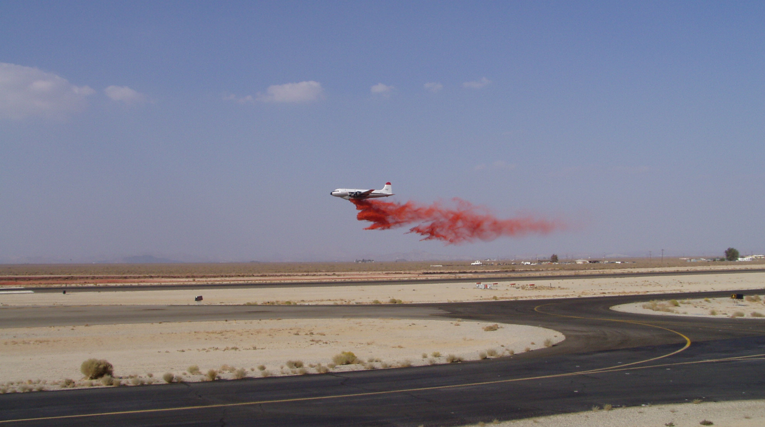

16 DECEMBER 2002
The following information is provided to assist you, the news reporter, when covering wildland fire fighting incidents in which fixed-wing aerial resources are being utilized. This information is subject to change. Correct and accurate information can be obtained from the incident information officer.

AIRTANKERS

A variety of aircraft are used to drop fire retardant on fires. They range from the Single Engine Air Tanker (SEATS) to the larger four engine cargo-type aircraft.

The majority of aircraft used for dropping fire retardant are maintained and operated by private contractors. There are a few SEATS and Super Scoopers that are operated by States and local government.

Airtankers are a National Resource. This means that they can be assigned to any fire in the United States at anytime. It is not uncommon for a tanker to be flying in California and be diverted to a fire in Colorado, as an example. Every evening, fire managers in Boise, Idaho determine the needs for the next day. This means that a tanker flying a fire in Southern California today could be assigned somewhere else tomorrow. Also, a tanker could be assigned to Fire A in Southern California, making it unavailable for Fire B that could be burning just a few miles away. Remember that tankers assignment could change back and forth between the two fires several times before the day is over!

Tankers can not fly at night. Normally, they will take-off 30 minutes prior to sunrise and must be on the ground 30 minutes after sunset. A pilot can not fly over eight hours in a fourteen hour duty day. Flight time begins when the tanker starts its take-off roll and ends when he pulls into his parking spot. Also, the aircraft crews are required to have a day off during every seven day period. You may go to a tanker base during a large fire and see one or two tankers parked. This is because they are on mandatory days-off.

AIRTANKER DESCRIPTIONS
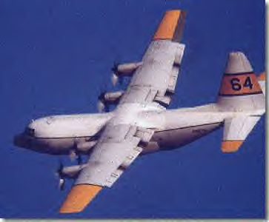

C-130: Has a high wing with four turbo-prop engines, jet engines with propellers. They generally carry 3000 gallons of fire retardant. They cruise at 275 miles per hour.

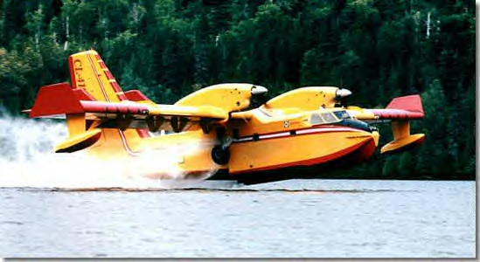
CL-415 "Super Scooper": Has a high wing with two turbo-prop engines. Skims 1621 gallons of water off of a lake and then mixes foam into the water through an on-board system. They cruise at 233 miles per hour.

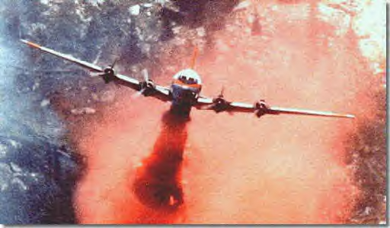
DC-4: This has a low wing with four radial (piston) engines. They were originally used as airliners. Tanker 152 originally saw service with the Air Force and flew in the Berlin Airlift! It is considerably smaller than the DC-6 or DC-7. It carries 2000 gallons of retardant. It cruises at 205 miles per hour.

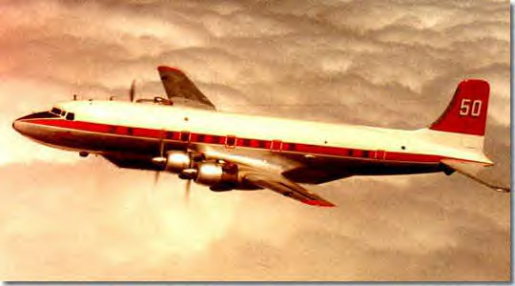
DC-6: Looks like a DC-4, only larger. It has three bladed propellers where the DC-7 has a four bladed propeller. It carries 2400 gallons of retardant and cruises at 240 miles per hour. Tanker 68 is the only DC-6 airtanker currently flying.

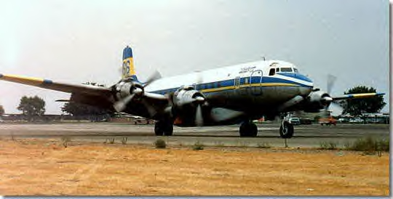
DC-7: Looks like a DC-6 or a bigger DC-4. It carries 3000 gallons of retardant and cruises at 260 miles per hour. It has a four bladed propeller.

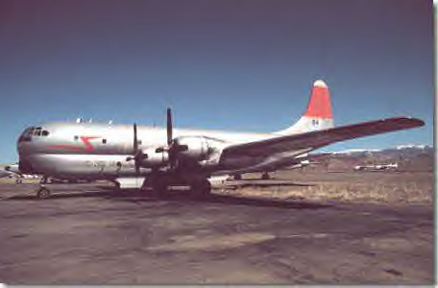
KC-97: This is a four engine aircraft that originally was used by the Air Force for in-flight refueling of other military aircraft. It can carry as much as 4500 gallons of retardant. The single example of this type of airtanker is assigned to Alaska and is rarely seen flying fires in the 48 states.

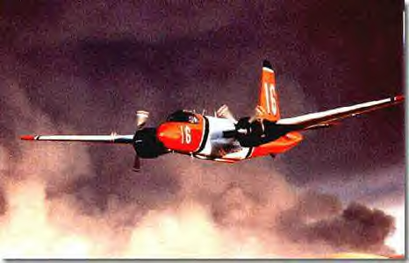
P-2: This Korean-war vintage aircraft was originally used by the navy for hunting enemy submarines. There are two variations used as airtankers. The SP2H can be identified by its bubble canopy. It carries 2000 gallons of retardant. The P2V does not have the bubble canopy and has a jet engine mounted on the outboard end of each wing. These additional engines give it more power and allow it to carry 2400 gallons of retardant.

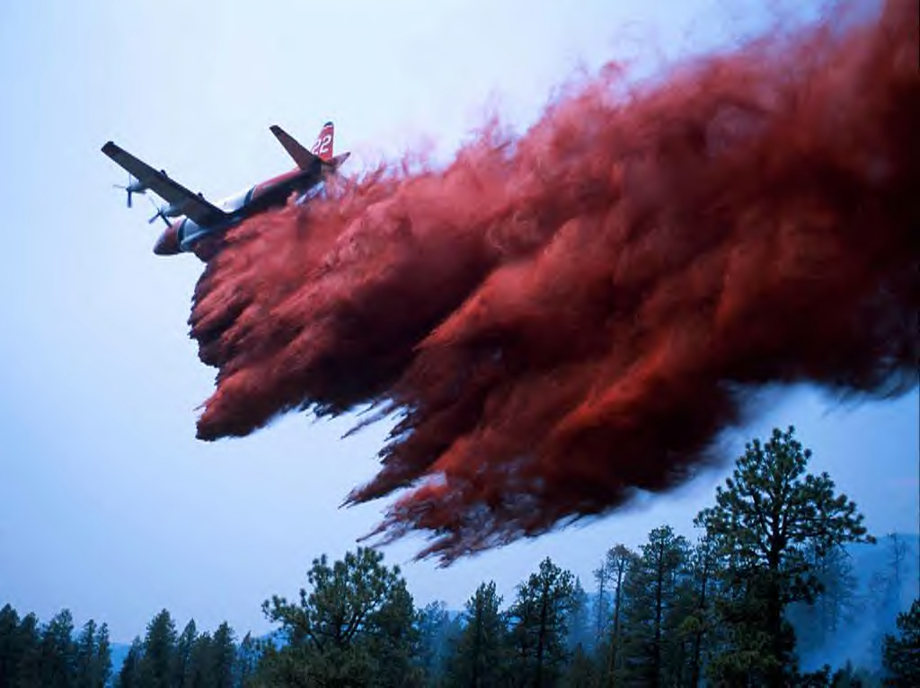
P-3: This is another sub chaser. More modern models of this aircraft can still be found flying with a variety countries including the US. Its turbo-prop engines provide enough power for this tanker to carry 3000 gallons of retardant. It cruises at 320 miles per hour.

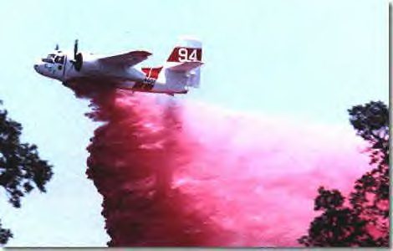
S-2: This aircraft was used by the US Navy for surveillance. These are aircraft are flown in Canada and California. The California aircraft are owned by the State of California. The original airtanker version with radial engines can carry 800 gallons of retardant while the later model, upgraded with turbine engines, can carry 1200 gallons.

LEAD PLANES

Lead planes are smaller aircraft. The most common lead plane is the Beech Baron. These are owned by the US Forest Service and flown by Forest Service pilots. They follow the same flight requirements as the air tankers. A few states, like Nevada, also have their own lead planes.

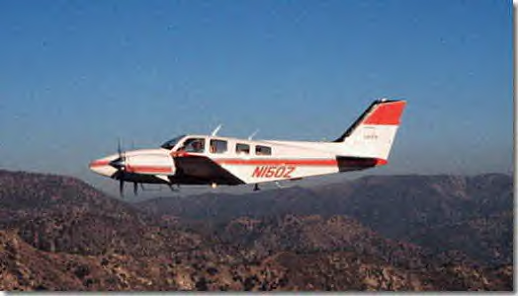
The job of the lead plane is to fly the area of the drop before the airtanker and notify the airtanker crew of any hazards. The lead plane will also show the tanker were to make the drop.

Generally, the lead plane will fly in front of the airtanker as they make a simulated "run" on the drop area. As they come around the second time, the airtanker will actually drop its load.

FIRE RETARDANT

Fire retardant is made by several different manufacturers. Fire-Trol is one manufacturer as is Phos-Chek. When you are referring to retardant as Phos-Chek, you're actually providing free advertising to one of the manufacturers! It should be referred to as Fire Retardant. (In airtanker slang, it is referred to as mud.)

Fire retardant contains chemicals that react with the vegetation, making the vegetation more resistive to fire. Dyes are added to give it its red color, this helps the pilots determine where the last drop left off. This red color must fade away after a couple of weeks to a natural color. Other chemicals in the retardant act as fertilizers, encouraging plant re-growth.

Most drops are from 100 to 150 feet above the fire. The retardant can be dropped all at once or it can be dropped in a trail. The drop can also be adjusted depending on how thick the vegetation is. This is called coverage level.

Fire retardant is not, generally, dropped on the fire. Water or foam is dropped on the fire from helicopters and water scooping aircraft like the Super Scooper. Retardant is dropped ahead of the fire to retard the spread of the fire, slow it down. It some cases, ground firefighters will build fire line along side of the retardant line or may even backfire from a retardant line. Sometimes the retardant maybe dropped along a fire line already cut by hand crews or bulldozers. This is called reinforcing the line.

AIR ATTACK

Air Attack is the person in the aircraft that is flying in a circle over the fire. This individual is working with the Incident Commander (IC) in determining where the airtankers can best be used. Air Attack also works like a control tower, assigning altitudes for airtankers to maintain while the airtankers await their turn to make a drop.

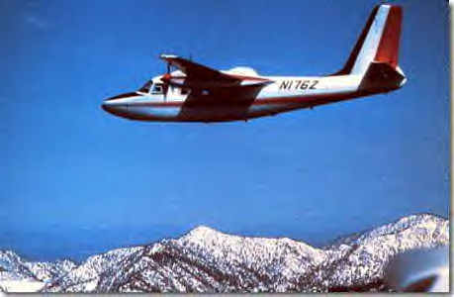
This aircraft is usually a high wing, twin engine aircraft like the Aero Commander, Turbo Commander, Cessna 337 or even the OV-10. The Air Attack officer is a firefighter. The aircraft and pilot are generally contractors. The California Department of Forestry and Fire Protection (CDF) fly the OV-10. Kern County Fire Department has their own Air Attack aircraft which may be seen occasionally on a Southern California fire.

The US Bureau of Land Management (BLM) has taken the lead plane and air attack plane to a new level. They have taken the air attack officer and put him in the lead plane, doing away with the need for one aircraft in the already congested air space. The BLM is using the King Air in this role and one of these aircraft is based at Fox Field.

MAFFS

MAFFS stands for Modular Airborne Fire Fighting System. This is the skid unit that slides into the cargo area of a C-130. These eight kits are owned and maintained by the US Forest Service. They are put into Air National Guard or Air Force Reserve C-130 aircraft. The military airtankers (MAFFS) can only be used once all of the commercial/contractor aircraft have been committed to an assignment. This is why the military aircraft will be seen sitting on the ground while the commercials are working their tails off!

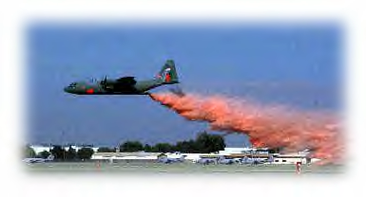
There are four military units qualified to use MAFFS: the Air National Guard units in California, Wyoming and North Carolina and an Air Force Reserve Unit in Colorado. MAFFS can only be called up after the Forest Service has sent a request to the Pentagon. The only exception to this is that the Governor of California, Wyoming and North Carolina can call up "their" unit to fight fires in their state.

These units have also been sent to foreign countries to assist in fighting fires. An official request must be received by our State Department, which is then forwarded to the Forest Service for action.

OTHER FIXED-WING AIRCRAFT

You may also find a variety of other types of fixed-wing aircraft flying around a wildland fire. Infrared aircraft take still photos and video of a fire to aid the Incident Commander in determining exactly were the fire is, what it is doing and were it might be heading. These aircraft also aid in mapping the fire.

Smokejumper aircraft are a variety of aircraft as well. These aircraft are used to deploy firefighters by parachute onto an incident, whether it is a single jumper of a "stick" of several jumpers. These aircraft are not seen to often in Southern California.

Another aircraft that can be found at an airtanker base, and not necessarily over the fire, is the charter aircraft. These aircraft are usually Boeing 737's flown by private contractors and used to transport a large number of firefighters and equipment to fires in various parts of the country quickly.

NASA has even been known to help! Using their ER-2 High Altitude Research aircraft, a civilian version of the U-2 spy plane, they take photos of fires and their associated smoke columns as well as taking air samples. This information is used in fire research programs. It is even common for NASA to provide satellite coverage.

SAFETY

If you're covering the fire on the ground, remember that airtankers drop ahead of the fire. That great spot for getting some great footage of the approaching fire might actually be the area the tanker wants to drop on! Be aware of your surroundings. If a tanker passes over you, his next pass might be dropping mud on you! Work with the Incident Information Officer, they know the safest place for you to be.

If you realize that you are in an area that is about to be dropped on, lay down on the ground. Move your camera and any other loss objects away from you. Stay away from loose rocks or anything else that the drop could dislodge and cause to hit you. Cover your head.
If you get hit with retardant, wash it off immediately. It is basically harmless, but it is very slimy! The retardant that is on the ground can be very hazardous when trying to walk on it.

If you are in an aircraft, simply stated, stay out of the way! Remember, these are large aircraft. They can not move too quick if they have to get out of your way. The pilots are concentrating on the fire and the other aircraft involved in fighting the fire. They are not paying attention to you. Obviously, you want to stay out of the smoke column. Remember, if you cause an airtanker to abort a drop, you could be jeopardizing the lives of firefighters on the ground!

CONCLUSION

Everyone fighting a fire from the air recognizes that you have a job to do. If you follow the instructions that are given to you, you will be able to safely cover the incident, whether you are on the ground or in the air.

You can better prepare yourself in advance. Visit the nearest airtanker base. Talk to the pilots. They love to show people their aircraft and tell them about it. If you're an airborne reporter, don't forget to talk to the Air Attack Officer. Ask him what is expected from you. You might be surprised; believe it or not, these folks want to work with you!

Aircraft photographs from the Associated Airtanker Pilots website, with the exception of cover photograph by Jeff Riechmann.

