AIRCRAFT PRE-FIRE PLAN

AIRCRAFT TYPE: Cessna 337 Skymaster / O-2 Reference: CDF Info. & T.O. 00 105E-9

AIRCRAFT DESCRIPTION: The 337 is a fairly common aircraft. The aircraft was originally used by the US Air Force as a forward air control (FAC) aircraft in Vietnam. Two engines, one in front and one in back, make it very reliable. They are often used for recon and air tactical operations.

Type | Length (ft) | Wing Span (ft) | Cruise Speed (Kts/mph) | Payload | Number of Pax Seats
337 Skymaster | 30 | 38 | 148 / 170 | 600 | 3
O-2 | 30 | 38 | 148 / 170 | 600 | 3

AIRCRAFT DIAGRAM
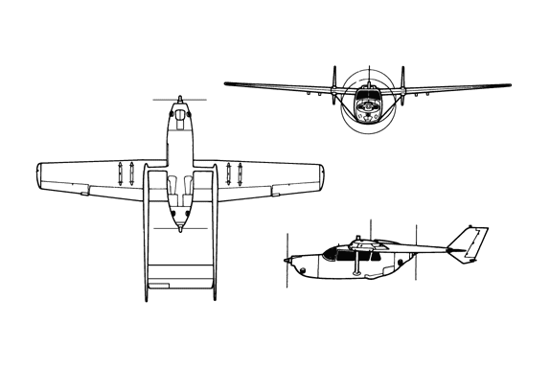

HAZARDS
- 122 gallons / 817.4 pounds of av-gas on-board (fully loaded), located in wings.
- 10 oxygen cylinders in various locations. (3 fixed and 7 portable cylinders)
- One battery located aft area of passenger compartment.
- Propeller danger zone 25 feet
- Engine exhaust :1500 feet.
- Engine Oil – 2.5 gallons
- Hydraulic fluid - .75 gallons.

APPROACH TO ENTRY POINT: (Engines running 80%+)
- Approach directly from the side, avoiding the propellers for a ten-foot radius.

PRE-DESIGNATED RESCUEMAN ACTIONS
- GAIN ENTRY
a. Normal entry – Rotate cabin door exterior handle, located right fuselage door, counterclockwise, open door outward. NOTE: Entry can only be made from right side of fuselage.
b. Emergency entry –
I. Rotate external door handle; if locked, break window and unlock door, rotate door jettison handle located right forward of door frames, up and aft to remove door. NOTE: On aircraft with recessed door handles, door must be unlocked from inside before door can be removed.
II. Open exterior access door, located forward left fuselage under pilot’s window, pull handle to release window. NOTE: To jettison pilot’s exterior access window, break window, remove plastic plate just behind pilot’s seat, pull handle forward, and pull window assembly down (O-2B and early A models).
c. Cut-in / Forcible Entry – Cut cabin enclosure as required.
- ENGINE SHUTDOWN
a. Retard mixture control levers, located center engine control pedestal, to the aft and CLOSED position.
b. Turn fuel selector switches, located top right side of cabin, to OFF position.
c. Place magneto switches, located lower left corner instrument panel, to downward / OFF position.
d. Place battery / master switch, located lower left corner of instrument panel, to downward / OFF position.
3. AIRCREW EXTRACTION
a. Pull upward on seat travel adjusting lever, slide seats aft to facilitate removal of crewmembers.
b. Unlatch lap belt, remove shoulder harness, and remove crewmember.

OTHER FACTORS
- Special tools/equipment: Power rescue saw and crash axe.
- Locations of switches and equipment and emergency shutdown procedures may vary for individual aircraft. Crews should be briefed prior to aircraft dispatch.

COMMUNICATIONS PLAN: National Air Tanker frequency – 123.975. This is the frequency used by all air tanker bases, air tankers, and air tanker support aircraft during fire fighting operations.

