AIRCRAFT PRE-FIRE PLAN

AIRCRAFT TYPE: Rockwell OV-10 Bronco Reference: T.O. 00-105E-9 and CDF info.

AIRCRAFT DESCRIPTION: Broncos are owned and operated by the Bureau of Land Management and by the California Department of Forestry. They have a second seat in tandem behind the pilot that may be occupied by an additional crewmember. The large windows provide good visibility for the pilot and observer. Broncos are used primarily as leadplanes but may also be used as Air Tactical Group Supervisor platforms. They are not allowed to fly below 500 feet with Forest Service personnel on board. Broncos can be fitted with an auxiliary fuel tank for extended range.

Length (ft) | Wing Span (ft) | Cruise Speed (Kts/mph) | Range (St. miles) | Payload | Number of Pax Seats
42 | 40 | 200 / 238 | 920 / 1420 | 3000 | 1

AIRCRAFT DIAGRAM
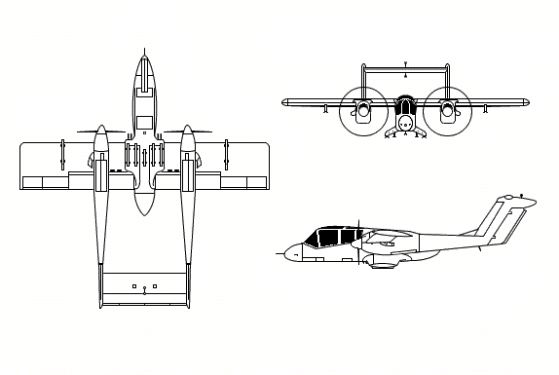

HAZARDS
- 375 gallons / 2512.5 pounds of jet fuel on-board (fully loaded), located in wings and fuselage. Internal 125 gallon auxiliary fuel tank access is through rear cargo door.
- 1 oxygen cylinder in aft portion of cockpit.
- Two batteries – Batteries are located in the upper area of each main landing gear wheelwell. Open access cover and remove quick disconnect fitting.
- Propeller danger zone 15 feet
- Engine exhaust: 20 - 30 feet.
- Pneumatic system pressurized to 80 psi.
- 2.25 gallons of oil per engine.
- 2.21 gallons of hydraulic fluid per engine. Hydraulic system is pressurized to 1500 psi.

APPROACH TO ENTRY POINT: (Engines running 80%+)
- Approach directly from the nose, avoiding the propellers for a ten-foot radius.

PRE-DESIGNATED RESCUEMAN ACTIONS
- GAIN ENTRY
a. Normal entry / Emergency entry
WARNING: With engines running, rescue access to aft cockpit is not possible. Secure engines from forward cockpit prior to entry.
I. Rotate pilot’s cockpit canopy door handle, located on right and left side of fuselage, clockwise 90 degrees on right side and counter clockwise 90 degrees on left side. NOTE: Bungee will hold canopy open on right side only.
II. Rotate observer’s cockpit canopy door handle, located on right and left side of fuselage aft of pilot’s cockpit, right side clockwise and left side counter clockwise. NOTE: Bungee will hold canopy open on right side only.
III. Rotate cargo compartment door external handle, located on aft side of fuselage, counterclockwise, pull door open.
b. Cut-In
I. Cut acrylic plastic canopy next to canopy frame for pilot and observer.
II. Cut aft of cargo doorframe to gain access to cargo compartment.
- ENGINE SHUTDOWN
a. Emergency Engine Shutdown
WARNING! With engines running, rescue access to aft cockpit is not possible. Secure engines from forward cockpit prior to entry.
I. Pull fire warning T-handle, located right upper instrument panel, out.
II. Retard condition levers, located left console both cockpits, full aft to FEATHER AND FUEL SHUTOFF POSITION.
III. Push battery switch, located left console just forward of power levers, to OFF position.
b. Normal Engine Shutdown
I. Retard power levers, located left console both cockpits to GROUND IDLE.
II. Retard condition levers, located left console both cockpits, aft to FUEL SHUT-OFF position.
III. Place fuel emergency shut-off switches, located right forward console, in SHUT-OFF position.
IV. Push battery switch, located left console just forward of power levers, to OFF position.
3. AIRCREW EXTRACTION
a. Unlatch lap belt and remove shoulder harness from crewmember(s). If seat track is not damaged during crash landing, use adjustable seat control to move seat in aft position when removing crewmembers.

OTHER FACTORS
- Special tools/equipment: Power rescue saw and crash axe.
- Location of switches and equipment and emergency shutdown procedures may vary for individual aircraft. Crews should be briefed prior to aircraft dispatch.

COMMUNICATIONS PLAN: National Air Tanker frequency – 123.975. This is the frequency used by all air tanker bases, air tankers, and air tanker support aircraft during fire fighting operations.

