AIRCRAFT PRE-FIRE PLAN

AIRCRAFT TYPE: P-3A Orion Reference: NAVAIR 00-80R-14-1

AIRCRAFT DESCRIPTION: This is a four-engine turbo-prop, originally designed for the U.S. Navy primarily for submarine surveillance. The civilian version is the Electra L-118. The turbine engines add reliability and power which gives the P-3A a short take-off roll and a three thousand-gallon retardant load. These are fast aircraft with relatively short turn around times. The P-3 can be identified by the low wing, four turbine engines with four blade propeller and eye brow cockpit windows.

Length (ft) | Wing Span (ft) | Turn Radius (ft) | Cruise Speed (kts/mph) | Range Loaded (St. miles) | Gross Weight  (lbs.) | Contract Op. Wt. (lbs.) | Retardant Load | Number Gates | ICS Type
106 | 99 | 65 | 275 / 320 | 2300 | 105,000 | 97,000 | 3000 | 1 | 1

AIRCRAFT DIAGRAM
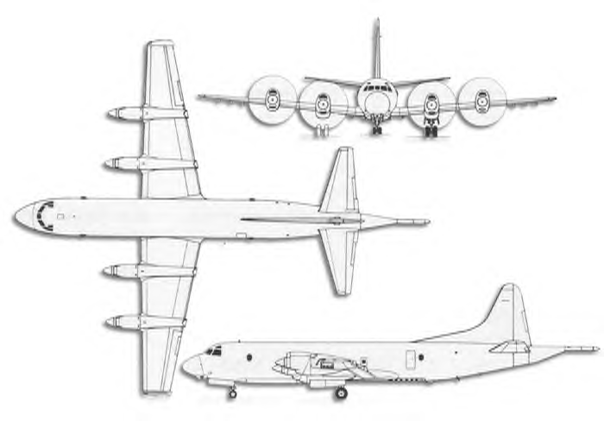

HAZARDS
- 6,560 gallons / 44,500 pounds of jet fuel on-board (fully loaded), located in wings.
- 1 oxygen cylinder located on left side. The valve is located just aft of flight station, on lower left of aft bulkhead.
- One battery located in nose wheel well.
- Propeller danger zone 25 feet
- Turbine blade failure 300 feet.
- Engine exhaust: 1500 feet.
- APU exhaust 15 feet.
- Pneumatic system pressurized to 3000 psi.
- Oil – 8 gallons per engine, Hydraulic fluid 30 gallons of 5606.
- Aircraft can fly with one engine shutdown as a precaution.
- Aircraft can experience hot brakes when landing on short runways.

APPROACH TO ENTRY POINT: (Engines running 80%+)
- Approach directly from the left side, aft of the wing, avoiding the propellers for a ten-foot radius.

PRE-DESIGNATED RESCUEMAN ACTIONS
- GAIN ENTRY
a. Normal entry – Normal entrance is through AFT cabin door on left-hand side of fuselage. Press button on handle to “pop” out handle. Rotate handle counter clockwise. PUSH door in and slide forward.
b. Emergency entry – In the event the Main entrance Door is inaccessible, emergency entrance may be gained through:
I. Flight station escape hatch, over cockpit.
II. Pilot’s auxiliary exit, left-hand side of fuselage just AFT of pilot’s window.
III. Overwing emergency exit hatches, both sides of fuselage.
c. Cut-in – Cut-in entry on side of fuselage, aft of wing.
- ENGINE SHUTDOWN
a. PARKING BRAKE: Set parking brake by depressing toe pedals and pulling parking brake handle, located on left crewmembers dash board, just above steering wheel column, above right knee.
b. Pull all four emergency shutdown handles, located on the top of the center dashboard.
c. Place APU switch, located center aft of overhead panel, to the OFF position. APUs may be secured externally by a safety switch located on left-hand side of fuselage, under cockpit, forward of the APU. NOTE: The APU Normal/Safe switch also disables the automatic fire extinguisher circuit.
d. Battery is located in nose wheelwell. To deactivate battery, remove quick disconnect fitting.
3. AIRCREW EXTRACTION
a. Lift quick disconnect lever to release shoulder harnesses and lap belt.

OTHER FACTORS
- Special tools/equipment: Power rescue saw and crash axe.
- Location of switches and equipment and emergency procedures may vary for individual aircraft. Crews should be briefed prior to aircraft dispatch.

COMMUNICATIONS PLAN: National Air Tanker Base frequency – 123.975. All air tanker bases, air tankers and air tanker support aircraft during fire fighting operations, use this frequency.

AIR TANKER CALL SIGNS: 00, 21, 22, 23, 25, 26, and 27.

