AIRCRAFT PRE-FIRE PLAN

AIRCRAFT TYPE: Lockheed P2V Neptune / SP2H Reference:

AIRCRAFT DESCRIPTION: There are currently three models of the P-2 being used as airtankers. P2V-5 and P2V-7 Neptune: Built for the U.S. Navy, the Neptune was designed for long range patrol and anti-submarine warfare. It saw active military service until the mid-60s. Two recip engines powered original versions and later two turbojets were added for take-off assistance. Both engines use the same aviation fuel. The Forest Service was the first to acquire surplus Neptunes and installed the first eight-gate tank on its own machine. As more became available operators picked them up and the tank and gating system were vastly improved. It is superbly suited for airtanker operations with its two jet engines adding power during take-offs and retardant drops. The P2V-5 and 7 are almost identical in performance with the –7 model distinguished by a bubble-shaped cockpit. Wing-tip tanks are optional on P2Vs. SP2H: Introduced as an airtanker in late 1987, this is a modified Lockheed P2V. The jet engines have been removed and two thousand-gallon retardant tank installed with computerized variable flow doors controlling selected retardant coverage level. Removal of the jets was partially offset by a smaller and lighter retardant system. The smaller retardant tank profile, mid-wing and the absence of the jet engines can identify it.

Type | Length (ft) | Wing Span (ft) | Turn Radius (ft) | Cruise Speed (Kts/mph) | Range Loaded (St. miles) | Gross Weight  (lbs.) | Contract Op. Wt. (lbs.) | Retardant Load | Number Gates | ICS Type
SP2H | 95 | 98 | 71 | 191 / 220 | 1100 | 67,000 | 62,000 | 2000 | 1 | 2
P2V | 86 | 98 | 72 | 195 / 225 | 1100 | 80,000 | 73,900 | 2400 | 6 | 2

AIRCRAFT DIAGRAM: (Lockheed P2V Neptune)

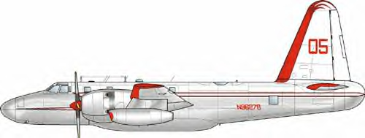

(Lockheed SP2H)

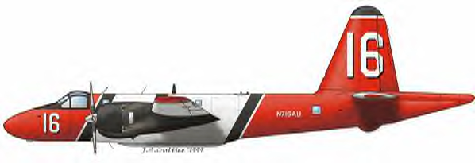

HAZARDS:
- NOTE: The SP2H is also known as the P2V-7.
- 1,400 gallons / 9380 pounds of aviation-gas on-board (fully loaded), located in wings and fuselage. The P2-V will carry more.
- 1 oxygen cylinder located within reach of crewmembers.
- Two batteries located in tail section on the aft side of the rear bulkhead inside near the wing root.
- Propeller danger zone 25 feet
- Turbine blade failure 300 feet.
- Engine exhaust 1500 feet.
- Hydraulic system pressurized to 3000 psi.
- Engine Oil – 80 gallons stored aft of each engine.
- Hydraulic fluid – up to 50 gallons.
- Can fly with one engine shutdown.
- Circuit breakers: P2V-5 – left side of interior fuselage, aft of entry point. P2V-7 – Left side of fuselage, forward of entry point.

APPROACH TO ENTRY POINT: (Engines running 80%+)
- Approach directly from the nose, avoiding the propellers for a ten-foot radius.

PRE-DESIGNATED RESCUEMAN ACTIONS:
- GAIN ENTRY NOTE: The SP2H is similar to the P2V-7.
a. Normal entry –
I. Aft of nose wheel in wheel well. Open door of left side of wheel well. P2V-5 door slides forward. / P2V-7 door is a roll up curtain.
II. On P2V-7, rotate yellow handle on aft bulkhead, down to release ladder.
b. Emergency entry – Open hatch over each crewmember by punching hole in fabric covers between hatches. This gives you access to handle, PULL handle. P2V-5 lift hatch and swing forward. / P2V-7 lift hatch and swing towards centerline of aircraft.
c. Cut-in / Forcible Entry -
I. Cut-in around all hatches and windows.
II. Cut-in on top of fuselage.
- ENGINE SHUTDOWN NOTE: The SP2H is similar to the P2V-7.
a. Retard engine throttles, located P2V-5 on center pedestal / P2V-7 on center overhead console, full aft.
b. Retard jet throttles, located to the right of the main engine throttles, full aft to OFF position. NOTE: Emergency jet engine shutdown can be located in various locations.
c. Retard fuel mixture control levers, located P2V-5 to the right of the throttles / P2V-7 to the left of the throttles, full aft to CUT OFF
d. Fuel switches, located P2V-5 under door in floor between crewmembers, rotate to OFF NOTE: Second valve is for hydraulics and this can be rotated as well. / P2V-7 aft of throttles full aft to OFF position.
e. Place battery master switch, located on the aft side of the center pedestal to the OFF position.
CAUTION: Magneto switches are located over center dashboard. If left on and propellers are rotated by hand, engines can momentarily attempt to fire. Magnetos should be placed in the OFF position as an added safety measure if time permits.
3. AIRCREW EXTRACTION
a. Unlatch lap belt and remove shoulder harness from crewmember(s). If seat track is not damaged during crash landing, use adjustable seat control to move seat in aft position when removing crewmembers.

OTHER FACTORS:
- Special tools/equipment: Power rescue saw, 12-foot ladder, and crash axe.
- Location of switches and equipment and emergency shutdown procedures may vary for individual aircraft. Crews should be briefed before aircraft dispatch.

COMMUNICATIONS PLAN: National Air Tanker frequency – 123.975. This is the frequency used by all air tanker bases, air tankers and air tanker support aircraft during fire fighting operations.

AIR TANKERS OF THIS TYPE:
SP2H: 01, 16, 18. P2V-5 Neptune: 05, 06, 07, 08, 09, 10, 11, 12, 55, and 99. P2V-7: 139, 140.

