AIRCRAFT PRE-FIRE PLAN

AIRCRAFT TYPE: Consolidated PB4Y-2 Privateer Reference: Mfg Info.

AIRCRAFT DESCRIPTION: This World War II airplane was built as a long-range bomber. Several versions were produced with the most obvious difference being the single tail design of the Navy PB4Y and the double tail Army B-24. The Navy version was nicknamed the “Privateer.” It was surplused by the military and acquired by airtanker operators in the ‘60’s and has been a mainstay ever since. It was refitted with more powerful engines and designated the Super PB4Y-2. Like other aircraft built in the ‘40’s, replacement parts are difficult to find and it’s future as an airtanker is limited. The PB4Y-2 can be identified by the bomber appearance of the nose, outside ladder on the fuselage, high wing, four piston engines and three-blade propeller.

Length (ft) | Wing Span (ft) | Turn Radius (ft) | Cruise Speed (Kts/mph) | Range Loaded (St. miles) | Gross Weight  (lbs.) | Contract Op. Wt. (lbs.) | Retardant Load | Number Gates | ICS Type
75 | 110 | 68 | 182 / 210 | 520 | 69,900 | 57,200 | 2200 | 8 | 2

AIRCRAFT DIAGRAM:
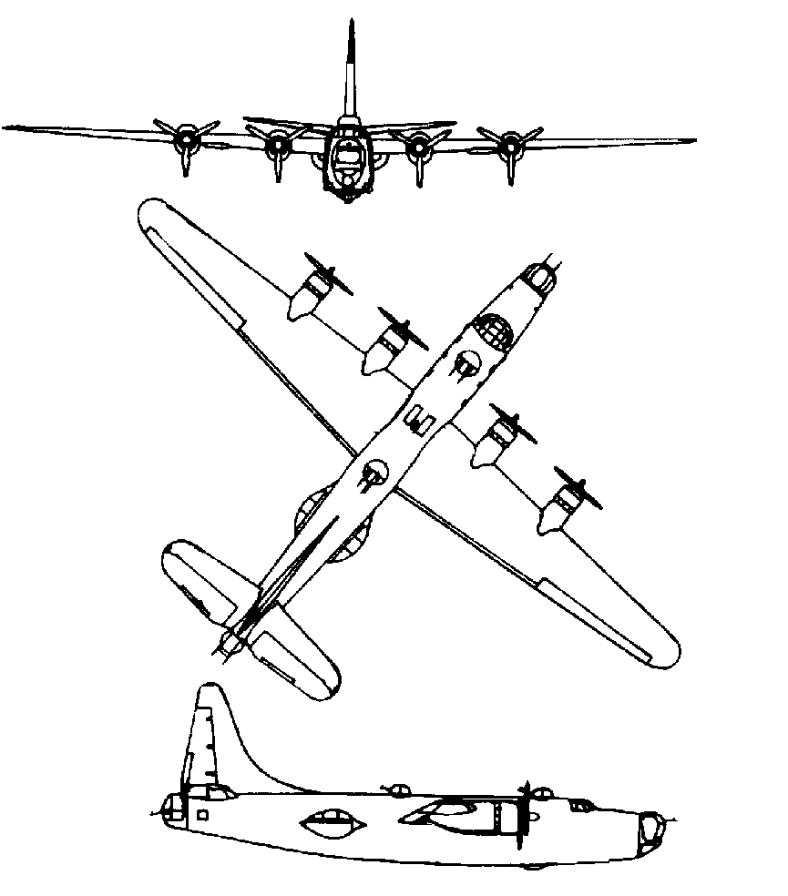

HAZARDS:
- Two retardant tanks can collapse onto center walkway during crash, creating access problem to cockpit when using normal entry procedures.
- Engines will smoke when starting.
- Engine(s) can have an exhaust stack fire caused by a build-up of raw fuel in the exhaust pipe. This will burn itself out and is usually not a hazard.
- Aircraft can fly with one engine shutdown.
- 1,600 gallons / 10720 pounds of av-gas on-board (fully loaded), located in wings.
- Two batteries are located on lower deck, near upper deck access, left side of aircraft interior.
- Propeller danger zone 25 feet
- Prop blast – 25 to 50 feet.
- Pneumatic system pressurized to 1500 psi. Engine Oil – 38 gallons
- Hydraulic fluid - 15 gallons of 5606, located in the aft portion, right side of flight (upper) deck. Up to 50 gallons including spare fluid. (There is a 1500-psi blowdown bottle located on the left wall, just aft of the pilot’s (left) seat. This is used to dump the retardant when all systems have on the aircraft have failed.)
- NOTE: There is only one hydraulic system, which operates the nose wheel steering, brakes, flaps and lowers the gear!

APPROACH TO ENTRY POINT: (Engines running 80%+)
- Approach directly from the nose, avoiding the propellers for a ten-foot radius.

PRE-DESIGNATED RESCUEMAN ACTIONS:
- GAIN ENTRY
a. Normal entry –
I. Using ladder mounted on left side of aircraft just forward of the wing, to gain access to the top of the aircraft. There are three emergency hatches located on the top of the fuselage. The hatches located aft of the wing and aft of the cockpit can be opened from the exterior. The hatch forward of the wing (Astro Hatch) can only be opened from the inside. To open exterior hatches, lift up on the handle and allow hatch to swing inwards. WARNING! Access to this hatch can be extremely dangerous when the engines are running.
b. Emergency entry –
I. Enter through the nose wheel well. Crawl aft to mid-ship area to gain access to the upper deck and cockpit. If aircraft has landed gear-up, force entry through nose bubble.
II. Break windows in tailcone.
c. Cut-in -
I. Cut around the former top gun turret opening. This is identified from the exterior by a large ring/circle of screws or bolts on the top of the fuselage, just aft of the forward emergency hatch.
II. In tail section, a hatch is located on the underside of the fuselage. It can not be opened from the exterior. Cut around hatch frame.
III. Break glass or cut around frames of all hatches and windows.
- ENGINE SHUTDOWN
a. Retard all 4 throttles, located in the center of the center pedestal, to the fall aft position.
b. Push all 4 fuel mixture levers, located on the right side of the center pedestal to the full forward position.
c. Place 4 fire wall shut-off switches, located on the left side of the center pedestal, next to the throttles, in the OFF position by lifting the guard and moving the switch up.
d. If fire is visible in an engine or the engine fire light is on, lift the guards on all four fire extinguisher switches (break safety wire first), located on the top right side of the dash board, and move the switch(s) to the up position for the appropriate engine(s).
e. 2 battery switches are located on the right wall, just above the co-pilot’s knee on the aft portion of the panel. Place these switches in the down (OFF) position.
3. AIRCREW EXTRACTION
a. Remove lap belts and shoulder harnesses from crewmembers.

OTHER FACTORS:
- Special tools/equipment: Power rescue saw and crash axe.
- Fire extinguisher located on rear of co-pilot’s (right) seat.
- Location of switches and equipment and emergency shutdown procedures may vary for individual aircraft. Crews should be briefed prior to aircraft dispatch.

COMMUNICATIONS PLAN: National Air Tanker frequency – 123.975. This is the frequency used by all air tanker bases, air tankers and air tanker support aircraft during fire fighting operations.

AIR TANKER CALL-SIGNS: 121, 124, 126, 127.

