AIRCRAFT PRE-FIRE PLAN

AIRCRAFT TYPE: Pilatus PC-7 Reference: T.O 00-105E-9

AIRCRAFT DESCRIPTION: The PC-7 is an advanced turbo-prop trainer used by a variety of air forces around the world. It has a low wing, is all metal construction with a tricycle landing gear. It comes with a two seat cockpit. It is currently used in wildland firefighting as in the Air Support Module (ASM) role in which it fills the role of lead plane and air attack. It is currently being used by the Department of Natural Resources in Alaska.

Length (ft) | Wing Span (ft) | Turn Radius (ft) | Cruise Speed (Kts/mph) | Range Loaded (St. miles) | Gross Weight  (lbs.) | Contract Op. Wt. (lbs.) | Crew/pax
32’ ¾” | 34’ 1-1/2” | 50 | 256 | 1634 | 4412 | 4412 | 1 or 2

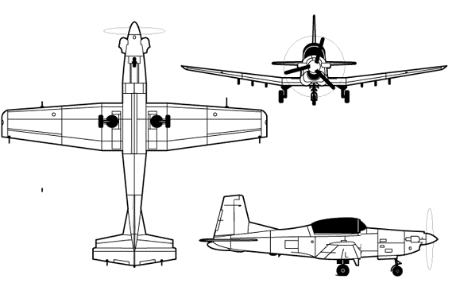
AIRCRAFT DIAGRAM:

HAZARDS:
1. 129 gal. of turbine fuel located in main wings. 42 gallons of turbine fuel located under each wing in a fuel pod.
2. One battery located on right side of fuselage, aft of the wing.
3. Propeller danger zone 10 feet
4. Engine exhaust – 25 feet.
5. Military version will have an ejection seat

APPROACH TO ENTRY POINT: (Engines running 80%+)
- Approach directly from the tail, aft of the wing on the left side.

PRE-DESIGNATED RESCUEMAN ACTIONS:
- GAIN ENTRY:
a. Normal entry –
I. Actuate the canopy actuator clutch, located at the forward left side corner of the canopy.
II. Use the external canopy hand grip, located on the forward left side of the canopy and open the canopy.
III. The internal canopy hand grip, located on the forward left side of the canopy, is used by the crew to open and close the canopy internally.
b. Emergency entry –
I. Use the external canopy jettison, located under the aft left corner of the canopy on the fuselage, to jettison the canopy.
c. Cut-in / Forcible Entry –
I. Cut-in canopy glass on all four sides along canopy frame.
- ENGINE SHUTDOWN
a. Pull the firewall shutoff operating lever, located on the left side of the forward instrument panel, aft to the SHUTOFF position.
b. Push battery switch, located on the right console, down to the OFF position. NOTE: There is also a battery switch in the aft cockpit located in the same location. Use the forward cockpit battery switch as the primary battery shutdown switch.
c. Do not actuate the reset switch, located on the right console right of the battery switch, unless electrical is required.
3. AIRCREW EXTRACTION
a. Pilot and co-pilot are attached to the seats by shoulder straps attached to the lap belt by a quick disconnect buckle. LIFT buckle cover to release shoulder harness and lap belt.

OTHER FACTORS:
- Special tools/equipment: Power rescue saw and crash axe.
- Aircraft constructed primarily of aluminum.
- Locations of switches and equipment and emergency procedures may vary for individual aircraft. Crews should be briefed prior to aircraft dispatch.

COMMUNICATIONS PLAN: National Air Tanker frequency – 123-975. This is the frequency used by all air tanker bases, air tankers and air tanker support aircraft during fire fighting operations.

