AIRCRAFT PRE-FIRE PLAN

AIRCRAFT TYPE: Grumman S-2F Tracker Reference: CDF Info.

AIRCRAFT DESCRIPTION: The S-2s were used extensively by the US Navy as surveillance aircraft. S-2F’s are used by the California Department of Forestry (CDF), and by the Canadians. CDF operates them without lead planes but usually under the supervision on Air Tactical Group Supervisor. Canadian airtankers may be used in the U.S. under special agreements when specific criteria have been met. The CDF S-2 air tankers are being modernized to turbine power, longer fuselages, and large retardant tanks.

Model | Length (ft) | Wing Span (ft) | Turn Radius (ft) | Cruise Speed (Kts/mph) | Range Loaded (St. miles) | Gross Weight  (lbs.) | Contract Op. Wt. (lbs.) | Retardant Load | Number Gates | ICS Type
S-2 | 44 | 73 | 45 | 175 / 200 | 1500 | 27,000 | 25,000 | 800 | 4 | 3
Turbine | 47 | 73 | 45 | 230/265 | 1500 | 29,150 | 29,150 | 1200 | Constant | 3

AIRCRAFT DIAGRAM
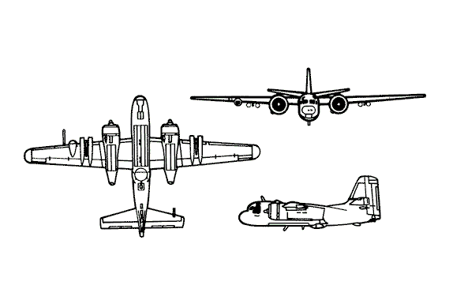

HAZARDS
- 544 gallons / 3644.8 pounds of av-gas on-board (fully loaded), located in wings. Turbine 730 gals / 4891 lbs Jet A.
- One battery located in rear of fuselage. Turbine – 2 batteries located in nose.
- Propeller danger zone 25 feet
- Prop blast 60 feet.
- Hydraulic system pressurized to 1500 psi.
- Engine Oil – 12 gallons per engine – 7 quarts per turbine engine
- Hydraulic fluid – 9.4 gallons. Turbine – 6 quarts

APPROACH TO ENTRY POINT (Engines running 80%+)
- Approach directly from the tail, avoiding the propellers for a ten-foot radius.

PRE-DESIGNATED RESCUEMAN ACTIONS
- GAIN ENTRY
a. Normal entry – Hatch is located right side, aft of the propeller. Move top lever forward to unlock position. Rotat handle clockwise, one-quarter turn to the open position.
b. Emergency entry –
I. Emergency escape hatch is located forward right hand side of fuselage over cockpit area. Hatch will open outwards. Rotate handle to open position.
II. Emergency escape hatch is located aft on top centerline of fuselage. Hatch opens inward. Rotate handle to open position.
c. Cut-in / Forcible Entry – Cut around frame of entry hatch.
- ENGINE SHUTDOWN
a. Place mixture control levers, located on right hand side of center overhead console, to IDLE CUTOFF. On turbine only need to pull condition levers located on right hand side of overhead console to full aft position. NOTE: Release latch on condition lever must be pulled down to allow condition lever movement. Then go step “d”.
b. Place throttles, located on center overhead console, to the CLOSED position.
c. Place ignition switch, located lower left corner of main dash, to the OFF position.
d. Place battery switch, located on left side of center overhead console, to the OFF position, time permitting. On turbine only, place battery switches (2), located on right side of center overhead console, to the OFF position.
3. AIRCREW EXTRACTION
a. Crewmembers and passengers are attached to seats by shoulder harnesses secured to a lap belt quick disconnect fitting. PULL lap belt quick disconnect fitting shoulder harness and lap belts will fall free.

OTHER FACTORS
- Special tools/equipment: Power rescue saw and crash axe.
- Locations of switches and equipment and emergency procedures may vary for individual aircraft. Crews should be briefed prior to aircraft dispatch.

COMMUNICATIONS PLAN: National Air Tanker frequency – 123-975. This is the frequency used by all air tanker bases, air tankers and air tanker support aircraft during fire fighting operations.

AIR TANKERS OF THIS TYPE:
Radial: 73, 74, 75, 76, 77, 78, 80, 91, 93, 94, 95, 96, 100, 154, 155. Turbine: 70, 71, 72, 79, 82, 83, 84, 86, 87, 88, 89, 90, 92

