AIRCRAFT PRE-FIRE PLAN

AIRCRAFT TYPE: CH-34 / S-58T Reference: “Old” T.O. 00-105E-9
IHOG Manual (1/98)

AIRCRAFT DESCRIPTION: The Sikorsky S-58T is a common twin turbine version of the piston powered S-58, which was built in the 60’s. Initial design for the conversion to turbine engine was done in the early 70’s, and by 1973 it was certified by the FAA for IFR operations. The S-58T has lower operating costs than the piston powered model. It has proven reliability, safety, high density altitude performance, and lifting capability. This helicopter requires a 30 by 30 foot landing pad.

Length (ft) | Rotor Dia. (ft) | Bucket Size (gals) | 1.5 Hour Fuel Load (gallons) | Fuel Consumption (gal/hrs) | Cruise Speed (Kts/mph) | Typical Equip. Wt. (lbs.) | Fixed Wt. Reduction (lbs.) | Pax Seats | ICS Type
42 | 56 | 420 | 165 | 110 | 90 / 104 | 7880 | 400 | 12 - 18 | 2

AIRCRAFT DIAGRAM:
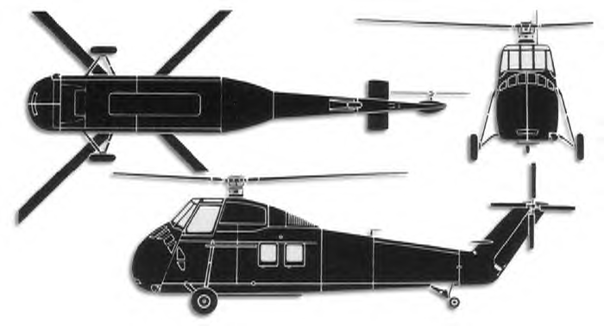

HAZARDS:
- NOTE: Location of switches and equipment and emergency shutdown procedures may vary for individual aircraft. Crews should be briefed prior to helicopter dispatch.
- Rotor blades.
- 263 gallons / 1762 pounds of fuel.

APPROACH TO ENTRY POINT: (Engines running 80%+)
1. Approach from side of aircraft to avoid main rotor blades. WARNING! Rotor blades can dip several feet. Firefighters should remain in a crouching position as they approach.

PRE-DESIGNATED RESCUEMAN ACTIONS:
- GAINING ENTRY
NOTE: Cockpit sliding windows, cargo doors, passenger and emergency escape hatches can be jettisoned by pulling appropriate emergency release handles.
a. NORMAL ENTRY
I. Rotate cabin door handle, located forward center of cabin door, slide door aft.
II. Enter through pilot’s compartment sliding windows (both sides).
b. EMERGENCY ENTRY
I. Pull emergency release handle, located upper forward of pilot’s compartment sliding windows, pull windows out.
II. Rotate emergency release handle, located upper forward corner of cabin door, down and pull door out.
III. Rotate emergency escape hatch release handle, located below emergency hatches on left-hand side of fuselage, down and pull hatches out.
IV. Pull emergency escape window tab, located in lower aft corner of rear window on right-hand side of fuselage, pull window out.
c. CUT-IN
I. Cabin windows on left-hand side of fuselage.
II. Window in cabin door right-hand side of fuselage.
- ENGINE SHUTDOWN
a. NORMAL SHUTDOWN
I. Rotate throttle, located on collective pitch lever right of center console, to CLOSED/OFF position. II. Place fuel mixture control lever, located on center console between pilot and co-pilot, in IDLE CUT-OFF position.
III. Fuel Boost Pump Switches, located on center console to OFF position.
IV. Place battery and generator switches, located on center console to OFF position.
V. Place rotor brake in ON position if rotor blades are turning. Rotor brake is located right of overhead switch panel. Red handle – pull down and forward.
- AIRCREW EXTRACTION
a. Unlatch lap belts and remove shoulder harness from crewmember(s).

OTHER FACTORS:
- Special tools/equipment: Power rescue saw.
- Location of switches and equipment and emergency shutdown procedures may vary for individual aircraft. Crews should be briefed prior to helicopter dispatch.

COMMUNICATIONS PLAN: National Air Tanker Frequency – 123.975. This is the frequency used by all air tanker bases, air tankers, and air tanker support aircraft during fire fighting operations.

