AIRCRAFT PRE-FIRE PLAN

AIRCRAFT TYPE: Sikorsky S-64 Skycrane/CH-54 Reference: T.O. 00-105E-9

AIRCRAFT DESCRIPTION: The S-64 was originally designed for the military and had interchangeable pods that fir underneath for troop transport, cargo, minesweeping, and field hospitals. It is powered by twin turbine engines and holds altitude records including a flight to 31,480 feet with a 4,400-pound payload. The Crane has a large bucket and can make quick turnarounds. Although the cost to operate per hour is high, the quantity of water or retardant delivered make it economical to operate. It requires a crew of two and has a third pilot station facing rearward for precision sling work. Skycranes have been modified to carry a 2000-gallon tank that can be filled through a draft hose with a pump on the end in less than a minute while the helicopter hovers over a water source. Skycranes are limited to operations under a 10,000-foot density altitude. Data below is for a specific version. Other versions may vary considerably in lifting capability.

Length (ft) | Rotor Dia. (ft) | Bucket Size (gals) | 1.5 Hour Fuel Load (gallons) | Fuel Consumption (gal/hrs) | Cruise Speed (Kts/mph) | Typical Equip. Wt. (lbs) | Fixed Wt. Reduction (lbs) | Pax Seats | ICS Type
89 | 72 | 2000 | 750 | 500 | 80/92 | 20,000 | N/A | N/A | 1

AIRCRAFT DIAGRAM
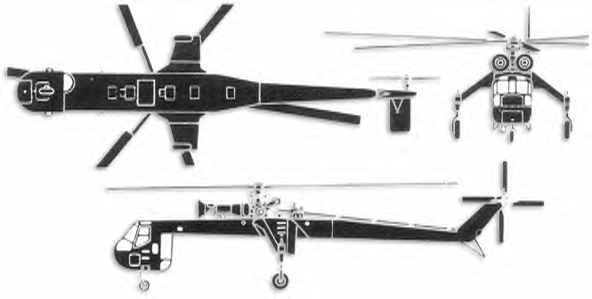

HAZARDS:
- 1353 gallons / 9065.1 pounds of jet fuel on-board (fully loaded), located in wings and fuselage.
- One battery located in nose of aircraft in compartment under left side crewmembers window..
- Rotor danger.
- Turbine blade failure 300 feet.
- Engine exhaust 12 feet.
- APU exhaust 15 feet.
- Pneumatic system pressurized to 3000 psi.
- Not uncommon to make immediate emergency landing for a “Chip Light” (senses metal in oil).

APPROACH TO ENTRY POINT: (Engines running 80%+)
- Approach directly from the side, avoiding the rotors that may dip towards the ground.

PRE-DESIGNATED RESCUEMAN ACTIONS:
- GAIN ENTRY
a. Normal entry –
I. Rotate entrance handle, located on aft edge of pilot’s and copilot’s entrance door, swing door OUT.
II. Rotate entrance handle, located on aft edge of rear cockpit entrance door on right side of crew compartment, swing door out.
b. Emergency entry –
I. Rotate emergency jettison release handle, located at forward lower corner of pilot’s and copilot’s entrance door, PULL door out.
II. Rotate emergency jettison release handle, located at forward lower corner of rear cockpit entrance door on right side of crew compartment, PULL door out.
c. Cut-in – Cut around windows.
- ENGINE SHUTDOWN
a. Emergency Shutdown -
I. NOTE: N1 levers have a detent in GRD IDLE (ground idle) position. To pass through the detent to SHUT- OFF position, PULL out on levers. Place N1 levers, located on overhead control quadrant, to SHUT-OFF position.
II. Place ignition switches, located in center panel of center console, to OFF position.
III. Place battery switch, located in center panel of center console, to OFF position.
b. Normal Shutdown -
I. NOTE: N1 levers have a detent in GRD IDLE (ground idle) position. To pass through the detent to SHUT- OFF position, PULL out on levers. Place N1 levers, located on overhead control quadrant, to SHUT-OFF position.
II. Place fuel valve shut-off handle, located on overhead quadrant, in CLOSED position.
III. Place fuel booster pump switches, located in upper panel of center console, to OFF position.
IV. Place ignition switches, located in center panel of center console, to OFF position.
V. Place battery switch, located in center panel of center console, to OFF position.
3. AIRCREW EXTRACTION
a. Unlatch lap belts and remove shoulder harness from crewmember(s).

OTHER FACTORS:
- Special tools/equipment: Power rescue saw and crash axe.
- Location of switches and equipment and emergency shutdown procedures may vary between individual aircraft. Crews should be briefed prior to dispatch.

COMMUNICATIONS PLAN: National Air Tanker Frequency – 123.975. This is the frequency used by all air tanker bases, air tankers, and air tanker support aircraft during fire fighting operations.

AIR TANKER CALL-SIGNS: Skycranes with fixed tanks will use 700 series numbers. 741, 742, 743, 744, 745, 746, 747, 748, 794, 796.

