AIRCRAFT PRE-FIRE PLAN

AIRCRAFT TYPE: Sikorsky S-70 Firehawk Reference: T.O. 00-105E-9, NAVAIR 00-80R-14-1, and UH-60 Blackhawk Interagency Helicopter Operations Guide and Los Angeles County Fire Dept. – Air Operations

AIRCRAFT DESCRIPTION: The UH-60 is currently operated by the military for personnel and cargo transport. Los Angeles County Fire Department currently operates two FIREHAWK versions, as do a few other contract operators and the Oregon National Guard. It is a complex aircraft with special maintenance requirements. The UH-60 military version is rarely seen on incidents since the military isn’t used until contract aircraft are unavailable. However, the FIREHAWK can be found operating throughout Southern California and in some other areas. They are too large and complex for many of our operations and need a large helibase with large pads and plenty of separation for takeoffs and landings. The rotor-wash is comparable to heavy-lift helicopters. The UH-60 can fly with a 660 gallon bucket. Los Angeles County also uses them for search and rescue (SAR) and medevac missions, flying with two paramedics and two pilots..

Length (ft) | Rotor Dia. (ft) | Fixed Tank (gals) | 1.5 Hour Fuel Load (gallons) | Fuel Consumption (gal/hrs) | Cruise Speed (Kts/mph) | Typical Equip. Wt. (lbs.) | Fixed Wt. Reduction (lbs.) | Pax Seats | ICS Type
65 | 54 | 1000 | 187 | 125 | 145 / 167 | 400 | N/A | 14 - 17 | 1

AIRCRAFT DIAGRAM:
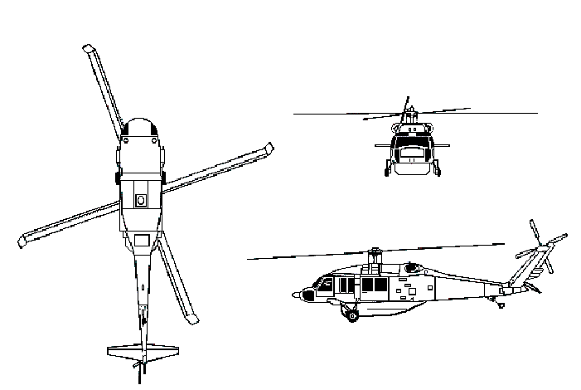

HAZARDS:
- 614 gallons / 4113.8 pounds of jet fuel on-board (fully loaded), located in fuselage and under passenger compartment.
- One battery located on cabin floor behind co-pilot.
- Inlet suction danger area is 4 feet.
- Turbine blade failure area – 300 feet.
- Engine exhaust – 30 feet.
- APU exhaust – 4 feet.
- Rotor minimum ground clearance – Main = 7 feet 6 inches. Tail = 6 feet 8 inches. (The main rotor disc diameter is 53 feet 8 inches and the tail rotor disc diameter is 11 feet.)
- Two pneumatic system pressurized to 1250 and 3200 psi.
- Engine oil – 3.8 gallons
- Hydraulic oil – 3.9 gallons
- Transmission oil – 8.15 gallons

APPROACH TO ENTRY POINT: (Engines running 80%+)
1. Approach directly from the front or side, exercising extreme caution around rotors, which can dip to within 8 feet of the ground. On military versions they can dip to within 4 feet of the ground.

PRE-DESIGNATED RESCUEMAN ACTIONS:
- GAIN ENTRY
a. Normal entry
I. Turn cockpit door handle counterclockwise to OPEN position to open door.
II. Turn cabin door handle counterclockwise to the OPEN position and slide door aft.
b. Emergency entry
I. Break window in cockpit door and pull jettison lever aft to release door hinges.
II. Break window in cabin door and rotate emergency handle, located below each window, to the aft OPEN position. Rotate bottom of window out to remove window.
c. Forcible Entry/Cut-in
I. Break window or windshield as required.
II. Cut around windows.
2. ENGINE SHUTDOWN – NOTE: To activate the installed fire extinguishing system, one T-handle must be pulled (agent is discharged to last T-handle pulled). Then reposition the fire extinguisher switch from OFF to MAIN or RESERVE. Battery switch must be in the ON position.
a. Pull engine emergency T-handles, located on center overhead control quadrant, FULL AFT.
b. PULL APU T-handle, located on upper console (aft of T-handles) DOWN.
c. Place battery switch, located on upper console (near APU T-handle), to the OFF position.
3. AIRCREW EXTRACTION
a. The pilot, co-pilot, crewman, and instructor / passenger are attached to the seats by a complete lap belt and dual torso-restraint shoulder harness attached to a rotary release buckle.
b. All troop seats have a lap belt and shoulder harness attached to a rotary release buckle.
I. ROTATE Rotary Release Buckle in either direction, to release shoulder harnesses and lap belt.

OTHER FACTORS:
- Special tools/equipment: Power rescue saw and crash axe.
- Locations of switches and equipment and emergency shutdown procedures may vary for individual aircraft. Crews should be briefed prior to helicopter dispatch.

COMMUNICATIONS PLAN: National Air Tanker Frequency – 123.975. This is the frequency used by all air tanker bases, air tankers, and air tanker support aircraft during fire fighting operations.

