AIRCRAFT PRE-FIRE PLAN

AIRCRAFT TYPE: Aerospatiale SA-315B Lama Reference: IHOG (1/98)

AIRCRAFT DESCRIPTION: The Lama is built in France and assembled in the United States. The main rotor turns from left to right as seen from the pilot’s seat. It is slow, not very fuel efficient, but has an excellent lift ability, even at high altitudes. In 1969 a Lama made the highest landing and takeoff recorded at 24,600 feet in the Himalayas. In 1972 the same Lama set the absolute altitude record at 40,820 feet. They are used for rappelling, short haul, search/rescue, bucket work, and passenger transport. The A-Star and Twin Star were meant to replace the Lamas but proved not to perform as well.

Length (ft) | Rotor Dia. (ft) | Bucket Size (gals) | 1.5 Hour Fuel Load (gallons) | Fuel Consumption (gal/hrs) | Cruise Speed (Kts/mph) | Typical Equip. Wt. (lbs.) | Fixed Wt. Reduction (lbs.) | Pax Seat | ICS Type
43 | 36 | 180 | 83 | 55 | 80 / 92 | 2600 | 180 | 4 | 3

AIRCRAFT DIAGRAM
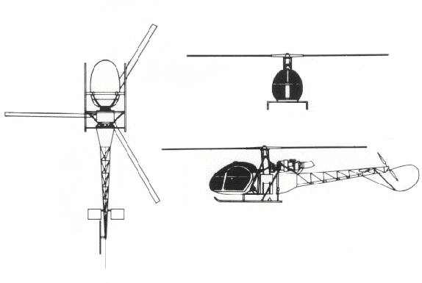

HAZARDS

Rotor blades.

Gallons / pounds of fuel

APPROACH TO ENTRY POINT (Engines running 80%+)
- Approach directly from the side, exercising extreme caution around rotors, which can dip to within four feet of the ground.

PRE-DESIGNATED RESCUEMAN ACTIONS
- GAIN ENTRY
a. Normal entry
b. Emergency entry
c. Forcible Entry/Cut-
2. ENGINE SHUTDOWN
3. AIRCREW EXTRACTION

OTHER FACTORS
1. Special tools/equipment: Power rescue saw and crash axe.
2. Location of switches and equipment and emergency shutdown procedures may vary for individual aircraft. Crews should be briefed prior to helicopter dispatch.

COMMUNICATIONS PLAN: National Air Tanker Frequency – 123.975. This is the frequency used by all air tanker bases, air tankers, and air tanker support aircraft during fire fighting operations.

