AIRCRAFT PRE-FIRE PLAN

AIRCRAFT TYPE: Aerospatiale SA-316B Alouette III Reference: IHOG (1/98) T.O. 00-105E-9

AIRCRAFT DESCRIPTION: The Alouette III is becoming rare. It is a good ship at higher density altitudes but very slow. The cabin is roomy and seats six passengers plus the pilot. The main rotor on this helicopter turns in the opposite direction as U.S. built helicopters.

Length (ft) | Rotor Dia. (ft) | Bucket Size (gals) | 1.5 Hour Fuel Load (gallons) | Fuel Consumption (gal/hrs) | Cruise Speed (Kts/mph) | Typical Equip. Wt. (lbs.) | Fixed Wt. Reduction (lbs.) | Pax Seat | ICS Type
42 | 36 | 144 | 83 | 55 | 80 / 92 | 3000 | 170 | 6 | 3

AIRCRAFT DIAGRAM
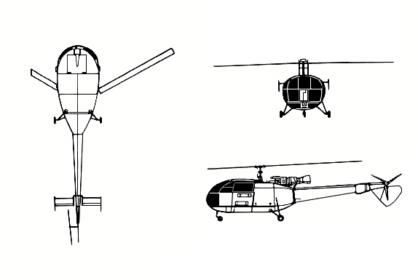

HAZARDS:

Main rotor can dip to within 4 feet of the ground. Avoid tail rotor..

Gallons / pounds of fuel. Located in tank aft of cabin.

Battery located on right side aft of passenger compartment.

Engine exhaust hazard

APPROACH TO ENTRY POINT: (Engines running 80%+)
- Approach directly from the side, exercising extreme caution around rotors, which can dip to within four feet of the ground.

PRE-DESIGNATED RESCUEMAN ACTIONS:
- GAIN ENTRY
a. Normal entry-
I. Enter through cabin doors by turning door handle downwards. Door opens forward.
II. Enter through sliding cargo doors by turning door handle to rear. Slide door aft to open.
b. Emergency entry-
I. To remove cargo doors, turn two keys to inside. Push two push buttons in, then turn them to inside.
II. For emergency release, break Plexiglas at lever (located internally) and move this lever to bottom to unlock release lug, then pull door towards you.
c. Forcible Entry/Cut-
I. Cut-in doors and windows as required.
2. ENGINE SHUTDOWN
a. Pull both fuel levers, located on forward portion of center control console, to the AFT position.
b. Place the battery switch, located on the overhead panel to the AFT position
3. AIRCREW EXTRACTION
a. Remove lap belts and shoulder harnesses.

OTHER FACTORS:
1. Special tools/equipment: Power rescue saw and crash axe.
1. Location of switches and equipment and emergency shutdown procedures may vary for individual aircraft. Crews should be briefed prior to helicopter dispatch.

COMMUNICATIONS PLAN: National Air Tanker Frequency – 123.975. This is the frequency used by all air tanker bases, air tankers, and air tanker support aircraft during fire fighting operations.

