AIRCRAFT PRE-FIRE PLAN

AIRCRAFT TYPE: Shorts SD 330 /C-23A Sherpa Reference: T.O. 00-105E-9

AIRCRAFT DESCRIPTION: In 1990 the Forest Service and Department of the Interior acquired several military excess C-23 Sherpas, a military variation of the Shorts SD 330. These aircraft were configured for smokejumping, paracargo operations, and transportation of people and cargo. The interior of the Shorts has plenty of space for cargo. These aircraft are all-weather capable and provide quick response to agency needs across the country.

Length (ft) | Wing Span (ft) | Cruise Speed (Kts/mph) | Range (St. miles) | Payload | Number of Pax Seats
58 | 75 | 148/170 | 500 | 3500 | 20 (10 jumpers)

AIRCRAFT DIAGRAM
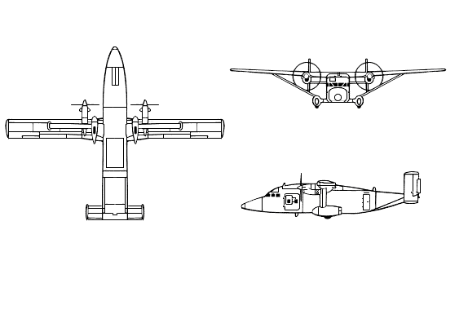

HAZARDS
- 672 gallons / 4502.4 pounds of jet fuel on-board (fully loaded), located in wings and fuselage.
- 3 oxygen cylinders in various locations near front of aircraft.
- Four batteries located in front of aircraft. Emergency battery in tail.
- Propeller danger zone 25 feet
- Turbine blade failure 300 feet.
- Engine exhaust 1500 feet.

APPROACH TO ENTRY POINT: (Engines running 80%+)
- Approach directly from the nose, avoiding the propellers for a ten-foot radius.

PRE-DESIGNATED RESCUEMAN ACTIONS
- GAIN ENTRY
a. Normal entry –
I. Turn handle on main cabin entry door, located left side aft of the wing, clockwise and pull open.
II. Turn handle on forward cargo loading door, located on left side forward of the wing, door clockwise and pull open.
b. Emergency entry –
I. Turn handle on any of two forward emergency exits left and right clockwise and pull to open.
II. Turn handle on flight compartment emergency exit, located over cockpit, clockwise and pull to jettison.
III. Turn handle on main cabin entry door, located left side aft of the wing, clockwise and pull to open.
IV. Turn handle on forward cargo loading door, located on left side forward of the wing, clockwise and pull to open.
c. Cut-In – Cut-in area each fuselage side aft of wing.
- ENGINE SHUTDOWN
a. Retard fuel levers, located on center console, to OFF position.
b. Retard LP valve levers, located in roof console, to SHUT position.
c. If fire buttons are illuminated or if there is evidence of fire in the vicinity of the engines, actuate the Fire Extinguisher Push Buttons located in the center overhead engine services panel.
d. Place electrical master switch, located left overhead electrical switch panel, to OFF position.
3. AIRCREW EXTRACTION
a. Unlatch lap belts and remove shoulder harness from crewmembers.
b. Passenger seats are equipped with lap belts only.

OTHER FACTORS
- Special tools/equipment: Power rescue saw, crash axe and 14 foot ladder.
- Locations of switches and equipment and emergency procedures may vary for individual aircraft. Crews should be briefed prior to aircraft dispatch.

COMMUNICATIONS PLAN: National Air Tanker frequency – 123.975. This is the frequency used by all air tanker bases, air tankers, air tanker support aircraft during fire fighting operations.

