AIRCRAFT PRE-FIRE PLAN

AIRCRAFT TYPE: Turbo Commander 690 Reference: Mfg. Manual

AIRCRAFT DESCRIPTION: The Turbo Commander series are high wing twin turbo-prop engine aircraft that are used for passenger and cargo transportation. The Forest Service has also used them for aerial photography. Many agencies are using the Commander in the Air Tactical Group Supervisor role. Some other models can be equipped with either piston engines or turboprop engines.

Length (ft) | Wing Span (ft) | Cruise Speed (Kts/mph) | Range (St. miles) | Payload | Number of Pax Seats
31 - 44 | 39 - 49 | 250 / 287 | 1250 | 3300 | 7

AIRCRAFT DIAGRAM

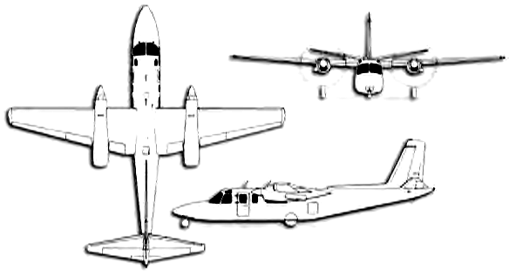

HAZARDS:
- 384 gallons / 2573 pounds of Jet A on-board (fully loaded), located in wings and fuselage.
- Two large batteries located in aft section of aircraft. Access to the battery is through the aft wall of the baggage compartment, accessible from baggage compartment.
- Propeller danger zone 25 feet
- Hydraulic system pressurized to 900 to 1075 psi.
- Hydraulic fluid – 3.2 quarts.

APPROACH TO ENTRY POINT: (Engines running 80%+)
- Approach directly from the nose, avoiding the propellers for a ten-foot radius. (When aircraft is resting on it’s wheels, bottom of door frame is 17 inches off of the ground.)

PRE-DESIGNATED RESCUEMAN ACTIONS:
- GAIN ENTRY
a. Normal entry – Cabin Door - located left side of aircraft under wing, rotate handle clockwise one quarter turn and swing door out and forward.
b. Emergency entry – Break windows if entrance cannot be gained through cabin door.
c. Cut-in – Cut cabin enclosure as required.
- ENGINE SHUTDOWN
a. Emergency Engine Shutdown
I. Retard Power Levers, located left side of center pedestal, to FLIGHT IDLE position.
II. Retard Condition Levers, located to the right of the power levers, aft to EMERGENCY SHUT-OFF / FEATHER position. NOTE: Lift up on levers while retarding to move aft of the ground idle position.
III. Place Engine Start Switches located on right and left overhead panel, to OFF position.
IV. Place Fuel / Hydraulic Switches located on right and left overhead panel, to OFF position.
V. Place Generator, then battery switch, located left edge of left overhead panel, to the OFF position.
b. Normal Engine Shutdown
I. On lower panel in front of pilots left knee, place Environmental Mode Switch in the OFF / RAMAIR position. Then turn Air Conditioning Switch to OFF. II. On overhead panel, turn OFF all switches except Control & Distribution, Bus, Battery and Fuel / Hydraulic switches.
III. On overhead panel, turn engine control switches to OFF. As props spool down to 50%, place power levers to Reverse Thrust. (The tabs on the levers must be lifted to retard levers aft to Ground Idle.
IV. When props stop turning, place battery switch, located upper left corner of left overhead switch panel, to the OFF position.
3. AIRCREW EXTRACTION
a. Unlatch lap belts from crewmembers. Personnel in front seats will have a shoulder harness.

OTHER FACTORS:
- Special tools/equipment: Power rescue saw and crash axe.
- There is an emergency exit under the right wing. There is no external handle for this exit and it can only be opened from the inside. Fire fighters should be aware that personnel could be exiting through this exit in an emergency.
- Location of switches and equipment and emergency shutdown procedures may vary for individual aircraft. Crews should be briefed prior to aircraft dispatch.

COMMUNICATIONS PLAN: National Air Tanker frequency – 123.975. This is the frequency used by all air tanker bases, air tankers, and air tanker support aircraft during fire fighting operations.

