AIRCRAFT PRE-FIRE PLAN

AIRCRAFT TYPE: Beechcraft U-21 Ute / Model 90 King Air Reference: USAF T.O. 00-105E-9

AIRCRAFT DESCRIPTION: The U-21 is the Army version of the Beechcraft Model 90 King Air. (The Navy uses a pressurized version called the T-44A as an advanced pilot trainer.) The rectangular windows distinguish it from other King Air’s. It can carry a crew of two and ten passengers. The U-21 is unpressurized while some models of the King Air can be pressurized. The State of Alaska Department of Natural Resources uses the U-21 in support of fire fighting operations. The Bureau of Land Management also uses this for their ASM module – which combines the Air Tactical Group Supervisor and Lead Plane roles.

Length (ft) | Wing Span (ft) | Turn Radius (ft) | Cruise Speed (Kts/mph) | Range Loaded (St. miles) | Gross Weight  (lbs.) | Contract Op. Wt. (lbs.) | Crew/pax
39’ 9-1/2” | 45’ 10-3/4” |  | 495 / 307 | 1814 |  |  | 2 / 10

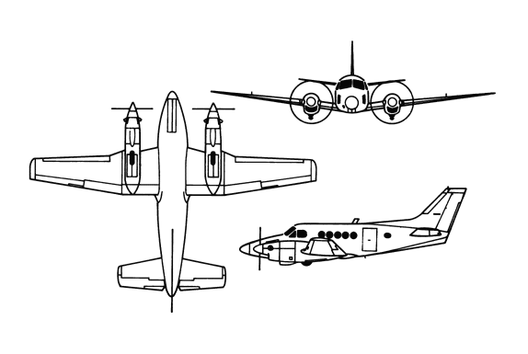
AIRCRAFT DIAGRAM

HAZARDS:
- 370 gallons / 2479 pounds of turbine fuel on-board (fully loaded), located in wings.
- One battery located in the top of the right wing, center section and is equipped with a quick disconnect plug.
- Propeller danger zone 15 feet
- Engine exhaust - 20 feet.
- Engine oil – 2.3 gallons per engine.
- Hydraulic oil – 1 pint per engine.

APPROACH TO ENTRY POINT: (Engines running 80%+)
- Approach directly from the tail, aft of the wing on the left side.

PRE-DESIGNATED RESCUEMAN ACTIONS:
- GAIN ENTRY: NOTE: In the event main door or escape hatches are inaccessible, emergency entry may be gained by breaking through windshield.
a. Normal entry – Rotate handle, located in center of passenger door on left side of aircraft down, and swing door down. NOTE: The main entrance door may be internally secured in closed position with safety chain. If door will not swing down after being unlatched, cut or break chain.
b. Emergency entry – NOTE: Emergency escape hatch on right side of fuselage is only accessible on certain models. Some models will have an escape hatch over the cockpit.
I. Cut in or break window in escape hatch on right side of fuselage, to gain access to jettison handle, located on inside aft edge of hatch.
II. Pull yellow cover, located over jettison handle, down.
III. Press release button, located directly beneath jettison handle, in.
IV. Pull jettison handle up and pull hatch out.
V. Rotate external handle on escape hatch over cockpit, lift hatch off.
c. Cut-in / Forcible Entry – Cut around frame of window on right hand side of fuselage..
- ENGINE SHUTDOWN
a. Position fuel firewall valve switches, located below the fuel management panel on left side of cockpit, down to OFF.
b. Push master switch gang bar, located on left subpanel near left crewmembers right knee, down to OFF position.
c. Pull propeller levers, located in center of control pedestal, aft to FEATHER position.
3. AIRCREW EXTRACTION
a. Pilot and co-pilot are attached to the seats by shoulder straps attached to the lap belt by a quick disconnect buckle. The passengers have a lap belt only. LIFT buckle cover to release shoulder harness and lap belt.

OTHER FACTORS:
- Special tools/equipment: Power rescue saw and crash axe.
- Aircraft constructed primarily of aluminum.
- Locations of switches and equipment and emergency procedures may vary for individual aircraft. Crews should be briefed prior to aircraft dispatch.

COMMUNICATIONS PLAN: National Air Tanker frequency – 123-975. This is the frequency used by all air tanker bases, air tankers and air tanker support aircraft during fire fighting operations.

