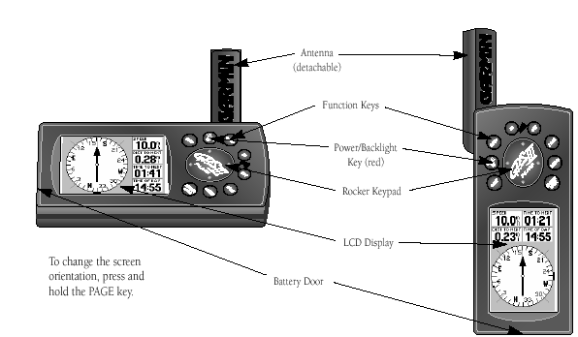
Forestry and Fire Applications for Garmin 12 Map and Garmin 3 Plus GPS Units

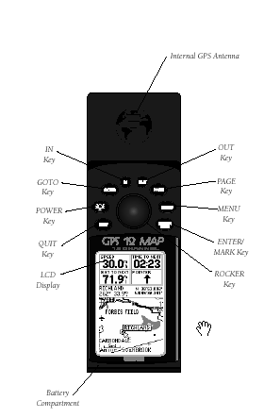

Compiled for the Idaho Department of Lands
By Dave VanNatter

Table of Contents
Introduction | page | 3
Setup | page | 4
Setup Track logging | page | 8
Record a "Track" to map of a road or boundary of project | page | 9
Managing tracks | page | 9
Intro to the Map page | page | 10
Record a "Waypoint" | page | 11
Navigate to a Waypoint (GOTO) | page | 13
Use your garmin as an accurate odometer | page | 13

Introduction
This list of Forestry and Fire applications for GPS units is only meant to supplement the instruction manuals for your particular unit

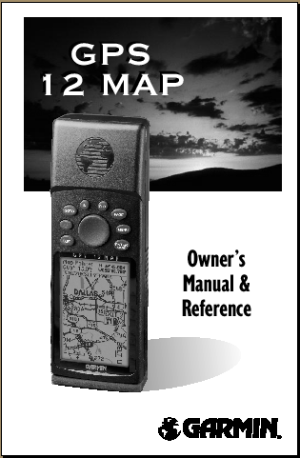

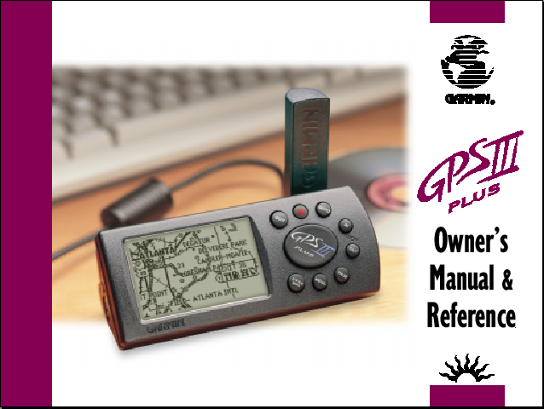

Setup
1. Push the red power on button to power up the unit then follow the on screen instructions Push <ENTER> and you should see the Satellite Status page (see below). You can cycle through the 6 pages forward with the <PAGE> button or backward with the <QUIT> button.

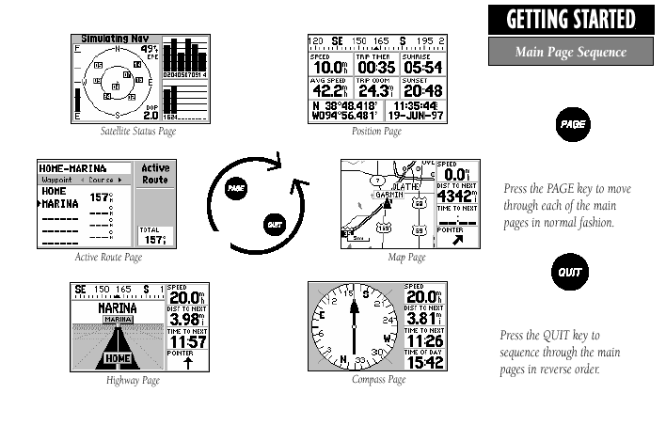

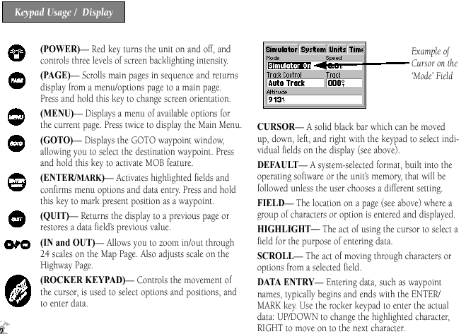

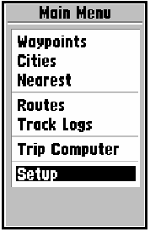
From any of the pages, you can get to the Main Menu by pushing the <MENU> twice. The Main Menu page should show up. Use the rocker keypad and scroll down to set up<enter>. Scroll to the right with the rocker pad to move to the different file tabs. Scroll down each tab and <ENTER> to change any of the set up items. Scroll up and down and <ENTER> to change the individual setting. I would recommend the following settings to get you started.
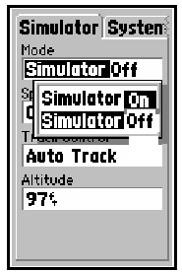

Check to see that the simulator is off

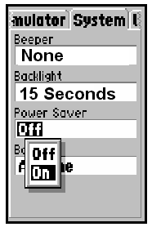

I have my Beeper set to none and backlight set to 15 seconds with power saver off.

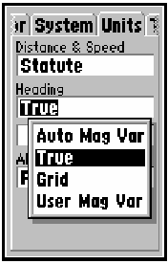

Set Distance and speed to Statute, heading to true and Altitude to feet.

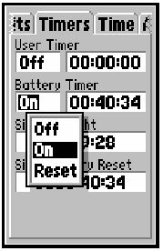 | I have my user timer off and battery timer on.
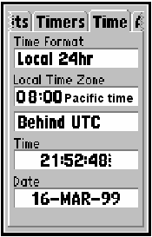

For pacific time, I set the local time to 8:00 hours behind UTC.
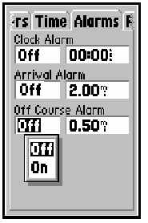

I have my alarms off but these might be useful in some applications
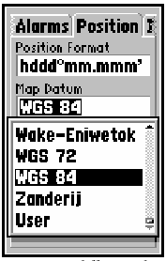

For most purposes and to transfer to Ozi Explorer software set your unit to the settings on the right. However another popular setting for GIS maps and USGS quads is to set the position at UTM/UPS and Map Datum at NAD27 CONUS.

The last setting to check is the interface.
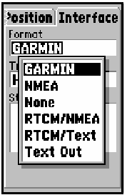
which should be set to GARMIN to transfer
information to and from you PC.

When you are done checking or changing the
settings push<Quit> and you will go back to the
Main Menu screen.

Set up track logging
From the Main Menu screen scroll down to Track Logs and push <ENTER>. You will see the Track Log page. Push <MENU> once and you will see the track log option menu. Scroll down to Setup logging and push <ENTER>

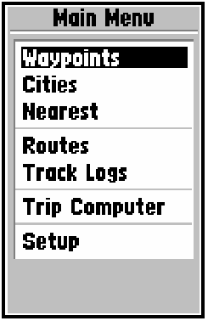
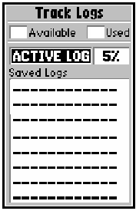
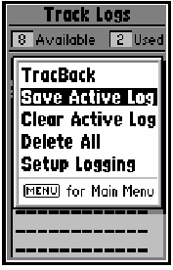
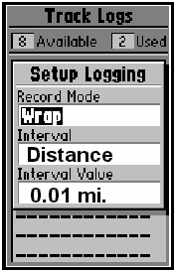

Set Record to Wrap. This will continue to record new track points over the oldest when the memory is full.

Set Interval to Distance this will automatically take a point at the distance you set below.

Set the shortest distance interval that will not use up all your memory
To calculate this you have 1900 points times the distance you set in this case 0.01 miles or you can record a maximum length track of 19 miles.

See your instruction manual for a more detailed explanation of this.
Recording Tracks
Tracks are the actual location of the path you traveled with the GPS and are visible on the Map page. The tracks can downloaded from your GPS unit to a PC. Tracks can also be uploaded to you GPS unit from a PC as an aid to navigation.

Before record a track, turn your unit on, and double-check the <track setup logging menu> to see if the unit is configured for logging. You can turn the tracking feature on or off. However, I leave my tracing on most of the time. Check the Satellite Status Page to see if you acquired 4 or more satellites and you have an Estimated Position error (EAP) of less than 40 feet.
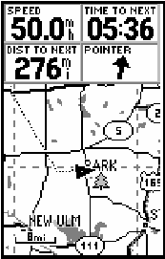

Your current position is the center white dot in the black triangle

Your track is shown on the screen as a dotted line

Your track will automatically recorded and saved if you have your unit set on wrap for record the most recent 1900 tract segments will be saved with the oldest erased. If you have large tracks you want to save simply turn the track recording off or download the track to a PC.

Managing Tracks (WARNING)

Do not use the save track feature on your GPS unit! The tracks are automatically saved.
If you save the track some how it reduces the number of point to 250 and this will destroy your work

Introduction to the Map Page

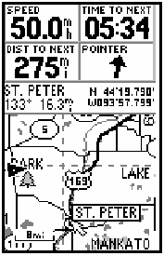  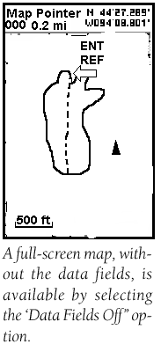 | Use the rocker keypad and you may pan to other areas of the map. When you pan the map a second arrow (white) appears on the map and a panned position status bar will show up with the distance bearing from your position to the coordinate at the tip of the white arrow. I fine this very helpful navigating in the field.  If you push <QUIT> after you have panned from your current position the pan arrow and panned status screen will disappear. The screen will again center on your current position and the map will move with the direction of travel  If you are panned from your current position and you push <ENTER/MARK>, you will enter a Waypoint at the paned position. If you are not panning you, enter the position of where you are currently standing.  While in the map page push <MENU>. Scroll down and select data fields off to view a larger map view. Then select Measure Distance. With this option you can measure distances on you map page. In this case, you can get a rough size of a fire area.

Record a “Waypoint”
You can record a Waypoint from
1 panning the map page
2. Using the <ENTER/MARK> button
3. Directly typing in New Way point
4. Importing from a PC computer

Using <ENTER/MARK> button

You can record your current position from any of the 6 main pages when your unit is receiving 4 or more satellites. Simply push and hold <ENTER/MARK>.

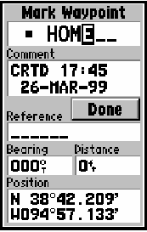  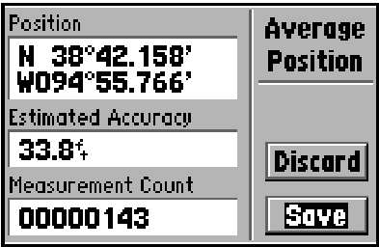 | The Mark Waypoint screen will appear. You may scroll down and edit any item by pushing <ENTER>.  The Waypoints will automatically be assigned a sequential number. 0r you may change them to any 6-digit name. Scroll to Done and push <ENTER> to save your Waypoint. To improve the accuracy of your way point collection while in the Mark Waypoint Page push <MENU>. Scroll down to Average Position push <ENTER>. You will have the Average Position page showing. Scroll down to Save and push <ENTER> after Measurement Count is over 180. This will return you to the Mark Waypoint page. Scroll up and over to Done and push <ENTER>.
New Waypoint

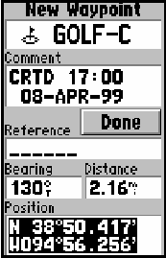
From the Main Menu page select Waypoints then push <MENU> scroll to New Waypoint and <ENTER>.
Any thing on the New Waypoint page can be changed or calculated by giving a new bearing and distance. Make sure you select and <ENTER>Done to save.

Import Waypoints from PC Software

Several software products allow you to export Waypoints from ArcView or point and click on a map and import to your GPS unit. Follow the instructions provided with your Software for this application.

Navigating to a Waypoint (GOTO)

There are several ways to Navigate or GOTO a Waypoint

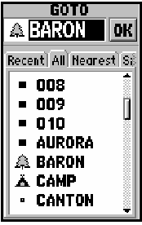
1. Push <GOTO> select the All tab then scroll down the list of Waypoints and <ENTER>.
The map page will show a straight line from your where you were when you pushed GOTO to the Waypoint. The Compass page, Highway page, and Route page will all be activated. These pages are all explained in the user manuals

WARNING
GPS units are not compasses and for any navigating by foot or slow speed You need to have a compass with you to determine the direction of the course to travel

NOTE
I like to use the Map page and the Compass Page to Navigate. When I get close to the final location and pan to the point I want to navigate to give me a map view then I use my hand compass

Use GPS as an accurate odometer
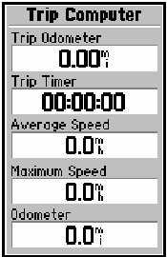
When you are at the location you want to start your odometer and you have good satellite coverage push <MENU> <MENU> From the Main Menu page select Trip Computer. Push <MENU> and Reset All. This will zero out the trip computer. For up to 10 miles the odometer will read to the nearest 100/mile or about 53 feet.

