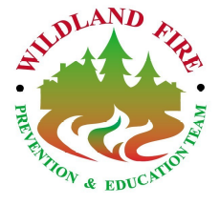
Golden Isles Wildfire Prevention & Education Team
Kingsland, GA

Phone: 912-510-5759

540-797-6241 (cell)
Fax: 912-576-0448

Daily Report
February 19, 2012

Team:
- Jim Funk Team Leader AD DBNF, Lawrenceburg, KY
- Donna Wilson PIO AD GW-JEFF NF, Roanoke, VA
- Tim Redick Team Member GFC, Glynn Co. GA
- Chelsea Parker Team Member FL FS, Perry, FL
- Keith Penrose Team Member USFWS, Savannah, GA
- Terri Jenkins, Team Member USFWS, Folkston, GA
- Ody Anderson Team Member NPS, Cumberland Island NS
- Eric Mosley Team Liaison Georgia Forestry Commission

Accomplishments:
(Administrative accomplishments will not be shown in the daily reports.)

Today was Chelsea Parker’s last day on the team. The team met for a review session of activities and events that we participated in over the last week. We also discussed strategies for next week.

The team visited the Okefenokee National Wildlife Refuge to review fuels and fire prevention concerns. The team then focused on the following target areas of concern: Moniac in Charlton County,Georgia and Moccasin community in Florida. Contacts were made with approximately 50 residents. Firewise brochures were given to all residents that were home. For those residents who were not home, Firewise door hangers were left. Most of the residents who were contacted were aware of the current wildfire conditions that could threaten their homes.

