Executive Summary
Golden Isles Fire Prevention and Education Team
February 2012

Long-term and cumulative drought conditions exist in southeastern Georgia and northern Florida. The fuel conditions for an elevated wildfire season exist with expectation of extreme wildfire behavior. Last year’s fire occurrence was one of the worst in Georgia’s history. Current drought and fuel conditions have the potential to be worse than last year.

An interagency effort to bring attention to the situation resulted in a national Fire Prevention and Education Team being ordered and stationed in Kingsland, Georgia with delegated authority in the Georgia counties of McIntosh, Glynn and Camden, and the Florida counties of Baker and Nassau. The primary focus of the effort was to raise awareness of the fire conditions and to strongly promote the Firewise program throughout the area. The agencies represented on the team were Georgia Forestry Commission, Florida Forest Service, US Fish and Wildlife Service, and the National Park Service.

Team composition was fluid during the two-week assignment, yet representatives from each agency were essential to the accomplishments of the team. An advisor from the NFPA Firewise Communities was also part of the team. His contribution was very significant and helped focus the Firewise efforts.
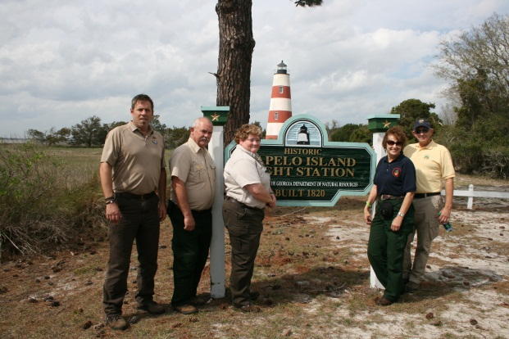
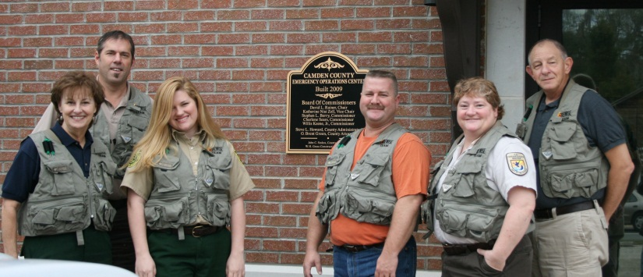

Donna Wilson, Keith Penrose, Chelsea Parker Keith Penrose, Tim Redick, Terri Jenkins,
Todd Chlanda, Terri Jenkins, Jim Funk Donna Wilson, Jim Funk

The team developed strategies and actions to address the stated objectives through media, contacts and programs with an attempt to keep the overall messages consistent, uniform, relevant, and dispersed through the delegated area. Special emphasis was placed on presenting Firewise Community development to island communities to address concerns fostered by last year’s island fire occurrence.

Overall strategy is to raise the awareness of what individuals and communities can do for themselves to lessen the impacts of wildfire and decrease the vulnerability of structures to embers and direct flame.

Objective 1: Provide consistent Firewise and fire prevention messages to the public, local governments, and media.

Strategy:
Develop key messages to address the current drought situation, Firewise opportunities, and potential of community action to reduce the risk of wildfire on lives and property.

Actions:
Researched current drought information and fuel conditions. Developed a summary of conditions and what they mean in plain language for general usage. Gathered detailed information about the situation from professional sources to deliver more in-depth explanations and predictions of the drought and its implications to wildfire risk for the immediate future.

Produced products documenting the current and expected drought conditions. Produced laminated maps to use at events and during public and media contacts.

Strategy:
Develop a short 3-8 slide PowerPoint presentation with the most significant drought and fuel messages and visuals for use as a stand alone or component of a larger presentation. The presentation will be formatted the same as other presentations being developed for the assignment.

Action:
Produced a presentation of the drought conditions as a stand-alone product, however; parts are incorporated into the larger PowerPoint presentation to be used with public meetings.

Strategy:
Utilize the NFPA Firewise Advisor to lead the development of the Firewise message for use in contacts and presentations. A product will be a one-page summary of the importance and opportunities for Firewise implementation in the area. Other products expected are a localized PowerPoint presentation carrying the Firewise message, a paper copy version of the presentation for small meetings where visual presentation is not practical, and a simple ‘What can you do?’ flyer for local contact use.

Action:
Developed the prevention message for the team assignment and used it to keep the message consistent in use among counties, agencies, media and the general public. Todd Chlanda, Firewise Advisor was very beneficial to the team by providing instruction on Firewise and new products available through the organization.

Objective 2: Promote regional Firewise and prevention education efforts and events already under way including presentations to civic and homeowners associations, participation in community events such as fairs and local celebrations.

Strategy:
Assemble packets with appropriate Firewise information and materials for distribution to fire department for their information and use in communicating Firewise to the communities.

Action:
Assembled forty packets of Firewise information for the specific purpose of distribution to fire departments. The intent is to familiarize the departments with the Firewise program, giving them the opportunity to learn the Firewise landscaping and construction elements prior to conducting workshops or demonstrations with the communities. There are 37 fire stations in the three Georgia counties, of which eleven are volunteer stations. Six fire chiefs were contacted for input to prevention concerns and to help distribute the packet to the remaining stations.

Strategy:
Explore the event opportunities occurring within the two-week time span of the delegation. Meet with county, local, and agency representatives to receive input on activities of interest, fire occurrence concerns, and opportunities to implement Firewise informational efforts.

List, prioritize, and plan events in the area that provide access to significant volumes of residents for discussion and distribution of Firewise and drought information. Attempt to spread the selected activities to different parts of the delegation area to impact maximum population and get dispersed message dispersal.

Actions:
Selected three specific events based on the size of the expected crowd or the meeting content. The events selected were the Mardi Gras Festival in St Marys in Camden County, the Olustee Reenactment in Baker County Florida, and the Tree Care Seminar in Woodbine in Camden County.

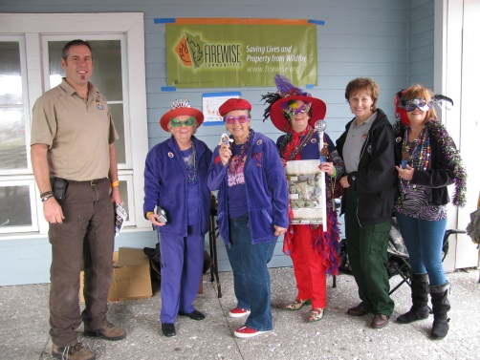
Mardi Gras Festival in St Marys, Camden County GA
Ten thousand people attended the Mardi Gras Festival. The team estimates they directly interfaced with 2,500 people giving literature on Firewise to adults and Smokey material to children.

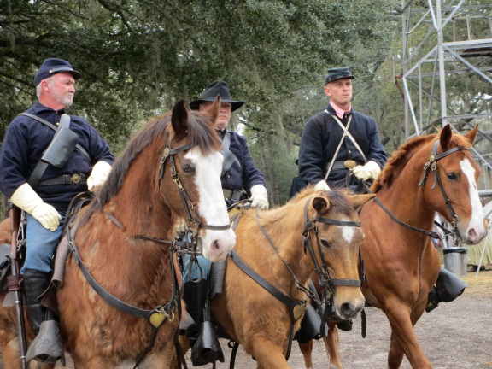
Olustee Reenactment, Baker County, FL
Three thousand people attended the Olustee Reenactment. The team spoke to about 500 individuals, again Firewise being the primary message. In both events the level of knowledge of the drought condition was high, moderate to high about fire safety and prevention, and very low about the Firewise program. A key set of contacts was with the Boy Scouts of America. Troop leaders were very interested in the Firewise program and wanted to pursue training within their organization. One mentioned the possibility of some day having a merit badge to emphasize the importance of the program and the personal safety message it carried.

Tree Care Seminar, Woodbine, Camden County GA
The intent of the Tree Care Seminar was to interface with arborists, landscapers, and tree care professionals to present material on Firewise landscaping and how the industry can assist in the effort. Approximately 80 people were in attendance. The team gave a brief presentation concerning current fire conditions and the activation of the team.

Objective 3: Raise overall awareness of the high wildfire danger, restrictions, and precautions currently in place on public and private lands in coastal areas of Southeast Georgia and Northern Florida.

Strategy – Media:
Utilize the key messages to use with media and contacting efforts informing area residents about relationships of current fuel conditions and the potential of significant fire occurrence.

Utilize and place existing PSA’s relevant to the mission on media outlets. Develop additional spots, radio messages, TV coverage, and print media stories for distribution as soon as possible. Use local EOC, fire department, or other identified individuals and organizations to assist in getting the products utilized.

Actions:
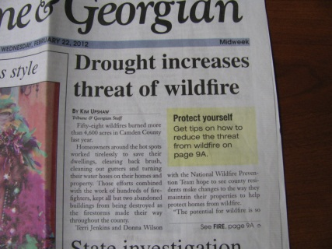
Contacted media by resending the news release prepared by GFC before the team arrived; included with the release was a request to contact the team’s Information Officer for more information and coverage of the current drought situation and Firewise. Two papers were interested. The Brunswick News was interested if they could get a photo opportunity showing mitigation in Glynn County.
The Camden Tribune & Georgian Newspaper was interested in doing a Firewise/Wildfire series of which one was completed and a photo opportunity was conducted for another one.

Sent PSAs to Georgia and Florida radio stations regarding the drought conditions. There are other PSAs that are ready for distribution when conditions change, i.e., burn ban or increase in arson starts. The team was not able to determine the extent of air time the PSAs received.

Created a “Firewise Tips for Residents” sheet for the media.

Strategy:
Identify opportunities to recognize or cover existing Firewise activities or efforts in the delegation area. Facilitate media coverage of meetings, demonstrations, trainings, or other venues that will broaden the message of Firewise.

Actions:
Prepared news release for team’s participation in Woodbine’s Arbor Day Celebration. Coverage was in the Camden Tribune & Georgian.
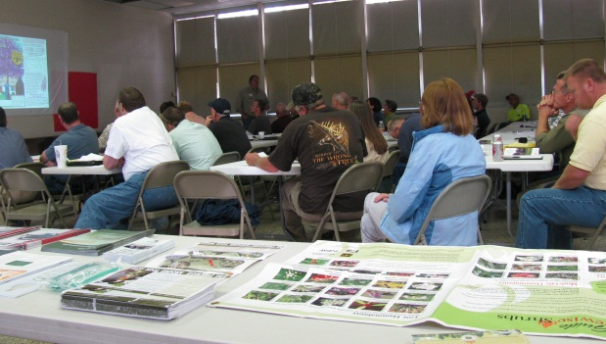
Attended the Tree Care Seminar held in Woodbine, GA. Interacted with approximately 80 landscapers, foresters, and arborists from Georgia and Florida. Team gave a brief presentation concerning fire conditions and the activation of the team. Media was invited.

Met with the Belvedere Island, GA community on two occasions. The first meeting was an informational exchange. A recognition certificate was submitted for their having a CWPP. The second meeting resulted in a commitment to seek HOA board approval to apply as a Firewise Community. Belvedere Island has completed the requirements for application.
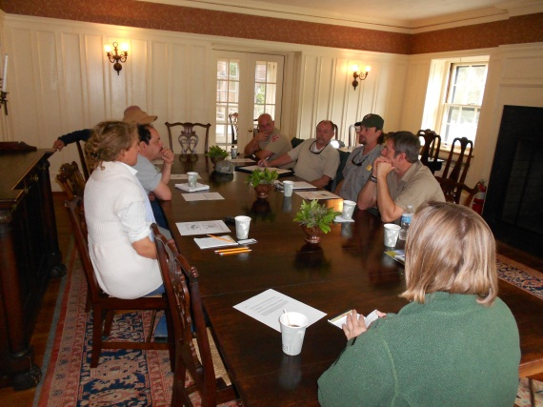
Met with Cumberland Island, GA residents to discuss the Firewise program, the progress of the Camden County CWPP, and the partnership role with the National Park Service. The meeting held at Greyfield Inn was very productive and will possibly result in a Firewise Community.

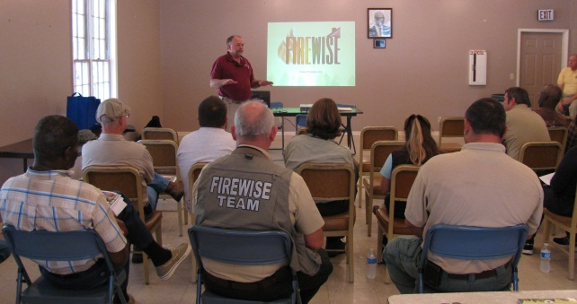
Met with residents of Sapelo Island, GA to listen to residents and resident-agency representatives as they discussed the infrastructural issue of the island. A Firewise presentation and discussion was held. Several key individuals were present including Fred Hayes, Georgia DNA, Island Manager, and Rusty Clark, GFS, Chief Ranger, McIntosh County.

Met with local Camden County Public Library officials in Kingsland, GA and St. Marys GA. Both branches agreed to display Firewise materials. St. Marys branch will make a Firewise display for library visitors this spring. Team members participated in Kingsland Library’s Children’s Reading Program, sharing the “Smokey Bear Story” to a new generation of children and parents. The Smokey Bear “flip” book is an excellent tool for outreach to young children.

Strategy:
Meet with federal, state, county, and community entities in all five of the delegated counties of Georgia and Florida. Identify opportunities to communicate with local stakeholders in residential, business, interest group, and association venues.

Action:
The team evaluated their ability to schedule and conduct meetings with county government office and decided fire departments were a more direct path to help get the Firewise message out to the public. A total of 6 fire departments were contacted in the three counties in Georgia. Reception of the program information was very positive.

The fire department in Baker County, FL has been fully engaged in spreading the Firewise message for some time. Prior to the team’s arrival local team members attended a Firewise cleanup day at the Firewise Community of Taylor.

Strategy:
Use the networks of others to maximize the dispersion of prevention messages. Also use the networks of participating agencies. Explore use of traditional, verbal, visual, and social networks to get the message out.

Action:
This action item was not accomplished to the team’s satisfaction. The concept was to utilize networks of all of those contacted to push the Firewise message and provide the links to other sources of information. The team feels the strategy is worth pursuing in the future as opportunities are presented and regulations permit.

Strategy:
Identify areas of concern through contacts with communities and individuals. Develop a plan to address the concerns of the area and threats to the community.

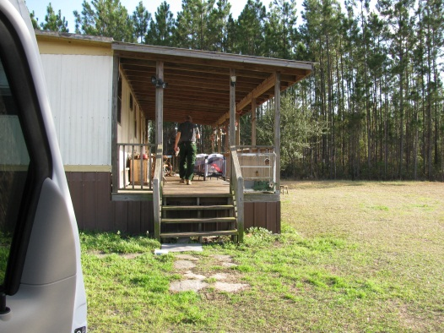
The team targeted and canvassed six areas of concern to conduct personal contacts and have direct interface with landowners. Each area effort produced results in increasing awareness of the fire and drought situation and the Firewise message. Although the areas have been contacted, they remain of concern. Additionally, the team was able to assess the area for landowner interest and possible prevention strategies that could assist the community. Two areas were Rossville Road and the area affected by the Georgia Shrimp Fire in McIntosh County. In close proximity were the areas of Moniac in Charlton County, GA and Moccasin Circle in Baker County, FL. In Nassau County, FL the team contacted residents and businesses in the Yulee Road area and along Hwy. 127 north of McClenny. Approximately 2,000 material products were distributed and 500 people contacted.

Objective 4: Create new Firewise products and programs for dissemination.

Strategy:
Determine if any new products are needed during the assignment or would be of use in future efforts. Utilize existing materials from participating agencies and the NFPA Firewise program to allow for early deployment of members to meet with counties and promote the Firewise program.

Identify agency and Firewise products that are in line with the developed prevention messages of the assignment. Order Firewise materials, banners, and other products that will complement the contacting and event coverage of the team.

Actions:
The decision was made not to create new campaign materials. Firewise materials were ordered and distributed. Smokey materials were used to reach young children and capture a moment with parents. Individual products were made for distribution to include a homeowner checklist, a website reference list, contact lists, and PowerPoints for use in meetings.

Recommend through Regional Firewise Coordinator the development of Firewise products appropriate for children.

Objective 5: Provide assistance in developing new delivery methods or products as time allows.

Strategy:
Explore the need and opportunities for additional delivery methods. Provide assistance where needed and submit recommendations of new ideas and concepts to the host agency for discussion and approval.

Query the public and local entities for methods they use to get their word out. Assess the ideas to use in the current assignment and in the future. Team will identify gaps in the ability to communicate to certain groups and find alternative methods to spread the Firewise message and garner support for local efforts.

Action:
The team recognized the need to utilize fire departments as a primary local source of information trust. This is a common source as are local grocery stops and restaurants in the rural community. No significant new networking systems were identified. The use of social media was discussed early and determined to be impractical within the current parameters of the assignment.

Objective 6: Establish a record-keeping process to provide a complete and organized electronic record of the team’s activities, accomplishments, contacts, expenditures, and recommendations for future actions.

Strategy:
Utilize existing team spreadsheets, electronic files, and established procedures to accurately track administrative information needed by the host to accurately depict accomplishments, time, and expenses for the assignment.

Actions:
Provided paper and electronic copies of all crew time reports, properly reviewed and approved by a designated official. All time, personnel costs, and related expenses were tracked on an Excel spreadsheet by individual, day, and assignment summary.

Tracked all expenses of the assignment for supplies, travel, lodging, per diem, printing, and miscellaneous items associated with team activities.

Tracked all expenses of individuals tied to the team, including those team members the host agency is not funding. The intent is to identify the total cost regardless of the funding partner. The data output will identify the funding partner so any combination of information can be retrieved.

Filed documentation is presented in paper form and contained in a file box for host agency storage. Electronic files are stored on a furnished external hard drive and copies of the information burned to CDs as the host requests.

Daily reports, a Prevention Strategy Plan, and a Final Report will be produced and copies made available in number as directed by the host agencies.

All of the above tasks were completed and documented both electronically and in hard copy.

