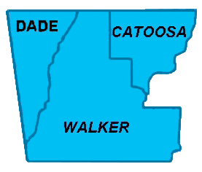

**Northwest Georgia Fire Prevention Team**

**Ringgold, GA**

|  |  |  |
| --- | --- | --- |
|  | Phone: 770-265-1606 **Daily Report**  **February 25, 2012** |  |

**Team:**

* Jim Sorenson Team Leader AD C-O NF Social Circle, GA
* Michael Williams PIO AD GW-JEFF NF, Roanoke, VA
* Beryl Budd Team Member GFC, SCFP Forester, Newborn. GA
* Mark Wiles Team Member GFC, Water Quality Specialist, Elberton, GA
* Glenn Coleman Team Member AD Kisatchie NF, Alexandria, LA
* Ken Poteet Team Member GFC, Ranger I, Dalton, GA
* Eric Mosley Team Liaison Georgia Forestry Commission

**Accomplishments:**

The office facilities available to the Team are closed on weekends, so emphasis was on doing contact work in the field.

The weather was somewhat cooperative, in that it was not raining; but it is still a little cold for many people to be in the gardening mood. However, two team members staffed an exhibit at a local gardening center in Fort Oglethorpe. They fielded a number of questions relative to dealing with the storm debris, and handed out informational materials.

One team member spend the day in the Cherokee Valley area, visiting with residents who have extreme fuel loadings in close proximity to their homes. An interesting, if discouraging, aspect of developments in this area is the fact that many of the tornado-destroyed homes have been rebuilt; but now these homes are in serious danger of being ravaged by fires occurring in the downed timber.

