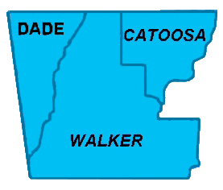

**Northwest Georgia Fire Prevention Team**

**Ringgold, GA**

|  |  |  |
| --- | --- | --- |
|  | Phone: 770-265-1606 **Daily Report**  **February 26, 2012** |  |

**Team:**

* Jim Sorenson Team Leader AD C-O NF Social Circle, GA
* Michael Williams PIO AD GW-JEFF NF, Roanoke, VA
* Beryl Budd Team Member GFC, SCFP Forester, Newborn. GA
* Mark Wiles Team Member GFC, Water Quality Specialist, Elberton, GA
* Glenn Coleman Team Member AD Kisatchie NF, Alexandria, LA
* Ken Poteet Team Member GFC, Ranger I, Dalton, GA
* Eric Mosley Team Liaison Georgia Forestry Commission

**Accomplishments:**

As is usual on these assignments, the fact that many of the agencies, businesses, and individuals with whom we need to work are not available on weekends limits our options for projects. We had a two-man team working the local hardware store with handouts explaining Firewise concepts. There was a good turnout by the public, so we feel it was time well spent. It is helpful to have a local GFC worker on this team, because the difference in burning restrictions in each of the three counties is difficult for an outsider to understand, let alone explain to the public. This team also visited with local EMT and other emergency-related folks to inform them on what we were up to with this project. That effort will continue tomorrow.

A team member spent most of the day traveling in the north part of Walker county, trying to assess the extent of damage caused in that area; there have been differing descriptions of that, and it was good to get the impression of our own member. He was also able to make a preliminary contact about the possibility of a community meeting there.

Considerable progress was made on developing a media plan to be implemented when we have a full team again.

We have had all of the assistance from the local GFC folks that we could ask for. This is especially appreciated when you consider that they were also victims of the tornado.

