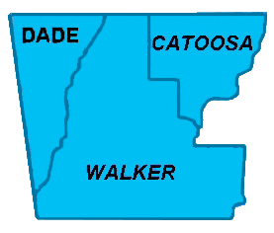

**Northwest Georgia Fire Prevention Team**

**Ringgold, GA**

|  |  |  |
| --- | --- | --- |
|  | Phone: 770-265-1606 **Daily Report**  **February 26, 2012** |  |

Team:

* Jim Sorenson Team Leader AD C-O NF Social Circle, GA
* Michael Williams PIO AD GW-JEFF NF, Roanoke, VA
* Beryl Budd Team Member GFC, SCFP Forester, Newborn. GA
* Mark Wiles Team Member GFC, Water Quality Specialist, Elberton, GA
* Glenn Coleman Team Member AD Kisatchie NF, Alexandria, LA
* Ken Poteet Team Member GFC, Ranger I, Dalton, GA
* Eric Mosley Team Liaison Georgia Forestry Commission

**Accomplishments:**

Several media events were scheduled for tomorrow and Wednesday.  We also scouted an area to take the media for some footage of the storm damage; and met with some local landowners who are willing to allow us onto their property to show the media the heavy fuel next to their homes.  This location is an ideal spot to show storm damage near a home, as well as the work that has been done in the area.  Both of the landowners were very friendly and very well spoken, and if the media chooses to speak with them, they would be good examples to represent the public.

In summary, on Monday, we scheduled field visits with eight media outlets, two in-studio interviews, and one public meeting.

Mark attended the City Council Meeting in Ringgold.

 Scouted in Walker county, meeting with local officials; getting opinions on what could be done to mitigate the situation.

Handed out Firewise materials at Home Depot and Lowes. Good turnout, due to nice weather for bringing the public out.

