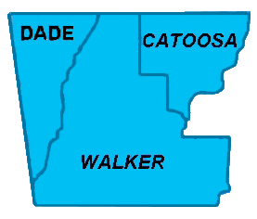

**Northwest Georgia Fire Prevention Team**

**Ringgold, GA**

|  |  |  |
| --- | --- | --- |
|  | Phone: 770-265-1606 **Daily Report**  **February 29, 2012** |  |

Team:

* Jim Sorenson Team Leader AD C-O NF Social Circle, GA
* Michael Williams PIO AD GW-JEFF NF, Roanoke, VA
* Beryl Budd Team Member GFC, SCFP Forester, Newborn. GA
* Mark Wiles Team Member GFC, Water Quality Specialist, Elberton, GA
* Glenn Coleman Team Member AD Kisatchie NF, Alexandria, LA
* Ken Poteet Team Member GFC, Ranger I, Dalton, GA
* Eric Mosley Team Liaison Georgia Forestry Commission

**Accomplishments:**

Today was essentially all media and community outreach.

**Media.**

Two television crews, (Channels 9 & 12), visited the same general area that we had used for this purpose on 28 February. In addition, Channel 3 indicated they were going to re-telecast their coverage of that date.

One newspaper, The Catoosa Weekly Community News, also sent a reporter to the site.

We continue to be surprised by the lack of interest we can generate with radio stations.

**Community Networking.**

Additional pre-work was done in preparation for community meeting to be held tomorrow in Flintstone.

A good meeting was held at the Cherokee Valley Baptist Church. This meeting was attended byMike Helton, Catoosa County Manager, Jim Cutler, District 3 County Commissioner, and DeWayne Hill, District 4 County Commissioner; Pastor Franky Ridley was the host. About a dozen local residents were also in attendance.