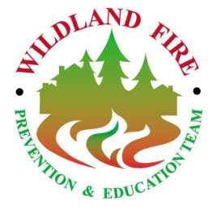
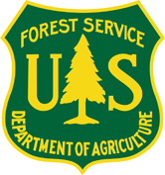
Northwest Georgia Fire Prevention Team

February 23 – March 2, 2012

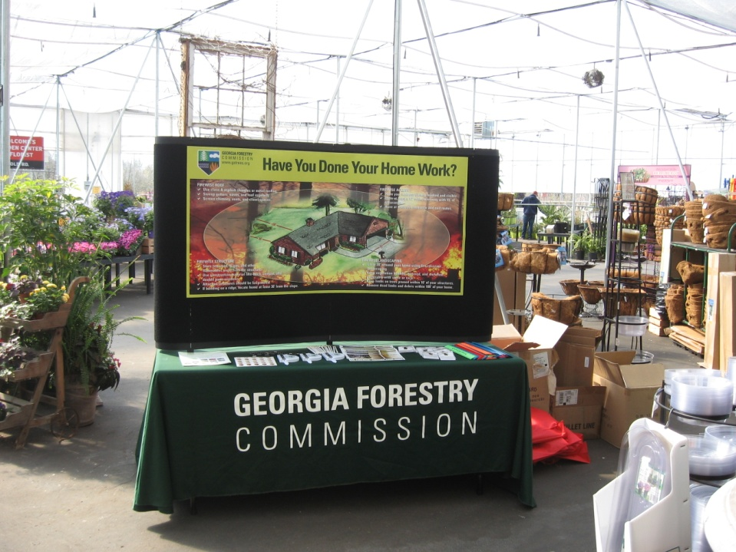

FINAL REPORT

CONTENTS:

Delegation of Authority 3

pREVENTION STRATEGY AND OBJECTIVES 4 - 5

CONTACT LIST 6 - 12

PRODUCTS 13

KEY MESSAGES 14 - 15

MEDIA COVERAGE 16 - 18

TEAM CONTACT INFO 19

BUDGET 20

APPENDIX 21 - 29

C.D. Back Cover

Delegation of Authority: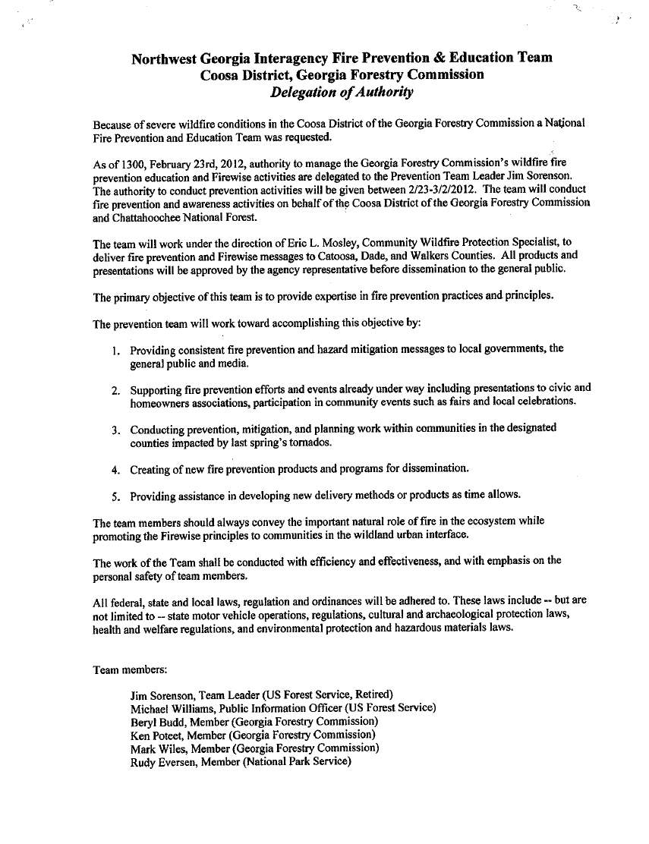

Prevention Objectives and Strategies

Objective 1: Provide consistent fire prevention and hazard mitigation messages to local government, the general public, and media.

Strategy 1: Our approach was to incorporate existing materials into our talking points and key messages whenever possible, rather than starting from scratch. Firewise messages were relied upon heavily and were modified to meet local objectives. By utilizing this tactic, we were able to quickly and effectively reach out to both the public and the media. Numerous homeowners were contacted. Four television stations and three newspapers carried this story.
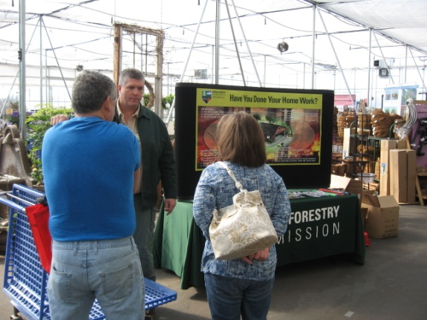

Objective 2: Support fire prevention efforts and events already under way including presentations to civic and homeowners associations, participation in community events such as fairs and local celebrations.

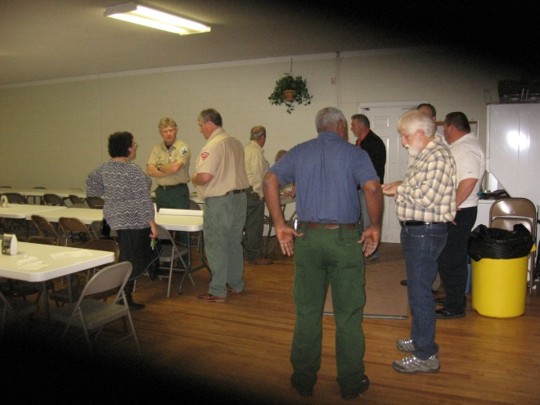Strategy 2: Face-to-face meetings and hosting community events was an area of emphasis. Two public meetings were held: one at Cherokee Valley Baptist Church, and one at a banquet hall in Flintstone, GA. Additionally, presentations were given at the Ringgold Town Hall meeting and Kiwanis Breakfast. Displays were set up and staffed at local businesses such as Home Depot, Lowes, Holcomb’s Garden Center, and Ace Hardware.

Objective 3: Conduct prevention, mitigation, and planning work within communities in the designated counties impacted by last spring’s tornados.

Strategy 3: We had good discussions with a number of officials in the three-county area. Most of these conversations were with Georgia Forestry Commission personnel; however information was also discussed with the National Park Service, and local fire departments. We also discussed the progress of Community Wildfire Protection Planning. Hosting a planning session would have been ideal, but the short duration of this project did not allow for this opportunity.

Objective 4: Create new fire prevention products and programs for dissemination.

Strategy 4: A grassroots approach to marketing our fire prevention messages was utilized whenever possible. Methods such as advertising on electronic signs utilized by businesses, and including prevention messages into utility bills were all explored. 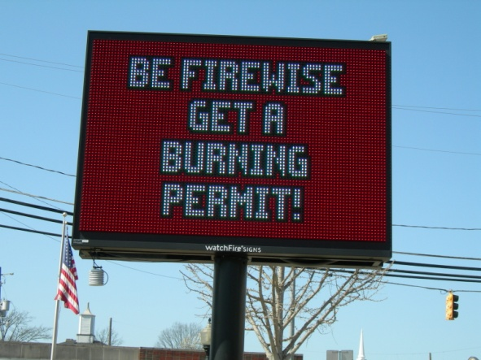

Objective 5: Provide assistance in developing new delivery methods or products as time allows.

Strategy 5: Fire Prevention messages were prepared for inclusion on the Catoosa County website, as well as that of the Cherokee Valley Baptist Church.

Contact List

Homeowner and Business Contacts
Name | Affiliation | Phone | Email | Notes
Amanda Vaughn | Battlefield Cinema 10 | (706) 861 - 8594 | NA | She referred me over to Screenvision at 1800 724 6684
Ben Scott | Cherokee Valley Homeowner | (701) 937 - 6567 | NA | Cherokee Valley Baptist Church Community Meeting Participant
Billy Kelley | Lowe's | NA | NA | Ken and Glenn set up a display on Mon. Made 50 contacts
Chris and Shana Chandler | Home Owners | (423) 316 - 1696 | NA | Mark and I met with Chris and Shana to discuss using their property for our Wednesday event.
David Klinger  194 Council Ln.  Ringgold 30736 | Home Owner | NA | falconnut@hotmail.com | Beryl's contact from 02/25
David Levi  776 Ware Rd.  Ringgold 30736 | Home Owner | NA | dl4849@catt.com | Beryl's contact from 02/25
Dede Greene | Home Depot | (706) 858 - 0398 | NA | Ken and Glenn set up a display on Mon. Made 50 contacts
Donna Greason | Disaster Response Outreach Team Case Manager | (423) 645 4100 | ringgolddisaster@gmail.com
Doug Evans  1849 Cherokee Valley Rd.  Ringgold 30736 | Home Owner | (706) 280-7277 | NA | Beryl's contact from 02/25
Frank Sagona  183 Greystone Dr.  Ringgold 30736 | Home Owner | (423) 653-7426 | fsagona@aol.com | Beryl's contact from 02/25
Franky Ridley | Cherokee Valley Baptist Church | (706) 935 - 6220  (706) 271 - 7654 (cell) | franky3@windstream.net | Community Meeting on Wednesday
Fred Turck | Assistant Division Director for Resource Protection | (804) 370 - 2047 | fred.turck@dof.virginia.gov | Fred sent over some sample PSA's to utilize for radio spots.
Jason Coats  35 Country Havan Ln.  Ringgold 30736 | Home Owner | (423) 991-7135 | jccoats2@catt.com | Beryl's contact from 02/25
Jason Howard  119 Ware Pl.  Ringgold 30736 | Home Owner | NA | jasonhoward@catt.com | Beryl's contact from 02/25
Jeanne Abdy |  | (423) 645 4100 | ringgolddisaster@gmail.com | Has access to multiple volunteer groups. Could be a good resource to partner with.
Joe McEntire | Pastor at New Friendly Baptist Church |  |  | Has a 7:30 Wednesday Prayer meeting.
Jonathan Stockil | Business Owner  Country Haven Retirement Center  120 Country Haven Ln.  Ringgold, 30736 | (706) 965-2799 | jnstocil@yahoo.com | Beryl's contact from 02/25
Laura Sparks | EMC | (706) 259 9441 x 1246 | NA | 03/01: Finally found a number. Turns out the contact is not Amy Blankenship, it is Laura Sparks.
Mark Cooper | Carmike Cinema | (706) 576-3400 | NA | Not open on the weekends. Will try back on Monday. 02/28: Spoke with Mark and he sent me a proposal. He is offering a 10% discount, but the ads are very expensive.
Martha Eaker | Rotary Club | (706) 965 - 5201 x-14 | NA | Meeting 12:00 on Tues, Feb 27.
Mary Devitt | Home Owner | (706) 965 - 7408  (423) 503 - 3948 | NA | Contact made on Feb 23 via email to Mike Helton. Concerned with fire potential near her home. Mark told her we would come give her an assessment. (She was wanting to know when we would be coming out to help clean up her damage)
Mashburn Equipment | Business Owner | (423) 834-2511 |  | Beryl's contact from 02/25
Max and Pam Pierce  274 Council Ln.  Ringgold, 30736 | Home Owner | NA | NA | Beryl's contact from 02/25
Myra Cochran | Cherokee Valley Homeowner | (423) 903 - 6567 | NA | Cherokee Valley Baptist Church Community Meeting Participant
Phil Cawood | Ace Hardware | (706) 935 - 2231 | NA | Ken and Glenn set up display on Sun. Made 50 - 60 contacts
Randall Franks | Kiwanis | NA | rfrankscatoosa@gmail.com | Meeting at 7:00 on Tues, Feb 27.
Ray Johnson | Home Owner | NA | NA | Land owner at the Thursday Feb 23 meeting.
Rodney Holcomb | Holcomb's Garden Center | (706) 861 - 4769 | Rodney@holcombgardencenter.com | Ken and Glenn set up display on Sat. Made 50 - 60 contacts
Steve McClure | Cherokee Valley Homeowner | NA | NA | Cherokee Valley Baptist Church Community Meeting Participant
William Bridges  102 Rosebud Ln.  Ringgold 30736 | Home Owner | (706) 935-3774 | NA | Beryl's contact from 02/25
Media Contacts
Name | Affiliation | Phone | Email | Notes
Adam Cook | CATOOSA CO NEWS  7513 NASHVILLE STREET  RINGGOLD, GA 30736  Counties Served: Catoosa  Media Type: WEEKLY | (706) 935 - 2621 | catoosacountynews@catoosanews.com | We took Adam to the field on Wednesday to write an article.
Antwan Harris | WRCB - Channel 3 (NBC)  900 Whitehall Road  Chattanooga, TN  37405 | (423) 267 - 5412 | aharris@wrcbtv.com | We took Antwan to the field on Tues to get some footage for his story. Antwan said they were going to re-air the story on Wed.
Becky | Editor  Walker Co Messenger  120 E Patton St  Fayette, GA 30728  Counties Served: Walker  Media Type: WEEKLY | (706) 638-1859 | walkercountymessenger@walkermessenger.com | Becky - They were planning on coming to the field with us until she found out that we have already been speaking with their sister station, The Catoosa County News. Said that if their sister station runs it, her station will also run the story.
Chris Conley | DADE CO SENTINEL  385 CHURCH STREET  TRENTON, GA 30752  Counties Served: Dade; Walker  Media Type: WEEKLY | (706) 657- 6182  (423) 593 - 9362 | editor@dadesentinel.com | Eddie has an interest in covering our story, but was not able to make it to Catoosa County because it is too far for him to go. He would be a good resource for someone to pursue for Dade County.
Evan Stone | WKWN-AM  12544 North Main Street  Trenton, GA 30752-2227  Counties Served: Dade  Media Type: RADIO | (706) 657-7594 | kwntv7@yahoo.com | Woman who answered the phone said to email PSA over to them and they would look at it. She sounded like she was trying to get me off the phone. Said that everything goes through Evan Stone. He does the PSA's and decides if the story would be worth covering as a News story. I called several times for Evan and he is always "unavailable." I do not think this is worth following up on.
John Madewell | WTVC - Channel 9 (ABC)  4279 Benton Drive  Chattanooga, TN 37406 | (423) 756-5500 | jmadewell@newschannel9 .com | We took John to the field on Wed to get some footage for his story. John also did a live broadcast from the field
Judy O'Neal | UCTV  106 HERRON STREET  Fort Oglethorpe, GA 30742  Media Type: Public Access Television | (706) 866 - 3677 | uctv3@yahoo.com | Steve Blackwell and Michael Williams participated in a 45 minute live Q and A with Judy and Alvin, and fielded calls from local viewers.
Mandy Odem | WDEF - Channel 12 (CBS)  3300 Broad Street  Chattanooga, TN 37408 | (423) 785-1200 | aodom@wdef.com | We took Mandy to the field on Wed to get some footage for her story.
Michael O'Neal | Catoosa Weekly Community News  Media Type: WEEKLY | (423) 314 - 9609 | maomao@hotmail.com | Came to the community meeting, and we also took him to the field on Wed to write another article.
News Director | WQCH  801 WARTHEN STREET  LAFAYETTE, GA 30728  Counties Served: Walker; Chattooga; Catoosa  Media Type: RADIO | (706) 638-3276 | wqchradio@aol.com  q-country@juno.com | Left message(s) - No return call
Tim Omarzu | Chattanooga Times Free Press  Media Type: DAILY | (423) 757 - 6651 | tomarzu@timesfreepress.com | Came to the community meeting. Thought about coming out to the field but he was able to get an additional story from the fire on Tues, so he did not need to go again.
Vanessa Cole | Coffee News  Media Type: NEWSLETTER | (706) 463-1117 | info@northgacoffeenews.com | Vanessa - Said that this is not really what they do. There is one section where they could put information about upcoming events. Said that if we have an upcoming event, they can put this in the newsletter free of charge, but they need the information well in advance of the meeting.
 | WJOC-AM  805 Chickamauga Avenue  Rossville, GA 30741-7404  Counties Served: Walker  Media Type: RADIO | (706) 861-0800 | wjocoffice@aol.com | Left message(s) - No return call
 | WUTC |  |  | Left message(s) - No return call
 | WSMC |  |  | Left message(s) - No return call
Community Contacts
Name | Affiliation | Phone | Email | Notes
 | Georgia Fire Prevention Team:
Beryl Budd | Prevention Team Member | (478) 733 - 2604 | BBudd@gfc.state.ga.us
Glenn Coleman | Prevention Team Member | (770) 265 - 1606 | GCOL83RAG@aol.com
Jim Sorenson | Prevention Team Member | (770) 265 - 1606 | vikingge@aol.com
Ken Poteet | Prevention Team Member | (706) 217 - 9215 | Whitfieldunit@gfc.state.ga.us
Mark Wiles | Prevention Team Member | (478) 953 - 9867 | mwiles@gfc.state.ga.us
Michael Williams | Prevention Team Member | (540) 525 - 1539 | mrwilliams04@fs.fed.us
 | Georgia Forestry Commission:
Chuck Arnold | Chief Ranger - Catoosa County | (423) 802 - 6507 | Carnold@gfc.state.ga.us  catoosaunit@gfc.state.ga.us
Eric Mosley | Team Liaison | (478) 363 - 0622 | emosley@GFC.STATE.GA.US
Heath Morton | Chief Ranger - Dade County | (706) 657 - 4211 | Hmorton@gfc.state.ga.us  Dadeunit@gfc.state.ga.us
Steve Blackwell | Chief Ranger - Walker County | (706) 638 - 5556 | Sblackwell@gfc.state.ga.us  Walkerunit@gfc.state.ga.us
 | Catoosa County Officials:
Keith Greene | Commission Chairman | (706) 965 - 2500 | keith.greene@catoosa.com
Jeff Long | Commissioner (District 1) |  | jeff.long@catoosa.com
Bobby Winters | Commissioner (District 2) |  | Bobby.winters@catoosa.com
Jim Cutler | Commissioner (District 3) | (706) 935 - 4740 | jim.cutler@catoosa.com | Met Jim at the Kiwanis meeting on Tues morning and at the Community Meeting on Wed night.
Dewayne Hill | Commissioner (District 4) | (706) 965 - 6228 | NA | Met Dewayne at the Community Meeting on Wed night
Mike Helton | Catoosa County Manager | (423) 991 - 2928 | mike.helton@catoosa.com | Mike hosted us at the Commission office. j
Steve Quinn | Emergency Management Agency Director | (423) 421 - 9241 | Squinn@catt.com
Chuck Nichols Jr. | Fire Chief | (706) 935 - 2001 | NA
Jim White | Deputy Chief | (706) 935 - 2001 | jimwhite@catoosafire.net
Duane Wilson | Angel EMS (Director) | (706) 861 - 1234 | NA
Mike Bentley | Angel EMS | (706) 861 - 1234 | NA
Dustin Bowes | Angel EMS | (706) 861 - 1234 | NA
 | Catoosa Station 1 |  | 5283 Evitt St  Ringgold, GA
 | Catoosa Station 2 |  | 13209 Hwy 151  Ringgold, GA
 | Catoosa Station 3 |  | 1705 Hwy 41  Ringgold, GA
 | Catoosa Station 4 |  | 2813 Keith Rd  Ringgold, GA
 | Catoosa Station 5 |  | 2222 Dogwood Rd  Ringgold, GA
 | Catoosa Station 6 |  | 5438 Three Notch Rd  Ringgold, GA
 | Fort Oglethorpe Station 1 |  | 201 Forrest Rd  Fort Oglethorpe, GA
 | Fort Oglethorpe Station 8 |  | 218 Old Mill Ln  Ringgold, GA
 | Fort Oglethorpe Station 10 |  | 1324 Mack Smith Rd  Ringgold, GA
 | Dade County Officials:
Ted Rumley | Commission Chairman | (423) 667 - 3999
Patrick Cannon | Sheriff | (706) 657 - 3233
Alex Case | Emergency 911 | (706) 657 - 4111 | acase@dadecounty-ga.gov
 | Walker County Officials:
Bebe Heiskell | Commissioner | (706) 638 - 1437 | commissioner@walkerga.us
Steve Wilson | Sheriff | (706) 638 - 1909
Larry Brooks | Resource Coordinator | (706) 638 - 1437 | l.brooks@walkerga.us
Randy Camp | Fire Chief (706) 539 1255
 | Catlett Emergency Services |  | 5172 Hwy 95 - Rock Spring, GA 30739
 | Cedar Grove Emergency Services |  | 5395 W Cove Road - Chickamauga, GA 30707
 | Chatt. Valley Emergency Services |  | 63 Cubine Road - Flintstone, GA 30725
 | Chickamauga Emergency Services |  | 404 Cove Road - Chickamauga, GA 30707
 | Dougherty Gap Emergency Services |  | 23716 Hwy 157 - Menlo, GA 30731
 | E. Broomstown Emergency Services |  | 3189 E Broomtown Road - LaFayette, GA 30728
 | High Point Emergency Services |  | 72 Pace Road - Chickamauga, GA 30707
 | Hinkle Emergency Services |  | 116 Hinkle Community Road - Lookout Mtn, GA 30750
 | Jenkins Rd Emergency Services |  | 207 Jenkins Road - Rossville, GA 30741
 | Kensington Emergency Services |  | 4995 Kensington Road - Chickamauga, GA 30707
 | Lee School Rd Emergency Services |  | 18 Old Lee School Road - LaFayette, GA 30728
 | Linwood Emergency Services |  | 12 Probasco Street - LaFayette, GA 30728
 | Naomi Emergency Services |  | 4072 E Hwy 136 - LaFayette, GA 30728
 | Rock Spring Emergency Services |  | 7249 N Hwy 27 - Rock Spring, GA 30739
 | Villanow Emergency Services |  | 63 Concord Road - LaFayette, GA 30728
 | W. Armuchee Emergency Services |  | 3839 W Armuchee Road - Summerville, GA 30747
 | Wallaceville Emergency Services |  | 2171 N Hwy 341 - Rossville, GA 30741
 | City of Fayette Officials:
Neal Florence | Mayor | (706) 639 - 1500 | nflorence@cityoflafayettega.org
Frank Etheridge | City Manager | (706) 639 - 1500 | fetheridge@cityoflafayettega.org
Tommy Freeman | Public Safety/fire | (706) 639 - 1500 | lfreeman@cityoflafayettega.org
 | City of Fort Oglethorpe Officials:
Lynn Long | Mayor | (706) 866 - 2544
Ron Goulant | City Manager | (706) 866 - 2544
 | Fire and Rescue | (706) 861 - 4194
 | City of Ringgold Officials:
Joe Barger | Mayor | (706) 935 - 2019
Dan Wright | City Manager | (706) 935 - 3061
 | City of Trenton Officials:
Anthony Emanuel | Mayor | (706) 657 - 4167
Chuck Cannon | Commissioner | (706) 657 - 4167
Greg Houts | Commissioner | (706) 657 - 4167
Sandra Gray | Commissioner | (706) 657 - 4167
Tommy Lawson | Commissioner | (706) 657 - 4167
Fire Chief | Jerry Kyzer | (706) 657 - 4167
 | City of Rossville
Teddy Harris | Mayor | (706) 866 - 1325
 | City Hall | (706) 866 - 1325

Products

Website Information: Versions of Firewise materials were utilized on local websites. Due to the limited amount of room for these websites, messages were condensed to fit in the available space.

Protect Your Home From Wildfire
- 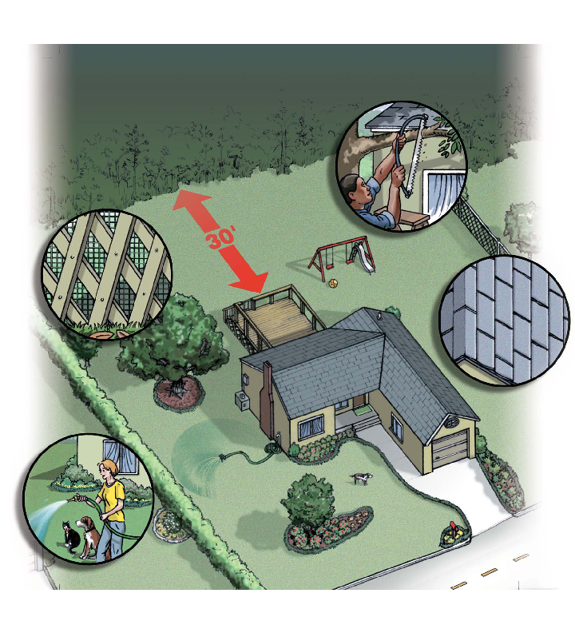Clear flammable vegetation up to 30 feet away from your house.
- Cut lower branches of trees 7-10 feet off the ground.
- Keep the lawn watered and mowed short.
- Clean leaf & needle fall that accumulates.
- Relocate woodpiles (firewood) at least 30 feet from structures.
- Clean the roof, gutters, and windowsills of leaves, needles, and other debris.
- Trim tree branches within 15 feet of the chimney.
- Clear the view of your house number and mailbox so emergency crews can see the 911 address & house number.
- Trim all tree branches overhanging the house.
- Trim tree branches overhanging the driveway to a 14-foot vertical clearance for emergency vehicles.
- Clear all deadwood and dense flammable vegetation within the 30-foot defensible space.
- Visit: http://www.gatrees.org/CommunityForests/WildLandUrban.cfm for more information on how to protect your home.

Flyers Created: Flyers were created containing Firewise materials for the public meetings. These flyers contained county specific information pertaining to the tornado damage, and included a picture of a home surrounded by dead and downed debris. Copies of these flyers are in the Appendix.

Key Messages

Summary:
Due to increased fire potential resulting from tornado damage in the spring of 2011, a National Wildfire Prevention and Education Team was ordered for Catoosa, Walker, and Dade Counties in North Georgia. The team will conduct Firewise and wildfire prevention awareness activities. The primary purpose of this team is to raise awareness and to help prevent human-caused wildfires through effective communication and activities.

Target Audiences:
- Catoosa, Walker, and Dade Counties
- Residents, homeowners, and landowners
- Public land users
- Interagency partners
- Local fire departments
- Media

Key Messages:
- Wildfire conditions have not improved in North Georgia, and another active fire season is expected this year.
  - Persistent drought conditions in North Georgia combined with debris from the tornadoes of last April have the Georgia Forestry Commission and its partners preparing for another potentially severe wildfire season.
  - Large amounts of dead and downed trees provide an abundance of fuel for potential wildfires.
  - Removal of heavy debris is becoming a challenge for private land owners; many of which do not have the means to remove significant amounts of large downed timber.

- Significant rainfall and cooler temperatures has created misconceptions regarding the fire danger in North Georgia.
  - Despite significant rainfall and cool weather, Catoosa, Walker, and Dade Counties are in drought conditions.
  - Tornado debris has been on the ground for nearly one year, and is highly combustible.
  - The potential for wildfire in North Georgia will increase as warm temperatures continue to dry the tornado debris.

- Due to increased fire potential a National Wildfire Prevention and Education Team was ordered for Catoosa, Walker, and Dade Counties in Northern Georgia.
  - This team consists of fire prevention specialists from the Georgia Forest Commission, US Forest Service, National Park Service, and local fire agencies.
  - The goal of this team is to empower individuals in at-risk counties with the knowledge they need to take proactive actions to help protect themselves and their communities this wildfire season.
  - Information on Firewise communities can be found at www.firewise.org.

- Working with the public as well as local officials to develop fire prevention strategies is critical to the success of this mission.
  - The multi-agency fire prevention team will work with homeowner associations, city and county officials, and local fire departments to educate individuals in the affected counties about the elevated risk of wildfires this spring.
  - Local organizations (churches, volunteer groups, special interest groups, etc) are encouraged to get involved.
  - Requests for meetings or for information on how to become involved can be made by calling (540) 525-1539 or emailing GeorgiaFirePreventionTeam@gmail.com.

Firewise Talking Points:
- The team will give advice for becoming proactive in protecting lives and properties in the event of a wildfire through the National Fire Protection Association’s Firewise program (www.Firewise.org).
  - Create 30 feet of defensible space around one’s property.
  - Reduce flammable vegetation, trees and brush around your home.
  - Remove or prune trees seven to 10 feet from ground and 15 feet from chimney.
  - Cut grass and weeds regularly.
  - Relocate woodpiles and leftover building materials away from home.
  - Keep roof and yard clear of debris.
  - Identify your home with an address on a mailbox or sign.
  - Easy access, easy egress (can fire trucks get in? Can you get out?).
  - Have a roof that will not burn (noncombustible materials).
  - Have an emergency plan when wildfire strikes.

Media Coverage

WRCB - Channel 3
Interview: http://www.wrcbtv.com/story/17039287/tornado-debris-burn-hazards

Channel 3 came to the field with us on February 28, to film some footage. We preselected an area on a local homeowner’s land for two reasons:
  - To illustrate the amount of debris adjacent to their home.
  - To illustrate the significant amount of work they have done to create defensible space and clear this debris.
These landowners were very accommodating and were able to articulate their story very well, which was encouraging in case the media chose to interview them. Michael Williams and Mark Wiles were interviewed. During the interview process, a wildfire started on the west side of Cherokee Valley Road. This fire tied into our message we were communicating to Channel 3. They ended up following us over to the wildfire where they were able to get some additional footage to add to their story.

WTVC - Channel 9
Interview: http://www.newschannel9.com/video/c/1137849423/local-news/1480990926001/local-news

Interview: http://www.newschannel9.com/video/v/1481496724001/local-news

Channel 9 came to the field with us on February 29, to the same location as the previous day. A group interview session (with two additional media outlets present) was conducted with Michael Williams and Mark Wiles, and they walked the camera crew through examples of how Firewise principles were being demonstrated at this property. Channel 9 decided to do a live report, and they conducted an additional live interview with Michael from the homeowner’s property.

WDEF - Channel 12
Interview: http://www.wdef.com/news/story/Wildfire-Worries-In-Tornado-Striken-Areas/9Rm0qzhVgkWOTiz4zH_BkQ.cspx

Channel 12 came to the field with us on February 29, to the same location as the previous day. Michael Williams conducted an on camera interview in the reporter’s vehicle on the way to the site. A group interview session (with two additional media outlets present) was conducted with Michael Williams and Mark Wiles, and they walked the camera crew through examples of how Firewise principles were being demonstrated at this property.

UCTV – Channel 5
Steve Blackwell and Michael Williams were guests on the Judy O’Neal show on the morning of February 29. They took part in an interview discussing various topics, and fielded questions from callers. The length of the live interview was approximately 45 minutes.

Catoosa County News
An article was released on Feb 22, based off of the press release that was sent to the Catoosa County News prior to our team assembling. Adam Cook came to the field with us on February 28. He took some pictures and conducted an interview with both Michael Williams and Mark Wiles. The Catoosa County Newspaper did not publish his article this week; it should be available during the week of March 5.

Chattanooga Times Free Press:
Tim Omarzu came to the public meeting we held on February 23. Several messages were left with Tim inviting him to the field for a more in-depth story. He returned a call after a few days to tell us that he did a story on the wildfire on February 28. He would contact us if he wanted to go out in the field over the next couple of days. The wildfire story that he wrote is in the media folder.

Catoosa Weekly:
Mike O’Neal came to the public meeting we held on February 23. He provided contact information for additional resources, and ran a story based off of the press release that was sent to him prior to our team assembling. Mike came out to the field with us on February 29 to write an additional story on the work we were doing. His story will print the week after our team closes out this assignment.

Non-Broadcast Advertising:

Several methods of portraying fire prevention/education messages were explored during the project: Lighted Reader Boards (such as those commonly found at banks), digitally projected messages during pre-screening of movies at local cinemas, inserting messages directly onto company websites, and inserting Firewise messages into EMC bill statements.

Lighted Reader Boards
We were able to put a message at the triangle intersection in Ringgold, displaying the words: Be Firewise, Get a Burning Permit! This information was accompanied with two phone numbers and the www.gatrees.org website. This idea could be expanded and could prove to be a very good grassroots marketing effort by targeting banks, convenient stores, and even non-electronic letter boards utilized by restaurants.

Digitally Projected Images in Theaters
Amanda Vaughn at the Battlefield Cinema 10 provided the contact information for Screenvision, who is the company that deals with onscreen advertisements prior to movie theater previews. Additionally, Screenvision is the advertising company for the Carmike Cinema in Dalton, as well as the four additional movie theaters near Fort Oglethorpe. Screenvision was contacted to set up an appointment to discuss pricing with an advertising representative. Mark Cooper sent over a proposal and spoke with us a couple of times to discuss pricing. While the idea of utilizing a movie theater to convey a Firewise message appears to be one that would reach a wide audience, the pricing is very expensive. A 10% discount was offered, but even with this discount, it is not recommended to pursue this avenue.

Websites
There were two opportunities for us to utilize Firewise messages on local websites:
- The Catoosa County Commission Office
- The Cherokee Valley Baptist Church
This is another option that would be worth expanding upon. Many businesses, organizations, and individuals utilize company or personal websites to illustrate their story. By tapping into this resource, the target audience could be expanded. Social media platforms such as Facebook and Twitter could also be explored.

EMC Billing Statements
The possibility of inserting Firewise messages into EMC statements was explored. Attempts to connect with both Laura Sparks and Amy Blankenship were unsuccessful. This idea should be pursued and additional companies that send billing statements via mail could be explored also.

Northwest Georgia Fire Prevention Team Contact Information

Members:

Jim Sorenson
U.S. Forest Service (Retired)
Social Circle, GA
(770) 265 – 1606
vikingge@aol.com

Beryl Budd
Georgia Forestry Commission
Newborn, GA
(478) 733 – 2604
BBudd@gfc.state.ga.us

Glenn Coleman
U.S. Forest Service (Retired)
Pineville, LA
(770) 265 – 1606
GCOL83RAG@aol.com

Ken Poteet
Georgia Forestry Commission
Dalton, GA
(706) 217 – 9215
Whitfieldunit@gfc.state.ga.us

Mark Wiles
Georgia Forestry Commission
Elberton, GA
(478) 953 – 9867
mwiles@GFC.STATE.GA.US

Michael Williams
U.S. Forest Service
Roanoke, VA
281 – 900 1722
Mrwilliams04@fs.fed.us

Budget:

Costs Associated With Northwest Georgia Fire Prevention Education Team (Thru 3 Mar 12)
Name | Item |  | 2/22 |  | 2/23 | 2/24 |  | 2/25 |  | 2/26 |  | 2/27 | 2/28 | 2/29 | 3/1 | 3/2 | 3/3 | To Date |  | Total:
Jim Sorenson (PETL) | Salary |  | 395.22 |  | 451.68 | 451.68 |  | 451.68 |  | 451.68 |  | 451.68 | 451.68 | 451.68 | 451.68 | 470.50 |  | 4,479.16 |  | 5,990
 | Per Diem |  | 34.50 |  | 46.00 | 46.00 |  | 46.00 |  | 46.00 |  | 46.00 | 46.00 | 46.00 | 46.00 | 46.00 |  | 448.50
 | Vehicle |  | 100.47 |  | 1.02 | 0.51 |  | 0.00 |  | 0.00 |  | 0.00 | 30.60 | 2.55 | 30.60 | 30.60 |  | 196.35
 | Room |  | 96.29 |  | 96.29 | 96.29 |  | 96.29 |  | 96.29 |  | 96.29 | 96.29 | 96.29 | 96.29 |  |  | 866.61
Mike Williams (PIO) | Salary |  | 136.44 |  | 301.31 | 318.36 |  | 409.32 |  | 409.32 |  | 318.36 | 318.36 | 420.69 | 318.36 | 318.36 | 318.36 | 3,268.88 |  | 4,859
 | Per Diem |  | 34.50 |  | 46.00 | 46.00 |  | 46.00 |  | 46.00 |  | 46.00 | 46.00 | 46.00 | 46.00 | 46.00 | 46.00 | 448.50
 | Vehicle |  | 23.29 |  | 23.29 | 23.29 |  | 23.29 |  | 23.29 |  | 23.29 | 23.29 | 23.29 | 23.29 | 23.29 | 23.29 | 232.90
 | Gas |  |  |  | 42.33 |  |  |  |  |  |  |  |  |  |  |  |  | 42.33
 | Room |  | 99.46 |  | 96.29 | 96.29 |  | 96.29 |  | 96.29 |  | 96.29 | 96.29 | 96.29 | 96.29 | 96.29 |  | 866.61
Mark Wiles (PETM) | Salary |  |  |  | 326.88 | 313.80 |  |  |  |  |  | 392.25 | 313.80 | 392.25 |  |  |  | 1,738.98 |  | 2,360
 | Per Diem |  |  |  | 28.00 | 28.00 |  |  |  |  |  | 28.00 | 28.00 | 28.00 |  |  |  | 140.00
 | Vehicle |  |  |  |  |  |  |  |  |  |  |  |  |  |  |  |  | 0.00
 | Room |  |  |  | 96.29 | 96.29 |  |  |  |  |  | 96.29 | 96.29 | 96.29 |  |  |  | 481.45
Beryl Budd (PETM) | Salary |  |  |  | 286.08 | 286.08 |  | 286.08 |  | 286.08 |  | 286.08 | 286.08 | 357.60 | 357.60 | 262.24 |  | 2,693.92 |  | 3,716
 | Per Diem |  |  |  | 28.00 | 28.00 |  | 28.00 |  | 28.00 |  | 28.00 | 28.00 | 28.00 | 28.00 | 28.00 |  | 252.00
 | Vehicle |  |  |  |  |  |  |  |  |  |  |  |  |  |  |  |  | 0.00
 | Room |  |  |  | 96.29 | 96.29 |  | 96.29 |  | 96.29 |  | 96.29 | 96.29 | 96.29 | 96.29 |  |  | 770.32
Glenn Coleman (PETM) | Salary |  |  |  | 479.92 | 411.36 |  | 411.36 |  | 411.36 |  | 411.36 | 411.36 | 514.20 | 514.20 | 308.52 | 274.24 | 3,873.64 |  | 5,369
 | Per Diem |  |  |  | 34.50 | 46.00 |  | 46.00 |  | 46.00 |  | 46.00 | 46.00 | 46.00 | 46.00 | 46.00 | 46.00 | 402.50
 | Vehicle |  |  |  | 21.85 | 21.85 |  | 21.85 |  | 21.85 |  | 21.85 | 21.85 | 21.85 | 21.85 | 21.85 | 21.85 | 196.65
 | Gas |  |  |  |  |  |  |  |  |  |  |  |  |  |  | 30.00 |  | 30.00
 | Room |  |  |  | 96.29 | 96.29 |  | 96.29 |  | 96.29 |  | 96.29 | 96.29 | 96.29 | 96.29 | 96.29 |  | 866.61
Ken Poteet (FF2) | Salary |  |  |  | 126.09 | 182.13 |  | 196.14 |  | 196.14 |  | 182.13 | 154.11 | 224.16 | 224.16 | 126.09 |  | 1,611.15 |  | 1,842
 | Per Diem |  |  |  | 28.00 | 28.00 |  | 28.00 |  | 28.00 |  | 28.00 | 28.00 | 28.00 | 28.00 | 7.00 |  | 231.00
 | Vehicle |  |  |  |  |  |  |  |  |  |  |  |  |  |  |  |  | 0.00
 |  |  |  |  |  |  |  |  |  |  |  |  |  |  |  |  |  |  |  | 24,138

Appendix:
Daily Reports:

Northwest Georgia Fire Prevention Team
Ringgold, GA

Phone: 770-265-1606

Daily Report
February 23, 2012

Team:
- Jim Sorenson Team Leader AD C-O NF Social Circle, GA
- Michael Williams PIO AD GW-JEFF NF, Roanoke, VA
- Beryl Budd Team Member GFC, SCFP Forester, Newborn. GA
- Mark Wiles Team Member GFC, Water Quality Specialist, Elberton, GA
- Glenn Coleman Team Member AD Kisatchie NF, Alexandria, LA
- Ken Poteet Team Member GFC, Ranger I, Dalton, GA
- Eric Mosley Team Liaison Georgia Forestry Commission

Accomplishments:
(Administrative accomplishments will not be shown in the daily reports.)

Pre-work meeting with Catoosa/Whitfield Unit Chief Ranger Chuck Arnold; introductions at Ringgold Fire Department in preparation for possible use of their facilities when county administrative office is closed for weekend.

Full team in place by 1300.

Introductory meeting with project clients: Georgia Forestry Commission field unit managers, county emergency management officials, federal agency representatives, and members of print/electronic media. Two members of the public in attendance, with some thoughtful input. Good meeting. Especially encouraging was the indication that there will be increased cooperation and joint planning among the various agencies with stakes in the issues at hand.

Began assessment of the skills and expectations of the team members and assignment of specific areas of responsibility for the coming activities.

Northwest Georgia Fire Prevention Team
Ringgold, GA

Phone: 770-265-1606

Daily Report
February 24, 2012

Team:
- Jim Sorenson Team Leader AD C-O NF Social Circle, GA
- Michael Williams PIO AD GW-JEFF NF, Roanoke, VA
- Beryl Budd Team Member GFC, SCFP Forester, Newborn. GA
- Mark Wiles Team Member GFC, Water Quality Specialist, Elberton, GA
- Glenn Coleman Team Member AD Kisatchie NF, Alexandria, LA
- Ken Poteet Team Member GFC, Ranger I, Dalton, GA
- Eric Mosley Team Liaison Georgia Forestry Commission

Accomplishments:
(Administrative accomplishments will not be shown in the daily reports.)

Field trip to areas affected by the tornadoes to acquaint team members with the scope and severity of the problems to be addressed. It is impossible to understate the importance of this trip. It is safe to say that few if any of us had ever seen the type of tornado damage that is exhibited in some of these draws and valleys. Many whole ridge sides had not a single tree standing, but rather thousands of sizeable trees lying ”jackstrawed” across the entire length and width.

The time spent visiting the site of all this damage served to prepare the team to address the issue.

An appointment was made with the Ringgold Kiwanis Club to speak at their breakfast meeting next week; contacts are underway for a similar effort with the Rotary Club.

Permission has been obtained to distribute Firewise materials and address the current fuel loading issues at Ace Hardware over the weekend.

Northwest Georgia Fire Prevention Team
Ringgold, GA

Phone: 770-265-1606

Daily Report
February 25, 2012

Team:
- Jim Sorenson Team Leader AD C-O NF Social Circle, GA
- Michael Williams PIO AD GW-JEFF NF, Roanoke, VA
- Beryl Budd Team Member GFC, SCFP Forester, Newborn. GA
- Mark Wiles Team Member GFC, Water Quality Specialist, Elberton, GA
- Glenn Coleman Team Member AD Kisatchie NF, Alexandria, LA
- Ken Poteet Team Member GFC, Ranger I, Dalton, GA
- Eric Mosley Team Liaison Georgia Forestry Commission

Accomplishments:

The office facilities available to the Team are closed on weekends, so emphasis was on doing contact work in the field.

The weather was somewhat cooperative, in that it was not raining; but it is still a little cold for many people to be in the gardening mood. However, two team members staffed an exhibit at a local gardening center in Fort Oglethorpe. They fielded a number of questions relative to dealing with the storm debris, and handed out informational materials.

One team member spend the day in the Cherokee Valley area, visiting with residents who have extreme fuel loadings in close proximity to their homes. An interesting, if discouraging, aspect of developments in this area is the fact that many of the tornado-destroyed homes have been rebuilt; but now these homes are in serious danger of being ravaged by fires occurring in the downed timber.

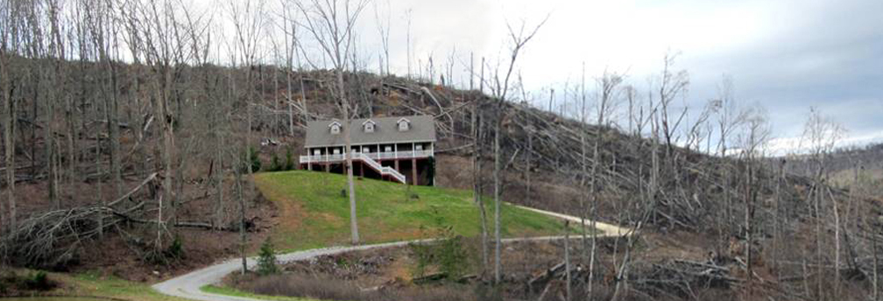

Northwest Georgia Fire Prevention Team
Ringgold, GA

Phone: 770-265-1606

Daily Report
February 26, 2012

Team:
- Jim Sorenson Team Leader AD C-O NF Social Circle, GA
- Michael Williams PIO AD GW-JEFF NF, Roanoke, VA
- Beryl Budd Team Member GFC, SCFP Forester, Newborn. GA
- Mark Wiles Team Member GFC, Water Quality Specialist, Elberton, GA
- Glenn Coleman Team Member AD Kisatchie NF, Alexandria, LA
- Ken Poteet Team Member GFC, Ranger I, Dalton, GA
- Eric Mosley Team Liaison Georgia Forestry Commission

Accomplishments:

As is usual on these assignments, the fact that many of the agencies, businesses, and individuals with whom we need to work are not available on weekends limits our options for projects. We had a two-man team working the local hardware store with handouts explaining Firewise concepts. There was a good turnout by the public, so we feel it was time well spent. It is helpful to have a local GFC worker on this team, because the difference in burning restrictions in each of the three counties is difficult for an outsider to understand, let alone explain to the public. This team also visited with local EMT and other emergency-related folks to inform them on what we were up to with this project. That effort will continue tomorrow.

A team member spent most of the day traveling in the north part of Walker county, trying to assess the extent of damage caused in that area; there have been differing descriptions of that, and it was good to get the impression of our own member. He was also able to make a preliminary contact about the possibility of a community meeting there.

Considerable progress was made on developing a media plan to be implemented when we have a full team again.

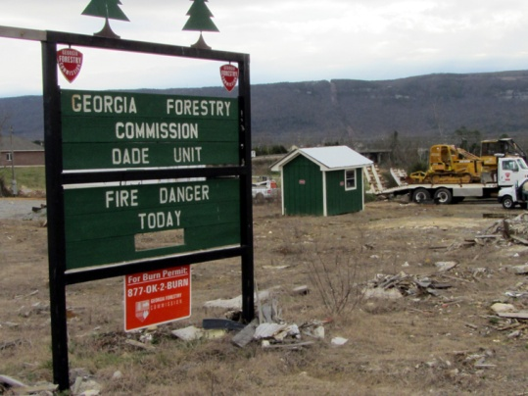
We have had all of the assistance from the local GFC folks that we could ask for. This is especially appreciated when you consider that they were also victims of the tornado.

Northwest Georgia Fire Prevention Team
Ringgold, GA

Phone: 770-265-1606

Daily Report
February 27, 2012
Team:
- Jim Sorenson Team Leader AD C-O NF Social Circle, GA
- Michael Williams PIO AD GW-JEFF NF, Roanoke, VA
- Beryl Budd Team Member GFC, SCFP Forester, Newborn. GA
- Mark Wiles Team Member GFC, Water Quality Specialist, Elberton, GA
- Glenn Coleman Team Member AD Kisatchie NF, Alexandria, LA
- Ken Poteet Team Member GFC, Ranger I, Dalton, GA
- Eric Mosley Team Liaison Georgia Forestry Commission

Accomplishments:
Several media events were scheduled for tomorrow and Wednesday. We also scouted an area to take the media for some footage of the storm damage; and met with some local landowners who are willing to allow us onto their property to show the media the heavy fuel next to their homes. This location is an ideal spot to show storm damage near a home, as well as the work that has been done in the area. Both of the landowners were very friendly and very well spoken, and if the media chooses to speak with them, they would be good examples to represent the public.
In summary, on Monday, we scheduled field visits with eight media outlets, two in-studio interviews, and one public meeting.
Mark attended the City Council Meeting in Ringgold.
Scouted in Walker county, meeting with local officials; getting opinions on what could be done to mitigate the situation.
Handed out Firewise materials at Home Depot and Lowes. Good turnout, due to nice weather for bringing the public out.
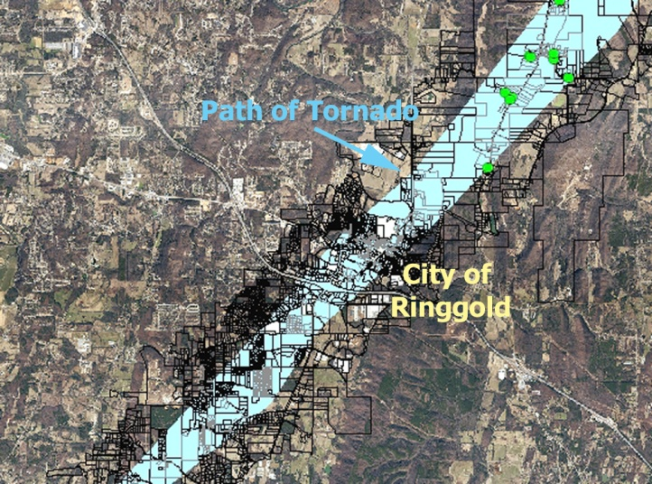

Northwest Georgia Fire Prevention Team
Ringgold, GA

Phone: 770-265-1606

Daily Report
February 28, 2012
Team:
- Jim Sorenson Team Leader AD C-O NF Social Circle, GA
- Michael Williams PIO AD GW-JEFF NF, Roanoke, VA
- Beryl Budd Team Member GFC, SCFP Forester, Newborn. GA
- Mark Wiles Team Member GFC, Water Quality Specialist, Elberton, GA
- Glenn Coleman Team Member AD Kisatchie NF, Alexandria, LA
- Ken Poteet Team Member GFC, Ranger I, Dalton, GA
- Eric Mosley Team Liaison Georgia Forestry Commission

Accomplishments:

Media.

Coordinated the scheduling of a media campaign within the Cherokee Valley region in Catoosa County. Local media outlets were contacted with television, radio and newsprint; and coordinated locations for media shots along the Cherokee Valley Road. Homeowner location on Graystone Road was identified at the residence of Chris and Shana Chandler. Media tours were scheduled at this location for Tuesday, February 28th and Wednesday, February 29th.
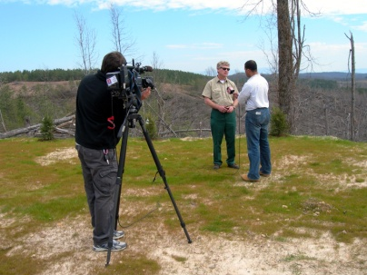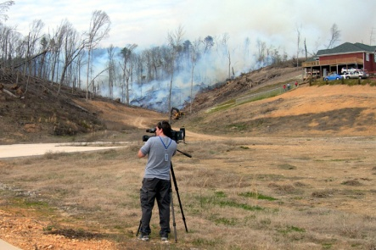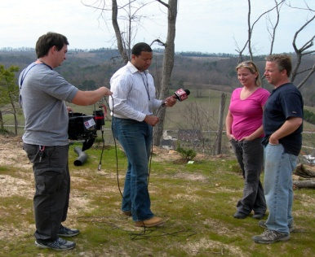

Community Networking.

Networking with local Disaster Outreach Team representative, Donna Greeson. Mrs. Greeson offered the services of the team for carrying out the recommendations of the Fire Prevention and Education Team, for the elderly, handicapped and uninsured citizens of Catoosa County.

Met with the Ringgold City Council at their regularly scheduled gathering located in the Ringgold City Hall. This meeting involved a presentation on the Firewise program to the Mayor and City Council, as well at the City Manager. The council agreed that the city would be in favor of participating in the program.
Prework was done in preparation for community meetings in Flintstone and at the Cherokee Valley Baptist Church.

Northwest Georgia Fire Prevention Team
Ringgold, GA

Phone: 770-265-1606

Daily Report
February 29, 2012
Team:
- Jim Sorenson Team Leader AD C-O NF Social Circle, GA
- Michael Williams PIO AD GW-JEFF NF, Roanoke, VA
- Beryl Budd Team Member GFC, SCFP Forester, Newborn. GA
- Mark Wiles Team Member GFC, Water Quality Specialist, Elberton, GA
- Glenn Coleman Team Member AD Kisatchie NF, Alexandria, LA
- Ken Poteet Team Member GFC, Ranger I, Dalton, GA
- Eric Mosley Team Liaison Georgia Forestry Commission

Accomplishments:
Today was essentially all media and community outreach.
Media.

Two television crews, (Channels 9 & 12), visited the same general area that we had used for this purpose on 28 February. In addition, Channel 3 indicated they were going to re-telecast their coverage of that date.

One newspaper, The Catoosa Weekly Community News, also sent a reporter to the site.

We continue to be surprised by the lack of interest we can generate with radio stations.

Community Networking.

Additional pre-work was done in preparation for community meeting to be held tomorrow in Flintstone.
A good meeting was held at the Cherokee Valley Baptist Church. This meeting was attended byMike Helton, Catoosa County Manager, Jim Cutler, District 3 County Commissioner, and DeWayne Hill, District 4 County Commissioner; Pastor Franky Ridley was the host. About a dozen local residents were also in attendance.

Fire Prevention Public Meeting

WHEN: Wednesday, February 29, 2012
TIME: 8:00 to 9:00 PM
PLACE: Cherokee Valley Baptist Church Fellowship Hall
1495 Cherokee Valley Road
Ringgold, Georgia
The destructive tornados that came through the area last April destroyed over 4600 forested acres in Catoosa County and many more in surrounding counties. These tornadoes also damaged or destroyed numerous homes in Catoosa County. The large amount of downed trees and debris presents a fire hazard for years to come. A Georgia Fire Prevention Team is presently working with the Georgia Forestry Commission to address these issues. The public meeting will discuss Firewise principles and other activities homeowners and landowners can do help mitigate some of the issues.
Fire Prevention Team members and Georgia Forestry Commission employees will be there to provide information.

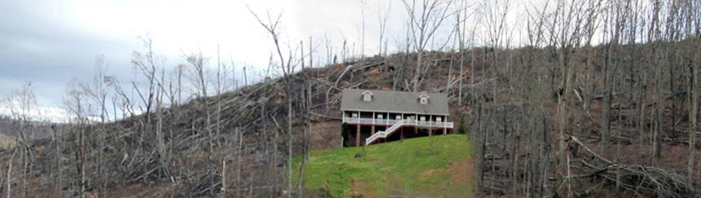

Fire Prevention Public Meeting

WHEN: Thursday, March 1, 2012
TIME: 5:00 to 6:00 PM
PLACE: The Banquet Hall (next to the Dinner Bell Restaurant)
3258 Chattanooga Valley Rd.
Flintstone Community
The destructive tornados that came through the area last April destroyed over 1600 forested acres in Walker County and many more in surrounding counties. These tornadoes also destroyed 87 homes and damaged more than 1000 in Walker County. The large amount of downed trees and debris presents a fire hazard for years to come. A Georgia Fire Prevention Team is presently working with the Georgia Forestry Commission to address these issues. The public meeting will discuss Firewise principles and other activities homeowners and landowners can do help mitigate some of the issues.
Fire Prevention Team members, Georgia Forestry Commission, and local Fire Emergency officials will be there to provide information.

