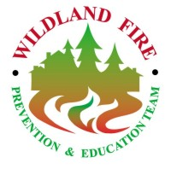 SW ZONE INTERAGENCY FIRE PREVENTION TEAM

Phone: (406)542-5880 FAX: (406)542-5885 email: swzoneteam@state.mt.us

FOR RELEASE: Date: 08/13/03 Contact: Jon Agner, Team Leader

HOMEOWNERS SHOULD FOCUS EFFORTS ON HOME FIRST

Homeowners concerned about nearby wildfires should prioritize their fire prevention efforts around their homes. The first priority should be possible home “ignition” spots. These are areas where flammable materials are on or within three feet of their home. Leaves and pine needles accumulated under decks and against the base of the home provide an ignition point for fire embers associated with passing fire fronts. In most cases, it’s not the large flame front that destroys homes, but the flaming embers that swirl and behave similar to blowing snow. If you know where swirling snow tends to drift around your home, expect burning embers to behave in a like manner. Another potential trouble spot is vents without mesh screening. Fire embers can be drawn into basements and attics through these unscreened vents and cause a home to burn down hours after a fire front passes.

When taking fire prevention measures around your home, focus on the home first and work out. Take a good look and assessment of what potential ignition spots may be present on and directly around your home. For additional information on protecting your home, visit www.firewise.org or call the fire prevention team at 542-5880.

###

