Southeast New Mexico Interagency Wildfire Prevention Team
Communication Plan
First Team
April 3 – April 16, 2006

Goal

Using a coordinated approach, guide interagency outreach efforts for wildfire prevention. The ultimate goal is to reduce human-caused wildfires in Southeastern New Mexico.

Target Audiences

USFS Supervisor/Deputy/PAO/FMO Staff
USFS District Fire Prevention employees
Local Tribal FMO and Mescalero Apache Reservation fire prevention representatives
Agencies and partners in the SE New Mexico Lincoln Zone – BLM, NPS, State Forestry
Communities
Volunteer Fire Departments
Local military bases
Congressional Representatives
State and local government
Recreational visitors
Media

Objectives

1. The primary objective of the team will be to coordinate with the Lincoln National Forest Public Affairs Officer and other agency representatives within the Lincoln Zone (see attached contact list) to establish a system whereby fire prevention activities will be a coordinated effort. In establishing this clearing house the team will set up a system for:

- Providing consistent fire prevention, restriction and closure messages to the public and the media.

- Supporting ongoing fire prevention education efforts already underway at the District level, and those of zone partners (see attached contact list).

2. A secondary objective for the team is to review existing USFS District Fire Prevention Plans and to work with Fire Leadership on the Forest to develop a comprehensive Forest-level Prevention Plan that is consistent with current national standards and direction.

Strategies

- Meet with agency and local leaders to discuss areas of concern or emphasis as related to wildfire prevention in Southeast New Mexico.

  - Meet with USFS district FMO’s and fire prevention technicians on Guadalupe, Sacramento, and Smokey Bear Ranger Districts. Find out what products are available; what has been done to date; what events are scheduled and how the team can help.

  - Contact other agency, community and state representatives to see how the team can help them.

- Meet with dispatch center directors to work out a plan for assistance during an incident.

- Research the establishment of a clearinghouse for prevention and education

  - Determine who will be the lead and the alternate

  - Determine how it will operate to ensure that messages are consistent and that all appropriate people have access.

- Research who will maintain fire prevention information on the Lincoln Zone for Fire Prevention Team website and how to ensure it is kept up to date in a timely manner.

  - Use the UtahFireInfo.com as a model for Zone fire information. Establish an easy domain name, such as “NewMexicoFireInfo.com”.

- Research what previous fire prevention teams created.

Planning

The Fire Prevention Team will provide the following assistance:

Supervisor’s Office
- Provide consistent fire prevention, restriction and closure messages to the public and the media.

- Support ongoing fire prevention education efforts already underway at the District level, and those of zone partners.

- Create a plan for coordination and assistance to dispatch centers in Alamogordo and Roswell to handle media during an incident.

- Establish records and files for subsequent teams to maintain an efficient transition between teams.

Tactics
    - Team member will be assigned to work with dispatch during an incident to handle media calls and updates. The person will work out of the Supervisor’s Office and attend briefings at the dispatch center. This team member will make sure that the Public Affairs Officer Joe Garcia is kept informed regarding all media contacts and fire updates.

    - Prepare news release on hunting season and the possibility of closing forest to hunting.

    - Prepare news release announcing arrival of the first national fire prevention team and, if desired, subsequent prevention teams.

    - Develop a draft logo for the Lincoln Zone Fire Prevention Team (Southeastern New Mexico Wildfire Prevention Team), for later completion by National Team 2.

    - Based on ideas from the field, develop a draft fire prevention campaign slogan and logo(s), for later completion by National Team 2. (“One example is: “Do Your Part, Don’t Start a Wildfire,” being used by USFS Sacramento District).
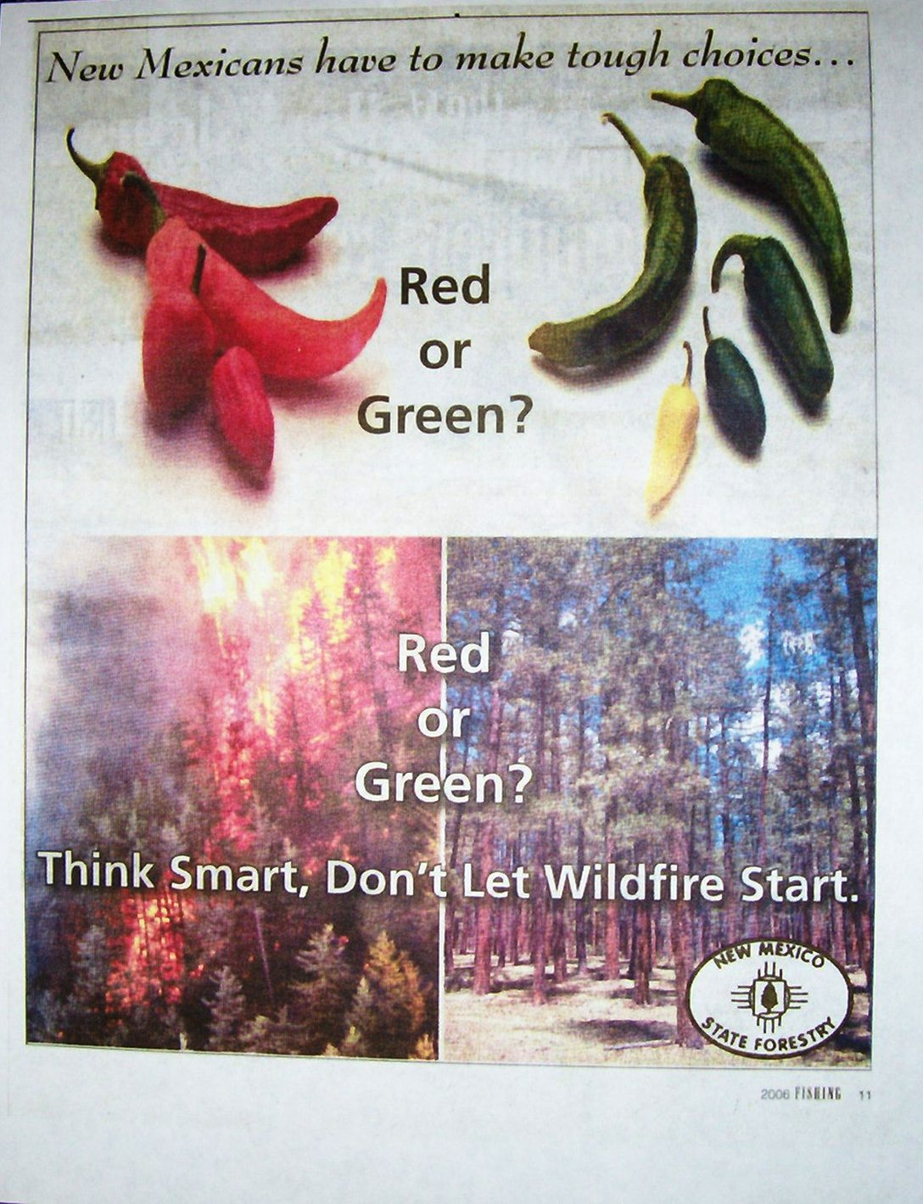
    - Based on ideas from the field, develop ideas for Banner Display(s) for use at events with team logo and slogan(s).

    - Work with the NM State Forestry to develop the “Red or Green” newspaper ad idea, for use by the team on poster, a display, etc. The ad shows red and green chili peppers, and a burning forest and green forest, with the words: “New Mexicans have to make tough choices…Red or Green? Think Smart, Don’t Let Wildfires Start”.

    - Develop draft ideas for flyers, brochures, handouts, coloring sheets coloring restaurant placemats, and other handout materials for later completion by National Team 2.

    - Order magnetic car signs to identify team.

    - Order Smokey Bear supplies for use by future teams.

    - Keep records and files (electronic files and hard-copy files) of accomplishments, including contacts.

Smokey Bear Ranger District (D-1)

- Help in writing a district fire-prevention plan
- Team to work with the Village of Ruidoso, in particular Rick DeIaco, Village Forester
- Raise community awareness of FireWise info
- More signs in Spanish
- Handout on what to do before/during/after a fire to protect your assets
- Better clarification of information in future closure notices

Tactics
- Write Draft district fire prevention plan.

- Visit with Rick DeIaco with the Village of Ruidoso; get a copy of his PowerPoint presentation about the Village WUI Project; ask how the team can help.

- Create PowerPoint from Rick DeIaco’s example and the NM State Forestry example that the Team/District/State can use at meetings.

- Develop a table-top interactive exhibit or display to use at events, based on the “Sand Table Exercise” that was presented at the 2nd Annual Sacramento District Wildland Fire Academy.

        - Cindy Frenzel worked with Julian Affuso and Marianne Gould on District 1, and Mike Testa and Donald Derrick from District 2, to make a sample display. The cost was approximately $100 for one display. Julian Affuso has volunteered to work with Rick Olsen Team 2 Leader to make 3 more displays. One each should be given to each USFS District Fire Prevention Technician, and the original display will be kept with Mona Fredrick, at the USFS Supervisor’s Office. Other agencies can borrow or request one of their own exhibits from future fire prevention teams.
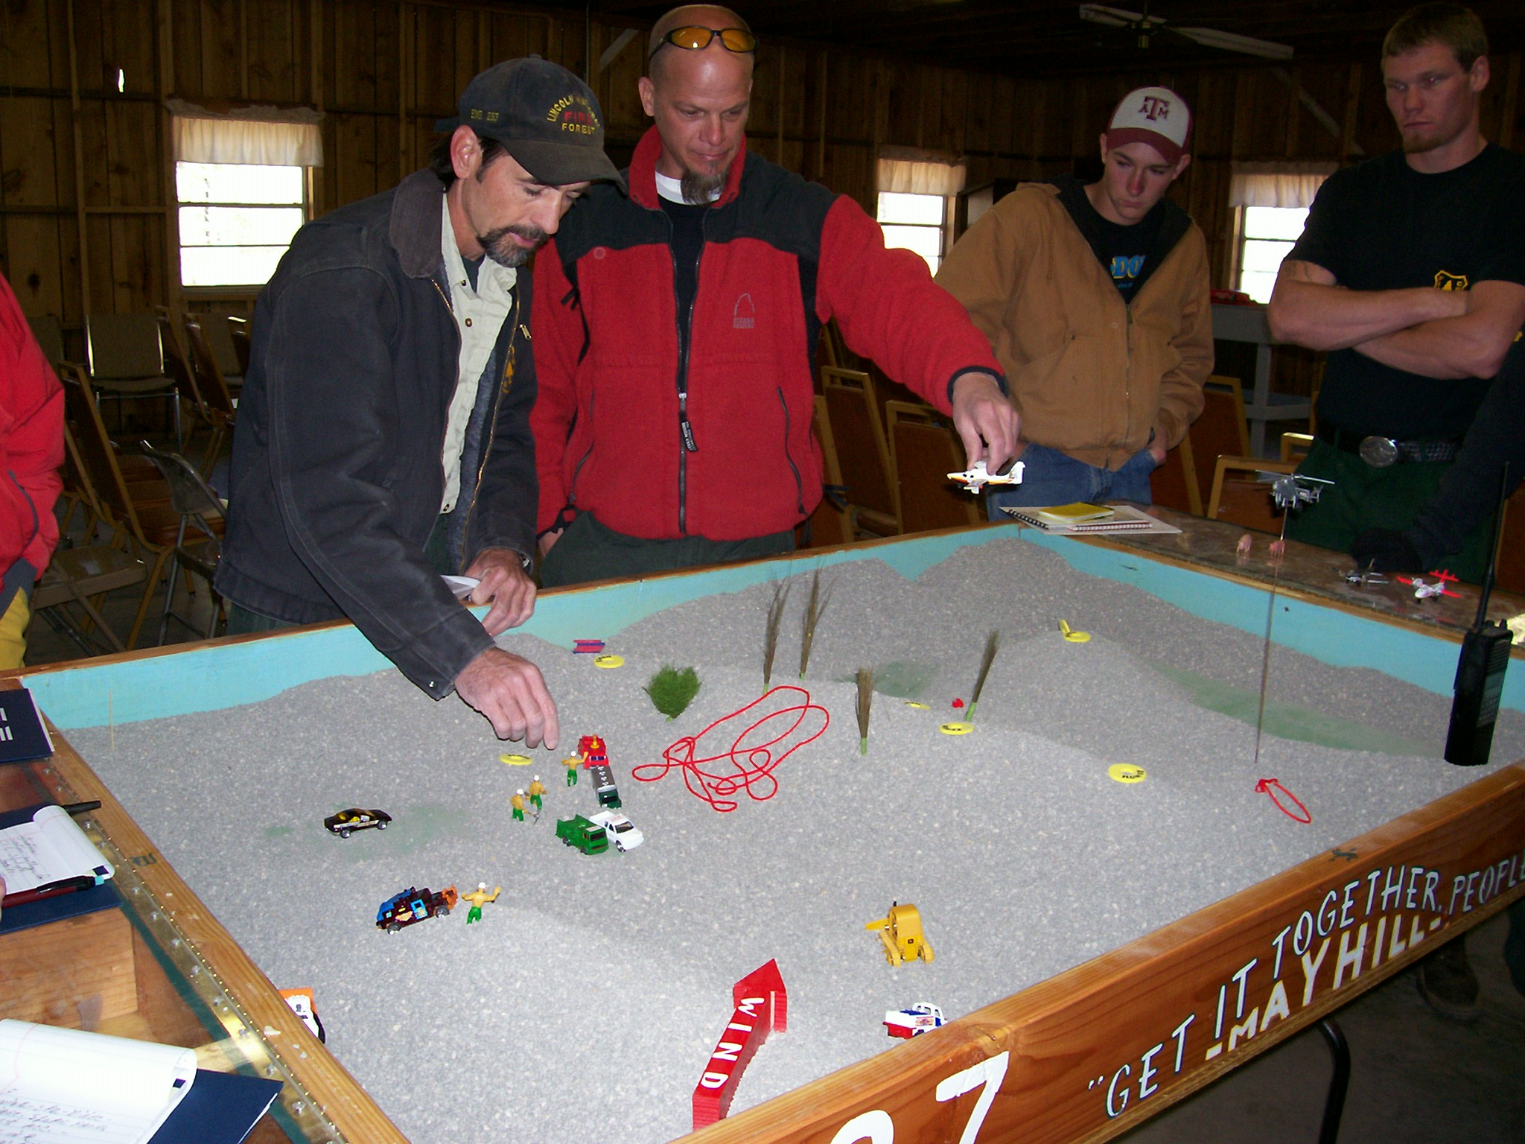

- Provide Firewise information to the Village of Ruidoso; coordinate messages and delivery method with Marianne and Rick DeIaco

- Develop fire-prevention signs in Spanish.

- Produce a fire-prevention PSA for the Smokey Bear Ranger District and Ruidoso area (Marianne has possible local spokesperson to help).

- Develop a handout on what to do before/during/after a fire to protect your assets.

- Work with Joe Garcia on closure notices to better clarify information so that it is interpreted consistently by districts, i.e., definition of stove.

- The following products should be ordered based on requests from the field:
        - “I Met Smokey Bear” stickers. (An example from the Virginia Department of Forestry is in the file. It was suggested that the stickers be smaller).

        - OUC stickers – Only You Can Prevention Wildfires. (A sample from Virginia Department of Forestry is in the files – an oval white sticker with black type – it was suggested that Smokey’s face be in the “O”, and the small writing be larger.)

USFS Sacramento Ranger District (D-2)

- Needs someone to create and staff exhibits at upcoming events.

- Help with updating the district fire-prevention plan.

Tactics
- Meet with Donald Derrick Lead fire prevention technician to develop needed exhibits and have someone available to staff.

- Update district fire-prevention plan.

BIA – Apache Summit

Needs help with festivals July 1-4 – Mescalero Apache Ceremony

Tactics
- Meet with Greg Cordova, Mescalero Apache Reservation Fire Chief to coordinate prevention activities with the Reservation. He has two fire prevention technicians funded by the reservation.

- The following product should be ordered based on requests from the field: Prevention Pocket Ash Trays. (Information is in the file and on the team’s email with the example made by the Virginia Department of Forestry.)

USFS Guadalupe Ranger District (D-3)

  - The prevention technician on Guadalupe is a one-man show. The District will need help during critical times—emphasis should be to provide on additional field prevention personnel.

  - Addition educational materials are needed on the district on “Good Fire/BadFire,” such as a brochure. Work with them to determine needs.

  - Target oil and gas industries with fire-prevention messages – continue to work with BLM single resource prevention people.

- Help in updating the district fire-prevention plan.

Tactics

    - Mike Salmon, Guadalupe Fire Prevention Technician is planning to place 12 fire prevention signs along state highways.

    - Mike has also set up a procedure to put out PSA’s and electronic billboards on short notice during critical times.

    - Mike worked with a fire prevention technician (2-week AD) from the BLM to develop restaurant menus and display cards with a fire prevention message; and “story boards” for Chad Stewart to present to the county commissioners, teaching them about “good fire/bad fire.”

- Establish an exhibit at Carlsbad Caverns NP Visitor Center and have someone staff it at critical times to target recreational visitors.

- Place a fire-danger sign at Whites City VFD adjacent to US Route 62.

- District will continue to work with single resource to provide Eddy County commissioners with more information on good fire, bad fire. They will contact the team if more assistance is needed in this area.

- Assign several field-going prevention team members to handle zone and to be available to go where the district needs assistance.

- Continue to target oil and gas industries

- Establish break points identifying when to bring in additional prevention resources during critical periods.

- Update district fire prevention plan.

Other Tactics needed for all districts:

- Create magnetic vehicle signs for Fire Prevention Team identification.

- Create magnetic vehicle signs with fire prevention message.

- Cookbook for Zone “If this happens, do this!”

- Webmaster/graphics person needed on subsequent teams.

Lincoln Zone

  - More outreach needed in prevention activities at military bases; Ft. Bliss, Holloman, White Sands.

Team Tasks

The first prevention team tasks:

  - Coordinate with the Lincoln National Forest Supervisor’s Office, Ranger Districts and other agencies and groups to develop an interagency approach for subsequent teams to use in providing consistent fire prevention, restriction and closure messages to the public and the media.

  - Visit agency and organizations’ key contacts across the southeastern part of New Mexico to assess needs and how best to address concerns.

  - Provide a transition report to assist subsequent teams in providing a coordinated effort to handle fire prevention messages and support to the field across southeastern New Mexico.

  - Draft a Lincoln National Forest Fire Prevention Plan.

  - Review Districts’ Fire Prevention Plans (if time allows).

