http://www.smokeybear.com/

http://www.firewise.org/

http://texasforestservice.tamu.edu/main/article.aspx?id=1542

The Story of Smokey Bear
Smokey Bear Page
Smokey's Coloring Book
US Fire Administration Kids' Page
Children's Fire Safety Tips
National Park Service Resource Management Education
Forest Puzzles
NOVA 'On Fire' interactive page

Children - Wildfire Study Resources
- BLM Fire Education Website Search on terms "Wildland Fire" or "Wildfire".
- Books on Wildfire for children from Wildlandfire.com and a link to the adults' fire books page.
- Burning Issues An interactive multimedia program that explores fires that occur on wildlands (Grades 5-10).
- wildfire.
- DOI Wildfire Education / Resource Management has activities, nice one for wildfire.
- Earth Observatory shows wildfires from space.
- FIRE CALL: A Wildland Firefighter Speaks Firsthand online audiovisual account from a person who fights wildfire. (Not for young children.)
- Fire Ecology, Association of
- Fire in Florida's Ecosystems
- FIRE in the southeast Information on prescribed fire in the southeast.
- Fire Wars: NOVA Click on the Teachers' Guide for info on teaching about wildfire.
- Fire Research Institute
- Fire Weather from NOAA
- FireWorks educational program for students in grades 1-10.
- Historical Fire Photos from the National Agricultural Library
- Historical Smokejumper Photos
- How Stuff Works - Wildfires
- Indians and Wildfire Use a bibliography
- Living With Fire is an educational game that puts you in the place of a fire manager, based on research and tools developed for real-world fire management. Recommended for ages 10 and up.
- Minnesota Wildfire Prevention Education curriculum and grade standards
- "Natural Inquirer" from the USFS has a variety of educational information and a new publication "Wildland Fire Natural Inquirer" available in pdf.
- National Interagency Fire Center Communicator's Guide Interactive wildfire education
- National Symbols Program has ideas, lesson plans etc and resources organized by region.
- National Wildfire Coordinating Group bibliography of wildland fire web sites
- Photo collection from Wildlandfire.com. Organized by category, includes Wildfire, Handcrews, Engines, Equipment, Helicopters, Airtankers
- Project Learning Tree has some units on wildfire (Pre-K-12)
- Smokeybear.com
- Stress and Wildfire, general
- Stress and Wildfire, kids what to look for, how to deal with it from NASP (168 K pdf).
- Studies of Wildland Fire Ecology studies from the NIFC website, National Park Labs
- Taking a Stand: Pros and Cons of Forest Fires interactive modules
- TetonFires.com has links to many educational wildfire resources.
- This Thing Called Fire, What Is It?
- Virtual Field Trips - Resources, not fire, but good ideas for computer-aided study topics. You could create one for fire.
- Wildfire Lessons Learned site has a wealth of information
- Wildfire, Nature's Hottest Fury, a class project
- Wildfire News Current wildfire news search of the internet.
- Wildland Fire Lessons Learned Center with everything under the sun relating to firefighter safety.
- Wind and Wildfires Facts from Weather.com
- Wisconsin Kids Page Search on terms "Wildland Fire" or "Wildfire".
- Woods on Fire wildfire effects on ecosystems. Easy to read.
Helping kids cope following wildfire:
- Helping Children After a Wildfire, Tips for Parents and Teacherss
- Responding to Natural Disasters: Helping Children and Families. Information for School Crisis Teams.

INTERESTING WEB SITES

Digital Camera http://cameraview.net/Camera%20Tips.htm

Smokey stuff
http://www.rankinbass.com/smokeyhome.html

http://www.nal.usda.gov/speccoll/exhibits/smokey/

Prescribed Fire
http://tncweeds.ucdavis.edu/products/handbook/05.PrescribedFire.pdf

http://ils.unc.edu/parkproject/resource/fire.html

http://www.fs.fed.us/database/feis/

http://www.pfmt.org/standman/prescrib.htm

http://www.mdwfp.com/wildlifeissues/articles.asp?vol=8&article=116

http://www.bugwood.org/pfire

http://www.nwcg.gov/pms/RxFire/rxfire.htm

Artwork Etc http://www.southerncustomexhibits.com/Illust.html

Screen Savers
http://regman.freeze.com/survey/marine/index.asp?f=aboutcommar14&s=marine&ch=hobbies

Web sites of Smokey interest

VA Department of Forestry
www.dof.virginia.gov
Firewise Virginia
www.firewisevirginia.org
National Firewise Program
www.firewise.org
Smokey Bear
www.smokeybear.com
National Wildfire Coordinating Group
www.nwcg.gov
National Symbols Program
www.symbols.gov
VA PLT
www.cnr.vt.edu/plt
About Forestry
www.forestry.about.com
NOVA
www.pbs.org/wgbh/nova/fire
Sparky the Fire Dog
www.sparky.org/
Tall Timbers Research Station
www.ttrs.org
RX Burn
www.pfmt.org
www.bugwood.org/pfire
FEMA for Kids
http://www.fema.gov/kids/
USFS
http://www.fs.fed.us/fire/
National Park Service Nature Net
www.nature.nps.gov
Fire Photos
www.firepix.net
Fire Effects Information – Relationships with fire
www.fs.fed.us/database/feis
Nature Conservancy
http://www.nature.org/
DCR – Department of Conservation & Recreation
www.dcr.state.va.us
What Tree Is It?
http://www.oplin.org/tree/
VA Tech School of Forestry
http://www.cnr.vt.edu/DENDRO/forsite/Idtree.htm
Red Cross (Wildfire)
http://www.redcross.org/services/disaster/0,1082,0_594_00.html
Natural Inquirer
www.naturalinquirer.usda.gov
National Park Service Digital Images
www.nps.gov/pub_aff/imagebase.html

Southern Area Coordination Center
http://gacc.nifc.gov/sacc/

National Wildland Fire Information
www.nifc.gov

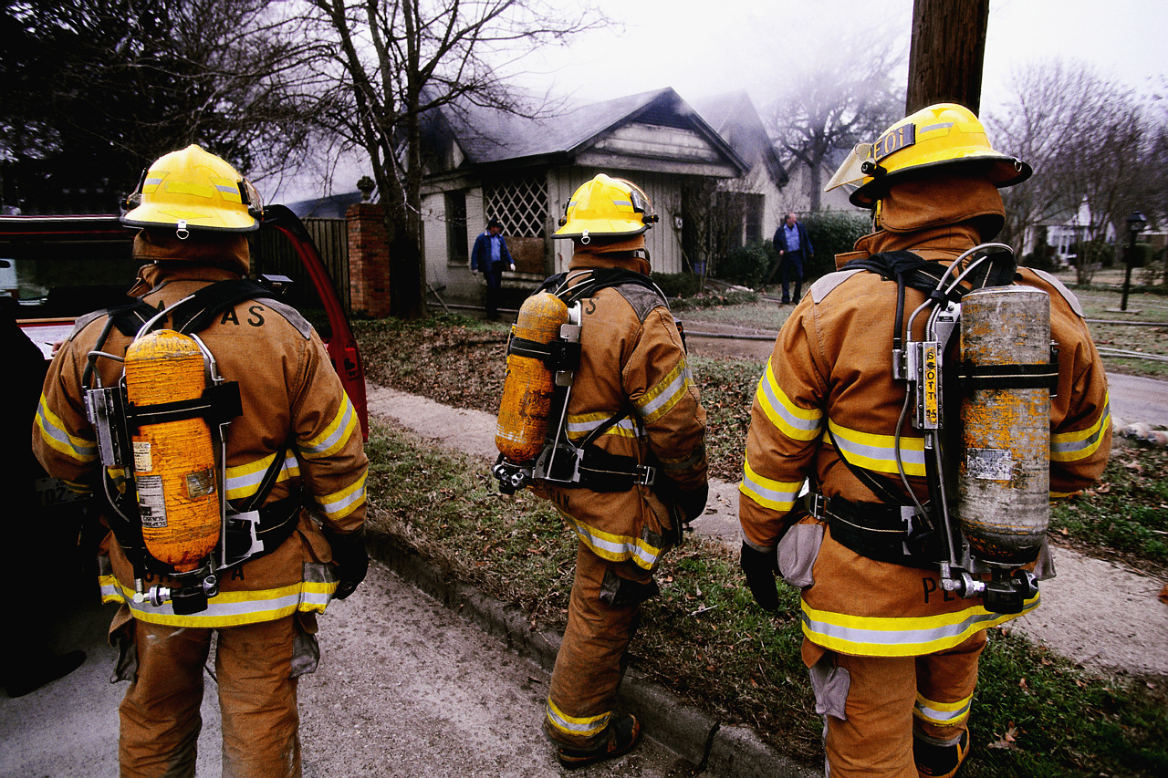

FIRE SAFETY WEB SITES FOR TEACHERS & STUDENTS

Access these sites through your computer’s Internet connection. Open the underlined address (URL). Information can be printed or downloaded to your computer. Be sure to follow links to other sites and find your way back with the “back” button.

All of the sites listed were active as of October 1, 2007. The evaluation is by the AVA Center staff according to the amount of information given and its potential use in the classroom.

ALL YOU EVER WANTED TO KNOW ABOUT FIRE EXTINGUISHERS 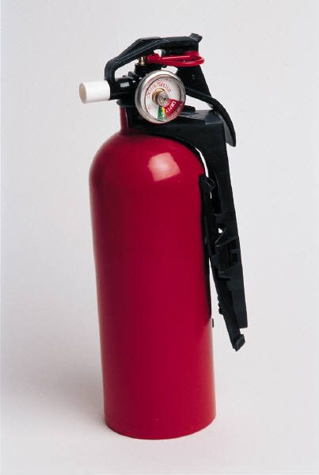
http://www.hanford.gov/fire/safety/extingrs.htm
Discusses the four types of fire extinguishers and the kinds of fires they are used for. Excellent

FIRE CALL: A WILDLAND FIREFIGHTER SPEAKS
http://www.nationalgeographic.com/firecall/
A streaming video of Norman Shuster, a veteran wildland firefighter who tells about how it feels to fight these fires and the awful dangers involved (includes both audio and captioned narration). Includes several links. Excellent

FIRE – 42EXPLORE
http://www.42explore.com/fire.htm
Basic information on fire along with extensive activities and links. Excellent

FIRE PREVENTION AND FIRE FIGHTING: POLYMERS THAT SAVE LIVES` NEW!
http://www.pslc.ws/fire/hsteach/index.htm
“These web pages will take you on a fun journey to explore the science of fire, beginning with how and why things burn and moving on to what's being done to keep things from burning. The chemistry of this stuff is really neat - what happens on the molecular level is really the down-and-dirty of the how-and-why. Guaranteed, when you're done, you'll never look at a candle in the same light.” Sections: Topics, Activities, Teacher Note and Tools. Excellent

FIRE SAFE KIDS PAGE
http://www.state.il.us/kids/fire/
Kids’ fire safety page from the Illinois State Fire Marshal’s office. Includes photos and information on Firedogs, Look for the Fire Hazards Game, Teaching Materials, photos and information on Fire Engines and Firefighters and their equipment and more. Excellent

FIRE SAFETY LINKS NEW!
http://webtech.kennesaw.edu/jcheek3/firesafety.htm
A page of links to fire safety sites. For elementary students. Excellent

FIRESAFETY.GOV NEW!
http://www.firesafety.gov/
A federal website on fire safety. For the general population. Excellent

FIRE WARS
http://www.pbs.org/wgbh/nova/fire/
A companion site to the Nova episode “Fire Wars”. “NOVA accompanies the men and women of a wildland firefighting crew known as the Arrowhead Hotshots as they battle one of the most destructive wildfire seasons ever, the summer of 2000.” Includes: Sections: The Producer’s Story (how they filmed it), The World on Fire, Outfitting Wildland Firefighters, How Plants Use Fire, Glossary of Fire Terms, Wildfire Simulator, On Fire and more. Excellent

FIREFIGHTER PROTECTIVE CLOTHING TOUR & FIRE ENGINE TOUR
http://www.ci.davis.ca.us/fire/pct/
Take an illustrated tour of the protective clothing firefighters wear to protect them from the intense heat of a fire. Each item of clothing also has a video clip. Then click at the bottom right for an illustrated tour of a fire engine. Excellent

THE HISTORY OF FIRE NEW!
http://library.thinkquest.org/27767/ingles.htm
Information on the history of fire and its uses. “Hello I am Flamita, I am here to introduce you to the fantastic world of knowledge, on this occasion it is my pleasure to present a discovery that is, I believe, the most important in the history "Fire". During your trip through these pages that I have designed alone, without any type of help from Ivan, Luis or Simon, I will explain to you step by step how it was adored in the ancient times and its most probable discovery, I will also teach you how and when to produce it under safe conditions, you will discover the dangers that it represents when it is out of control, the main uses and finally I will show you some first aid techniques for burns.” Sections: Video, Introduction and Definition, In the Ancient Times, Probable Discovery, How and When to Produce a Fire, When Fire Becomes Dangerous, Uses, First Aid, and more. For elementary students. Excellent

HOTDOG’S FIRE SAFETY COLORING BOOK
http://www.nyc.gov/html/fdny/html/safety/firesafety_book.shtml
A coloring book from the New York City Fire Department. To download or print out. 20 pages. Excellent

INFERNO: AN INTERACTIVE WEBSITE ON WILDFIRE NEW!
http://library.thinkquest.org/C0119184/
A website by students for upper elementary and up students on wildfire. Sections: Historical Fires, Fighting Fires, Preventing Fires, Community and Interactive. Excellent

KENT VIRTUAL FIRE DEPARTMENT
http://www.kent.k12.wa.us/curriculum/vtours/fire/index.html
A virtual fire station in which students can tour the different stations and see interviews with some of the firefighters. Includes lesson ideas and fire safety info sites. Excellent

KERN COUNTY FIRE DEPARTMENT TOURS AND PHOTOS
http://www.co.kern.ca.us/fire/media/index.htm
Includes a Slideshow, Explore a New Fire Engine, Explore Charlie 3 (fire engine for airport fires), A Virtual Tour of Station 67 and a Virtual Tour of Station 62 (airport fire station). Good photos. Excellent

KIDS FIRE SAFETY TIPS 
http://www.kfst.net/
Features Buzzy the Smoke Detector, Reddy the Fire Extinguisher, Squirt the Water Drop and their friends. They provide simple safety tips for children. Includes BedTime Checklist, Flashlight Guy, Stop, Drop and Roll, Safety in the Kitchen, Call 911, and other safety tips such as from Beanie the Bike Safety Helmet. A bright and colorful site for primary students. Includes also an Emergency Escape Plan contest. Excellent

NYS FIRE SAFETY KIDS PAGE
http://www.dos.state.ny.us/kidsroom/firesafe/firesafe.html
Hershey the Arson Dog teaches kids about fire safety and the work of these talented animals. Sections include: Arson Dogs, Fire Week History, Fire Lessons, Puzzles, Quiz Time, Fire Trucks, Action Photos, and Ask Hershey. Outstanding site with good information and photos. Excellent

SCOTTIE’S FIREHOUSE
http://www.scottiesfirehouse.com/

Scottie the Firefighter leads 3rd and 4th graders through fun learning about fire safety. Sections: Fire Safety Check List; Color & Learn; Did You Know?; Scottie’s Story Book; Interactive House; Fire Escape Plan; History of Scottie; Puzzles & Games; Scottie’s Scrapbook; Scottie’s Art Gallery; and Information for Fire Safety (Educators). A bright, colorful site. Outstanding. Excellent

SMOKEY BEAR
http://www.smokeybear.com/
The official web site of Smokey Bear – (Only YOU Can Prevent Forest Fires). Includes Smokey Kids (In the Forest, Campfire Games {including Smokejumper! The Firefighting Game}, Bear Facts and Smokey Mail), Only You (The Science of Wildfires, Fighting Fires, Good Fires/Bad Fires, Prevention), and Smokey’s Vault (Story of Smokey, History of Campaign, Smokey on the Radio, Images of Smokey). Excellent

SPARKY THE FIRE DOG 
http://www.sparky.org/
Aimed at children 5-9. Includes News Flash – Cool to Do – Fun with Firetrucks – The Story of Sparky – Hot Diggity Dalmatians – Sparky’s Arcade – and Ask Sparky. Excellent

STATE FIRE MARSHAL’S OFFICE KIDS’ PAGE
http://www.firesafekids.state.tn.us/index.html
Flash the Fire Dog guides primary level students through various exercises to increase their awareness of fire safety. Includes: Test Your Knowledge; Is Your Home Safe?; Exit Drills, Stop, Drop & Roll; Word Search Game; and a Coloring Book. Excellent

KIDS FIRE SAFETY PAGE
http://www.usfa.fema.gov/kids/
Features Smoke Alarms, Escape Planning and Home Fire Safety, Hydro’s Hazard House, Games and Become a Junior Fire Marshal. For grades K-3.

WILDFIRES VIRTUAL FIELD TRIP NEW!
http://www.field-trips.org/sci/wildfire/
An online field trip to teach students about wildfires. Includes terms to learn. Excellent

WOODS ABLAZE
http://whyfiles.org/018forest_fire/index.html
Are wildfires always bad? Why Files examines the various positions on fighting wildfires and how they can be a hazard to man but a boost to nature. Excellent

YELLOWSTONE FIRES – RADIO EXPEDITION
http://www.nationalgeographic.com/radiox/frame.html?yellowstone/
” The great fires of 1988 scorched nearly half of Yellowstone National Park. NPR’s Alex Chadwick was there, covering it all for NPR. Ten years later he returned to check the park’s pulse. His diagnosis? “When you get out of your car, when you really see the forest, you realize, Ah, it’s all springing up.” Get the story behind the story and find out how “nature bounces back.” Listen to the broadcasts and then read the background to the story. Excellent

BOOTS THE CLOWN FIRE SAFETY PAGE
http://www.geocities.com/EnchantedForest/Dell/5811/
A fire safety site from Boots the Clown, a fire safety clown in Nashville, TN. Includes information on smoke detectors, fireworks safety tips, word games to copy or download, a photo album, Hot Links and more. Fun music and animation but some pages slow to load. Very Good

CRAFTS FOR KIDS: FIRE SAFETY NEW!
http://www.dltk-kids.com/crafts/miscellaneous/fireweek.html
A collection of crafts, songs and more for primary students. Includes coloring pages, crafts, songs, greeting cards and more. Very Good
FIRE SAFETY ABC’s 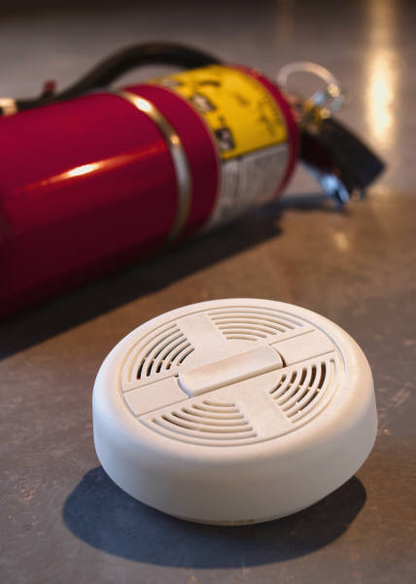
http://www.ou.edu/oupd/fireprim.htm
Fire Safety Questions and Answers. Good basic information on fire extinguishers, evacuating a burning building and what to do if… situations. Includes a True/False Quiz. Very Good

FIRE SAFETY COLORING BOOK
http://www.ci.mil.wi.us/display/displayFile.asp?docid=4502&filename=/User/cbates/firecolorbook.pdf
A PDF format coloring book from the Milwaukee Fire Department. Needs Adobe Acrobat to print. Very Good

FIRE SAFETY COLORING BOOK
http://www.westcov.org/kids/fscolor.html
A fire safety coloring book to print out for kids to color. Very Good

FIRE SAFETY LINKS
http://www.hvfd.com/kidspage.html
Very good links page. Very Good

FIRE SAFETY LINKS NEW!
http://www.picadome.fcps.net/lab/currl/fire/default.htm
Links to fire safety sites with activities for elementary students. Very Good

FIRE TRUCK CRAFTS
http://www.enchantedlearning.com/crafts/fire/
Two craft activities for pre-k or kindergarten students for a lesson on fire safety. Includes constructing a fire truck from cardboard and making a fire truck snack. Also includes three coloring pages, either to print or online. Very Good

HOME FIRE ESCAPE PLAN
http://www.ci.phoenix.az.us/FIRE/escfire.html
Detailed information from the Phoenix Fire Dept. on setting up a home escape plan. Very Good

JUMPSTART – EARTH SCIENCE – WILDFIRE RESEARCH NEW!
http://www.sciencemaster.com/jump/earth/wildfire.php
Examines the research the USGS is doing on wildfires to meet the needs of the firefighting community and to research the role of fire in the environment. Better than it sounds. Very Good

JUVENILE FIRESETTERS
http://www.geocities.com/fire-ed/firesetters.html
Information for adults on what is a child’s natural curiosity about fire and what is a warning sign of too great an interest. By age level. Very Good

NATURE’S FURY – WILDFIRES
http://www.nationalgeographic.com/eye/wildfires/wildfires.html
Information on wildfires from the National Geographic. Sections: Introduction, The Effect, The Phenomena, and The Science. Each section has an Image Gallery and there are numerous video and audio clips. Very Good

911 SAFETY RAGE
http://library.thinkquest.org/J001802/
A ThinkQuest site on safety with games (including helpful friends to provide hints) and several activities to print out and do. Very Good

SOS FIRES: YOUTH INTERVENTION PROGRAM
http://www.sosfires.com
A web site for the exchange of information on youth fire setting. Click on Welcome. Includes What’s New, Resource Exchange, Events Calendar, Links, FAQs, SOS Fires Training Program, and a Parent/Teacher Resource Center featuring articles on teen fire setting and links. Very Good.

STAYING ALIVE – KID ZONE
http://www.stayingalive.ca/kids_zone.html
Flip the Fire Monkey and Mrs. Aboutfire teach children about how fires start and how they behave. Sections: Coloring Pages, Room to Room Safety, Fire Mazes, Word Searches and Crossword Puzzles. There’s also an Ask Firefighter Shane section where children can ask questions. Very Good

THE SUPER SAFETY SITE NEW!
http://library.thinkquest.org/CR0211500/
A site on safety including Fire Safety, School Bus Safety, Water Safety, Bicycle Safety, Electricity Safety, Babysitting Safety, Fun Puzzles and more. For elementary students. Very Good

THE SURVIVE ALIVE PROGRAM
http://www.survivealive.org/main.html
Information, including an instructional guide, on the Survive Alive program. Includes: Learn How to Survive Alive, Tour the Survive Alive House, Fire and Life Safety Information, The Kids’ Club. Very Good

USFA KIDS RESOURCES FOR PARENTS AND TEACHERS NEW!
http://www.usfa.dhs.gov/kids/parents-teachers/
“The pages listed in the menu to the left will help you guide children through the Kids Page. They include discussion points for talking about fire safety and prevention with your kids offline, lesson plans, fire safety recalls related to children's products, publications and educational resources. The Kids Page is targeted towards children in grades Pre-K through 3.” Very Good

WILDLANDFIRE.COM – THE HOME OF THE WILDLAND FIREFIGHTER – PHOTOS
http://www.wildlandfire.com/photos.htm
A huge number of photos of wildfires and firefighting. Very Good

ALFY – TEACH, LEARN, COMMUNICATE
http://www.alfy.com/teachers/teach/thematic_units/Fire_Safety/Fire_safety_1.asp
Some fun, fire safety links for kids. Good

ARTHUR’S FIRE SAFETY TIPS NEW!
http://pbskids.org/arthur/firesafety/index.html
A page of fire safety tips for primary students. Good

THE FIRE FIGHTER’S CREED 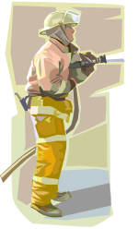
http://www.fire-find.com/ffcreed.html

A copy of the Fire Fighter’s Creed, spelling out the universal mission of the firefighter. Good

FIRE SAFETY: A SCAVENGER HUNT FOR FIRST GRADE NEW!
http://jl046.k12.sd.us/fire_safety_scavenger_hunt.htm
A simple online scavenger hunt for first grade students. Good

FIRE SAFETY TIPS FOR THE HOLIDAYS
http://stepbystepcc.com/firesafety.html
Tips to make the holidays safe from fires. Sections: Trees, Lights, Decorations, and Fireplaces. Good

HOW FIRE WORKS
http://science.howstuffworks.com/fire.htm
How fire burns. Shows the science behind a fire. Good

HOW FIRE EXTINGUISHERS WORK
http://home.howstuffworks.com/fire-extinguisher.htm
Examines what fire extinguishers do and how they should be used. Good

HOW SMOKE DETECTORS WORK
http://home.howstuffworks.com/smoke.htm
A description of how smoke detectors work to detect smoke and fire and to warn people. Good

LET’S LEARN ABOUT FIRE SAFETY – SCAVENGER HUNT NEW!
http://homepages.ius.edu/MHOYLAND/lessons/webhunt.htm
An online scavenger hunt for first grade students. Good

MINOR BURNS – PREVENTION AND TREATMENT
http://www.quickcare.org/skin/burns.html
A short page on the treatment of minor burns. Good

NATIONAL WEATHER SERVICE – FIRE WEATHER FORECASTS
http://fire.boi.noaa.gov/
The National Weather Service tracks areas where fire risk is high due to weather conditions. Use the map to find the forecast in any area. Good

PURCHASING AND INSTALLING YOUR SMOKE DETECTOR
http://ohioline.osu.edu/aex-fact/0690_3.html
A fact sheet on what kind of smoke detector to purchase and where in the home smoke detectors should be placed. Good

SO YOU WANT TO BE A FIREFIGHTER?
http://www.wildfirenews.com/fire/articles/jobs.html
A look at what it takes, in skills and guts, to become a wildfire firefighter. Includes both serious and tongue-in-cheek observations. Good

10 TIPS FOR FIRE SAFETY
http://www.cyberstreet.com/firedept/10tips.htm
Ten basic fire safety tips for everyone, young and old. Good

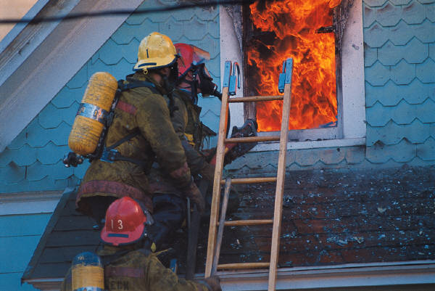
LESSON PLANS
BLAZING LAPTOPS: USING TECHNOLOGY TO FIGHT FIRES – LESSON PLAN
http://www.nytimes.com/learning/teachers/lessons/19981015thursday.html
A lesson plan for grades 6-12 on fighting fire. “Students explore how digital maps and global satellite positioning are helping firefighters in the San Bernardino Valley. Students will then research what factors promote fire danger and various fire-fighting techniques.” Excellent

A BURNING ISSUE: UNDERSTANDING THE DYNAMICS OF FOREST FIRES – LESSON PLAN
NEW!
http://www.nytimes.com/learning/teachers/lessons/20070626tuesday.html?searchpv=learning_lessons
A lesson plan for grades 6-12 on forest fires. “In this lesson, students reflect on the ecological and chemical changes caused by forest fires. Then they work in groups to create diagrams showing how specific variables can affect a forest fire and the chemical reactions that take place during combustion. Finally, students use their knowledge to evaluate fire prevention and management techniques.” Excellent

CALAMITY SANE: UNDERSTANDING RESPONSES DURING EMERGENCY SITUATIONS – LESSON PLAN
http://www.nytimes.com/learning/teachers/lessons/20040907tuesday.html?searchpv=learning_lessons
A lesson plan for grades 6-12 on how people respond to emergency situations such as fires. “In this lesson, students observe responses to emergency situations by participating in and making observations about a fire drill. They then analyze the fire drill proceedings from the perspective of a sociologist investigating social order during disaster response.” Excellent

FIRE AND FIRE PREVENTION – A THEMATIC UNIT PLAN NEW!
http://www.eduref.org/cgi-bin/printlessons.cgi/Virtual/Lessons/Health/Safety/SFY0012.html
A unit on fire safety for grades 2-3. “A thematic unit on fire and fire prevention is essential for students of all age levels. However, knowledge of this topic becomes particularly important for young children, who are vulnerable when a fire occurs due to their inexperience and lack of knowledge about the potential dangers of fire. Children in the second or third grades often use appliances, and they may be placed in situations where fires can easily occur. Teaching children about the dangers of fire and informing them about how to become active in preventing fires may actually prove life-saving should they ever be involved in a serious fire.” Excellent

FIRE PREVENTION ACTIVITIES AND RESOURCES FOR FIRE PREVENTION MONTH
NEW!
http://teacher.scholastic.com/lessonrepro/lessonplans/firetheme.htm
Lesson plans and theme units on fire prevention. Sections: Forest Fires, Fire Safety, and Firefighters. Excellent

FIRE PREVENTION TEACHER’S GUIDE NEW!
http://teacher.scholastic.com/lessonrepro/lessonplans/tguidefire.htm
A teacher’s guide from Scholastic.com about fire prevention. Includes activities, coloring pages and more. Excellent

FIRE SAFETY: ACTIVITIES TO SPARK LEARNING NEW!
http://www.educationworld.com/a_lesson/lesson/lesson026.shtml
An article on teaching fire safety including links to activities and websites. Excellent

FIRE SAFETY LESSON PLANS, ACTIVITIES AND COLORING PAGES NEW!
http://teachers.askacop.org/firesafetyweek.html
A list of links to lesson plans, webquests, games, activities, coloring pages to print out and more. SEE ALSO WEBQUESTS Excellent

FIRE SAFETY – POWERPOINTS, LINKS, LESSON PLANS AND MORE NEW!
http://facs.pppst.com/firesafety.html
A page of links to powerpoint presentations, lesson plans, webquests and activitiesfor teachers and elementary students. Excellent

ON FIRE – CURRICULUM UNIT NEW!
http://illuminations.nctm.org/LessonDetail.aspx?ID=U156
A curriculum unit on fire for junior/senior high students. “Wildfire and wildfire environments provide interesting applications of the measurement and algebra standards. This unit introduces the components of a fire-safe and fire-wise environment. Students create a fire-wise location through calculations and measurement of percent slope, defensible space distance, and various vegetation separation distances. The unit plan culminates with students designing a fire-wise property and testing their fire-wise IQ.” Includes five lesson plans. Excellent

SMOKEY THE BEAR TAKES ALGEBRA – LESSON PLAN
http://illuminations.nctm.org/index_d.aspx?id=381
A lesson plan for senior high students on the factors that play a role in creating a fire-hazard index. “This lesson introduces students to the many factors that play a role in creating a forest-fire danger rating index. Students work with the Angstrom and Nesterov Indexes. To complete the activities related to these indexes, students should be comfortable with linear, quadratic and exponential functions. Summation notation is also used with the Nesterov index. Graphing calculators are required for completing some of the activities.” For advanced students. Excellent

YELLOWSTONE FIRES – EXPLORING THE ENVIRONMENT – LEARNING UNIT
http://www.cotf.edu/ete/modules/yellowstone/YFmain.html
A unit for grades 5-8 on wildfires. “In 1995, a report by the Congressional Research Service stated that the current fuel management policy's reduction of fire control costs and damages is not well documented. For this reason, a group of concerned government agencies has contacted your team of environmental biologists. This group would like your help in resolving this policy debate. They would like to know whether or not to allow naturally-caused fires in national parks to burn to their natural conclusion. The government agencies are particularly interested in your recommendations based on your Earth System Science (ESS) analysis of a fire's impact on the air, land, water, and living things.” Excellent

CANDLE COMBUSTION COMPARISON – LESSON PLAN NEW!
http://www.nasaexplores.com/show_58_teacher_st.php?id=031002155334
A lesson plan for grades 5-8 on candles. “Objective: To compare the heat energy output of different types of candles.” Very Good

FIRE, FIRE SAFETY AND EMERGENCY VEHICLES THEME PAGE
http://www.fastq.com/%7Ejbpratt/education/theme/firesafety.html
A theme page with activities and lessons on fire safety. Very Good

FIRE SAFETY THEME PAGE
http://stepbystepcc.com/firesafety.html
A page for primary children with songs and activities on fire safety. Very Good

FIREFIGHTERS AT WORK – LESSON PLAN NEW!
http://www.eduref.org/cgi-bin/printlessons.cgi/Virtual/Lessons/Social_Studies/Civics/CIV0019.html
A lesson plan for grades K-1 on what firefighters do. “This lesson is about fire fighters at work. The students will learn how fire fighters fight fires in the city, country, forest, and on the waterfront. They will also learn about the equipment used to fight fires. At the end of the lesson, students will be able to draw a picture of a fire fighter at work and be able to write a description of what the fire fighter is doing while he/she is working. The students' drawings and descriptions will then be placed on a bulletin board titled, What Fire Fighters do at Work.” Very Good

SAFETY INSPECTION- LESSON PLAN NEW!
http://www.nasaexplores.com/show_912_teacher_st.php?id=030103114914
A lesson plan for grades j9-12 on analyzing fire strategies in public buildings. Very Good

SAFETY TIPS WITH OFFICER BUCKLE AND GLORIA – LESSON PLAN NEW!
http://www.readwritethink.org/lessons/lesson_view.asp?id=1019
A lesson plan for grades K-2 on fire safety. “Recognizing problems and identifying solutions are skills that help students develop awareness of themselves and their surroundings. After reading the book Officer Buckle and Gloria by Peggy Rathmann, students explore potential safety problems and then devise possible solutions. Each student creates a safety tip poster similar to the ones in the book to present a solution to one of the identified safety problems. Students communicate their safety messages to others by displaying the posters around the school or in the community. This lesson could easily be adapted for use with older students.” Order the video from the AVA Center VT503499 Very Good

SAY NO TO PYRO – LESSON PLAN
http://www.eduref.org/cgi-bin/printlessons.cgi/Virtual/Lessons/Health/Safety/SFY0007.html
A lesson plan for kindergarten and 1st grade on how to handle situation where someone is not being safe with fire. “Children need to learn how to handle situations where something is not safe when dealing with fire. This will show them what to do when they come across a situation where there is a possible problem.”
Very Good

SCALE DRAWING OF A HOME FIRE ESCAPE ROUTE – LESSON PLAN NEW!
http://www.nasaexplores.com/show_912_teacher_st.php?id=021230121244
A lesson plan for grades 9-12 in which students create a scale drawing of their home and map out a fire escape route. Very Good

TEACHING THEME: FIRE PREVENTION NEW!
http://www.teacherplanet.com/resource/fireweek.php
Resources and links for fire prevention month. Very Good

CANDLE FLAME IN MICROGRAVITY – LESSON PLAN NEW!
http://nasaexplores.com/show_58_teacher_st.php?id=02122494157
A lesson plan for grades 5-8 on candle flames in microgravity. “Objective: To observe a candle flame's properties in free fall.” Good

CANDLE FLAMES – LESSON PLAN NEW!
http://nasaexplores.com/show_58_teacher_st.php?id=02122493525
A lesson plan for grades 5-8 on candle flames. “Objective: To investigate the effect of gravity on the burning rate of candles.” Good

FIRE ESCAPE ROUTE – LESSON PLAN` NEW!
http://www.nasaexplores.com/show_k4_teacher_st.php?id=021230114241
A lesson plan for 4th grade students on setting up an escape plan in case of a fire. Good

FIRE DETECTION – LESSON PLAN NEW!
http://www.nasaexplores.com/show_k4_teacher_st.php?id=021230115027
A lesson plan for grades K-4 on fire. “Objective: Students will learn that smoke is poisonous and what equipment can detect and put out fires.” Good

FIRE DRILL LINE-UP – LESSON PLAN NEW!
http://www.pecentral.org/lessonideas/ViewLesson.asp?ID=4408
A lesson plan for any grade level on lining up for a fire drill. “Since special area teachers may have any given class in their care during a fire drill, I started searching for a way to account for students during a fire drill, without having to run across the gym to grab my plan book from the office. My solution was to keep a copy of my class lists by the exit door. I taped a folder made of construction paper to the wall and placed these lists inside this folder. Now during a fire drill, I have my students line up and grab the class list on the way out. Not only does it save considerable time, the students never leave my sight.” This is less a lesson plan than a tip for teachers. Good

FIRE SAFETY – LESSON PLAN NEW!
http://www.pecentral.org/lessonideas/ViewLesson.asp?ID=1142
A lesson plan for grades 3 and up on fire safety. “Have the equipment (listed above) set out into 4 safe areas of the gym or outdoor area. Divide students into 3/4 groups. When they get to the area they are to work together to design an obstacle course that utilizes all of the equipment in their area. (Teacher can pre-design these courses if they want)
Explain to the students that in order to safely get out of your house during a fire you may have to negotiate different obstacles during that escape. Have the students practice going through course.” Good

FIRE SAFETY – LESSON PLAN
http://teachers.net/lessons/posts/2069.html
A lesson plan for 2nd grade students on fire safety. “The students will be able to appreciate the importance of a Fire Safety Plan through the demonstration of the three key points: 1.) Stop, Drop, and Roll Procedure 2.) The Great Escape Method 3.) Home Safety Rules.” Good

FIRE SAFETY – STOP, DROP & ROLL – LESSON PLAN
http://www.lessonplanspage.com/OSSFireSafetyStopDropRollK.htm
Lesson plan for Kindergarten students on Stop, Drop and Roll in which students learn the technique, when it is used and sequence the words. Good

FIRE SAFETY WORD SEARCH
http://www.surfnetkids.com/games/fire-ws.htm
A word search game for kids on fire safety. Good

FIRE SAFETY WORD SEARCH GAMES
http://www.usfa.fema.gov/kids/g.wrdsrch.htm
Two fire safety word search games. Good

FIREFIGHTER CHORE BOARD
http://www.geocities.com/learnatplay/firefightercb.html
A plan for a chore board using a firefighter theme. For primary grades. Good

HOW FIRES BURN – THE FIRE TRIANGLE – LESSON PLAN
http://www.eduref.org/cgi-bin/printlessons.cgi/Virtual/Lessons/Health/Safety/SFY0202.html
A lesson plan for grades K-2 on the fire triangle. Good

OXYGEN, OXYGEN EVERYWHERE! – LESSON PLAN NEW!
http://www.nasaexplores.com/show_58_teacher_st.php?id=030804135305
A lesson plan for grades 5-8 on fire. “Objective: To determine the percentage of oxygen in the air and compare it to the amount needed to sustain a fire.” Good

PLANNING AN ESCAPE – LESSON PLAN NEW!
http://www.nasaexplores.com/show_k4_teacher_st.php?id=021224102331
A lesson plan for grades K-4 on escaping a fire. “Objective: To identify the importance of a home fire escape plan.” Good

PRESCHOOL CRAFTS FOR FIRE SAFETY
http://www.preschooleducation.com/afire.shtml
Five simple craft activities for fire awareness and safety. Good

PRESCHOOL SNACKS FOR FIRE SAFETY
http://www.preschooleducation.com/cfire.shtml
Directions for four snacks for preschool students as part of fire safety lessons: Fire Engine Cookies, Fireman’s Shake, Energy Chews, and Candle Snacks. Good

PUT THE FLAME OUT! – LESSON PLAN NEW!
http://www.nasaexplores.com/show_58_teacher_st.php?id=021224103043
A lesson plan for grades 5-8 on fire and flames. “Objective: To observe how carbon dioxide affects a burning candle.” Good

RESCUE 911 – LESSON PLAN NEW!
http://www.pecentral.org/lessonideas/ViewLesson.asp?ID=1138
A lesson plan for grades 3-5 that explains the roles of first responders to fire calls. “Purpose of Activity: To work cooperatively as a group and to gain an understanding of the roles and responsibilities of those individuals who serve our community and respond to 911 emergency calls. This activity is used during October and an academic intergration activity to promote fire safety month.” Good

SMOKE ALARMS – LESSON PLAN NEW!
http://www.nasaexplores.com/show_k4_teacher_st.php?id=02122495706
A lesson plan on smoke alarms for grades K-4. “Objective: To identify the purpose of smoke alarms, and to identify where they should be installed.” Good

TEACHING ELEMENTARY STUDENTS ABOUT FIRE SAFETY – LESSON PLAN
http://www.eduref.org/cgi-bin/printlessons.cgi/Virtual/Lessons/Health/Safety/SFY0013.html
A lesson plan for grades 2-3 in which students act out safe and unsafe campfire practices. Good

WHAT IS FIRE? – LESSON PLAN NEW!
http://www.nasaexplores.com/show_k4_teacher_st.php?id=021223131119
A lesson plan for K-4th grade students on fire. “Objective: To create a concept web about fire, and to draw illustrations showing what to do in the event of a fire.” Good

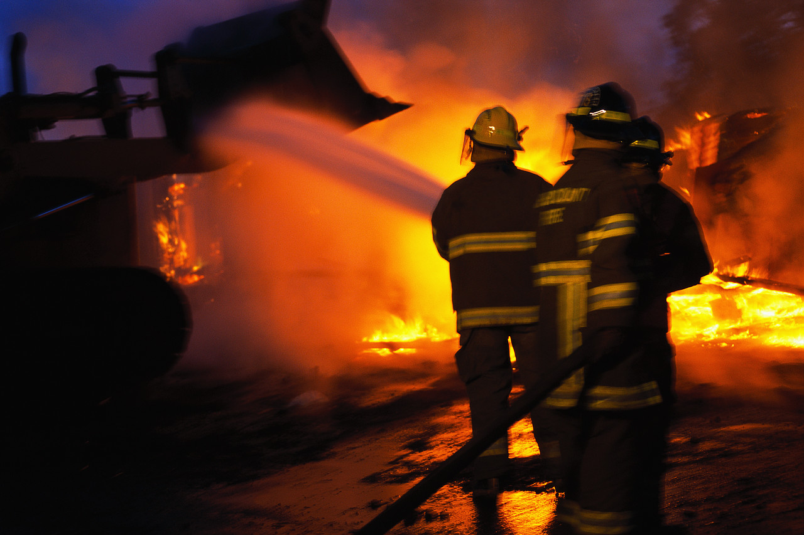
WEBQUESTS

FIRE SAFETY LESSON PLANS, ACTIVITIES,COLORING PAGES & WEBQUESTS NEW!
http://teachers.askacop.org/firesafetyweek.html
A list of links to lesson plans, webquests, games, activities, coloring pages to print out and more. SEE ALSO LESSON PLANS Excellent

FIRE SAFETY WEBQUEST
http://studenthome.nku.edu/~webquest/Pugh/introduction.htm
A webquest on fire safety for grades 2-3. “Firefighters help save lives. As a firefighter you can also save lives by providing other students with some fire safety tips. You are going to work in assigned groups of three to gather information and then create a fire safety brochure which you will share with students in another classroom. Then you will work alone to design a fire escape plan poster.” Excellent
JUNIOR FIREFIGHTERS WANTED WEBQUEST 
http://schools.sd68.bc.ca/ed611/scott/test.html
A webquest for kindergarten to 1st grade on fire safety. “Jr. Fire Fighters are needed to help teach fire safety. The Jr. Fighters will also need to know how to prevent fires from starting in and around their homes. To become a Jr. Fire Fighter you will work with a partner to explore different parts of fire safety and prevention. You will then use your knowledge to devise and practice a safe route out of your home. Continue with caution, fires are dangerous!” Excellent

LEARN NOT TO BURN – WEBQUEST NEW!
http://www.besd61.k12.il.us/webquests/1st%20Grade/firesafety/firesafety.html
A webquest on fire safety for 1st grade students. “Learn how to be fire safe. At the end of this webquest, you will be asked to make a poster and show how your family is fire safe. You will draw a fire escape plan that includes at least two ways out of each room in your house and your meeting place. You will also show where your smoke detectors are in your house. There will also be a quiz at the end of this webquest - so pay attention!” Excellent

WILDLAND FIREFIGHTING AND FIRE SAFETY WEBQUEST
http://learn.sdstate.edu/webquest/firefighting/HausWebQuest.htm
A webquest for grades 7-12 on fighting wildfires. Students learn about firefighting tactics and the differences in fighting fires in buildings and outdoors. “During this WebQuest I will be asking students to formulate their own plan of attack. I will provide students with information and tactics that are needed and used by firefighters in the field. They will formulate an essay describing how they will execute the head of the fire incident team’s orders to come to the end of a successful mission of extinguishing a fire.” Excellent

FIRE- A WEBQUEST ABOUT FIREMEN AND FIRE SAFETY
http://projects.edtech.sandi.net/sessions/firesafety/t-index.htm
A webquest for primary students on the role of firefighters in the community and what children and their families can do to help prevent fires. Very Good

FIRE SAFETY AND PREVENTION WEBQUEST
http://oneweb.utc.edu/~deborah-mcallister/educ575/wq03SaraNaylor_RobinNewberry/WQNaylorNewberry.htm
A webquest for third grade students on fire safety including recognizing fire hazards. “In this WebQuest, you will learn different fire hazards to look for in your house. Fire hazards are different things that could possibly start a fire if they are not taken care of. You will also learn what to do if a fire should start in your house. Knowing what to do could save both you and your family if you ever are in a fire.” Very Good

FIRE SAFETY IN YOUR HOME WEBQUEST http://education.wichita.edu/m3/tips/health/second/safety/webqstfrm.htm
A webquest for primary students on fire safety in the home. Students learn what to do if there’s a fire, evacuation plans and more. Very Good

FIRE SAFETY WEBQUEST
http://www.juliethompson.com/Webquest/fire/
A webquest for third grade students on fire safety in which they must develop aids to help people remember fire safety rules. Very Good

FIRE SAFETY WEBQUEST NEW!
http://missdsclassroom.com/webquestintro.html
A webquest on fire safety for middle school students. “Firefighters help save lives. In your assigned groups, you are to create a fire safety pamphlet. Include tips on how to prevent fires, what to do in case of a house fire and what to do if your clothing catches fire. You are responsible with sharing this pamphlet with your neighbors. Then you are to individually create a personal plan of action in the case of a fire for your home. You are to run an evacuation drill with your family.” Very Good

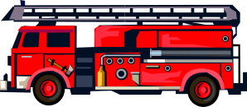
FIRE TRUCKS – BUILD YOUR OWN – WEBQUEST
http://arapaho.nsuok.edu/~hiskett/webquest.htm
A webquest in which elementary students learn about fire trucks and design their own. Very Good

FIRE SAFETY WEBQUEST NEW!
http://questgarden.com/46/40/2/070207140548/
A webquest for kindergarten students to teach them what to do in case of a fire. Good

Prepared by the Cumberland County AVA Center staff. Please call #856-451-0817 or email: avacenter@cumbavac.org with questions or suggestions for future web site lists.

This site list will be sent by email to all teachers with school email addresses. If you do not have a school email address and would like to receive the list via email, please send us your email address. Note that lists cannot be forwarded from your school address to your home address. They must be sent directly because of file size.

The site list is also posted on two other web sites:
http://www.atlanticava.org
http://www.salemcountyava.org

October 2007

