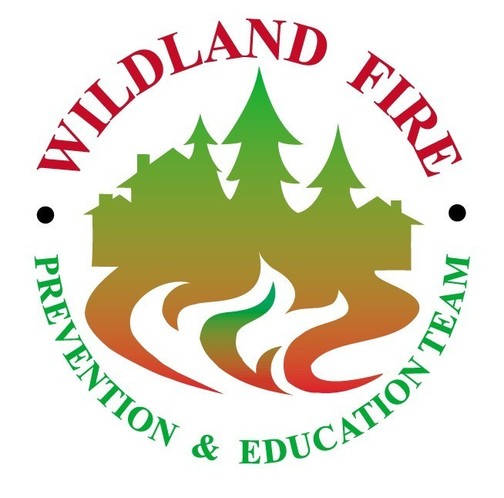

FINAL REPORT

Insert Date

Fire Prevention and Education Team
Insert location and address of host unit

ABSTRACT (sample)

In November 2000, the Francis Marion National Forest in southeastern South Carolina requested an interagency prevention and education team be assigned to the Forest to assist with their prevention efforts to stop arson fires. The team arrived on November 18, 2000 to begin a two-week assignment. The team was based at the Witherbee Ranger Station. The team met with various staff from the Francis Marion and Sumter National Forests and the South Carolina State Forestry Commission on December 1, 2000 to overview the results of the assignment. This report details the activities and accomplishments of the South Carolina Interagency Fire Prevention and Education Team assigned to Witherbee.
TABLE OF CONTENTS
_____________________________________________________

- Introduction

- Communication Plan

- Objectives and Accomplishments

- Recommendations

- Appendices (sample list of what might be included)

Daily Activities
Key Contact Lists
Materials Distribution locations
News Releases and Clippings
Publications
Fire Prevention Plan Outline
Arson Task Force Use
Fire Prevention Plan Assessment
Other Products

_____________________________________________________
Acknowledgements

The Team acknowledges the following individuals and organizations for assisting us in completing our assignment:

Introduction

Background (sample)

The Francis Marion and Sumter National Forests requested an interagency fire prevention and education team be assigned to the Francis Marion National Forest to help them address an escalating woods arson problem on the Forest.

Over the last two years, the Francis Marion has experienced about a 200% increase in the number of fires annually. Normally, the Forest gets between 50 to 70 fires per year. Since January 1, the Francis Marion has had 220 fires, with arson accounting for 86% of these fires. Since October 1, the Forest has had roughly 80 woods arson fires, the largest of which was 184 acres.

The Forest has been very concerned by the adverse affects from this ongoing arson problem. Their primary concern, of course, has been with firefighter and public safety. The high volume of fires and long hours over the last two years have strained the local fire crews. Nevertheless, they have done an admirable job of handling the fire load, maintaining a high degree of camaraderie and professionalism. In addition, these arson fires are generally set in heavily traveled areas of the Forest where additional fire traffic and smoke can pose a threat to travelers. Some of these fires have also been set on or near private lands where lives and property have been threatened.

The Forest is also concerned with the escalating costs of these fires, both directly, from suppression costs, and indirectly, from the losses in other important programs because people have been committed to fire. The dramatic increase in fires has impacted all the personnel on the Francis Marion, many of whom have been involved with suppression activities. As a result, all programs have been affected.

The program most adversely impacted by the increased fire load is the prescribed fire program. Because of the escalating arson problem, fire managers have not been able to accomplish any prescribed burning this year, which is of great concern to the Forest.

The Francis Marion annually burns between 30,000 and 35,000 acres of its 250,000 acres and is hoping to expand its prescribed fire program within the next 5 years. The South’s pineland ecosystem evolved through fire. It requires regular burning every 3 to 5 years to maintain healthy and diverse communities. The longleaf pine, in particular, thrives on fire, requiring low-intensity ground fires to remove competing trees and vegetation and to stimulate its growth. Therefore, the prescribed fire program on the Francis Marion is essential for reducing dangerous accumulations of fuel and improving habitat for wildlife and several endangered species.

This ongoing arson problem could have further consequences for the Forest. In areas with heavy fuels, the drought conditions that have persisted since September have created the conditions for large, uncontrolled wildfires. The Forest has received a small amount of moisture recently, but even a few days of warm weather and low relative humidity are enough to dry things out and drive the fire danger back up.

The South Carolina Interagency Fire Prevention and Education Team arrived on November 18, 2000 to begin a two-week assignment. The team was based out of the Witherbee Ranger District in Cordesville. The team first met with the District Ranger and staff from the Forest on November 19 to brief the team on the history of the arson problem and discuss the team’s objectives, areas of emphasis, and key contacts. The team has had ongoing coordination with these Forest personnel throughout their assignment and met with them to report the results of their assignment on December 2, 2000 (See appendix for details on daily activities.)

Report Contents

This report contains the following major sections:

Communication Plan: This plan describes the principal communication objectives, key messages, target audiences, and methods and products used to accomplish the objectives.

Objectives and Accomplishments: This section discusses the objectives agreed upon by the District Ranger and staff and lists the major accomplishments completed for each objective.

Recommendations: The team identified several actions that should be considered to further the fire prevention and education program on the District.

Appendix: The appendix contains business and communication products and supporting materials.

Team Members

Team Members included: (sample layout)

Sue McCourt, Team Leader Dave Merrifield
District Fire Prevention Officer Fire Prevention Specialist (Retired)
Plumas National Forest Lassen National Forest
P.O. Box 7, 23 Mohawk Road 2550 Riverside Drive
Blairsden, CA 96103 Susanville, CA 9613o
Phone: 530-836-7136 Phone: 530-258-2292
Fax: 530-836-0493 Cell: 530-249-2292
E-mail: smccourt@fs.fed.us E-mail: prevention_plus@yahoo.com

Jim Hanrahan, Calvin Bailey
Battalion Chief Regional Staff Director, Coastal Region
Sequoia Nation Forest South Carolina Forestry Commission
Route 4 Box 548 413 Sidneys Road
California Hot Springs, CA 93207 Walterboro, SC 29488
Phone: 661-548-6503 Phone: 843-538-3708
Fax: 661-548-6236 Fax: 843-538-2193
E-mail: jhanrahan@fs.fed.us E-mail: cbailey@scfc.state.us

Maggie McCaffrey
Writer/Editor
Montrose Bureau of Land Management
2465 South Townsend
Montrose, CO 81401
Phone: 970-240-5396
Fax: 970-240-5369
E-mail: maggie_mccaffrey@co.blm.gov

2. Communication Plan

Communication Objectives (sample)

The following are key communication objectives to assist in accomplishing the fire prevention and education team objectives:

- Create public awareness of the woods arson problem on the Francis Marion National Forest

- Identify the adverse affects of woods arson

- Enlist public support to help stop the woods arson problem

- Encourage people to call an arson hotline number with any information that would help identify the arsonist

Key Messages (sample)

The team developed key messages to raise public awareness of the woods arson problem on the Francis Marion and encourage them to report woods arson to an established statewide arson hotline number.

- Arson is a crime. People should report any information related to woods arson fires to the statewide arson hotline 1-800-92-ARSON.

- Woods arson fires are dangerous to firefighters and the public

- Woods arson fires have been set on private land, threatening lives, homes, and property

- Woods arson fires are generally set in heavily traveled areas of the Forest where smoke can limit visibility for motorists

- Woods arson fires are costing the American taxpayer millions of dollars

- Woods arson fires cost the federal government millions of dollars directly in the form of suppression costs, and indirectly, by taking money, people and time away from work which would benefit wildlife and people

- Woods arson fires keep forest personnel from accomplishing other important resource work, including prescribed burning, which is essential to the health of the forest

- The lack of prescribed burning, in combination with the drought conditions that have persisted since September, could create major control problems for firefighters.
Target Audiences

Principle audiences for the fire prevention and education materials included:

Method and Products (sample)

Method and products used to help convey prevention messages included:

News Releases: News releases were sent to area media and key contacts to inform them of the team's existence and objectives. Additional woods arson prevention messages were included in the releases. Releases were also sent to inform the media about the new signing program for arson fires and prescribed fires and about to provide a detailed discussion of how these arson fires are affecting the prescribed fire program on the Forest. These news releases functioned to generate media interest and feature stories on fire prevention and reporting through 1-800-92-ARSON hotline.

Personal Contacts and Coordination: Contacts were made with state and local government offices, fire departments, other agencies, and the media. Objectives for these contacts included: information gathering, information sharing, and coordination.

Key Messages and Prevention Tips: Public Service Announcements (PSAs) and Talking Points were developed for use by the team and agency personnel. The PSAs and Talking Points were also distributed to the media.

Signs and Posters: Signs and posters were either obtained from other agencies or developed by the team. Some of the signs were designed to sign the arson fires and the prescribed fires to help the public distinguish between the two. The posters were distributed to local area markets, county stores, restaurants, and the like.

3. Objectives and Accomplishments

The Francis Marion National Forest agreed to the following objectives. Actions to achieve the objectives are identified in detail under each objective. (Sample)

Objective 1: Develop a plan of long and short range goals targeted at reducing arson fires on the Francis Marion National Forest and surrounding forest area.

Accomplishments:

Gathered historical data
- Obtained briefing from Forest on day of arrival
- Gather statistics for use in press releases and talking points
- Display costs incurred to taxpayers to suppress arson fires

Observations and Recommendations

Observation: (sample)
Forest Arson Prevention Committee has recently been established to deal with growing arson problem. Group has yet to meet and develop goals and objectives targeting a program

Recommendation:
- There remains confusion on how to attach a dollar amount reward to conviction of an arsonist. Need to explore additional avenues to offer a set dollar amount award upon arrest and conviction.
- Include a representative from South Carolina Forestry Commission to ensure unified approach to arson problem
- Utilize the Fire Prevention Plan template provided by National Fire Prevention team to develop a plan of action to target woods arson fires.
- Review accomplishments, contacts and recommendations to continue arson fire prevention program developed by the National Team.

Observation:
Good interagency cooperation has been established for fire suppression

Recommendation:
- Utilize same partnerships to spread fire prevention message. Maintain contact with Rembert Wrenn, Berkeley County Fire Commissioner, as conduit to the volunteer fire departments to distribute materials.

- Maintain close contact with South Carolina Forestry Commission to maintain consistency with fire prevention program.

