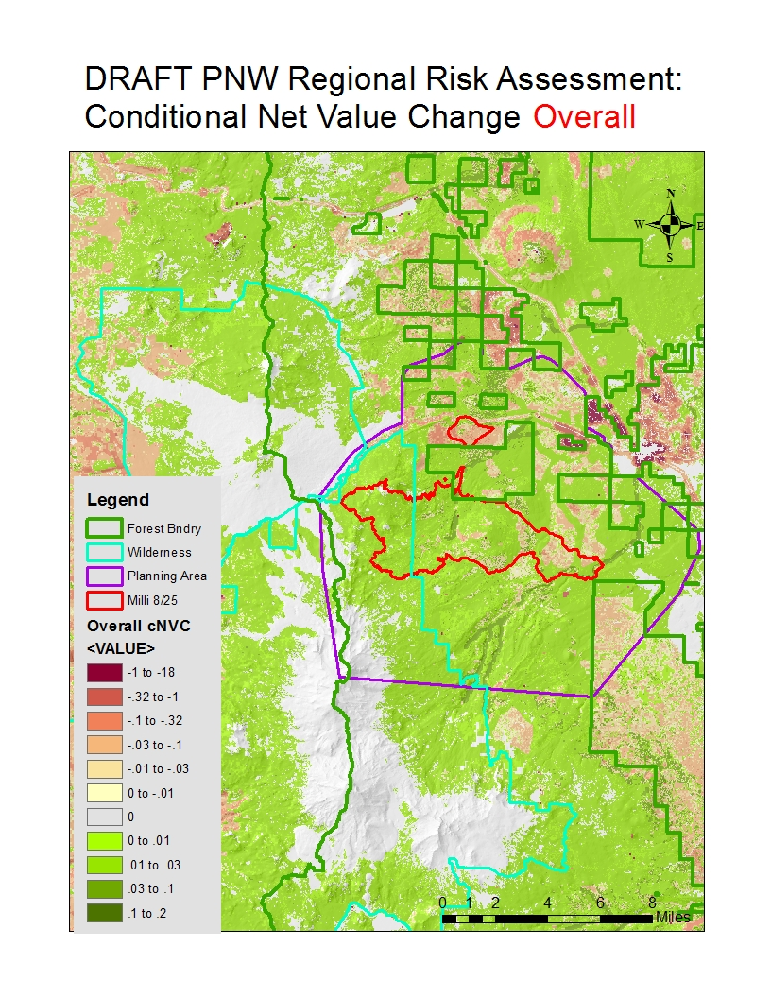

**PNW QWRA Highly Values Resources and Assets**

**Assets**

* Human habitation
* Communication sites
* Transmission lines, high and low voltage
* Railroads
* Interstates and state highways
* Recreation, high and low development
* Ski areas
* Historic structures
* Seed orchards
* Sawmills

**Resources**

* Timber
* Muniple watersheds
* Vegetation departure
* Bull trout
* Chinook and Coho Salmon
* Steelhead
* Marbled Murrelet
* Northern spotted owl
* Sage grouse

