# 2017 Fire Season Key Elements

## Introduction

Several elements played roles in how the 2017 fire season progressed and the outcomes of the fires. Weather and climate are key elements in determining the length and severity of a fire season, although this season demonstrated that some factors that previously used to predict the severity of the fire season did not provide the same predictive power as in the past. Interagency cooperation and coordination are essential for managing wildfires and minimizing losses. As workforces continue to shrink, no single federal or state agency can handle this task alone even on many single fires, much less on multiple fires and across an entire fire season. Prevention and fire education programs reduce the probability of human-caused fires, but cannot eliminate them. Nonetheless, the prevention program was a key factor in the lack of human-caused fires during the total eclipse.

## Weather and Climate

### Pre-fire Season

Winter and spring of 2016-2017 brought cold temperatures and continuous heavy accumulation of precipitation to the Pacific Northwest and the Northern Rockies. As late as May, precipitation totals revealed that Oregon and Washington had received well above average rain or snow for the prior six months. Some climate zones were well above average accumulation and by April, regional reservoir storage was reported as reaching full capacity.

As of May 1st 2017, SNOTEL reporting sites were reporting greater than typical accumulation of snow (Figure x). Timberline Lodge in Oregon had tabulated more than 520 inches total snowfall. The cold, wet winter was attributed to La Niña conditions, which typically bring such conditions to the Pacific Northwest.

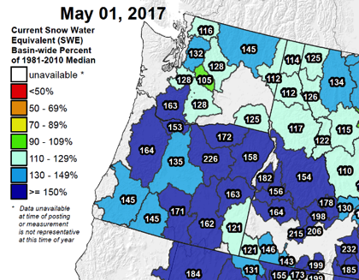

Figure x. Snow water equivalent as of May 1 indicated snowpacks of well above average across most of the Northwest, particularly in Oregon. Source: Natural Resources Conservation Service.

However, temperatures across the Northwest geographic area began warming above average in spring of 2017 even as precipitation continued across much of the area. Precipitation declined significantly after mid-June but temperatures continued to climb above average across the geographic area. For example, Yakima, WA warmed to above average temperatures in March and remained above average until October, with well above average temperatures in June through mid-September (Figure x).

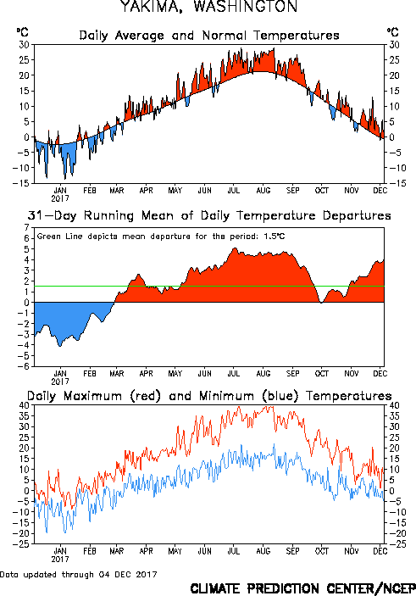

Figure x. Departure from average temperatures in Yakima, WA for 2017. Red indicates warmer than average temperatures, blue indicates cooler than average, green line indicates the mean departure from average for the year. One degree C equals 1.8 degrees F. Source: NOAA.

### Fire Season Temperatures

Temperatures continued to warm through July and peaked in August. July temperatures were well above average for much of the western US while August of 2017 proved to be the warmest August on record for a number of climate zones in Oregon, Washington, and northern California (Figure x). Multiple records were set for consistent warm temperatures.

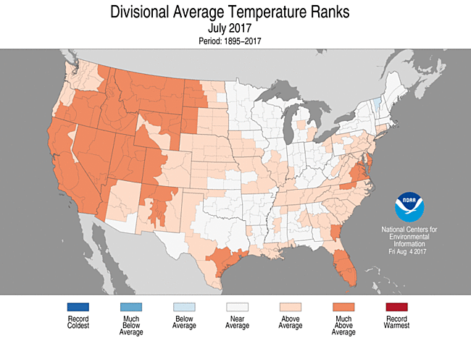 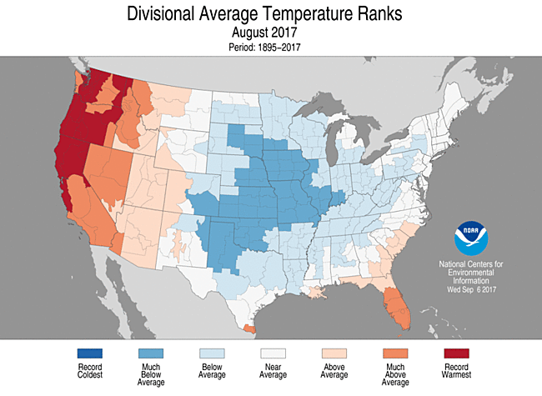

Figure x. Departure from average temperatures for July and August 2017 by climate division. Source: NOAA.

A look at a time series of August temperatures for Oregon, Washington, and Idaho stretching back to 1950 reveals that August of 2017 was the warmest ever recorded (Figure x). August temperatures for this region appear to be on an upward trend since about 1995. Only four Augusts since 1995 have had average or below average temperature.

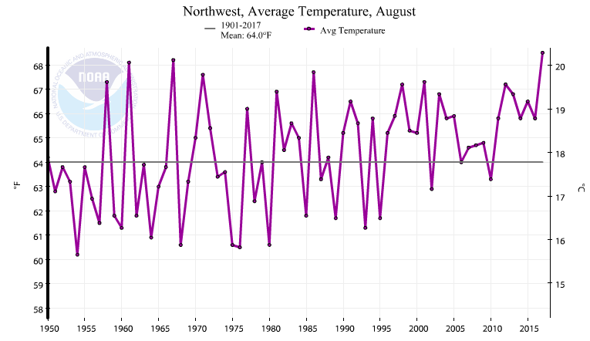

Figure x. Time series of average temperature in August for Oregon, Washington, and Idaho combined. Source: NOAA

The three month period (June, July, and August of 2017) proved to be the warmest on record for the significant portion of the western United States (Figure x).

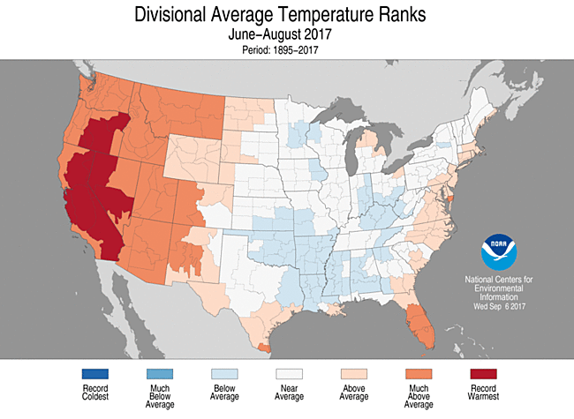

Figure x. Departure from average temperatures for meteorological summer (June-August) 2017 by climate division. Source: NOAA

Temperatures fell back to normal or below in mid-September when a wet cold front brought a major weather change to the region. Cold, moist air lingered over the region bringing rainfall substantial enough to put a stop to new large fire outbreaks and halt the growth of existing large fires. Fire season was effectively ended by this event.

### Fire Season Precipitation

Precipitation continued to accumulate over the Northwest geographic area in the spring of 2017, even as temperatures began rebounding back above normal. However, periodic frontal systems stopped arriving in mid-June and a lengthy dry spell followed. Cities such as Portland and Seattle went over 50 days before rain returned, briefly and sparsely, in early August. Another dry spell lasting more than month followed on its heels.

|  |  |
| --- | --- |
|  | In mid September a strong frontal system brought several days of sustained rainfall to the region. Rainfall totals were over 5 inches in selected westside locations between September 15 and 20; September 19 was particularly wet in much of western Oregon and Washington (Figure x).  The accumulation of through Sep 20 rain was sufficient to halt ignitions of new large fires and significantly reduce growth for ongoing large fires. The wet spell effectively ended fire season for 2017. |

Figure x. 24-hour rainfall amounts for September 19, 2017 in Oregon and Washington. Source: NOAA

Overall, the three-month period June through August of 2017 was drier than typical for most of the northwest geographic area but was not the driest on record (Figure x). However, the high temperatures over the same period resulted in much drier conditions than would otherwise be expected based on precipitation alone.

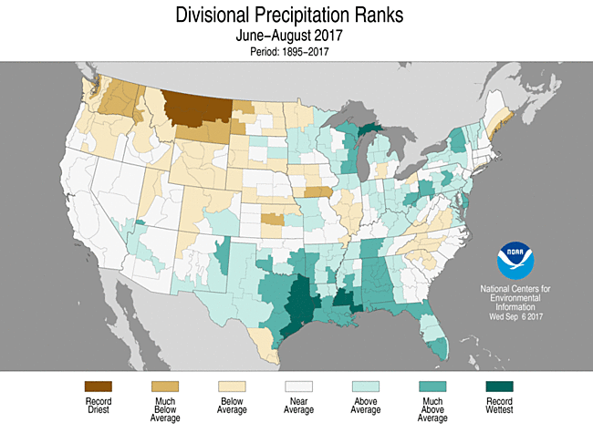

Figure x. Departure from average precipitation amounts for meteorological summer (June-August) 2017 by climate division. Source: NOAA

### Flash Drought Development

The rapid change in temperature followed by the lack of precipitation in June created a flash drought potential. Flash droughts develop very quickly with little or no warning that a drought is developing. The wet winter and spring combined with the warm temperatures resulted in significant plant growth. However, as the precipitation dwindled and temperatures began to climb, the atmospheric demand for water resulted in very high evapo-transpiration rates, leading to rapid curing of grasses, rapid loss of moisture from dead woody fuels, and rapid development of drought stress in live fuels such as trees and shrubs. Over the three month period between when the rains ended in mid-June and when they restarted in mid-September, the equivalent of extreme drought developed over the forests of the Northwest (Figure x).

Unusually warm temperatures in July and August likely led to the flash drought. Energy Release Component (ERC) values, a measure of fire danger and seasonal drought, also ran well above average across Oregon and Washington from June through mid-September. All time record ERC values were equaled in July and repeatedly exceeded during August and early September (see below as well).

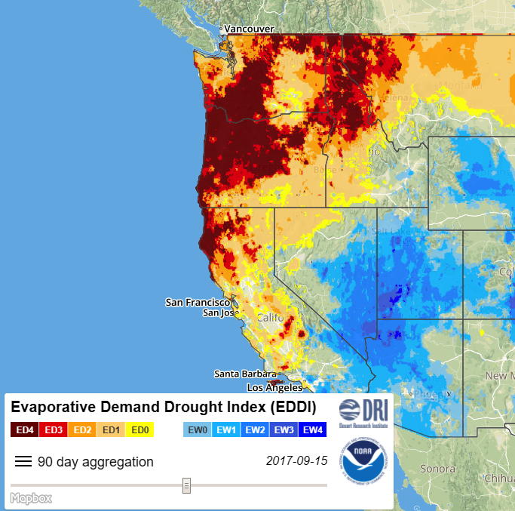

Figure x. Evaporative Demand Drought Index for the July 15 through September 15 period. Sources: Desert Research Institute and NOAA

### Trends in Fire Danger

In contrast to fire season 2016, Energy Release Component (ERC) show less variation during 2017. After precipitation ceased and temperature rose in mid-June fire danger began a steady upward climb. Regional ERC values were already a standard deviation or more above normal by early July and continued to climb. All-time record (since 1990) values of regional ERC were achieved around August 1 and again in late August due to the continuing hot, dry weather. Only a brief decline was evident during a short spell of light rain in early August (Figure x).

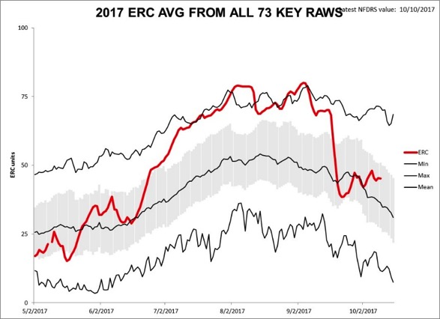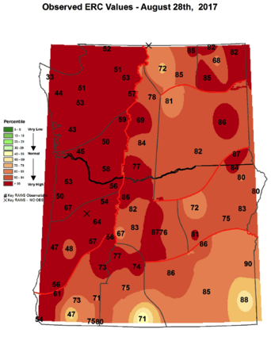

Fig X: Regional Trends in ERC 2017 Fig X: Peak ERC values late Aug

### 2017 Lightning Statistics

From June 1 through Sep 30 34,883 strikes were recorded over Oregon and Washington in 2017. This is the fourth lowest total for a fire season since the year 2000 (Figure x). The average for fire seasons 2000-2017 was 77,155 strikes.

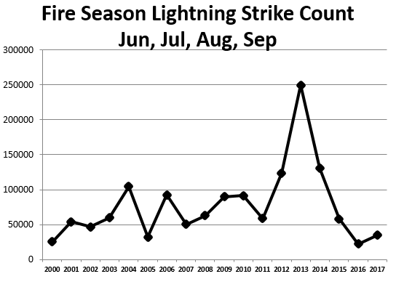

Figure x. Annual lightning strike counts over the last 17 years during June through September. 2017 was not a particularly active lightning year.

Despite the below-average number of lightning strikes, fire activity was high due to the bulk of fire starts from strikes occurring at periods of hot, dry weather, in July and again in August. In addition, drought conditions helped to make both live and dead fuels highly susceptible to burning. The strikes were distributed more evenly spatially during fire season 2017 than in the 2016 season. Noteworthy fire starting events occurred at peaks of fire danger in July and the second week of August.

### Wind Events

Wind is always a significant factor in fire behavior and fire spread. Certain types of wind events are more problematic than others. Two of these that played a big role in the 2017 fire season were so-called foehn winds and winds associated with thermal troughs, sometimes referred to as heat lows.

A foehn wind, also known as a gravity wind, is a wind created by extreme pressure gradients between nearby surface high and low pressure systems and usually under an upper air high pressure system. The surface high and low set up a pressure gradient that results in wind flowing from the high towards the low while the upper air high pressure system pushes the winds towards the surface, hence the name “gravity wind”. The east winds of western Oregon and Washington and the so-called Chetco Effect are examples of foehn winds. In east winds, high pressure in the Columbia Basin combines with low pressure offshore to essentially pull the warm, dry air from the eastside over to the westside. These winds are strongest at passes and down the Columbia River Gorge. In the Chetco effect, the high pressure is to the north and the low pressure to the south and the differing circulation patterns around each (clockwise around high pressure, counter-clockwise around low pressure) combine to funnel winds down the Checto River and out to sea. In both cases, as the air mass falls, it warms and dries, increasing fire danger and helping fires to spread faster. The winds can also be very gusty and will shift with how the terrain shifts. An east wind event resulted in the rapid spread to the west on Eagle Creek Fire. The Chetco Effect was responsible for the rapid spread of the Chetco Bar Fire towards Brookings. Thermal trough-related east winds occurred on July 22-24, August 18-20, and September 2-4.

Thermal troughs can be thought of as miniature cold fronts. They typically bring very warm and very dry air with strong, gusty winds, causing fires to spread rapidly to the north or northeast. Thermal troughs affected several fires in western Oregon and the large fires in eastern Washington. Southwest Oregon in particular experienced several thermal trough passages, resulting in significant growth on fires in the Miller, Umpqua North, and High Cascades complexes. A strong thermal trough pushed the Diamond Creek Fire into Canada. Strong thermal trough-related west winds affected central Oregon and central Washington on June 12, July 15, and August 13, 16, and 30.

## Successful Interagency Coordination and Cooperation

### July 4 Rainbow Family Gathering

The Rainbow Family of Living Light (RFLL)is a loose-knit group of people without leadership or organization who participate in a national gathering once a year. Attendees come from across the country. Since 1972, the event has taken place on a different national forest during a two-week period surrounding the Fourth of July holiday. This event draws people from all over the United States and can bring crowds of 10k-30k people. Every spring there is a tribal council of elders that convene and meditate to choose a final location for the gathering. The spring counsel was held on the Umatilla National Forest on the North Fork John Day ranger district on XX/XX/XXXX. The council decided to hold the annual gathering on the Malheur National Forest near the communities of John Day Oregon and Seneca Oregon. Immediately after the announcement, the Forest Service began establishing an incident management team consisting of Fire managers, natural resource specialists, law enforcement officers, health and safety coordinators, and community liaisons. The incident management team coordinated closely with county officials and law enforcement officers to provide for public safety and resource protection. . The Forest then worked with RFLL attendees to develop a Resource Design Criteria that outlined expectations for the agency and gathering participants to provide for the welfare and safety of all forest users, the surrounding community, and protection of natural and cultural resources.

The team was fully assembled in John Day OR by June 19th. The team was a unified command effort consisting of two incident commanders. One being Law enforcement and the other being a fire manager. The law enforcement commander would oversee the 30-40 officers that would provide 24/7 coverage of the gathering. The Fire command would oversee the Natural resource staff and the rest of the team which was comprised of safety officers, information officers, finance officers and GIS specialist. The gatherings official dates are July 1st-7th, but prior to the event, members of the family will build up makeshift infrastructure (slit trenches, kitchens etc.). Any group of people this large usually causes spikes in unlawful behavior in the area of the gathering and in the surrounding communities. In an effort to alleviate the potential large work load on the community’s court system the USFS and the DOJ held a remote mobile court to process violations that happened at the event. At least 15 arrests were made on the national forest, and 117 violation notices were issued, according to the Forest Service. A spokesman for the U.S. Attorney’s Office, said about a quarter of the arrests were felonies. About half of the violations were related to traffic or vehicle offenses, he said, and about a quarter were related to drugs. Other violations were related to alcohol, officer interference, fires and forest roads and trails.



This event also presented fire risks to the event gatherers and the general public. Large prevention efforts were made to educate the large group of people, most of whom were unfamiliar with western forest fire dangers. The amount of campfires and makeshift ovens that were constructed as well as the possibility of ignitions from fireworks, tobacco and drug use, vehicles driving on dry grasses and several other ignition sources were all prevention points made to gatherers. The forest held several cooperator meeting in efforts to educate and help many of the burdens that could impact the small community of John Day. John Day police, Grant County Sheriff’s department, Grant county roads department, Oregon State police, Burns Paiute Tribe, Harney County Sheriff’s Department, Blue Mountain Hospital, Oregon Department of Forestry, Department of Human Services, Oregon Department of Transportation, Oregon Water Resource Department all came together to plan and discuss how the event would impact their individual agencies. The event would bring approximately 13,120 people to the Malheur National Forest. Two deaths did occur at the event. There were approximately $100,000 Dollars of unpaid medical services provided and the cost to manage the unauthorized event was near half a million dollars. The management team would stay in place until July 7th, there after a local type 3 team would manage the event clean-up efforts. Those efforts were the responsibility of the Rainbow Family. Natural resource specialist would reenter the site July 10th and begin assessing impacts to the site. This effort is still underway and will be for several years.

This event was an unplanned event in the midst of an abnormally busy fire season and during a time when the forest was in critical fire conditions. This event was also in front of the solar eclipse which would also have large impacts on the community of John Day. Forest service collaboration with all effected agencies was essential in mitigating all hazards that an event like this brings with it. This even would bolster relationships between the USFS and the other agencies involved setting up a frame work for success prior to the solar eclipse event that would bring even larger amounts of people to the area.

### August 21 Solar Eclipse

In July 2016, the PNW region began preparing for the Aug. 21, 2017 total solar eclipse—the first such event visible from the contiguous United States since February 1979—with the Oregon Coast being the first easily accessible place where the eclipse was visible. Central and eastern Oregon were touted as the best sites in the nation to view totality due to conditions such as dry weather, clear skies, and limited light pollution.The path of totality stretched across Oregon, crossing multiple public lands, including the Siuslaw NF, Willamette NF, Mt. Hood NF, Deschutes, Ochoco NF and Crooked River National Grasslands, Umatilla NF, Malheur NF, Wallowa-Whitman NF, Northwest Oregon BLM District, Prineville BLM District and Vale BLM District.

The Oregon Office of Emergency Management estimated 750,000 to 1 million people would come to Oregon to witness the eclipse. The numbers were based on the fact that all hotel rooms, as well as reservation campsites, were all booked, some more than a year ahead of the event. Many people were expected to view the eclipse from public lands, and without experience camping or recreating in primitive environments. Leadership in the BLM and Forest Service formed planning teams, concerned that the influx of people would not only tax local units, but also put additional stress on highways, backcountry roads, campgrounds, communities, infrastructure, airports, and airspace. Adding to the complexity was that the eclipse occurred during the peak of fire season.

Most staff areas from USFS and BLM were involved in planning efforts for over a year across Oregon, at the local, sub-regional and statewide levels. The eclipse provided a unique opportunity for the USFS and BLM at the local unit and regional office to reach out to non-traditional cooperators and partners, such as county and state emergency management officials, hospitals, law enforcement at all levels and county government. For example, the Central Oregon Fire Management Service conducted a day-long simulation that included various partners and cooperators from five counties. The USFS Regional office and the BLM State Office planning efforts included objectives focused on public and employee safety, customer service, fire protection and resource protection.

The Pacific Northwest Wildfire Coordinating Group (PNWCG) had the eclipse as a standing agenda item to discuss ways to coordinate public use restrictions, resource availability and planning efforts. The PNWCG Executive Simulation included the complexities surrounding simultaneous multiple large fires and the solar eclipse.

The Oregon Office of Emergency (OEM) Management Planning Group (including representation from USFS and BLM) coordinated public safety planning and response among local, state, federal and tribal stakeholders, including the areas of resource management, mutual aid assignments, common staging areas, EOC activity and declarations of emergency, as well as applicable Emergency Service Functions. OEM activated the state Emergency Operations Center, Emergency Coordination Center and the Air Operations Center. The OEM Joint Information System (with representation from USFS and BLM) was responsible for coordinating public safety and information messages through a communication strategy that includes a social media calendar with unified messages and activated the OEM Joint Information Center. Multiple county and local EOCs and JICs were also activated

During the immediate timeframe around the Solar Eclipse, many units had prepositioned resources and were prepared for the influx of visitors. Fire restrictions were in place across the state, with no campfires allowed. Some areas touted as popular view spots were closed due to fire activity, such as the Mount Jefferson Wilderness Area. After more than a year of planning and simulation exercises with a multitude of cooperators, the Eclipse and events surrounding it came off without any additional incidents.

### Fire Prevention and Education

In 2017, OR/WA BLM dedicated close to $1.1 million through 12 assistance agreements to working with over 87 communities to help protect themselves from wildfire. Projects range from Community Wildfire Protection Plan (CWPP) maintenance, Rural Fire Protection Association (RFPA) education, the Washington Fire Adapted Communities Fire Learning Network’s fire adaptation-themed video project, and sage-grouse habitat protection projects.

An application has been developed to offer an easily accessible platform for display and analysis of interagency fire occurrence data in Oregon and Washington. The data source is the Research Data Archive, based on available information from the authoritative systems of record. The application is now in the beta test phase.

Major accomplishments include the successful deployment of National Fire Prevention Education Teams across the path of totality in Oregon during August’s Solar Eclipse. This was the largest scale anticipated single event in the history of organized fire prevention efforts, and resulted in no significant human-caused fires. See Appendix I.

### MAC Group Adjustment of Priorities

During periods with high fire activity and a high demand for resources, the Pacific Northwest Region will put together a group that aides with the distribution and reallocation of resources to the fires with the highest need. The Northwest Multi-Agency Coordinating Group (NW MAC) works to provide adequate firefighting resources to meet current and anticipated needs, and decides where to allocate resources most effectively during periods of shortages. The MAC is responsible for:

* Prioritizing incidents
* Allocating or reallocating firefighting personnel and equipment
* Facilitating federal and state disaster response
* Keeping agency leaders and media informed
* Identifying and resolving issues across agencies

The NW MAC is activated anytime the Pacific Northwest (PNW) goes into a Preparedness Level 4. Fires outside of Oregon and Washington had already limited the amount and type of national and international resources the Northwest could obtain. Montana also had a record fire season with critical resource needs set as higher priority nationally than the Northwest during parts of August and September. Three major hurricanes (Harvey, Irma, and Maria) made landfall in the southeastern U.S., Puerto Rico, and U.S. Virgin Islands during the middle of the western fire season, with firefighting resources from across the nation providing disaster assistance to the affected areas. British Columbia saw its worst fire season in history and used nearly all the resources from the international partnerships with Mexico, Australia, and New Zealand. As a result, much of this assistance was not available to the United States, although the Northwest was able to make use of two airtankers through the international agreement.

The 2017 Pacific Northwest fire season saw a high need for resources due to the number and size of the existing fires that were occurring as well as substantial amount of initial attack. This made coordination between management teams, dispatch centers, fire managers and the NW MAC extremely important. This resource shortage would result in the rapid shifting of fire prioritization, affect the distribution of critical resources across the region and in some cases, and determine the length of time long-duration incidents would be able to utilize those resources.

Resource allocations at the NW MAC level are based on many factors including the types of values at risk, and the urgency of the threat. The NW MAC also considers the immediate threat to people, homes, cities, businesses, critical infrastructure, private timberlands, socioeconomic reasons, or political factors. Size and fire behavior are not necessarily the driving factors of resource allocation.

The Chetco Bar Fire was the priority fire in the nation from August 21 through September 1, after making a significant run towards the town of Brookings and prompting large evacuations in its path. Prior to that run, it was a lower priority due to its remote location, and the low-level threat to people and property. Immediately after the fire run, resources were reallocated from long-term indirect management strategy fires to support a new fire strategy that sought to immediately mitigate threats to values at risk and achieve incident short-term objectives.

The Northwest would remain as the region of national priority from August 13 until September 1. Priority fires within the Northwest changed several times as fires across the region progressed over time and reacted to weather events. The Milli Fire on the Deschutes National Forest became the priority fire in the PNW in anticipation of the August solar eclipse and the drastic increase in the amounts visitors central Oregon. As the solar eclipse event ended the prioritization of resources moved from Milli, back to Chetco bar. Then on September 2, Eagle Creek Fire ignited in the Columbia River Gorge National Scenic Area. The fast moving fire burned over the trail, leaving 153 hikers to shelter in place overnight. The fire grew rapidly, closing off three major transportation passageways including the complete halt of commercial river traffic on the Columbia River, the railroad, Interstate 84 and Highway 30 in addition to a flight restriction over the fire. All of this was in addition to evacuations in multiple communities. Eagle Creek Fire remained the highest priority fire in the Northwest and nation for the remainder of September.