# Overview of the 2017 Fire Season

## Introduction

This report summarizes the 2017 fire season for Region 6 (R6) of the Forest Service and the Oregon/Washington (OR/WA) State Office of the Bureau of Land Management (BLM). This report includes summary statistics for the fire season, preseason information, factors that affected the season (including duration, intensity, and resources), and a timeline of the 2017 fire season. Because of the difficulty in separating some data into agency-specific information, some of the statistics below apply to all jurisdictions in the Northwest. The accompanying appendices provide more detail on specific fires by subgeographic area (Appendices A through F), post-fire stabilization and rehabilitation (Appendix G), the fire prevention and education teams (Appendix H), the August Eclipse Report (Appendix I), the use of science and technology in managing wildfires (Appendix J), air quality and smoke management (Appendix K), and Spanish language documents provided during the fire season (Appendix L).

## Basic Fire Statistics

In Oregon and Washington, 3,404 fires burned 1,121,442 acres this season across all jurisdictions (Figure 1). BLM experienced 257 fires for 224,984 acres while the Forest Service saw 1,354 fires for 754,269 acres. This season can be ranked 6th highest in the last ten years in terms of number of large fires, and is 4th in terms of acres burned for the Northwest as a whole. Across all jurisdictions, initial attack was able to contain all but 126 of these fires for an initial attack success rate of 97 percent. Most of these large fires originated on National Forest System lands. Initial attack success rate was similar for the BLM and Forest Service as for the Northwest as a whole.

The nature of the fire season differed between Oregon, Washington, and the Northwest as a whole (Figure 2). In the Northwest as a whole, the Forest Service had about 40 percent of the fires but 67 percent of the acres burned. BLM had only 7.5 percent of the fires but 20 percent of the acres. In contrast, ODF and WDNR combined had 45 percent of the fires but only 4 percent of the acres. In Oregon, the Forest Service had the most fires (55 percent) and acres burned (69 percent) of any single agency. BLM had only 11 percent of the fires and about 21 percent of the acres. ODF had the second highest number of fires (32 percent) but less than one percent of the acres. In Washington, WDNR had the most fires at 64 percent, which burned only 9 percent of the affected acres. The Forest Service was nearly the opposite with 16 percent of the fires and 65 percent of the acres. BLM had only two percent of the fires but 19 percent of the acres. Based on acres burned, the fire season was more severe in Oregon than in Washington and more severe in both states for the National Forests than for BLM.

Figure 1. Number of acres burned in the Northwest on all jurisdictions over the last 10 years. Source: NWCC

The number of human-caused fires verses lightning caused fires had opposite dynamics in Oregon as compared to Washington (Table 1). Oregon had more lightning-caused fires while Washington had more human-caused fires. This same pattern was present for BLM and the Forest Service as well.

Table 1. Number of human-caused verses lightning caused fires for the Northwest as a whole, for each state, and for BLM and the Forest Service. Source: NWCC

|  |  |  |
| --- | --- | --- |
|  | Human-Caused | Lightning-Caused |
| Northwest | 2,150 | 1,254 |
| BLM | 98 | 159 |
| Forest Service | 523 | 831 |
| Oregon | 919 | 1,139 |
| BLM | 83 | 153 |
| Forest Service | 347 | 786 |
| Washington | 1,231 | 115 |
| BLM | 15 | 6 |
| Forest Service | 176 | 45 |

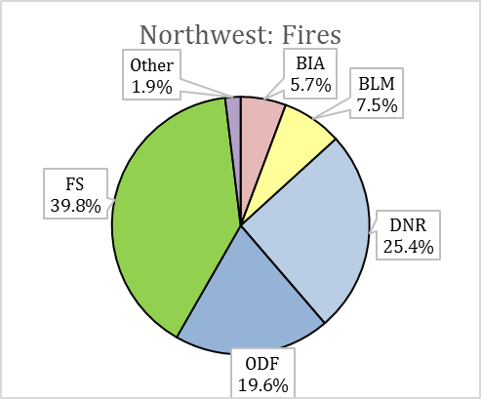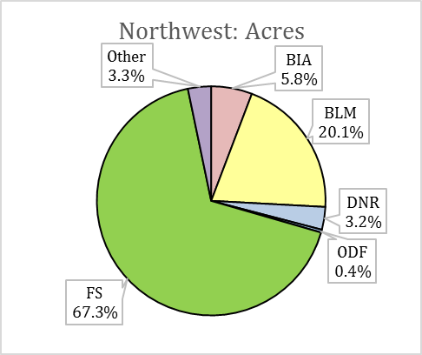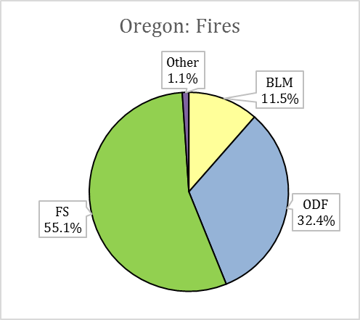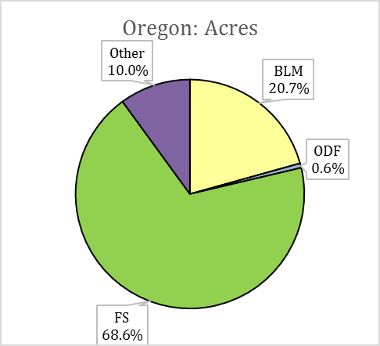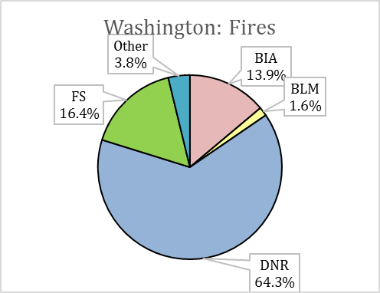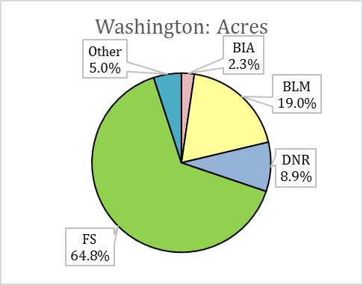

Figure 2. Total fires and acres burned in the Northwest, Oregon, and Washington by jurisdiction. Source: NWCC

In both agencies, lightning accounted for slightly over 60 percent of all starts in 2017 across the Northwest. Lightning started about 65 percent of fires originating on BLM managed lands in Oregon but only about 29 percent of fires in Washington. Similarly, lightning started 69 percent of fires originating on National Forest System lands in Oregon but only 20 percent of fires in Washington.

In Oregon, fire starts on all jurisdictions spiked during four periods – late June, late July, early August, and early September (Figure 3A). The greatest number of fires ignited on August 10, with 86 (out of 108) fires caused by lightning. Washington saw minor spikes in fire starts in late June, early July, and mid-July (Figure 3B). In both states, the number of human-caused fires was relatively steady through the summer with an average of 10 per day across the region during the summer months.

B

A.

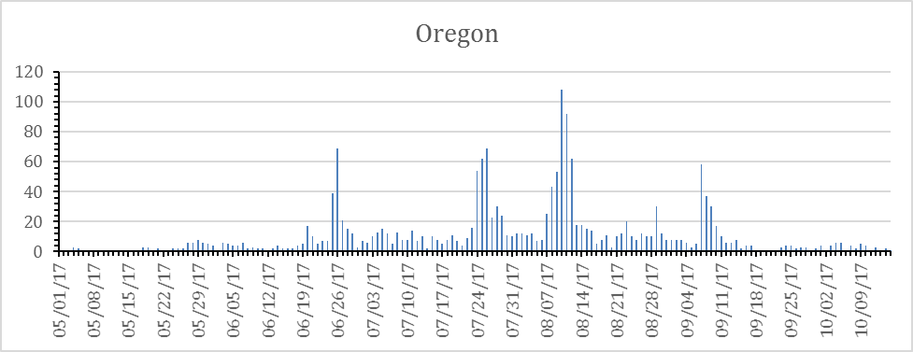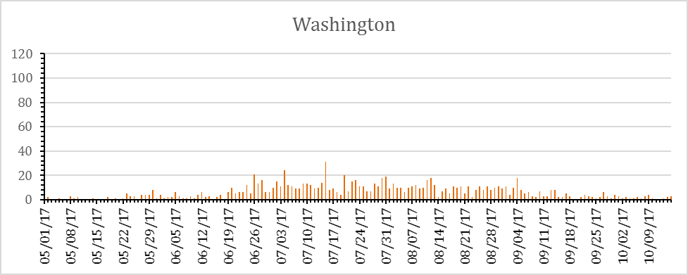

Figure 3. The number of fires started each day in Oregon (A) and Washington (B) across all jurisdictions. Source: NWCC

## Large Fires

A large fire is one that burns at least 100 acres in forests or 300 acres in grass, shrubs, or shrub-steppe (often referred to as “rangelands”). While there were one or two large fires as early as late May, the number of large fires burning simultaneously began increasing in late June and increased rapidly in August. Large fire occurrences peaked at 38 large fires on September 11-12. By the end of October, 12 large fires were still active.

Managing large fires typically requires a large number of firefighting personnel and other firefighting resources. More personnel are needed to manage large fires in forests than in rangelands due to the types of fuels involved, typical fire behavior and the overall duration of large forest fires. A long duration rangeland fire typically lasts for about 2 weeks whereas a long duration forest fire typically lasts for several weeks to several months. The number of personnel assigned to large fires in the Northwest increased in August and peaked on September 4 with over 10,000 people assigned (Figure 4).

Figure 4. The number of people assigned to large fires occurred as early as late May with low numbers assigned until late July, when the number assigned increased rapidly due to the rapid escalation of fire growth. Source: NWCC

Large fires use incident management teams (IMTs) to:

* Order and assign firefighting resources to specific locations on each fire in order to perform specific tasks (Operations),
* Develop daily plans for managing the fire, order and release firefighting resources (Plans),
* Track and report costs and claims (Finance), and
* Provide the infrastructure needed for the fire and the firefighters such as communications, food, sanitation, transportation to and from the fireline, showers, and other supplies (Logistics).

In addition, IMT information officers gather, draft and publish fire updates and fire information for the media and the public. As fire representatives, they are the primary source of fire information and updates. They work to disseminate information to the media and the affected communities through traditional print media and through social media channels (Fire Information).

Incident management teams are categorized as Type 1 and Type 2. Type 1 IMTs usually handle the more strategically difficult fires, including “fire complexes,” or multiple fires located in the same general area that become managed as one incident. Occasionally fires are large enough to require multiple incident management teams, such as on the Chetco Bar Fire. The number of Type 2 IMTs assigned to Northwest fires peaked at 10 teams on September 3 and 19 (Figure 5). The number of Type 1 IMTs peaked at 7 between September 5 and 10. The largest number of IMTs, both Type 1 and 2, assigned at any one time was 17 on August 15th, with many of these teams managing complexes and multiple incidents. Many of the large fires on the Forest Service used both Type 1 and Type 2 incident management teams, with multiple teams required over the duration of the fire. In contrast, most large fires that affected BLM required only a single Type 2 incident management team due to the generally short duration of rangeland fires.

Figure 5. The daily number of Type 1 and Type 2 incident management teams assigned to large fires in the Northwest across all jurisdictions. Source: NWCC

Large forest fires tend to last a long time before they are contained or controlled as compared to rangeland fires. Most often, fires that start early (May and June) or late in the season (mid-September and later) are relatively short duration while those that start in the middle of fire season (July, August and early September) tend to last longer. In large part, these differences are due to the warmer and drier fuels and weather conditions, as well as the frequency of weather events that start and spread fires. Day length and sun angle can also play a role late in the fire season as the peak burning period becomes shorter and sheltered areas do not dry out as quickly after rainstorms. However, even a forest fire starting at the peak of fire season can appear to be short-duration if another fire overtakes it. When that happens, the smaller fire ends and is absorbed into the larger fire.

Figure 6 illustrates the duration of several selected large wildfires in 2017. Sutherland Canyon, Straight Hollow, Ana, Hawk, and Cinder Butte were all rangeland fires that started on BLM managed lands. Hawk depicts one extreme of large fire duration, lasting only three days. In contrast, Indian Creek Fire was already a long-duration fire when it merged with Eagle Creek Fire. Some of the longest lasting fires were Abney, Ollalie Lookout, Milli, Norse Peak, Burnt Peak, Knox, Happy Dog, and Brokentooth, all of which were fires that started on National Forest System lands.

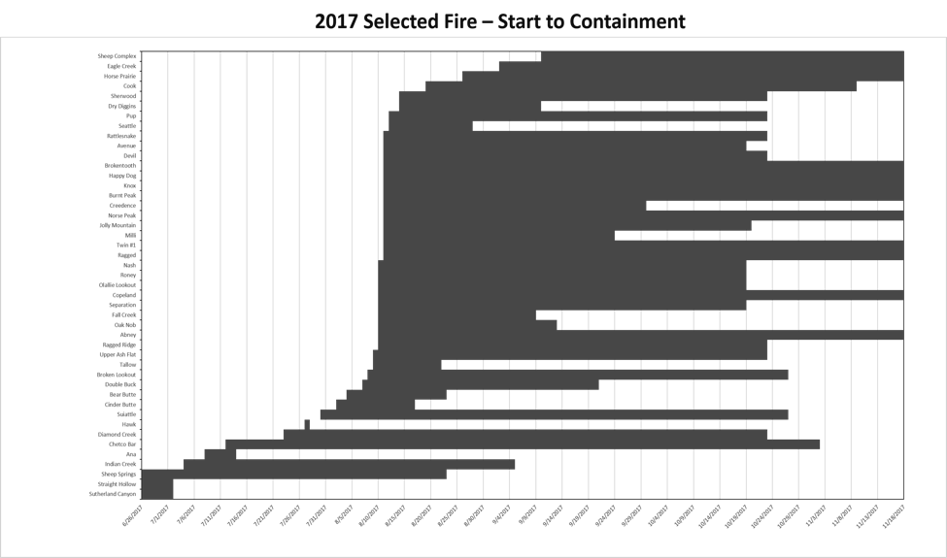

Figure 6. The duration of several 2017 fires in Oregon and Washington from start date to containment date.

## Aviation: Smokejumper, Rappel, Airtanker Bases, UAS

## Region 6 Smokejumpers

## The North Cascades Smokejumper Base and the Redmond Smokejumper Base are the two active smokejumper programs in the Pacific Northwest. There were 72 smoke jumpers in the region in 2017 that had a total of 1,163 jumps (training and fire) to staff 61 different fires. Nationally, there were 287 Forest Service Smokejumpers located across seven bases. Nationally, there were 6 minor and 4 serious injuries reported in 2017. The 2017 injury rates are significantly lower than the 25-year average. What about regionally?

## Fire overhead/ single resource assignments

The Pacific Northwest smokejumper programs provided an incredible amount of miscellaneous overhead in 2017. Redmond Smokejumpers filled 58 single resources assignments totaling 770 person days. The 770 person days were 53% of the Redmond Smokejumpers’ fire suppression activities in 2017. The North Cascades Smokejumper Base provided assistance to incident management teams on 17 separate large fires through 29 single resource assignments and provided training opportunities in SOF2, LTAN, ICT3, DIVS, TFLD, and CRWB positions.

Rappel Program

The Pacific Northwest is home to 5 rappel programs. This year, the Sled Springs and Blue Mountain rappel programs were consolidated/combined in 2017 to create the La Grande Rappel Crew. In total, Pacific Northwest Rappellers were delivered to 136 initial fires, 8 extended attack rappels (in remote locations), and were aerially delivered to 40 helitack fires where rappelling wasn’t required. The rappel program flew 1600 flight hours on large fire support (buckets, long line work, passenger transport) in support of 164 different fires.

Air Tanker Bases

In 2017, large airtankers delivered 4,813,055 gallons of retardant in total, with 3,464,317 dropped on USFS and BLM land.

Klamath Falls Airtanker Base

The Klamath ATB supported four different agencies in fighting 32 wildland fires. Flying from Klamath Falls, 37 different airtankers delivered 273 loads of 608,177 total gallons of retardant. August 1 was the busiest day for the Klamath Falls Airtanker Base. They delivered 30 loads for 82,534 gallons to the July Complex and Devils Lake fires. The Klamath ATB , 78% of retardant delivered in 2017 went to USFS fires and 17% to BLM fires. 62% of all retardant use went to Region 5, primarily the Modoc NF. Note that the 20 year average shows Region 5 consistently a greater customer than Region 6. In 2017 there was a significant decrease in state use compared to the 20-year average.

Redmond Airtanker Base

The Redmond ATB supported seven different agencies in fighting 85 wildland fires. Flying from Redmond, 27 different air tankers carried 691 loads and dropped over 1,689,492 gallons of fire retardant, an all-time record for the base (for comparison, 400,072 gallons were dropped in 2016 and 726,833 in 2015). The T-10 airtanker was on contract from May 19th to October 29th and was one of the busiest Air tankers in the Federal fleet, accumulating a total of 226 flight hours. T-10 flew 285 sorties, and dropped over 854,000 gallons of retardant.

*Single Engine Air Tankers (SEATs)*

The Redmond Air Tanker Base also supported single engine air tankers (SEATs). These are mainly contracted by the Bureau of Land Management and the Oregon Department of Forestry (O.D.F.). This season, 12 different SEATs operated out of Redmond. They supported 5 agencies, fighting 21 wildland fires. They carried out 155 loads of retardant, totaling 111,768 gallons. They flew approximately 137 Hours out of the Redmond ATB.calcul

*Air Attack*

The Redmond air tanker base was also the designated home for the Central Oregon Fire Management CCOFMS) Air Attack platform. This aircraft, its pilot, and the Air Tactical Group Supervisor (ATGS), provided critical support to many fire and aviation operations. The Air Attack platform was stationed at the base from June 1st to September 30th, 122 days. In 2017, it flew on 117 different fires, and acquired 296.1 Flight Hours. This is well above the yearly average of 35 fires and 122 Flight Hours.

*Full Service Retardant Contract*

In 2017, the crew pumped 691 loads, for 1,689,492 gallons of retardant. This total is almost exactly our ten year average of 700,000 gallons plus an extra one million gallons! The contract ran from June 1st to October 15th. In addition to the large number of gallons, the number of days we pumped retardant was significant. Of the 137 contract days, we pumped at least one load of retardant on 68 days. About once every 2 days, (50%).

La Grande Airtanker Base

The La Grande ATB supported 196 missions on 53 different fires delivering a total of 283,834. La Grande ATB supported fires with retardant with 129 SEAT loads and 67 Large Air Tanker loads. La Grande ATB experienced it’s busiest days on July 29 when two heavy air tankers and two SEATs flew 12 loads for 25,845 gallons, and on August 4 when six heavy air tankers and two seats flew 47 loads for 73,243 gallons.

UAS Program

The Bureau of Land Management’s (BLM) inaugural year for the Unmanned Aircraft Systems (UAS) program was 2017, with 70 pilots trained and 2,821 flights nationally. Ten of those newly trained operators trained are OR/WA BLM employees who flew ~60 hours. UAS is a useful tool for strategic and tactical planning for a variety of tasks including large fire support, fire investigations, mapping, and reconnaissance. Nationwide there were 677 flights in support of fire operations.

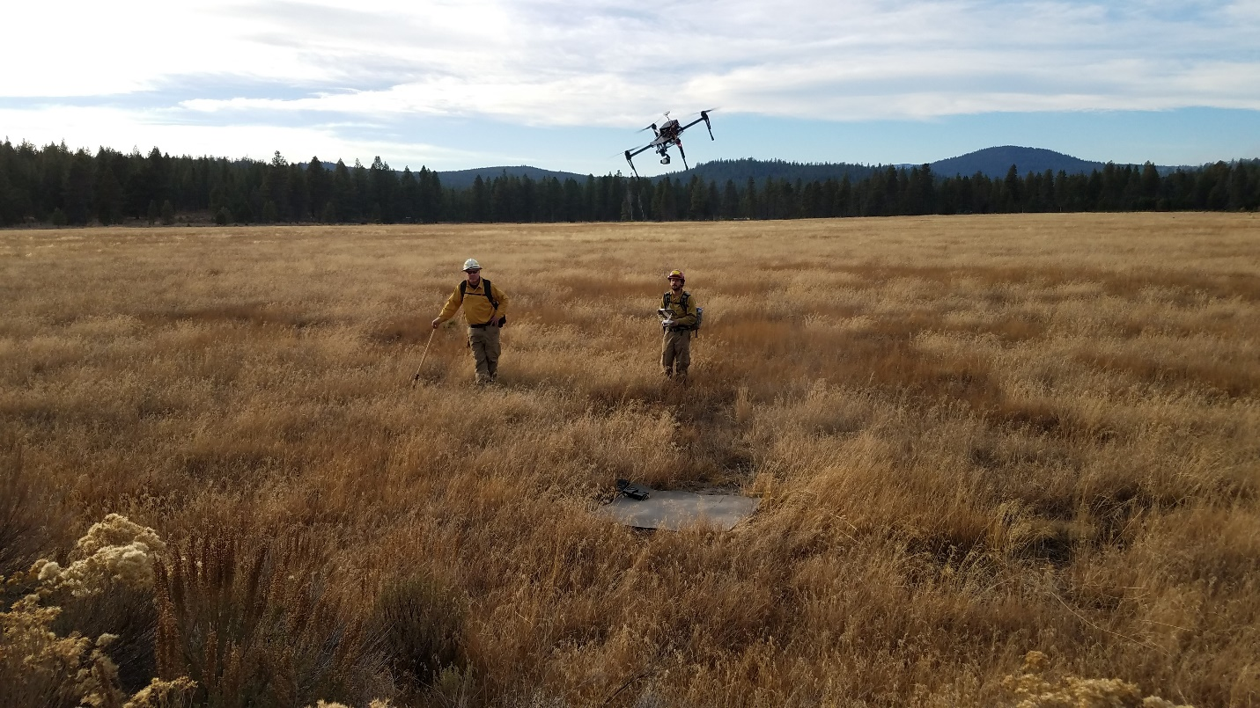

Researchers studying fire patterns during a prescribed fire at the Sycan Marsh on October 18, 2017.



The BLM’s drone program manager, Gil Dustin, flies a 3DR Solo quadcopter equipped with a GoPro 4 camera, May 18, 2017, at the Horning Seed Orchard in Clackamas County. Photo by Matt Christenson, BLM

## Large Fire Costs

Out of the 3,404 wildfires the Northwest experienced, 126 large fires resulted in most of the costs. Based on data reported on ICS-209 forms and agency financial systems, the Forest Service and BLM collectively spent nearly $600 million dollars in direct suppression and emergency stabilization costs in 2017. That cost does not account for the direct costs between containment and control, indirect costs to the agencies for bringing in additional firefighting resources to fill in when the home unit resources were already committed to wildfires. Nor does it account for the costs to local, state, and county agencies, or for costs to businesses and homeowners, or health-related expense caused by wildfires.

The Forest Service costs were much greater than BLM costs, largely due to the number of people and the much longer duration of forest fires as compared to rangeland fires. Based on date in ICS-209 forms, the Forest Service spent an estimated $497 million dollars with most of that spend on fires in Oregon (over $420 million). Based on data in the financial system as of September 27, 2017, BLM spent an estimated $30 million with most of that spent on Oregon fires as well. It was the rare fire in BLM that cost more than $500,000 while in the Forest Service, it was the rare fire that cost less than $500,000.

## Preparedness Levels

Preparedness levels indicate the severity of fuel and weather conditions, level of fire activity, and the availability of firefighting resources. The Northwest Coordination Group (NWCG) sets the preparedness level for the Northwest while the National Multi-Agency Coordination Group (NMAC) sets the national preparedness level each day throughout the year. As preparedness level increases, more federal and state employees become available to assist in firefighting efforts. In addition, resources from other parts of the country not experiencing wildfires are more likely to be ordered to regions where fires are actively burning. During the 2017 fire season, crews, IMTs, and other resources from the eastern United States and Alaska came to Oregon and Washington. At higher preparedness levels, the Department of Defense may make military resources available, such as helicopters, aircraft that can be fitted with temporary retardant tanks, and crews from the Army and National Guard.

On average, the Northwest slowly rises from PL1 to a peak at PL3 or PL4 (average is PL3.6) in mid-August, and then slowly falls back to PL1 by early October. Preparedness level in 2017 rose to PL2 in late June, about two weeks earlier than usual and reached PL3 by mid-July, about one month earlier than is typical (Figure 7). The Northwest reached PL4 about the same time it normally reaches PL3 and only 8 days later moved to PL5 on August 12, remaining there a record 40 days, until September 21. After that, the Northwest began dropping preparedness levels relatively quickly, returning to PL1 by October 21. For comparison, in 2015, the Northwest moved to PL5 on August 13, but remained there for only 23 days before dropping back to PL4 on September 5 and to PL1 by October 9.

Figure 7. Preparedness levels in 2017 (bars) as compared to the 10-year average (line). Source: NWCC

Nationally, the preparedness level reached PL4 on July 9 and PL5 on August 10. The national level remained at PL5 for 39 days, dropping back to PL4 on September 18 and PL1 on October 31. In addition to high activity in the Northwest, the Northern Rockies, Northern California, and the Great Basin had high fire activity with the great demand for firefighting resources.

Fireline Injuries and Illnesses

The Pacific Northwest had a total of 199 reportable injuries and illnesses involving Forest Service and BLM personnel associated with fire operations. Between May 1 and November, the BLM had 51 injuries or illnesses and the USFS had 148. Some of the major injuries involve bees, ticks and insect bites that required medical attention. Fireline injuries to the ankles and knees and lower back were also common. Multiple eye injuries were recorded that involving ash, organic material or insects. Exposure to poison oak to chemicals and toxins in wildland-urban interface were also notable. The USFS and BLM recorded only a handful of heat related illnesses in 2017.

The numbers recorded above will differ from the numbers recorded in the Appendices for individual fires. The numbers above are for agency personnel while the numbers in the fire profiles appendices also account for injuries to other interagency or contract personnel that occurred on fires that were in BLM or USFS jurisdictions (paycodes?).

Facilitated Learning Analysis

Facilitated Learning Analysis (FLA)are interagency reports developed by the Wildland Fire Lessons Learned Center after an incident, accident, or near miss with the goal of developing and nurturing a high reliability organization through a learning culture. With a commitment to learning rather than blaming, FLAs reinforcing high reliability by taking a hard look at near misses within the wildland fire community. The intent of a Facilitated Learning Analysis (FLA) is to improve performance by capitalizing on the shared experiences of participants. A learning culture sees unintended outcomes as valued opportunities to learn and grow and be better, more reliable tomorrow. How an agency responds to an accident is enormously important. In 2017, the Wildland Fire Lessons Learned Center developed 3 FLAs for accidents and near misses in Oregon and Washington and developed. They are

* ~~June 19- USFS vehicle struck a power pole returning from a recently burned unit~~
* July 16- FLA for motor vehicle accident in Washington
* ~~August 4- RLS for heat related illness on Devils Lake Fire~~
* ~~August 1- RLS for a tree strike, Devils Lake Fire~~
* August 18- FLA for entrapment near miss, Chetco Bar Fire
* August 27- FLA for engine rollover with serious injury, Miller Complex
* ~~August 30- RLS Whitewater Fire heavy equpiment strikes tree~~
* ~~August 30- RLS Whitewater Fire spider bites~~
* ~~September 2- RLS for tree strike, Jade Creek Fire~~
* ~~September 3- RLS for tree strike, Whitewater Fire~~
* ~~September 6- RLS for a dozer tip over, Avenue Fire~~
* ~~September 6- RLS for CPR success, Chetco Bar Fire~~
* ~~September 26- RLS for engine wheel stud malfunction~~

All of the FLAs and RLSs can be access via the Wildland Fire Lessons Learned Center website.

CISM Response

Critical Incident Stress Management (CISM) is a comprehensive, integrated, systematic, and multi-tactic crisis intervention approach to manage stress after traumatic events. CISM is a coordinated program of tactics designed to alleviate negative reactions to traumatic experiences.

Critical Incidents are unusually challenging events that have the potential to create significant human distress and can overwhelm the usual coping mechanisms of an individual or group. They are typically sudden, powerful, traumatic events, which are outside the range of ordinary human experiences that initiate a crisis response. Personnel may experience a critical incident as a result of a line of duty death, off-duty death, or serious accident or injury. The effects of traumatic stress are best prevented and mitigated through the use of Critical Incident Stress Management. The use of CISM increases health, morale, and productivity. It may decrease posttraumatic stress disorder, acute stress disorder, and other adverse effects.

In 2017, the Pacific Northwest responded to five CISM requests.

* Non-fire employee involved in motor vehicle accident that resulted in a public fatality
* Engine rollover with injuries on the Miller Complex
* Non-fire personnel assigned to the Miller Complex experienced the death of a family member
* Incident involving several fire personnel and local district personnel who were involved in the resuscitation attempts were a member of the public suffered a fatal heart attack
* Non-fire incident: bereavement after the loss of an off duty fire employee

## Structures Lost

The Northwest does not have a history of losing structures in wildfires, but in recent years that has begun to change. Fortunately, it remains rare to lose a large number of structures in a single incident. Based on data reported in ICS-209 forms, 112 structures were lost in the Northwest, 61 in Oregon and 51 in Washington. Of these, 26 were single residences, 83 were minor structures (sheds, barns, etc.), and three were either mixed residential/commercial or nonresidential commercial structures. Twenty-nine of the 126 large fires burned structures. In Oregon, the greatest losses happened on the Chetco Bar Fire (6 residences, 24 minor structures); in Washington, the greatest losses happened on the Monument Hill Fire (3 residences, 20 minor structures).

Structures were lost on seven fires and two complexes that originated on National Forest System lands, with the greatest losses on the Chetco Bar Fire (30 structures); five of the structures were lost in Washington and 38 in Oregon. Four fires originating on BLM managed lands resulted in structure losses with the greatest losses on Cinder Butte Fire (four structures); one structure was lost in Washington and eight in Oregon.

## Evacuations

Large fires in 2017 seemed to have resulted in an unusually high number of evacuations, although this statistic is not formally tracked. Based on daily incident reports (form ICS-209) 42 of the 126 large fires had some level of evacuation. Evacuation levels can be thought of as a variation Ready, Set, GO!

Level 1: Get Ready- *residents should be aware that danger exists in the area*

Level 2: Get Set- *residents must be prepared to leave at a moment’s notice*

Level 3: Go – *residents should leave immediately*

Six large fires reached only Level 1 evacuation notices and six reached level 2. Thirty-six fires reached Level 3 evacuations and several fires had Level 2 evacuations in some areas and Level 3 in others. On seven of the fires that reached Level 3, the number of people evacuated was not recorded. On the remaining 29 fires, 8,858 people evacuated to friends or family, 512 sheltered in place, and 126 moved to temporary shelters. Chetco Bar Fire had the highest number of evacuations with 5,148 residents under Level 3. The next highest was Eagle Creek, with 1,822 people evacuated, including nearly the entire populations of Cascade Locks, Dodson, Warrendale, Bridal Veil, and Latourell.

## Other Season Statistics

* Number of ESF4 activations – none in Oregon and Washington
* Number of Conflagration Act activations (Oregon) – 5 (Nena Springs twice, Milli, Chetco Bar, Eagle Creek). Conflagration Act declared for Flounce Fire, but cancelled before mobilization occurred due to heavy rain.
* Number of Fire Service Mobilization Plan activations (Washington) – 21
* FEMA/Fire Management Assistance Grant requests:
  + Washington – 3 approved, 2 requested and later withdrawn
  + Oregon – 4 approved (Milli, Chetco Bar, Eagle Creek, Pipeline)
* National Guard mobilizations –
* Active duty military mobilizations – 245 soldiers from Joint Base Lewis-McCord (Umpqua North Complex, High Cascades Complex, Elephant Fire)