## Appendix B: Central Cascades (Umpqua, Willamette, and Deschutes National Forests, Roseburg BLM)

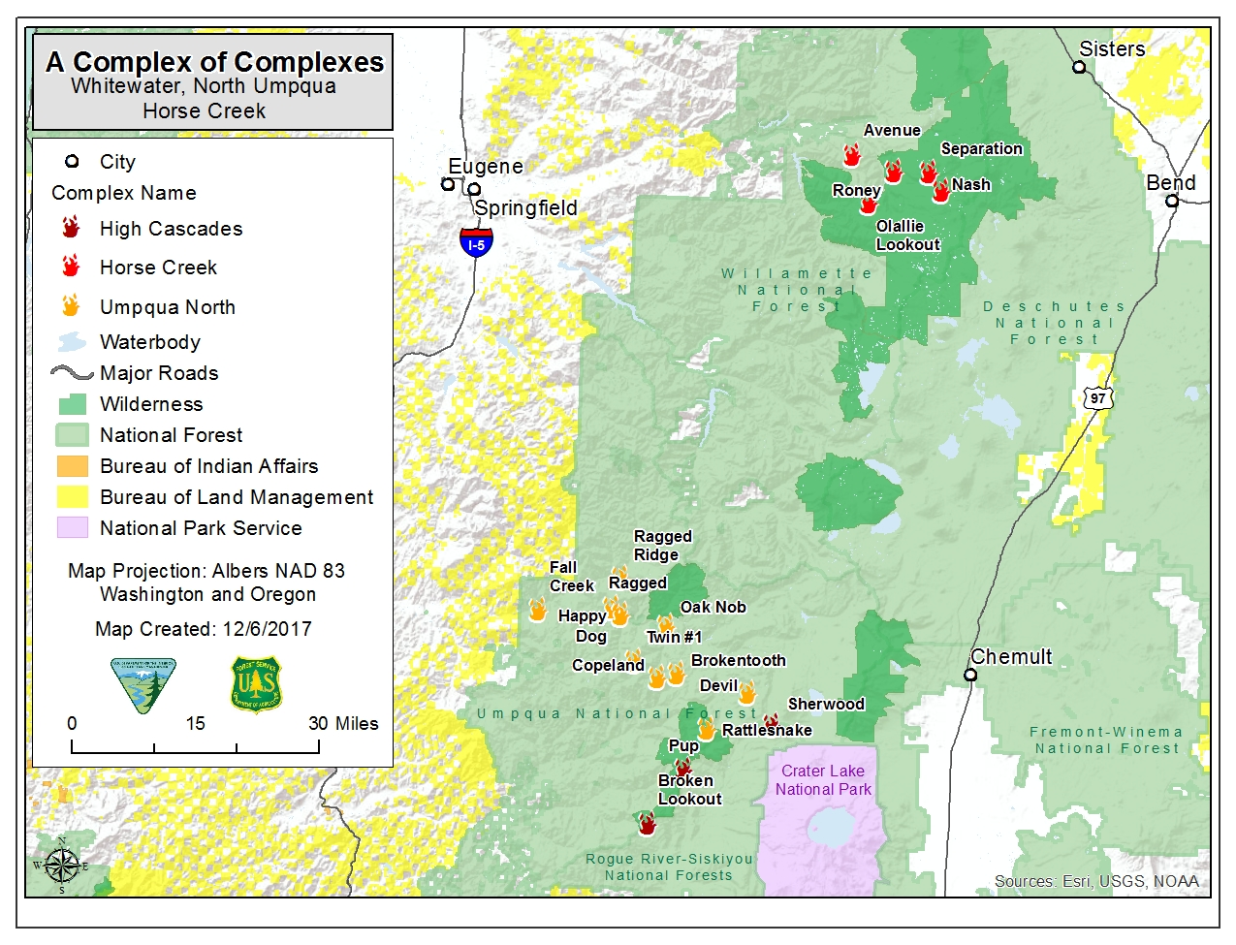

### Sheep Springs

|  |  |
| --- | --- |
| Date of Ignition | June 26, 2017 |
| Cause | Lightning |
| Containment |  |
| Land Ownership at Ignition Point | Deschutes National Forest |
| Preparedness Level at Time of Ignition | National: PL 2  Regional: PL 2 |
| Fire Size | 696 acres |
| Estimated Cost | $780,000 |
| Land Jurisdictions Affected | National Forest |
| Resources at Incident Peak | 180 Personnel  7 Crews  11 Engines  2 Water Tenders  1 Helicopter  2 Heavy Equipment |
| Injuries |  |
| Structures Destroyed | 0 |
| Cooperators | Forest Service, Oregon Department of Forestry |

**June 26-27**

The Sheep Springs Fire started from a lightning strike in the early morning of June 26. The fire ignited in an area with abundant snags that had burned in the 2003 B&B Complex. An Oregon Department of Forestry engine responded on June 27 and recommended using an indirect attack strategy due to the number of snags, the hot and dry conditions, and increasing winds. Firefighters began preparing an indirect fireline for use in burn out operations to contain the fire.

**June 28-29**

A Type 3 incident management team assumed operational control of the fire on June 28. The fire grew over this two-day period from 10 acres to an estimated 20 acres, spreading slowly but steadily in the B&B fire scar. Smoke impacts in the Metolius Basin reminded locals of the B&B Complex, making the rapport with the community a management concern along with public and firefighter safety.

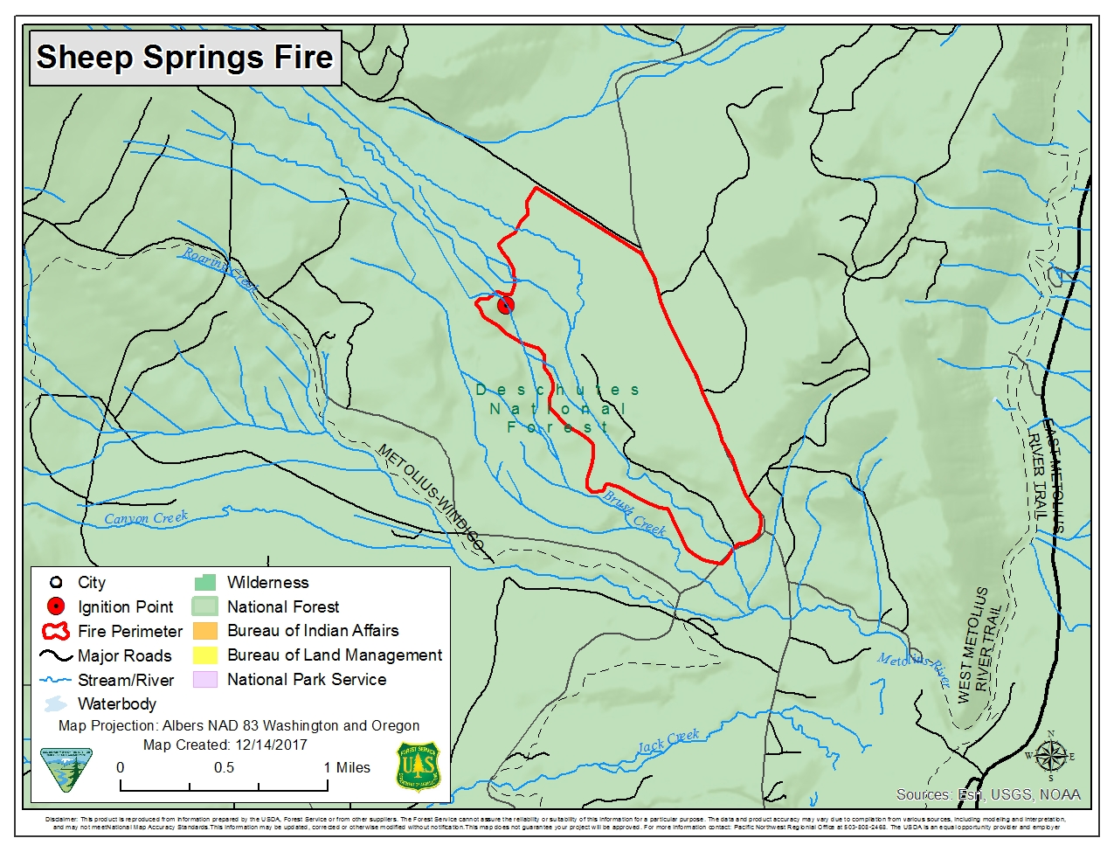**June 30**

Current and planned burn out operations increased the fire size to an estimated 750 acres, although the burn out operations were not yet complete. The fire rated as 50 percent contained due to the combination of completed fireline, level of completed burn out, and the continued slow spread of the main fire. Mop-up began on parts of the burn out area to make sure the fire would not spread beyond the established control lines.

**July 1-2**

Better mapping reduced the fire size to 696 acres. Burn out operations were completed by July 2, and mop-up and patrolling began to ensure the fire stayed within the established perimeter. Spotting concerns across the firelines were a possibility from burning snags near the fireline.

**July 3-5 and beyond**

Management of the fire was transferred back to the Ranger District on the morning of July 3 and most of the crews and engines sent back to their home units. Mop-up of remaining hot-spots along the perimeter and patrolling of the firelines continued for some time after July 5 before the fire was considered fully contained. Mop-up did not occur in the fire interior due to the safety threat of all the snags. As a result, the fire was checked regularly until the District was certain that it would not spread beyond the control lines. The estimated full containment date was July 31, although effectively occurred earlier than that date.

**Significance**

Oregon Department of Forestry has a reputation for very aggressive tactics on wildfires with a preference for direct attack strategies and tactics. Since an Oregon Department of Forestry engine was first on the scene, the engine captain was the initial incident commander. However, that person readily recognized the high safety risks posed by the number of snags in the fire area and initiated an indirect attack strategy to contain the fire.

### Horse Prairie

|  |  |
| --- | --- |
| Date of Ignition | August 26, 2017 |
| Cause | Human |
| Containment |  |
| Land Ownership at Ignition Point | Private |
| Preparedness Level at Time of Ignition | National: PL 5  Regional: PL 5 |
| Fire Size | 16,436 acres |
| Estimated Cost | $16,300,000 |
| Land Jurisdictions Affected | Private, BLM |
| Resources at Incident Peak | 1,099 Personnel  49 Crews  39 Engines  27 Water Tenders  8 Helicopters  13 Heavy Equipment |
| Structures Destroyed | 2 |
| Injuries |  |
| Cooperators | Bureau of Land Management, Forest Service, Cow Creek Tribe, Oregon Department of Forestry, Oregon National Guard, Oregon State Fire Marshall, Douglas County Sheriff, Tenmile Fire Department, Camas Valley Fire Department, Riddle Fire Department, Douglas Fire Protective Association, Local Timber Companies |

**August 26**

The Horse Prairie Fire started mid-afternoon on private lands under severe burning conditions – hot, dry, and with an unstable atmosphere. The fire exhibited extreme behavior almost from the moment of ignition, with tree torching, crowning runs, and rapid spread in the understory. Smoke affected residents along Highway 42 and Olalla Road immediately. The area of the fire start was a checkerboard of private timberlands and BLM-managed lands with commercial timber and late successional reserves. The initial responders included Oregon Department of Forestry, BLM, Tenmile Fire Department, Camas Valley Fire Department, and local timber companies. The fire grew to an estimated 425 acres in less than 12 hours.

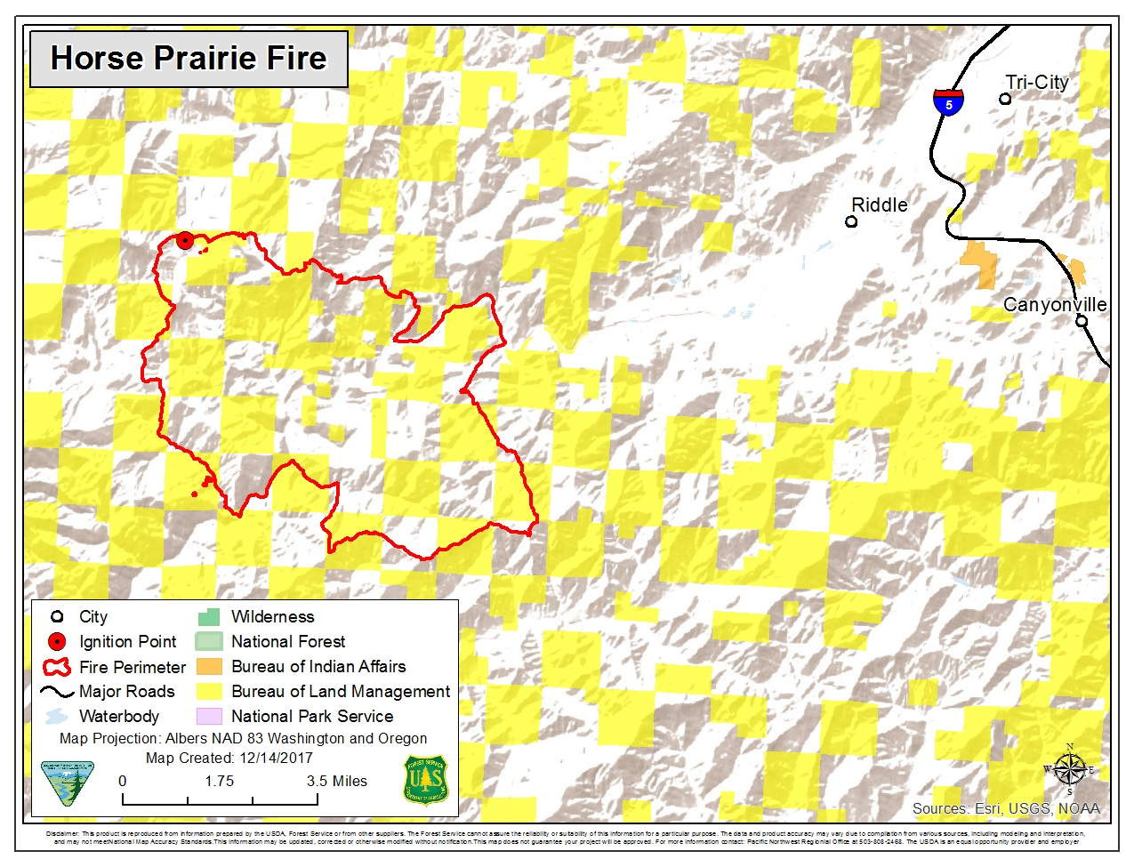

**August 27-September 1**

Morning inversions dampened fire spread in the mornings and also hampered air operations. Once the inversions lifted around midday or mid-afternoon, fire behavior picked up and the fire made significant runs, burning in recently felled timber, young Douglas-fir plantations, and older Douglas-fir forests on both private and public lands. It quickly began moving into steeper, more rugged terrain, contributing to control difficulties and prompting the use of indirect suppression tactics. Rapid spread and the values at risk resulted in rating Horse Prairie as a high priority fire. However, severe regional and national resource shortages made it difficult for the team to receive the resources requested.

Smoke from the fire affected residents along Highway 42 and Olalla Road as well as Roseburg and Winston. On August 28, the Douglas County Sheriff’s Office issued Level 2 evacuation orders for the area from the junction of Doe Creek Road and Cow Creek Road to the junction of Union Creek and Cow Creek Road. On August 29, the fire spotted across Cow Creek resulting in the Sheriff’s Office issuing Level 3 evacuation orders for Cow Creek Road between Union Creek-Cow Creek junction and Glenbrook Road. Roads on both public and private lands in and around the fire were closed to public use as a safety precaution. Crews from the Oregon National Guard also joined the firefighting efforts on August 29. By August 30, the fire was moving into ponderosa pine stands. On the positive side, control lines on the north and northwest sides of the fire were holding and crews made good progress on line construction on the northeast side of the fire.

The fire was estimated at 11,500 acres on August 31 with 39 crews and 34 engines assigned to the fire. While the fire size continued in increase, much of that increase was now due to burn out operations on the western side of the fire that tied the fireline into Cow Creek. Mop-up progressed on the northwest, north, and northeast sides and beginning on the western side. A wind shift helped to push smoke away from nearby communities, providing some relief. By September 1, fire spread was slowing as firefighters gained the upper hand. All established lines continued to hold. Structure protection efforts around the residences on Cow Creek continued. Crews began preparing contingency lines in case the forecast warming and drying conditions caused the fire to spot across control lines. The incident management team moved the incident base camp to a new location near Riddle.

**September 2-8**

Containment of the Horse Prairie Fire grew steadily through the period. By September 2, the fire had 49 crews and 39 engines assigned to it. The homes along Cow Creek Road were considered secure and mop-up continued on the cooler parts of the fire. Inversions, smoke, and excessive heat remained on-going problems, however. On September 3, the fire made downhill runs under north winds and smoke reduced visibility along Cow Creek Road to as little as 50 feet. Security at road closures increased due to the Labor Day holiday. On September 5, the high pressure system that had been affecting the fire began to break down, bringing more unstable conditions, shifting and gusty winds, and an increased risk of erratic fire behavior. Fire behavior was very active over the next two days with downhill runs, crowning, and spotting up to ½ mile. All resources focused on mopping up, gridding for spot fires, and felling all snags within 300 feet of the control lines. September 7 was the first day the fire did not increase in size as some rain fell with more expected. The Douglas Sheriff’s Office reduced the evacuation orders for Cow Creek Road to Level 1 as a result. On September 8, additional rain, cooler temperatures and higher relative humidity aided containment efforts.

**September 9-24**

Containment of the fire increased every day through the period, reaching 95 percent by September 18, and steady demobilization of firefighting resources began. The team used an unmanned aircraft system equipped with an infrared camera as well as handheld infrared cameras to locate hot spots. The Central Oregon Railroad line reopened on September 10. The team held a community meeting on September 12 at the Riddle Community Hall to discuss the fire and a legislative tour of the fire on September 14. The temporary bridge over Cow Creek was removed on September 13. A dry cold front moved over the fire on September 13, bringing gusty winds, and more seasonable temperatures and relative humidity. Command of the fire was transferred to a local type 3 incident commander on September 15. Of the 16,436 acres within the fire perimeter, 7,626 acres were managed by Roseburg BLM and 8,810 acres were managed by private timber companies.

**Significance**

Even though Horse Prairie was a relative small fire, the values at risk, especially private commercial timberlands, made this fire a high priority in the Northwest. As a result, this fire had as many crews and nearly as many engines assigned to it as the much larger Chetco Bar Fire.

### Whitewater

|  |  |
| --- | --- |
| Date of Ignition | July 23, 2017 |
| Cause | Lightning |
| Containment |  |
| Land Ownership at Ignition Point | Willamette National Forest |
| Preparedness Level at Time of Ignition | National: PL 4  Regional: PL 3 |
| Fire Size | 11,493 Whitewater Fire  14,451 complex total |
| Estimated Cost | $39,702,783.00 |
| Land Jurisdictions Affected | Forest Service |
| Resources at Incident Peak | 827 Total personnel  24 Crews  30 Engines  17 Water Tenders  5 Helicopters  19 Heavy Equipment |
| Structures destroyed | 0 |
| Cooperators | Forest Service, Bureau of Indian Affairs, Bureau of Land Management, National Park Service, Marion County Emergency Management, Oregon Department of Forestry, Linn County Sheriff, Marion County Sheriff, Washington State Department of Natural Resources |

Whitewater Fire was reported on July 23, and attributed to a holdover from a lightning strike about a month earlier. The fire was located in Mount Jefferson Wilderness, approximately three miles up the Whitewater Creek Trail, 20 miles east of Detroit, Oregon. A local Type 3 Team took charge of the 50-acre fire July 25.

Early efforts focused on full suppression with a light touch. The fire was burning inside the wilderness boundary and presented limited risk to private property and timber values. Located about four miles from the Whitewater Creek Trailhead, the fire was in a popular launching point for hikers into the wilderness area. Early on, local crews hiked 3 miles into the wilderness to begin suppression efforts and by July 26, the fire was estimated at 15% contained. Hand crews built fireline and helicopters dropped water to prevent the fire’s spread. Fire managers also used helicopters to fly in five pumps and thousands of feet of hose to get water to strengthen existing handlines. By July 27, over 85% of the fire had handline around the 80-acre fire, and the remaining 15% was located on inaccessible rocky cliff bands.

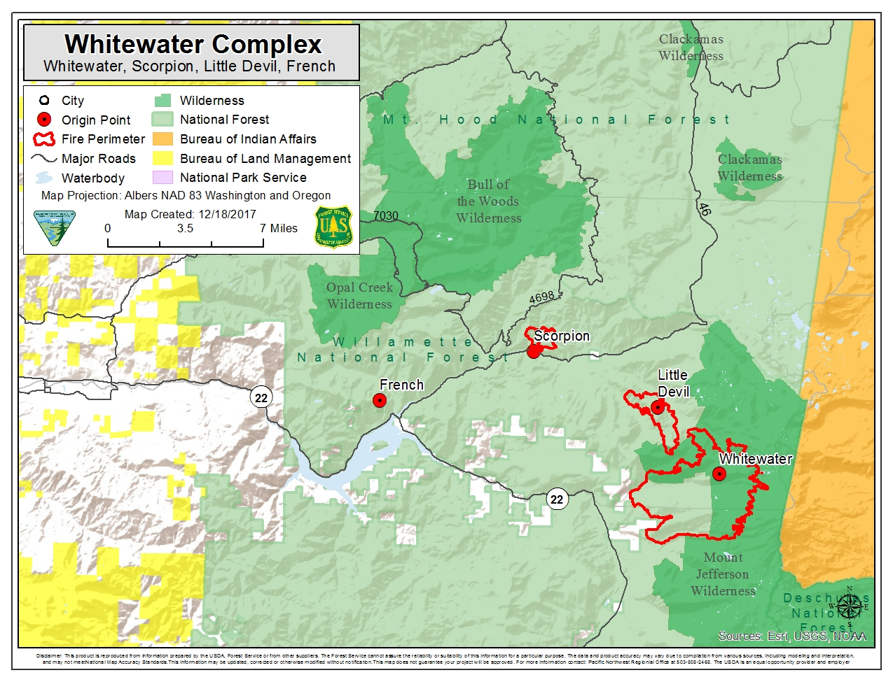On July 28, fire managers began to develop large scale contingency plans, including ordering heavy equipment to work on fuel reduction around the road systems next to Whitewater Creek outside of the Mount Jefferson Wilderness. At this time, Willamette forest managers ordered a Type-2 team based on forecasts for hotter, drier conditions, and an incident base camp was established at Hoodoo Ski Area. At this time, the fire was at 89 acres in size.

On July 31, the Type 2 team took command of the fire and the Willamette Forest Supervisor closed all trail access points into Jefferson Park inside the Mt. Jefferson Wilderness, including 11 miles of the Pacific Crest Trail. On August 1, the weather forecast was for very hot, dry and unstable conditions to the fire area for several days. The fire grew to 1,500 acres overnight, crossing out of the Mount Jefferson Wilderness near the Whitewater Trail and threatening 100 residences and 150 other structures. Rapid spread continued on August 2 to the west with the fire reaching an estimated 4,579 acres.

On August 3, a heavy smoke inversion tempered fire behavior and grounded aircraft due to low visibility. Dense smoke continued to cause problems for fire operations as well as affecting air quality in central Oregon generally on both sides of the Cascade crest. By August 5, the closure expanded to almost half of the Mount Jefferson Wilderness and 28 miles of the Pacific Crest Trail. On August 7, the area closure was expanded yet again to include 117,000 acres in the Mount Jefferson area. Crews used indirect tactics, constructing fireline away from the main fire and burning out to protect the identified values at risk from the fire.

August 10 brought thunderstorms to the fire area late in the day in the fire area. Two small lightning-caused fires from the storms were discovered on August 11 approximately three miles southeast of the Breitenbush Community on Devil’s Ridge in steep terrain. Aircraft were used to keep those fires in check. Crews constructed fireline around the smaller of the two fires on August 12, but the larger fire was in inaccessible, rocky terrain. For the next several days, crews continued to construct indirect line, burn it out, and hold it and supported initial attack operations on new starts in the Whitewater fire area. Light rain on August 13 aided firefighting efforts for a brief period, but unseasonably hot and dry conditions quickly returned. By mid-month, national and regional demand for firefighting resources was extremely high. On August 15, a Type 1 incident management team took over management of the fire and supported the Little Devil, French, Rebel, Avenue, and Box Canyon fires as well.

On August 21, during the eclipse, fire behavior decreased dramatically as temperatures dropped and relative humidity increased. On August 22, the team added Ollalie, Pete, Separation, and Roney fires to their responsibilities. East winds caused these fires to grow rapidly. On August 23, Horse Creek Complex was established to include Avenue Fire and Olallie, Separation, Roney fires. Due to the unavailability of additional incident management teams, the team for Whitewater and Little Devil also managed the Horse Creek Complex.

On August 27, a new Type 1 incident management team assumed command of Whitewater, Little Devil, and Rebel fires and the Horse Creek Complex. A red flag warning was in place on August 28 had for dry and unstable conditions and on that day, Scorpio Fire was detected at 30 acres north of Breitenbush. Potato Hill Fire was discovered at 50 acres on August 29. Crews continued to employ indirect tactics, but using direct attack when burning conditions and fire behavior permitted. Dense smoke hampered firefighting efforts on many days and affected air quality in communities to the west.

On September 19 the entire area saw heavy rain and mixed snow, effectively halting fire spread. Firefighting efforts then transitioned to suppression repair and retrieval of equipment. A local Type 3 team assumed management of the complex on September 27.

**Significance**

Whitewater Fire ignited in an area located within the 2017 solar eclipse path of totality. The fire would trigger an extensive area closure in a large stretch of public lands in a prime viewing location for hundreds of thousands of visitors. The smoke from Whitewater Fire along with multiple fires burning in the region at the same time would impact the quality of life of many people, and the recreation of thousands of visitors, and would impact the local economy in communities near Detroit Ranger District.

Although the number of structures threatened were far less than in other large fires in the region, the effects from the smoke, the impaired visibility, and the extensive area closure had a notable impact to many people this year in particular. A 1000-person hike to Mt. Jefferson to view the solar ellipse was cancelled, almost 28 miles of Pacific Crest Trail were closed, and an untold amount of people planning to camp or hike during the eclipse had to change their plans. This brought higher numbers of people towards coastal forests and towards central and eastern Oregon.

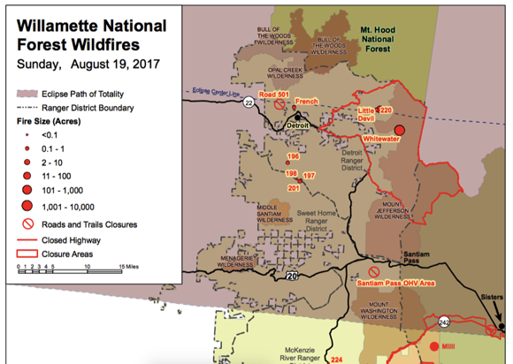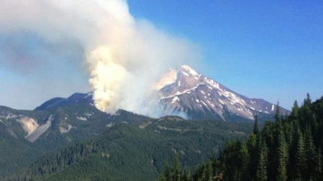

### Umpqua North Complex

|  |  |
| --- | --- |
| Date of Ignition | August 11, 2017 |
| Cause | Lightning |
| Land Ownership at Ignition Point | Umpqua National Forest |
| Preparedness Level at Time of Ignition | National: PL 5  Regional: PL 5 |
| Fire Size | Brokentooth -3,941 acres  Fall Creek - 4,827 acres  Oak Knob - 59 acres  Happy Dog - 31,141 acres  Devil - 874 acres  Copeland - 699 acres  Rattlesnake - 1,373 acres  #320 - 115 acres  4 other fires - 3 acres |
| Estimated Cost | $42,890,561 |
| Land Jurisdictions Affected | Forest Service, BLM, Private |
| Resources at Incident Peak | 1157 Personnel  29 Crews  84 Engines  27 Water Tenders  5 Helicopter  28 Heavy Equipment |
| Injuries |  |
| Structures Destroyed | 1 |
| Cooperators | Forest Service, Bureau of Land Management, Bureau of Indian Affairs, U.S. Fish and Wildlife Service, National Park Service, National Weather Service, Oregon Department of Forestry, Oregon Department of Transportation, Douglas County Sheriff, Douglas Forest Protective Association, PacifiCorp Energy, American Red Cross, Glide School District, Cow Creek Band of the Umpqua Tribe, U.S. Army |

**August 11-13**

Lightning started several fires on the North Umpqua Ranger District and began spreading rapidly under hot, dry, and windy conditions. The Forest Supervisor ordered a Type 1 team to manage the fires as a complex given the increasing scarcity of firefighting resources and the number of new starts across the region. A Type 1 team from Alaska was assigned to the complex of approximately 34 fires and given initial attack responsibility over 183,919 acres of the North Umpqua Ranger District on August 13. Several campgrounds were evacuated along Highway 138 and trailheads closed. The fires threatened the community of Dry Creek.

**August 14-20**

Fall Creek, Happy Dog, and Ragged Ridge fires quickly emerged as the main threats and the focus of much of the firefighting effort. The Douglas County Sheriff’s Office issued Level 3 evacuation orders for the Dry Creek community, resulting in the evacuation of 50 people, and Level 2 evacuation orders for Moore Hill Lane. Other values at risk included transmission and distribution lines, commerce and tourism on the Umpqua River, cultural and heritage resources, threatened and endangered species habitat for northern spotted owl and salmon, and recreation facilities such as trailheads and campgrounds.

Morning inversions with dense smoke hampered air operations on most days, but also dampened fire behavior until lifting around mid-afternoon. Once the inversions lifted, fire activity increased with fires spreading via spotting and rolling material. The fires remained active well into the night. Steep terrain created multiple concerns over access to existing and any new starts and firefighter safety given the number of fires included in the complex, the extent of rolling material, and limited escape routes and safety zones.

Happy Dog Fire burned 13 power poles on August 13 and begin burning through the Dry Creek community. A structure protection group was in place to protect the homes with both day and night shifts. On August 18, Happy Dog spotted across the North Umpqua River, soon posing threats to the Clearwater area and Steamboat as well as hampering access to the Calf Copeland cluster of fires. Fall Creek Fire spread primarily south and west, threatening to cross the National Forest boundary onto a checkerboard of BLM-managed lands and private lands. Several fires began merging together, such as Happy Dog and fires 396 and 397, as well as the cluster of fires around Brokentooth and Devil’s Canyon.

The team held a community meeting in Glide on August 15 to provide an update on the fires and firefighting efforts and to answer questions. Several campgrounds, trails, and recreation sites were closed. The Sheriff’s Office and Oregon State Marine Board closed the North Umpqua River between Boulder Creek and Susan Creek.

On August 16, the Sheriff’s Office initially lowered the evacuation level for Dry Creek to 2, but a rapid increase in fire behavior later in the afternoon, resulting in re-imposing Level 3 evacuation orders and expanding the area of coverage to include the Illahee area. By August 18, the Sheriff’s Office issued Level 1 evacuation orders for the Susan Creek residential area and for the Clearwater area on August 20 due to spotting and spot fire spread from Happy Dog and Fall Creek fires.

Rolling material onto the road promoted Oregon Department of Transportation to close the road shoulders and pullouts along Highway 138 between mileposts 31 to 35 and 45 to 50.5 and later to close the highway between mileposts 39 to 54 and use pilot cars to escort vehicles through the closure area. PacifiCorp deenergized the powerlines in the area as well.

**August 21-27**

Both Happy Dog and Fall Creek fires continued to move both east and west along Highway 138, threatening additional miles of highway corridor, transmission lines, and a hydroelectric power plant site. Ragged Ridge Fire was threatening an alternative confinement line to the north. The structure protection group was now also working several miles ahead of the fires developing protection plans for individual homes and structures. On August 21 and 22, Oregon Department of Transportation closed Highway 38 between mileposts 50 and 51 to all traffic, including firefighter traffic, due to dense smoke and debris falling on the highway, later expanding the closure to all but firefighting traffic between mileposts 43 and 54. The team held a community meeting in Glide on August 22 and in Tokatee on August 23 to update people on the status of the fires and answer questions. Although crews continued to make some progress on Fall Creek, Ragged Ridge, and Happy Dog fires, terrain and falling debris continued to limit firefighting efforts, especially in Devil’s Canyon. Moderating weather aided firefighting efforts, allowing firefighters to conduct some burning out operations to strengthen containment lines, especially on Fall Creek and Ragged Ridge fires. Firing operations were also used to help protect the PacifiCorp transmission lines, residences at Soda Springs and Slide Creek, the Fish Creek Power Plant, and Toketee Ranger Station. On August 26, the team established a 200-person camp east of the closure area on Highway 138 to facilitate firefighting efforts. Crews developed contingency lines by reopening roads, brushing out roads, and reestablishing old dozer lines used in previous fires.

By August 27, conditions became hotter and drier and fire activity increased. Happy Dog Fire spotted across Forest Road 28; the spot fire quickly grew to 30 acres. Mudd 2 and Brokentooth fires also crossed Forest Road 28 and spread rapidly to the southeast. Four new fires, likely holdover fires from the lightning event two weeks prior, popped up as well. An infrared flight on August 27 mapped 18,073 acres within the complex and revealed that Happy Dog and Ragged Ridge fires had joined north of Highway 138.

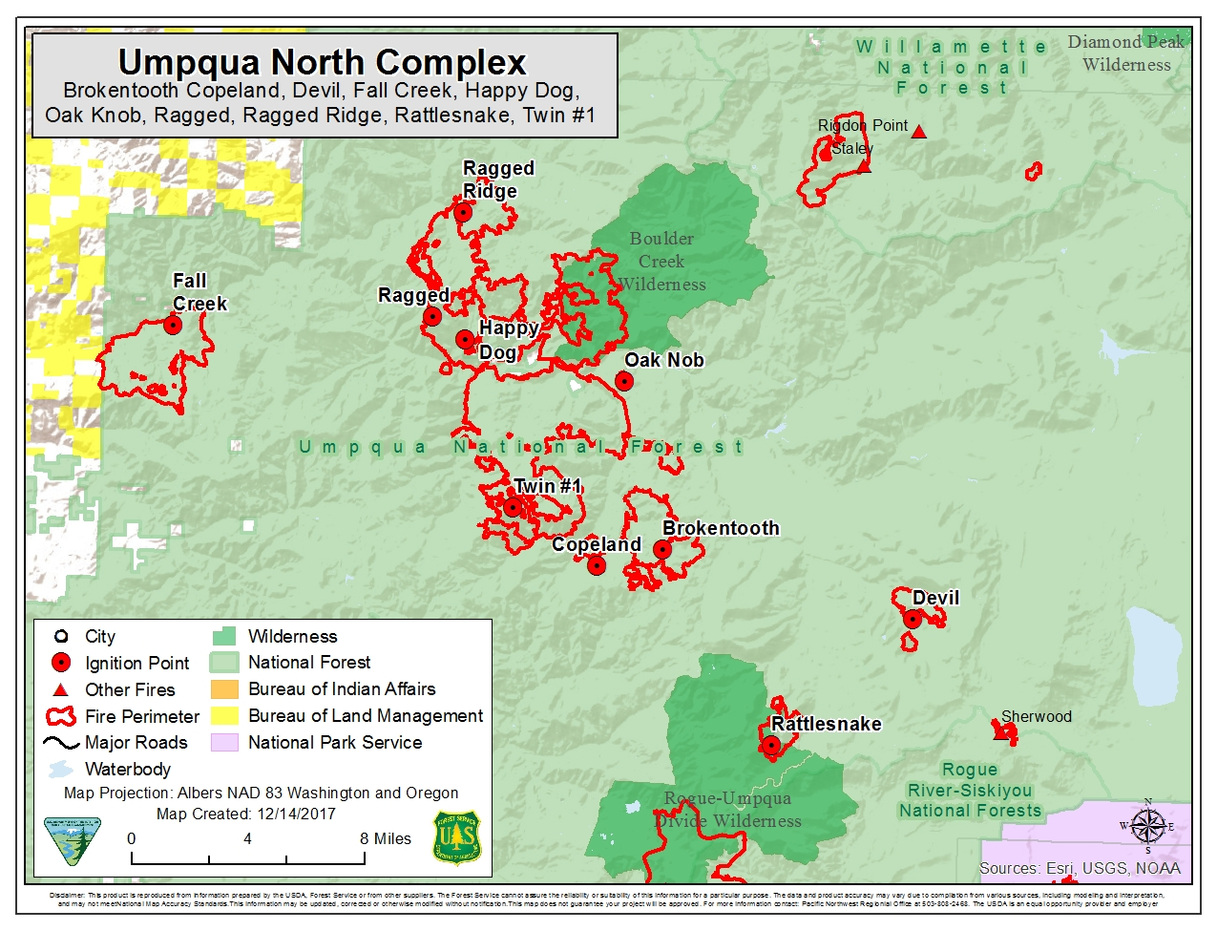

**August 28-September 3**

Severe burning conditions led to the widespread use of indirect suppression tactics such as construction of containment lines away from the fire edges followed by burning out and the construction of contingency lines in case the main containment lines did not hold. Spot fires, inversions, thermal trough passages, and dense smoke remained problematic throughout the week. By August 29, Happy Dog Fire began burning into other recent fire scars and crews worked to keep the fire from emerging from those burn scars. The Sheriff’s Office reduced the evacuation notice to Level 2 in the Dry Creek and Illahee areas and Highway 138 was reopened between mileposts 43 and 47, allowing those residents to return home on August 29.

The team held community meetings in Glide on August 30 and Tokatee Ranger Station on September 1. The Alaska Type 1 team transferred command of the complex to a California Type 1 team on September 1. The Sheriff’s Office also increased the evacuation order to Level 2 in the Slide Creek area on September 1. On September 2, the team used an unmanned aerial system to scout Rattlesnake Fire in the Rogue-Umpqua Divide Wilderness to assist in developing a management strategy for this fire and established a secondary fire camp at Diamond Lake to reduce drive times for firefighters.

**September 4-10**

Firing operations continued to contain the active fires in the complex. For example, crews burned out along Forest roads to tie Happy Dog and Brokentooth fires together since these fires seemed inclined to burn together anyway, and to keep Happy Dog Fire from burning additional areas along Highway 138. Air quality conditions prompted Oregon Department of Environmental Quality to issue an air quality alert for the area in and around the complex on September 4. Dense smoke continue to affect both the fire behavior and the ability to use helicopter bucket drops until the end of the week.

On September 4, the Sheriff’s Office lifted the Level 1 evacuation orders for Moore Hill Lane and Susan Creek area. Firefighters secured the Illahee area, allowing PacifiCorp to reenergize the transmission line. By September 7, cooler, moister conditions and some rain moved over the complex area, allowing firefighters to begin using direct attack tactics on portions of Happy Dog and Ragged Ridge fires. Oregon Department of Transportation reopened all of Highway 138 with pilot cars operating between mileposts 47 and 54. Rain fell on the complex on September 8 but also brought an estimated 186 lightning strikes in Douglas County. The team used an unmanned aerial system to scout southern boundary of Happy Dog Fire and Brokentooth Fire for access and to assess fire behavior. Suppression action was taken to check Rattlesnake Fire as it moved out of the wilderness with additional actions planned when firefighting resources are available.

On September 9, Soldiers of Task Force Spearhead, 1-2 Stryker Brigade Combat Team, 7th Infantry Division, Joint Base Lewis-McChord, Washington, completed their first day of training on the fireline. The following day, they began working on the Devil, Brokentooth and Ragged Ridge fires. Additional rain on the 9th aided suppression efforts. Fall Creek Fire was contained on September 10.

**September 11-17**

The team held a public meeting in Roseburg at the Umpqua National Forest headquarters on September 11. Crews began making significant progress in containing the more active fires across the complex. Dense smoke returned on September 12 as conditions dried and fire activity began to pick up. However, direct attack tactics became more viable across more and more of the complex as days shortened and more seasonable temperatures and relative humidity resumed. The main weather concerns changed to cold front passages.

Holding, mop-up, and suppression repair operations continued on inactive fires and less active portions of the main fires. Some rain fell on the Devil Fire on September 12 and scattered areas of the complex on September 13. Fire activity overall declined as fires or portions of fire moved into the mop-up phase and scattered rain and cloud cover kept temperatures lower and relative humidity higher. By September 13, the complex was an estimated 40,343 acres in size with Happy Dog the largest fire. The Umpqua National Forest reduced the extent of the area closure in the Cougar Bluffs area and reopened Fall Creek Trail on September 13.

A holdover fire in the Devil’s Canyon area popped up on September 16 and was quickly suppressed. Holding, mop-up, and patrolling continued on all fires, although increased fire activity was noted in the Eagle Rock area just north of Highway 138. Crews focused their efforts on the east side of the Happy Dog Fire, the west flank of the Brokentooth Fire, the north end of the Ragged Ridge Fire and the Highway 138 corridor. The California Type 1 team transferred command of the complex to a Great Basin Type 2 team on September 16 and the incident base camp was moved from Glide to the Diamond Lake area.

**September 18-October**

As much as 3 inches of rain and snow fell on the complex on September 18 and 19, allowing the firefighting efforts to switch to mop-up, patrol, suppression repair, and backhaul of all the equipment out on the firelines. Public use restrictions were lifted on September 19 and Highway 138 fully opened on September 20. By September 22, the Umpqua National Forest began reducing area, trail and road closures although some roads, trails, and campgrounds would remain closed until next spring. September 24 was the last day on the fireline for the soldiers of Task Force Spearhead, 7th Infantry Division, 23rd Brigade Engineering Battalion who handled multiple fire suppression and repair assignments on not only the Umpqua North Complex but also High Cascades Complex and Elephant Fire. Fallers worked with Oregon Department of Transportation to remove hazard trees along Highway 138 by September 25, which also resulted in resumption of pilot cars during falling operations.