## Appendix K: Air Quality and Smoke

The 2017 fire season had significant and lasting effects on air quality across the states of Oregon and Washington. Smoke resulted in a number of health impacts, often affecting even healthy people, as well as impairing visibility for a prolonged period. On the worst days, visibility was limited to less than one mile. Along with impacts to human health, dense smoke resulted in temporary road closures and required people to travel at reduced speeds when roads were open. The iconic volcanoes in the Cascades were largely invisible for much of the main tourism season. Smoke resulted in decreased tourism, adding to the economic impacts of the 2017 fire season.

### How is Air Quality Measured?

Air quality regulators and the federal agencies use the Air Quality Index (AQI) to characterize the impact of different concentrations of smoke on human health. The Environmental Protection Agency (EPA) developed the AQI to provide a simple indicator of the potential impacts of air pollution on human health. The AQI is based on the levels set particles 2.5 microns and smaller (PM2.5) and ozone. In the case of smoke, the pollutant of concern is PM2.5 (Table L-1).

Table L-1. Air Quality Index categories and their interpretation.

|  |  |  |
| --- | --- | --- |
| **AQI Category** | **24-hour PM2.5 concentration (ug/m3)** | **Meaning** |
| Good | 0-12 | Air pollution is considered satisfactory and poses little or no risk. |
| Moderate | 12.1-35.4 | Air quality is acceptable; however, for some pollutants there may be a moderate health concern for a very small number of people who are unusually sensitive to air pollution. |
| Unhealthy for Sensitive Groups | 35.5-55.4 | Members of sensitive groups may experience health effects. The general public is not likely to be affected. |
| Unhealthy (for everyone) | 55.5-150.4 | Everyone may begin to experience health effects; members of sensitive groups may experience more serious health effects. |
| Very Unhealthy | 150.5-250.4 | Health alert: everyone may experience more serious health effects. |
| Hazardous | 250.5-500 | Health warning of emergency conditions. The entire population is more likely to be affected. |

### Daytime vs. Nighttime Smoke Impacts

Smoke impacts may be worse during the day or during the night, depending on the speed, size, and complexity of fire spread, on atmospheric stability, and on the topography. Rapidly moving fires in heavy timber produce very high volumes of smoke. Typically, that smoke rises, gets carried by higher level winds and then to mixes to ground level some distance from the fire. In extreme cases, smoke from a large and rapidly spreading fire can affect the air quality in communities hundreds of miles away.

Warming temperatures during the day help create wind that moves smoke around. At night, temperatures tend to cool, winds die down and smoke starts to flow downhill and down drainages into valleys.

Topography can trap smoke into an area, particularly at night. Drainages that become wider for a short distance and then narrower tend to trap smoke in the small valley at night. A comparison of the air quality in Oakridge and Eugene illustrates how nighttime smoke can affect the air quality in one area of a river drainage, but not another. Both communities lie on the Middle Fork of the Willamette with Oakridge located within the Willamette National Forest and Eugene in the Willamette Valley. Air quality in Oakridge was Moderate or worse through most of August while Eugene had many days of Good air quality. Oakridge was affected by nighttime smoke from several fires in the central Cascades that became trapped in the small valley where Oakridge sits. That smoke never made it as far down as Eugene. The nighttime smoke concentrations grew worse as August continued, reaching Unhealthy or worse levels by August 27 while Eugene experienced a range of air quality, including several days when the air quality was Good. On August 3, air quality was worse in Eugene than in Oakridge, suggesting that Eugene had a greater impact from daytime smoke than Oakridge did. In early September, both locations were greatly affected by smoke as several complexes in the central Cascades experienced large growth.

Several locations in Oregon and Washington are well known for trapping smoke due to topography. Some of these are also designated as non-attainment areas under the Clean Air Act. In western Oregon, the Rogue River Valley and Oakridge are the best known smoke traps. Smoke can become trapped in the southern Willamette Valley as well, although it happens less often in the summer than in other locations. In eastern Oregon, Sisters, Bend, Klamath Falls, Lakeview, La Grande, John Day, and Burns can become smoke traps. The Dalles has the right topography to be a smoke trap, but is downstream from mostly grassland fuels that rarely create the same type of smoke problems as forest fuels. In Washington, the known smoke traps are in the eastern part of the state, largely because that is where the large fires typically occur. Well known smoke traps include Yakima, Leavenworth, Chelan, Wenatchee, Omak, Winthrop, Twisp, and Republic. Several communities in northeastern Washington might also be smoke traps, such as Metaline Falls and Kettle Falls, but typically do not experience frequent large fires in the area.

### Air Quality Summary

In Oregon, the air quality was generally Good until August, not clearing up in most places until mid-September when the rains came. Southwest Oregon, Central Oregon, and the southern Willamette Valley bore the brunt of poor air quality for prolonged periods. Air quality was the worse in Oregon between August 27 and September 8. September 6 was the single worst day with 31 of 39 monitoring sites reporting particulate levels high to enough to rate as Unhealthy or worse. Other widespread poor air quality days were August 28, September 3, and September 5.

In Washington, air quality was also mostly Good until August. In eastern Washington, air quality degraded to Moderate or worse over much of August and September, while in western Washington, air quality remained Good except for two periods in early August and early September. Air quality was worse in central Washington and the Spokane area than in other areas. Communities near the Canadian border, such as Omak, Twisp, and Winthrop had a number of Unhealthy days, fueled in part by the fires in British Columbia. Air quality across much of northern Washington, both west and east of the Cascades, saw a number of unhealthy air quality days in early to mid-August. In western Washington, the period of worst air quality was in August, likely due primarily to smoke from British Columbia. In eastern Washington, September 5 through 7 were the worst days with every reporting unit experiencing Unhealthy or Very Unhealthy air quality. Hazardous air quality was not measured at any location in Washington.

### Northwest Oregon

Northwest Oregon suffered from unhealthy air quality from early to mid-August and again in early September (Figure L-1). Smoke from four major complexes of fires in the central Cascades was the main culprit in the southern Willamette Valley. Smoke from wildfires in British Columbia reached the northern Willamette Valley in August, causing degraded air quality at that time. The Eagle Creek Fire in the Columbia River Gorge was responsible for Moderate to Very Unhealthy air quality in early September in Portland and the surrounding area.

Unhealthy air quality occurred over 1-2 days on August 2-3 over much of the Willamette Valley. The worst air quality occurred in the September 1-7 period, reaching Unhealthy and Very Unhealthy levels in much of the Valley, but quickly improving after that. However, September 16 was a day of Moderate to Unhealthy air quality in much of the area as well.

The southern Willamette Valley experienced more smoke than the northern Willamette Valley. Over the August-September period (61 days), approximately 1/3 of the days had Moderate or worse air quality in Cottage Grove, Eugene, Springfield, Oakridge, and Portland. Oakridge had 10 days with air quality rated as Unhealthy or worse, while Cottage Grove, Eugene, Springfield, and Sweet Home experienced 6-7 days with Unhealthy or worse air quality from smoke. In addition, Eugene, Springfield, and Oakridge had at least one day with air quality rated as Very Unhealthy. Oakridge had the fewest number of days with Good air quality in August and September, largely due to nighttime smoke impacts.

Figure L-1. Distribution of AQI categories through the summer for selected locations in Northwest Oregon.

### Southwest Oregon

Air quality in Southwest Oregon was degraded for most of the August-September period with the worst air quality occurring from mid-August through mid-September (Figure L-2). Air quality was rated Moderate or worse for 45 to 48 days in the Rogue River Valley, depending on location, and for 34 days in the Umpqua River Valley due to particulates from wildfire smoke. Eleven to 15 days reached Unhealthy or worse in the Rogue River Valley, with only five days so rated in the Umpqua River Valley. Ashland, Medford, and Provolt each had at least one day rated as Hazardous, where the air quality was considered dangerous for everyone.

The Rogue River Valley was essentially surrounded by wildfires burning in the Coast Range, Cascades, and northern California, along with some fires in the valley itself. Smoke reached the Rogue River Valley from Chetco Bar Fire and from the High Cascades and Miller complexes in Oregon. No matter which way the wind blew in much of August and September, it carried smoke from somewhere into the valley, with both daytime and nighttime smoke contributing to air quality problems. Provolt, Grants Pass, and Ashland had the highest number of days rated as Unhealthy to Hazardous, followed by Cave Junction. Surprisingly, the air quality in Medford reached Very Healthy only one day (September 6) and Unhealthy only twice (September 3 and 5). The Umpqua Basin was more fortunate in that most of their smoke came from fires burning in High Cascades and Umpqua North complexes. However, the late August-early September period still resulted in severely degraded air quality in Roseburg with September 3 reaching Very Unhealthy levels and a scattering of days rated Unhealthy before and after that.

Figure L-2. Distribution of AQI values through the summer for selected locations in Southwest Oregon.

### Central Oregon

Air quality in Central Oregon (the area from Klamath Falls to The Dalles) followed much the same trend as Southwest Oregon (Figure L-3). The entire area experienced Moderate air quality or worse for 30 to 48 days. Air quality deteriorated rapidly beginning in mid-August, especially for Sisters, Bend, and Klamath Falls, lasting until mid-September. Klamath Falls had the fewest number of days rated as Good air quality in the August-September period, but also the most number of days rated as Moderate. Prineville had the best air quality, relatively speaking, reaching no worse than Unhealthy for four days while Sisters had the worst air quality, reaching Hazardous levels on August 20 through 22. Klamath Falls, Bend, and Sisters were adversely affected by both daytime and nighttime smoke.

Poor air quality in central Oregon was largely due to large fires and multiple complexes in the central and southern Cascades. Milli Fire and the Horse Creek Complex affected Sisters and Bend while North Pelican sent smoke into Klamath Falls. Air quality in The Dalles was largely affected by the Eagle Creek Fire in early to mid-September, reaching Very Unhealthy levels on September 6 and Unhealthy levels for several days before and after that date.

Figure L-3. Distribution of AQI values through the summer for selected locations in Central Oregon.

### Northeast Oregon

The general lack of large wildfires in Northeast Oregon kept air quality from degrading severely for prolonged periods (Figure L-4). While air quality was rated as Moderate or worse for over a month, much of that time the air quality was Moderate. The number of days rated as Unhealthy or worse ranged from two to three days, concentrated over a four-day period between September 5 through September 8. Only Pendleton reached Very Unhealthy levels and for only one day on September 6.

Unlike in most years, the Blue Mountains experienced a relatively mild fire season, with few large fires. The most likely sources of the particulates that caused degraded air quality were smaller fires, and occasional smoke from wildfires in British Columbia, although blowing dust may have contributed to the Very Unhealthy day in Pendleton.

Figure L-4. Distribution of AQI categories through the summer for selected locations in Northeast Oregon.

### Southeast Oregon

As in Northeast Oregon, Southeast Oregon experienced a relatively benign fire season with respect to smoke, with few very large wildfires. Air Quality was Good to Moderate over most of the August-September period (Figure L-5). The worst air quality was two days of Unhealthy air in Burns on September 6 and 7.

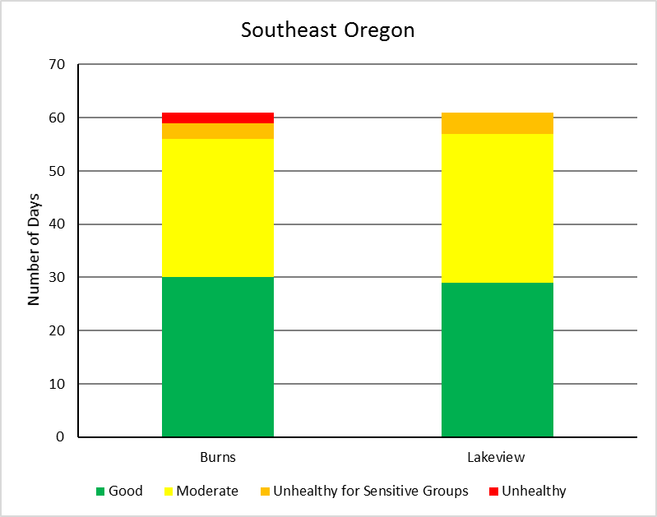Figure L-5. Distribution of AQI values through the summer for Burns and Lakeview.

### Western Washington

Air quality in Western Washington remained Good for most of the August-September period (41 to 56 of the 61 days, Figure L-6). Western Washington experienced two distinct periods of Moderate air quality or worse. The largest period was in early to mid-August. All but one sensor registered Moderate to Unhealthy air quality on August 2 and 3. For a short period between September 5 and 7, most sensors registered enough particulates to classify the air quality as Moderate to Very Unhealthy. Over the two-month period, North Bend had the worst air quality with 12 days rated as Unhealthy for Sensitive Groups or worse and the only location to report Very Unhealthy air quality (September 5). Cheeka Peak, Darrington, Kent, Puyallup, and the Seattle-Tacoma area had seven to eight days of Unhealthy for Sensitive Groups or Unhealthy air quality, mostly in early August.

Much of the smoke in August was likely from wildfires in British Columbia. Western Washington experienced a number of smaller fires that likely contributed as well, particularly in the Seattle-Tacoma area. Smoke from wildfires in eastern Washington, such as Norse Peak Fire, also likely affected western Washington to some degree through nighttime smoke. Vancouver was also impacted by the Eagle Creek Fire in early September.

Figure L-6. Distribution of AQI values through the summer for selected locations in Western Washington.

### Eastern Washington

Air quality in Eastern Washington was much poorer than Western Washington. Air quality was rated as Good for about two weeks from mid- to late-August and after mid-September (Figure L-7). Communities with 15 or more days rated as Unhealthy for Sensitive Groups or worse included Clarkston, parts of Spokane, Toppenish, Twisp, Wenatchee, Winthrop, and Yakima. Very Unhealthy air quality occurred in Airway Heights, Chelan, Clarkston, Ellensberg, Spokane, Sunnyside, Toppenish, Wenatchee, and Yakima for two to three days between September 5 and 7. Unhealthy air quality occurred at all other locations in that same period, with the exception of Chelan and Omak on September 5.

August 2 through 12 was another period of generally degraded air quality across eastern Washington, with Unhealthy air quality reported for much of the period in Omak, Sunnyside, Twisp, Wenatchee, and Winthrop. Other locations with at least one day rated as Unhealthy over that same period include Airway Heights, Chelan, Clarkston, Kennewick, Leavenworth, Mesa, Moses Lake, Ritzville, Spokane, Toppenish, and Wellpinit.

Smoke during the first half of August was likely a combination of smoke from wildfires in British Columbia and from local wildfires. For example, smoke from the Jolly Mountain and Norse Peak fires affected Yakima and the surrounding area, while Diamond Creek Fire affected the air quality in the Methow Valley. In contrast, smoke and degraded air quality in September was most likely from local wildfires, particularly in the Cascades. Poor air quality in Clarkston may also have been due to nighttime smoke from wildfires in western Montana and central Idaho that was funneled down the Clearwater River basin.

Figure L-7. Distribution of AQI values through the summer for selected locations in Eastern Washington.