Appendix A: Southwest Oregon

The 2017 fire season in Southwest Oregon was significant in many ways. The Rogue River-Siskiyou NF had 146 fires, 12 of which became large fires, four of those over 5,000 acres. Between the Chetco Bar, Shan Creek, Miller Complex and High Cascades Complex, the RRS had 26 type 2 and 1 incident management teams, an area command team and a joint information center. Chetco Bar was not only the largest fire in the PNW, but also the top priority fire in the nation during the peak of fire season, and its impact reached not only private homes and lands, but also more than 7,000 acres of BLM-managed lands and commercial timber. Several factors, including the history with the 1987 Silver Fire and the 2002 Biscuit Fire made the Chetco Bar Fire politically charged, leading to the Forest to host four meetings and make a concerted effort on telling the factual story of the initial attack efforts through an interactive timeline and storymap.

The Miller Complex included the Abney Fire, which was burning on the portion of the forest that is in California, meaning the IMT worked with multiple partners and a different geographic area. The forest ordered a type 2 team just for the Abney Fire on Oct. 14 – well after the rest of the fires in the region had been contained.

The High Cascades Complex was truly a complex incident, starting with teams on individual fires, then combining fires into complexes, splitting fires into two different complexes and moving fires between complexes.

One thing that stood out about all of the fires in this appendix were the duration. The Chetco Bar Fire started from lightning in late June and still had incident management teams on it well into September. The Miller Complex started in mid-August and released the last type 2 IMT on Oct. 20.

While the duration of the fires was taxing to the local units, it was also a trying time for all the communities in SW Oregon. Smoke (which is covered in a separate part of this report) impacted communities for much of the summer. Evacuations were in place on many of the fires. Even now, long after the fires have been called out, closure areas remain in effect as recovery efforts continue.

**Chetco Bar**

|  |  |
| --- | --- |
| Detected/Reported | July 12, 2017 |
| Cause | Lightning |
| Containment | November 2, 2017 |
| Land Ownership at Ignition Point | Kalmiopsis Wilderness/ USFS |
| Preparedness Level at Time of Ignition | National PL 4/ Regional PL 2 |
| Fire Size | 191,125 acres |
| Estimated Cost | $72,000,000 |
| Land Jurisdictions Affected | USFS, BLM, State, Private |
| Resources at Incident Peak | 1744 personnel (3 Type-1 crews; 53 Type-2 crews); 12 helicopters; 44 engines; 59 heavy equipment |
| Injuries | 5 |
| Structures Destroyed | destroyed: 20/ 8 additional damaged |
| Cooperators | US Forest Service, Oregon Department of Forestry, Coos Forest Protective Association, Oregon State Fire Marshal, Bureau of Land Management, American Red Cross, Curry County, Brookings Fire & Rescue, Harbor Rural Fire Protection District, Brookings PD, Cape Ferrelo Rural Fire Protection District, Winchuck Volunteer Fire Department, Oregon State Police, Josephine County, Illinois Valley Fire District, Josephine County Fire Department |

Interactive Progression Map:

<https://usfs.maps.arcgis.com/apps/TimeAware/index.html?appid=9e8ec04918734c6a96b88ec7226d4265>

**July 12:** A commercial airline pilot first reported the Chetco Bar Fire on the afternoon of July 12, 2017. The fire was burning mid-slope along the Chetco River. The first size up by aviation resources put the fires at one-half acre with low to moderate spread potential in timber and brush. It was a suspected holdover fire from lightning storms on June 24 and 25. A crew of four heli-rappellers were dispatched to the fire, which was burning within the footprint of the 1987 Silver Fire and the 2002 Biscuit Fire.

The IC reported being on the ground in the fire area at 4:14 p.m. Air attack requested aerial support to provide water bucket drops to check the fire spread. Three helicopters made 54 bucket drops totaling 17,280 gallons of water dropped on the fire during the first 24 hours.

Meanwhile, the IC requested permission to construct a helispot at a location east of the fire and was approved shortly thereafter. At that time, the IC reported the fire to be one-half to three-quarters acres in steep terrain, creeping and smoldering in thick brush, with burning materials rolling out from the bottom of the fire. Two sawyers constructed a helispot and coordinated radio traffic with Air Attack and RVICC, while another sawyer cut brush. Two 20-person hand crews and logistical support were ordered, due to report to the helibase for shuttle at 8 a.m. on July 13.

Because of the steep, difficult terrain, and tall, volatile brush and hazardous trees in the fire area, the IC also requested the closest location of an available short-haul helicopter in case of an injury. Helicopter aviation resources remained on the fire until 9:14 p.m. Air Attack reported the fire was holding at three-quarters of an acre, burning in heavy fuels. The rappellers continued work constructing the helispot until 10:30 p.m.

**July 13:** The fire grew to more than 10 acres overnight and was established on the north side of the spur ridge. Four more rappellers, saw fuel, and medical gear were ordered and arrived at 9 .m. The IC reported at 8 a.m. to Rogue Valley Interagency Communication Center (RVICC) that the fire had pockets of high heat with dead and down material and heavy brush. He also requested an additional type 1 (heavy) or type 2 (medium) helicopter to support with bucket work. The additional four rappellers arrived about 9 a.m.

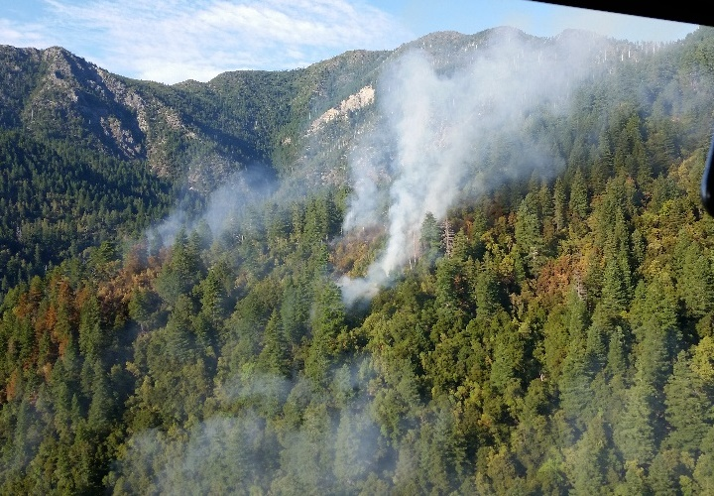By early afternoon, fire intensity increased significantly, to the point the IC and trainee were concerned that their route back up the hill to the helispot may be cut off. He directed bucket drops from the Type 2 helicopter to cool the area. With just eight firefighters on scene and the increased fire behavior, the IC was concerned that with fire on both the north and south sides of the drainage, the fire could make a direct run towards the helispot. The fire behavior, rugged terrain, limited resources and no escape routes added up to an unacceptable risk of entrapment, and the IC made the decision at 3:05 p.m. to elevate

*Photo shows fire during ICT3   
reconnaissance flight July 13*

the fire to a Type 3 IC. The rappel helicopter returned to retrieve the first load of firefighters off the hill at 3:47 p.m. Meanwhile, two helicopters dropped 58 buckets totaling 18,200 gallons of water that day.

Based on WFDSS, the Agency Administrator decided to take an indirect suppression strategy on the fire, which would be managed by a Forest Type 3 Incident Management Team. The decision incorporated the Forest Service Chief’s focus items found in his 2017 Letter of Intent for Wildland Fire to “implement strategies and tactics that commit responders only to operations where and when they can be successful, and under conditions where important values at risk are protected with the least exposure necessary while maintaining relationships with the people we serve.”

The decision was to complete a long-term assessment to evaluate the threat to values at risk relative to the current fire location and projections over the next three-week period. The primary values at risk at the time were located outside the wilderness area 6-10 miles to the south and southwest of the fire (Industrial timber lands/Federal timber lands, Emily Camp, Quail Prairie and Pearsoll Peak Lookouts and Packers Cabin). Considerations were also given to public safety and socio-political economic concerns in development of the strategy. The course of action included minimal use of resources to monitor fire activity and look for potential management action points and areas for contingency line construction. The decision also recognized the need to implement a communication strategy to inform the public, cooperators, and key stakeholders on fire status and planned actions.

Between July 13 and 19, the Type 3 IMT began constructing containment lines outside the wilderness boundary to the south and southwest of the fire in anticipation of “Chetco Effect” winds (a NE to SW flow) which could be expected to occur 2-4 times during the fire season. Resources began brushing roads and trails to be utilized in the event the fire crossed south of the Chetco River.

A new WFDSS decision was issued on July 19, reaffirming the July 13 WFDSS decision. The fire was approximately 300 acres in size, burning exclusively on National Forest System Lands. Cooperators, including Coos Forest Protective Association (CFPA), Oregon Department of Forestry (ODF), and local government entities, were updated on the current situation and decision. Fire behavior was low to moderate spreading in surface fuels (primarily brush fields).

Over this period, firefighters cleared helispots in order to land and install remote automated weather stations (RAWS) to obtain accurate weather data from near the fire site. Fire crews also constructed primary fire line and explored access points from the outer edge of the Kalmiopsis Wilderness to locate ridgelines closer to the fire’s perimeter within the wilderness that would allow safe access for the firefighters to take action.

The IMT determined that addressing the southwest portion of the indirect containment strategy was necessary. Crews were tasked with opening road systems and chipping brush with the objective of constructing contingency lines. The fire grew to about 500 acres, still well within the wilderness. The fire behavior remained low-to-moderate. The first forest area closure was implemented on July 20.

**July 21-25:** The IMT installed a remote camera to monitor the fire’s movement and activity and requested GIS support to provide detailed maps the Kalmiopsis Wilderness plus surrounding areas to help determine contingency and alternate fire lines. Operations identified and began clearing contingency lines, primarily using existing roads and trails, and improving lines used in the 2002 Biscuit Fire. Two Interagency Hotshot Crews (IHC) were ordered, but no crews were available on July 23 when the order was placed.

On July 24 a National Incident Management Organization (NIMO) team was ordered for the incident due to the anticipated long-term duration of the incident. The NIMO team assumed command of the incident on July 29 and continued to implement the strategy and course of action of the July 19 WFDSS decision. Roads and trails outside the wilderness boundary continued to be prepared for potential burnout operations should the fire cross the Chetco River.

By July 24, 80 firefighters were constructing and improving containment lines. Two IHC Crews arrived and analyzed options for containment lines closer to the fire. The crews also were utilized for contingency line work with the other resources in order to expedite the work.

Over this timeframe, the fire had an east wind event that increased the fire behavior to about 100 acres a day in growth, but the Chetco River was checking spread to the south and west.

Between July 29 and August 14 the fire grew from 2,180 acres to 5,438 acres with spread primarily to the north and northeast. The fire remained north of the Chetco River. On the evening of August 15 and morning of August 16 the fire experienced its first “Chetco Effect” wind event that resulted in the fire crossing the Chetco River to the south. The winds are created when northeast winds are pushed downslope from the surrounding mountains towards the Pacific Ocean. This movement increases the wind’s temperature up to forty degrees above the surrounding areas. The Chetco River Valley further funnels the winds to the west into the Brookings area. Infrared mapping from August 16 estimated the size of the fire to be 6,011 acres. Fire growth between August 17 and August 21 outpaced modeling predictions for a “Chetco Effect” wind.

The fire became established south of the Chetco River on August 17. Three air tankers dropped 30,823 gallons of retardant in and adjacent to the wilderness to slow the spread of the fire. The team requested resources from both the High Cascades Complex and the Shan Creek Fire. The forest law enforcement officer closed Packer’s Cabin, a local rental cabin, asking renters to evacuate to allow crews to complete structure preparation. Hand line construction was completed on the south side of the Chetco River through the Wild and Scenic Corridor to the Chetco River, as well as primary contingency lines north and south of the Chetco River. The fire was estimated at 8,500 acres with 65 personnel assigned.

An infrared (IR) flight on August 18 estimated the fire to be 10,957 acres. During this timeframe, the fire breached the primary contingency containment line that crews had been preparing. Point-protection tactics were undertaken to protect values at risk at a private ranch and Wilderness Retreat. The fire continued to gain momentum and exponentially increased in size prompting additional resources to be ordered.

At 7:30 a.m. on August 18, the IC recommended the Curry County Sheriff evacuate roads south along Chetco River to Alfred Loeb State Park. Curry County activated its Emergency Operations Center (EOC) in Brookings. Around 10:30 a.m., visibility was too poor for air tanker use, and Type 1 helicopters were requested for bucket work. One heavy (Type I helicopter), on loan from the Miller Complex, dropped 30,000 gallons of water on the fire.

An engine crew experienced a near miss at Packer’s Cabin around noon when the fire cut off its egress route. Crews were preparing to burn out around the cabin to create a buffer when a spot fire crossed the road during their burn operations, became established, and compromised the engine’s egress. The three engine crewmembers maintained communications with a helicopter assigned to that division who requested more aerial resources for the potential entrapment. An order was placed for support from air attack, an air tanker and a rappel ship, and a VLAT borrowed from the Milli Fire jettisoned a load of retardant on the fire after responding to the near miss. The crew then made their way into the black and remained there until 5:30 p.m. when it cooled enough to return to the cabin. The crew stayed at Packers cabin until early the next morning when the passing flame front had cooled enough to allow for a safe egress.

A Facilitated Learning Analysis (FLA) was developed for this near miss and can be accessed in the Wildland Fire Lessons Learned Center.

The forest ordered the type 2 IMT that was finishing up on Shan Creek Fire to be reassigned to Chetco Bar to support the NIMO team.

At 3:30 p.m., a Level 2 Evacuation order was issued for Gardner Ridge and Cate Road. Three structures burned. The fire was estimated at 22,042 acres at 4 PM with 65 personnel assigned.

IR flown on August 19 showed the fire to be 48,825 acres. Red Flag conditions were in effect from the late afternoon through the following day. Unified command was initiated between NIMO/Rocky Mt. Team Black and CFPA. The Conflagration Act was invoked by Governor Brown, allowing for the deployment of Oregon State Fire Marshal resources to support the fire. The Level 2 evacuations for Gardner Ridge Road turned to a Level 3 Evacuation at 6 p.m. Firefighters began backfire operations north and west of Wilderness Retreat to protect structures. Their efforts redirected fire spread to the east and south, allowing resources to begin structure protection and firing operations around Wilderness Retreat and the Chetco River Inn. Five primary residences and 18 minor structures burned on Gardner Ridge and Cate Road. The fire was estimated at 48,825 acres at 11 PM with 280 personnel assigned. IR flown on August 19 showed the fire to be 48,825 acres.

**Aug. 20:** Oregon State Fire Marshal’s Office (OSFM) resources began officially supporting the incident at 6 a.m., and joined unified command, with NIMO/RM Team Black/CFPA. OSFM had responded with 4 task forces of structure protection, which included 127 personnel on equipment in addition to 26 personnel on the Incident Management Team. Operations formalized plans for an aggressive attack to occur when the weather moderated. Under continuing Chetco Effect winds, by late that evening the fire grew to an estimated 91,551 acres.

During the August 16th through 20th timeframe, the protection of Life/Safety was the priority. Unified Command was established between the USFS (two IMT’s; NIMO and an IMT2), the Oregon State Fire Marshal, and the Coos Forest Protective Association. The Curry County Emergency Operations Center (EOC) was activated to coordinate evacuation activities. Multiple evacuation notices were issued by the Curry County Sheriff’s Office that affected over 3000 residences/properties.

**Aug. 21:** The number of incident responders grew to 788 on August 21. Use of aviation assets was limited due to the smoke produced by the fire. The Chetco Bar Fire experienced rapid growth during National Preparedness Level 5, which contributed to delays getting resources. This was anticipated and was overcome by using previously established lend/lease procedures with nearby incidents. The teams held an informal meeting at the Red Cross Evacuation Shelter at Riley Creek Elementary School, and a meeting at Azalea Middle School in Brookings. Approximately 1,000 people attended. The Agency Administrator ordered a National Type 1 IMT to manage the Chetco Bar Fire. National Guard resources were supporting the incident by providing 24/7 security at road closures, traffic assistance at control points, mop-up, fire rehabilitation and extraction of hose and pumps.

OSFM structure prep and triage began in the Carpenterville Road area. CFPA and private timber industry resources worked with resources assigned to construct direct and indirect line on the far western flank of the incident. This action was instrumental in the protection of a number of residences in the Gardner Ridge and Wilderness Retreat areas. The weather conditions finally moderated and allowed for operational resources to initiate direct and indirect line construction on the west and south sides of the fire. Between August 17 and August 21, Chetco winds had driven fire growth from around 6000 acres to almost 100,000. The fire was 97,758 acres with 788 resources assigned.

**Aug. 22:** The incident meteorologist warned of the potential for the Chetco Effect to return over the fire area on Aug. 26. The fire was 99,944 acres at 10:15 PM with 1,078 personnel assigned.

**Aug. 23:** PNW Team 3 (Type 1 IMT) was in briefed at 2 p.m. The unified command teams held a public meeting in Gold Beach at the Curry County Fairgrounds. The fire was 102,333 acres, now categorized as a megafire, with 1,174 personnel assigned. Approximately 251 personnel and 75 pieces of equipment were assigned through OSFM.

**Aug. 24:** The ICs, Sheriff and Oregon State Police conducted a tabletop exercise to work through a potential evacuation of areas north of Brookings and Brookings proper. At 5 p.m. a Level 1 evacuation notice went into effect for Brookings. Eight LAT’s, one SEAT and one VLAT dropped a total of 46,892 gallons of retardant on the fire. The fire was 104,144 acres at 11:20 PM with 1,398 personnel assigned.

The August 24 damage assessment confirmed that five single residences and 20 other minor structures had been destroyed. As of August 24, 1,712 single residences (2,367 people), 809 nonresidential commercial properties, and 50 minor properties remained threatened. Temporary Red Cross Shelters had been established for displaced residents.

**Aug. 25:** The fire was mapped at 105,518 acres with 1,612 personnel assigned. PNW Team 3 shadowed the NIMO and Type 2 team and joined Oregon State Fire Marshal’s Office and CFPA in unified command at 6 a.m. on Aug. 26.

**Aug. 26:** Transfer of Command to Pacific Northwest Team 3.

**Sept 3:** The National Weather Service issued a heat warning, and high temperatures and critically low humidity contributed to an increase in fire behavior. On the eastern flank, a significant smoke column developed to a height of 23,000 feet. Shifting winds improved visibility, allowing aircraft to support ground operations with water drops on portions of the fires. Over 500 people attended the community fire briefing in Cave Junction.

**Sept 4:** An excessive heat warning remained in effect with temperatures above 100 degrees, creating critical burning conditions including numerous spot fires. Level 1 evacuation order issued for residents of Illinois Valley. Level 3 “GO” evacuation order issued for Illinois River Road within US Forest Service boundaries, including Oak Flat. Forest Closure area expanded due to fire growth on the eastern flank.

**Sept 6:** On September 6, a non-fire employee located in fire camp went into cardiac arrest and was resuscitated by EMS on scene. After the individual collapsed, a medic responded quickly and conducted CPR for about 30 seconds until the individual regained consciousness. The patient was transported to nearest cardiac center in Medford, Oregon. A Rapid Lesson Sharing (RLS) assessment was developed for this incident and can be accessed via the Wildland Fire Lessons Learned Center website.

**Sept-Oct:** The fire received precipitation, with some areas reported over an inch of rain in early September. The fire experienced another warming trend before returning to cooler temperatures and increased precipitation in mid- to late- September. On 9/18 Curry County Sheriff’s Office lifted all evacuation orders for Curry County. Pacific Northwest Type 1 Team 2 transferred command of the Chetco Bar Fire to a Type 3 organization on October 5. On October 18th, the Chetco Bar Fire transitioned from a Type 3 to a Type 4 organization.

A Burned Area Emergency Response (BAER) Team arrived in early October to conduct post fire hazard mitigation. Weather continued to moderate fire behavior and spots of heat decreased significantly.

**November 2:** Fire was declared 100% Contained.

**Shan Creek**

|  |  |
| --- | --- |
| Date of Ignition | August 10 |
| Cause | Lightning |
| Containment | September 1, declared out on November 6, 2017 |
| Land Ownership at Ignition Point | Rogue River Siskiyou NF; US Forest Service |
| Preparedness Level at Time of Ignition | National Preparedness Level 4  Regional Preparedness Level 4 |
| Fire Size | 156 |
| Estimated Cost | 1,700,000 |
| Land Jurisdictions Affected |  |
| Resources at Incident Peak | 262; 1 Type-1 crew; 4 Type-2 crews; 1 camp crew; 22 engines; 5 heavy equipment |
| Injuries | 1- respiratory distress 8/18 |
| Structures Destroyed | 0 |
| Cooperators |  |

The lightning-ignited Shan Creek Fire was reported August 10, burning about 10 miles west of Grants Pass, Oregon, on the Rogue River-Siskiyou National Forest. Initial attack fire crews responded on August 11 and made progress on the fire. Due to the its potential and multiple fires in Southwest Oregon, the MAC group made the decision to redirect an out-of-area type 2 incident management team—Rocky Mountain Team Black—which had been ordered to preposition in Central Washington for upcoming weather events. Team Black assumed command of the Shan Creek Fire, which was estimated at 400 acres, on August 17.

Fire crews had already successfully contained all but the west flank of the fire by the time the Rocky Mountain team arrived. The team mapped the Shan Creek Fire at 156 acres, had firefighters install a hose lay around the perimeter and had the fire 85 percent contained by August 19, when they transferred command back to a type 3 team. Since the Chetco Bar Fire had made a significant push toward Brookings, Oregon, the MAC group reassigned Rocky Mountain Team Black to support the NIMO team on that fire.

**Miller Complex**

|  |  |
| --- | --- |
| Date of Ignition | August 14 |
| Cause | Lightning |
| Containment | November 2 |
| Land Ownership at Ignition Point | 25 lightning fires, mostly on the Rogue River-Siskiyou NF |
| Preparedness Level at Time of Ignition | National Preparedness Level 5  Regional Preparedness Level 5 |
| Fire Size | 39,715 |
| Estimated Cost | 38,924,000 |
| Land Jurisdictions Affected | 25 fires, multi-jurisdictional in several counties in Oregon and California |
| Resources at Incident Peak |  |
| Injuries | 20 |
| Structures Destroyed | 0 |
| Cooperators |  |

A series of thunder and lightning storms moved across the Rogue River-Siskyou National Forest on August 14 igniting 25 wildfires that spanned across two separate National Forests, two GACC’s, two states, and 3 counties (and 2 IMTs). The series of fires became managed as the Miller Complex. All fires within the complex were terrain and fuel drive and in the early stages fire growth was primarily a result of rollout and slope reversal. All IMTs that commanded this fire during its duration noted the jurisdictional complexities in managing an incident that was across state and regional boundaries.

When the fires first ignited, a local Type 3 organization was already in place managing earlier ignitions and assumed responsibility for some of the new fire starts. A Type 2 organization took command of the fire on August 16 to address the increased complexity around safety, external political factors and resource constraints. A contain and control strategy was already being utilized due to the hazards presented to firefighters by the steep terrain and numerous snags. The team took on an incident that had multi-jurisdictional boundaries with challenging collaborative missions, and had low priority status for resource allocation. On August 18, smoke became a significant issue over the complex. Locally generated smoke was enhanced by considerable smoke from other area fires – most notably the Chetco fire. It remained hot and dry, but temperatures in the lower valleys were affected quite a bit by smoke shading. On August 19, unauthorized incursions by two non-mechanized hang gliders that grounded all aircraft over the fire.

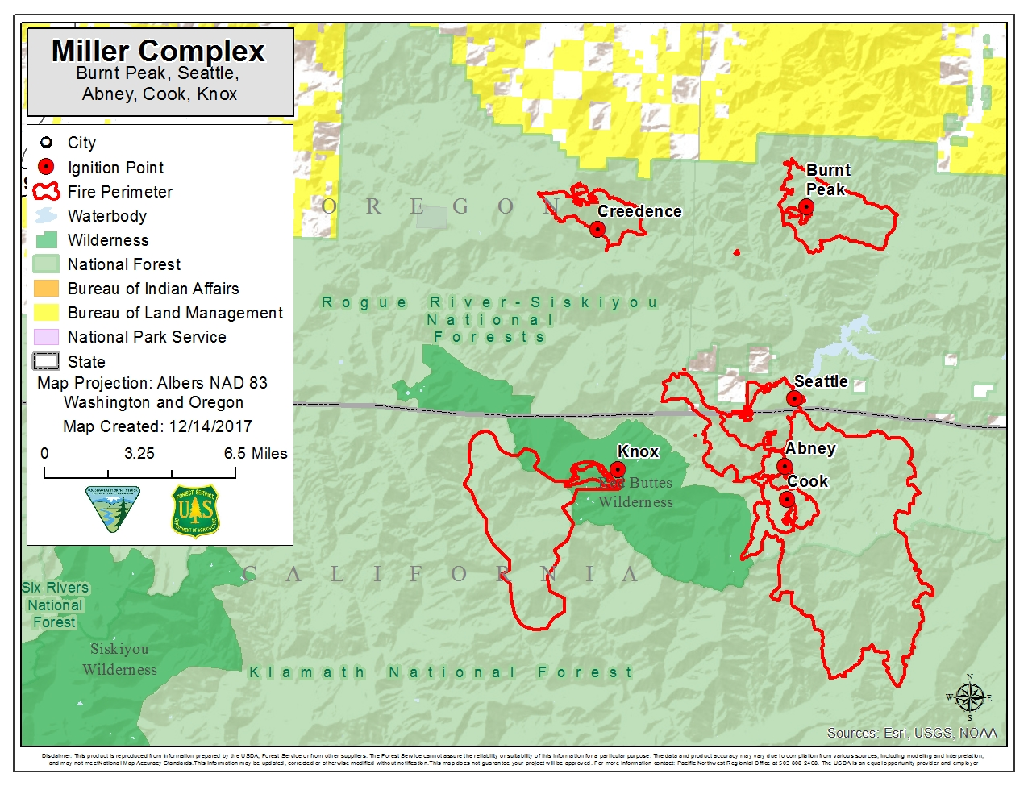

Very heavy smoke covered the complex beginning August 20 and continued through August 23. Temperatures in the valleys during this period were relatively cool and high humidity due to the smoke trapped under the inversion. By August 24, seventeen of the original 25 fires ignited were contained and in patrol status. Smokey conditions and resource shortages persisted and as the incident progressed towards some containment, a Type 1 IMT took command of the incident. On August 25 when the Type 1 IMT took command, the fire was 46% contained.

An engine rollover resulting in a serious injury occurred on Aug. 27. A Type 6 contract engine was assigned to conduct structure triage assessments. While driving, the driver came too close to the edge of the roadway and rolled down a steep embankment into a shallow creek. The engine driver was not wearing his seatbelt and was seriously injured. Although not ejected, the driver was partially pinned underneath the engine, and partially submersed in the creek. Seeking to understand the risk management process and cultivate a learning environment, the Regional Forester requested a Facilitated Learning Analysis (FLA) team to review the accident, which is attached at the end of this appendix.

Heat began to build again on Aug. 31, and a red flag warning for poor night time humidity recoveries and gusty east winds was issued for the night of the 31st into the morning of Sept. 1. Very hot weather returned Sept. 1 and continued through Sept. 5. Another red flag warning for poor night time humidity recoveries and strong east winds was issued for the night of Aug. 31 and this was followed by a red flag for hot, dry, and unstable weather with a Haines index of 6 on Sept. 1, prompting a mandatory evacuation for (evacuation Level 3) for 40 residences in the Applegate community.

During this hot spell, temperatures peaked at around 100 degrees on Sept. 1 and humidities bottomed out at 12% over the peaks on Sept. 3.

The other significant event on Sept. 3 occurred when the incident management team branched the Abney Fire. Due to the activity on the southern end of that fire, the number of fires in the Miller Complex and land jurisdictions affected, the team managing the Eclipse Complex on the Klamath National Forest assumed command of branch of the Abney Fire south of the Pacific Crest Trail.

A red flag warning for poor night time humidity recoveries and strong east winds was issued for the night of Sept. 3 into the morning of Sept 4. Sept. 4 and 5 were generally hot, dry, and smoky with less wind as a thermal trough moved right over the complex.

Red flag warnings were issued for the potential of lightning on very dry fuels for both Sept. 6 and 7. Thunderstorms formed south of the complex on Sept. 6, but weakened and collapsed as they moved over more stable air. The cause of the stability was very thick smoke which limited and in some cases almost totally blocked the sun from reaching the ground, which in turn severely limited surface instability. Sept. 7 was a much more active day as a very strong trough moved through. Thunderstorms were already on the radar as of day break, and these storms gradually moved over the complex through the morning. Five different lightning alerts were issued for the divisions and ICP during the thunderstorm outbreak. While not a lot of rain fell, there was a fairly widespread tenth of an inch over the complex. Far western areas of the Abney fire reportedly received more. While no observations were collected, radar estimated between a tenth and quarter of an inch fell there. The thunderstorms knocked down smoke on area fires and their winds helped clear out the smoke that was already present. As a result, smoke was much thinner over the complex on Sept. 8, and visibilities improved to several miles. On Sept. 8, evacuations were relaxed for all communities on the Oregon side of Miller Complex. On Sept. 11, the Type 1 team transferred command of the fire to a Type 2 team.

Generally warmer conditions were observed Sept. 15 and 16, but smoke returned and held surface temperatures down and humidity’s up in many locations.

On Sept. 15, three members of the same crew working on the Abney Fire suffered medical incidents. One was stung multiple times in the head and neck, one crew member received a significant laceration to the hand, and a third crew member suffered a serious heat-related injury.

Conditions began to change significantly on Sept. 17. Clouds moved over the area as a cold front approached the coast, and a few showers were observed over the complex. Rain moved in overnight and into Sept. 18 with as much as a half-inch of rain observed over the western portions of the incident and lighter amounts elsewhere. Rain became much spottier during the afternoon, then returned again the night of the 18th into Sept. 19. Another one quarter to one half inch of rain was observed, again, mostly focused over the western portions of the fire. Temperatures were much cooler and humidity’s very high through the 18th and 19th over the entire incident with highs ranging from the mid-40s over the ridges to the upper 50s in the valleys and humidity’s remaining above 60% area-wide through the two day period.

A strong warm front moved through the complex in the early morning hours of Sept. 20. Rain was once again sparse, but winds were strong with west-southwest winds gusting up to 41 mph for much of pre-dawn morning hours. A strong cold front is expected in the afternoon of the 20th, which will bring showers and possibly a wetting rain.

On Sept. 22, the incident was turned over to a Type 3 team. The incident was 65% contained and had 200 firefighters assigned.

A mid-October heat wave caused an increase in fire activity on the Abney Fire on the northeast flank where private property was still threatened. With a continued warming and drying trend in the forecast, the Rogue River-Siskiyou Forest managers decided on Oct. 14 to order a type 2 team to assume command on Oct. 16. The team was in place through Oct. 20 when the area received significant rainfall and the fire was transferred back to the local unit.

The fire reached 100% containment on November 2.

**High Cascades**

|  |  |
| --- | --- |
| Date of Ignition | 7/23/2017 |
| Cause | Lightning |
| Land Status at Fire Origin | Rogue River-Siskiyou National Forest, Umpqua National Forest, Crater Lake National Park, Fremont-Winema National Forest |
| Preparedness Level at Time of Ignition | National: PL 5  Regional: PL 5 |
| Fire Size | Acres: 79,870 |
| Estimated Cost | $65,000,000 |
| Land Jurisdictions Affected | National Forest, National Park |
| Maximum Resources Assigned | Personnel: 1150  Crews:  Engines:  Water Tenders:  Helicopter:  Heavy Equipment: |
| Structures Destroyed | 1 minor structure |
| Cooperators | Forest Service, Oregon Department of Forestry, National Park Service, Oregon Department of Transportation, Jackson County, Douglas County |

**Late July – Early August:** A series of lightning storms started upwards of 40 ignitions dispersed through the Rogue-Siskiyou NF, the Umpqua NF and Crater Lake National Park. Initial attack resources were unable to contain all of the fires in the complex due to the number of fires reported, difficult access, heavy volume of recent initial attack activity by local resources and general shortage of regional resources.

Local units ordered incident management teams for several of the fires. The Blanket Creek Fire began on July 26 and was managed by a type two team based out of Prospect, Oregon. On July 31, that team also assumed command of the Spruce Lake Fire.

The timeline of the High Cascades Complex is indeed complex. Fires in the surrounding area were managing separately, then complexed, then moved from one complex to another throughout the duration of the incidents.

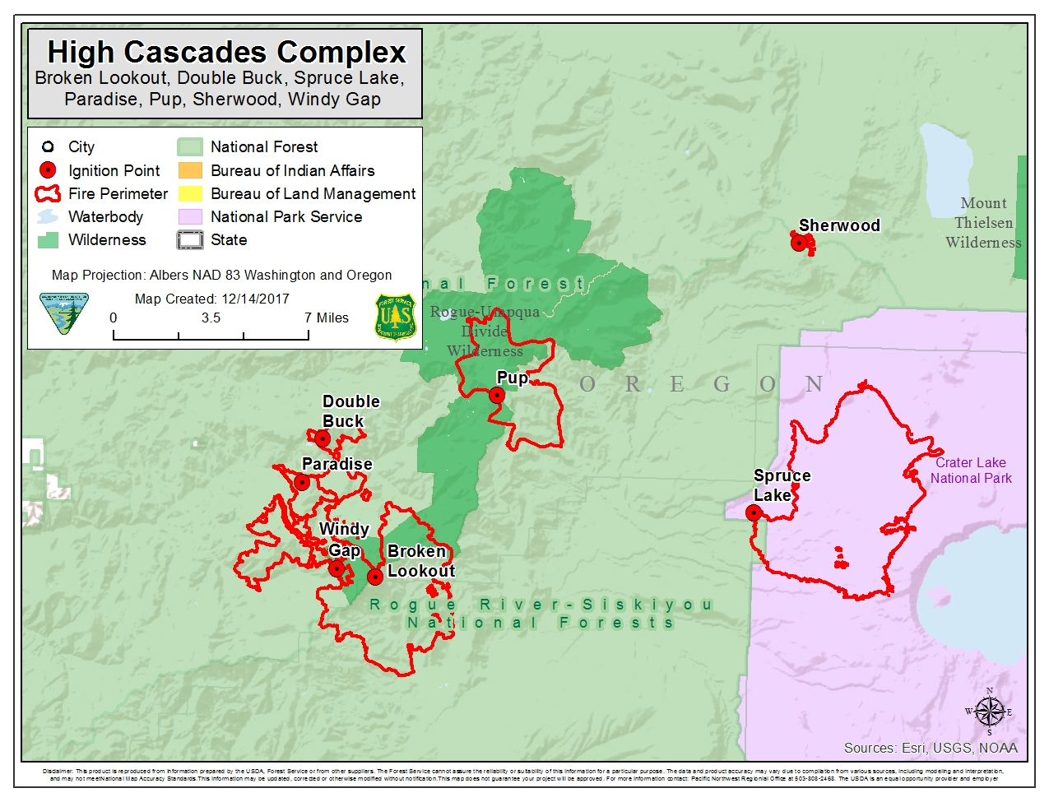**August 13-16:**

On Aug. 13, the Broken Lookout, Pup, North Pelican, Blanket Creek and Spruce Lake fires became managed as a complex under one IMT. Broken Lookout, Pup and North Pelican were originally part of the Falcon Complex and managed by a different team.

Most of the initial attack efforts were effective with the exception of nine fires that became the High Cascades Complex, the largest of which were the Blanket Creek and Spruce Lake fires. The nine fires totaled approximately 10,500 acres by Aug. 14. The fires were burning in continuous mixed conifer stands with abundant dead and down trees and standing snags. The size and jurisdictional complexity along with the possibility of this being a long-term event, prompted local fire managers to order a type 1 team to manage the complex. The team managed all fires in the complex and were responsible for initial attack of any new starts in a 451,322-acre management area. Their strategy was to manage the incidents as full suppression fires, utilizing existing roads and fuel breaks to create direct and indirect lines.

The fires prompted the closure of many trail systems and forest roads, as well as portions of the Pacific Crest Trail within Crater Lake National Park. The fire complex threatened the communities of Red Blanket Creek, Union Creek, Diamond Lake and Prospect. The incident was an immediate threat to 84 single residences, 8 mixed commercial residential, 28 nonresidential commercial and 75 additional minor structures and outbuildings, in addition to threatening several T&E species habitats including the spotted owl. On August 16, the Oregon National Guard 141st Brigade support battalion arrived on the incident supplying 150 additional personnel to assist with suppression efforts.

**August 17 – Sept. 18**

Over the next several days, fire weather conditions worsened with an unstable atmosphere influencing the complex. Efforts were made to insert firefighters on the north side of the Broken Lookout Fire but the plan was abandoned due to how close the fire was to another large fire (The Falcon Complex) and the possibility of the fires growing together. The fires continued to grow daily with some active crown runs and short-range spotting. As the fires continued to grow, aircraft was utilized to keep sections of line in check while ground crews prepped indirect lines.

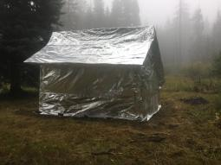By Aug. 28 the complex had reached 19,000 acres. The Blanket Creek Fire had grown to 9,300 acres had prompted a level 1 evacuation for Mazama Village. The Broken Lookout Fire had also made a run on the same day and prompted a level 1 evacuation for the community of Union Creek. The workload region wide had diverted many of the available resources to assist with critical fire suppression efforts needed to protect the threatened communities, commercial businesses and high value natural resources. The Blanket Creek and Broken Lookout fires needed difficult line construction and critical burn outs in steep, rocky, timbered areas to accomplish containment as well as protect communities and high value natural resources.

Structure wrapped on High Cascades Complex

The addition of the Pup fire to the complex also complicated the incident. It was burning in the Rogue-Umpqua Divide wilderness in steep and remote terrain. The fire threatened the Hershberger Telecommunications site and the Hershberger Lookout. The Complex was eventually split between two teams and divided into West and East zones.

By mid-September the Blanket, Spruce Lake, Broken Lookout, Pup and North Pelican Fires combined reached approximately 80,000 acres.

**Sept. 18 – October 31**

The week of September 18, the region was hit with a significant weather event that brought abundant rain to the fire area. Most work efforts were then redirected to suppression repair and stabilization. The fire was split between two type 3 management teams, dividing the work load between jurisdictions on the Rogue River-Siskiyou National Forest and the Umpqua National Forest. The fire was called controlled on October 31.