## Appendix C: Southeast Oregon (Burns, Lakeview, Prineville, and Vale BLM, Fremont-Winema National Forest)

## Introduction

The fire season was mild in the rangelands of southeastern Oregon. In all, 29 large fires originated on the four BLM Districts in southeastern Oregon, burning an estimated 135,133 acres. Vale District experienced the greatest number of large fires with 14, which affected an estimated 37,557 acres. Burns District had only four large fires, but had the greatest number of acres affected at 58,267, mostly in the Cinder Butte Fire. Lakeview District had five large fires, affecting an estimated 8,019 (the least acres of the four Districts), and Prineville District experienced six large fires for 31,290 acres. Only three fires – Cinder Butte, Rhoades Canyon, and Bowden – exceeded 10,000 acres in size. The 5,874-acre Ana Fire was the most significant fire that affected the Fremont-Winema NF. Later in the summer, the Blanket Creek Fire (covered under the High Cascades Complex in Appendix A) also burned onto the Fremont-Winema NF.

## Greater Sage-grouse and RFPAs

Protection of habitat for the greater sage-grouse is a top priority for wildfire response in southeastern Oregon. Both the approved resource management plan amendments for sage-grouse (sage-grouse amendments) and the 2015 Integrated Rangeland Fire Management Strategy lay out principles and management direction for reducing the impacts of wildfire on sagebrush ecosystems. Sage-grouse and several other species, such as pygmy rabbit and pronghorn antelope, in these plant communities are dependent on sagebrush for food and cover. Most sagebrush species do not resprout and often require several decades to return to useful habitat. Like northern spotted owls and marbled murrelets, sage-grouse depend on a type of old-growth that requires long recovery times.

Land use plan amendments specific to greater sage-grouse and the Integrated Rangeland Fire Management Strategy cover the four eastern Oregon BLM Districts (Burns, Lakeview, Prineville, and Vale). The 2016 sage-grouse amendments identified three different types of habitat areas, based on the State of Oregon’s sage-grouse management strategy. Sagebrush Focal Areas (SFAs) have the highest value for maintaining sage-grouse and sagebrush habitat and are considered the most intact and contiguous habitat remaining. Priority Habitat Management Areas (PHMA) contains the habitat used by 90 percent of sage-grouse for breeding and brood-rearing; in southern Oregon along the Nevada and Idaho borders, SFA overlaps with PHMA. General Habitat Management Areas (GHMA) largely connects the patches of PHMA. All of Oregon’s PHMA also has been designated as Priority Areas for Conservation, or PACs, with 20 PACs identified throughout southeastern Oregon. These PACs are the highest priority for wildfire protection.

Eastern Oregon has a limited number of state and federal firefighting resources and their ability to provide rapid response to new fires is also limited. To make supplement existing capacity, BLM and Oregon Department of Forestry have been promoting the formation of Rangeland Fire Protection Associations (RFPAs). These RFPAs have proven to be valuable assets in protecting sage-grouse habitat.

The RFPAs are well trained and well equipped to fight wildland fires. They receive equipment, much of it military surplus vehicles, through Oregon Department of Forestry and via grants from county, state, or federal partners. As a result, RFPAs have engines, water tenders, dozers, and lowboys for transporting heavy equipment. Grants also help the RFPAs purchase radios and personal protective equipment (PPE), such as fire shirts, hardhats, and fire shelters. Both ODF and BLM provide training and additional PPE. Members of an RFPA are able to take on all the suppression tasks, such as line construction and burn out operations, that federal and state firefighters do.

Oregon Department of Forestry provides oversight and guidance to the RFPAs, but each RFPA is an independent entity. In 2017, Oregon had 22 RFPAs located across much of eastern Oregon (Table C-1). Nineteen RFPAs responded to wildfires on BLM-managed lands in 2017. Jordan Valley RFPA had the most responses, followed by Post/Paulina and Brothers/Hampton RFPAs. All told, RFPAs responded to 85 wildfires that wound up burning 96,539 acres.

Table C-1. Locations of RFPAs, number of fires in 2017 they responded to, the total acres associated with those fires. Source: Brent Meisinger

|  |  |  |  |
| --- | --- | --- | --- |
| BLM District | RFPAs | Total Responses | Total Acres |
| Burns | Crane  FG  Fields/Andrews  Lone Pine  Silver Creek  Wagontire | 18 | 58,582.4 |
| Lakeview | Warner Valley | 5 | 1 |
| Prineville | Ashwood  Brothers/Hampton  Gateway  Post/Paulina  Twickenham | 38 | 5,388 |
| Vale | Blue Mountain  Burnt River  Ironside  Jordan Valley  Lookout/Glasgow  Vale | 28 | 32,568.5 |

The following three fires illustrate how wildfires affected important sage-grouse habitat as well as other resource values and the roles that local RFPAs and rural fire departments played in handling those fires.

### Ana Fire

|  |  |
| --- | --- |
| Date of Ignition | July 9, 2017 |
| Cause | Human |
| Containment | July 14, 2017 |
| Land Ownership at Ignition Point | Private |
| Preparedness Level at Time of Ignition | National: PL 3  Regional: PL 2 |
| Fire Size | 5,874 acres |
| Estimated Cost | $2,900,000 |
| Land Jurisdictions Affected | Private, BLM, National Forest, State |
| Resources at Incident Peak | 405 Personnel: 11 Crews; 32 Engines; 9 Water Tenders; 3 Helicopters; 4 Heavy Equipment |
| Injuries | 0 |
| Structures Destroyed | 2 |
| Cooperators | Bureau of Land Management, Forest Service, Oregon Department of Forestry, Oregon Department of Transportation, Oregon State Police, Surprise Valley Electric, Summer Lake Rural, Christmas Valley Rural, Paisley Rural, Summer Lake EMS |

The Ana Fire started on July 7 on private land north of the town of Summer Lake and quickly spread under the influence of high winds and dry fuels. The fire threatened approximately 25 homes, 10 commercial buildings, and 10 other structures along with sage-grouse habitat in the Picture Rocks Priority Area for Conservation, Highway 31, the transmission line that roughly parallels Highway 31, and cultural resources towards the north of the fire. Several rural fire departments along with resources from the Forest Service and BLM responded to the fire.

By July 8, Ana Fire had burned approximately 700 acres with hot, windy conditions hampering control efforts. Dense smoke on Highway 31 affected traffic safety, resulting in closure of the highway, the main route between Bend and Lakeview.

Lakeview District ordered a Type 2 Incident Management Team on July 9 to take over managing the fire due to the threats to Summer Lake, Highway 31, private timber, and sage-grouse habitat. The Ana Fire, now estimated at 3,200 acres continued to burn actively (See Figure C-1). The Lake County Sheriff’s Office issued Level 2 evacuation orders for residents of Ana Estates and homes along Highway 31 two miles south of The Lodge. The national preparedness level increased to 4, indicating firefighting resource shortages developing in several geographic areas.

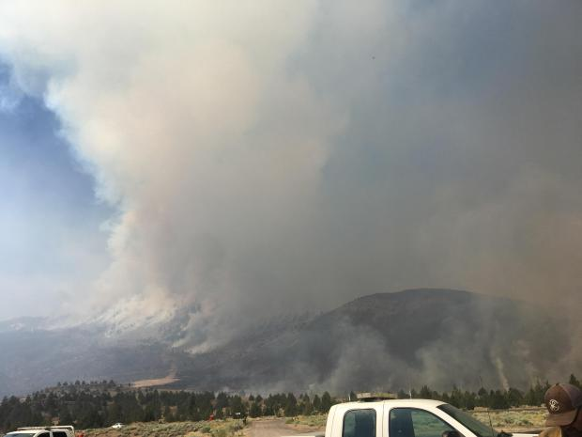

Figure C-1. Ana Fire on July 9, 2017. Source: Inciweb

A Type 2 incident management team assumed command of the fire on July 10. Ana Fire was now an estimated 6,000 acres in size and had burned lands managed by Lakeview BLM and the Fremont-Winema National Forest, as well as state owned lands and private lands. An outbuilding, a barn and a hunter’s cabin were believed to be damaged or destroyed by the fire. The fire crossed Highway 31, burning from west to east. Parts of the fire were difficult for crews to reach, hampering control efforts, although crews made good progress on the fire otherwise.

Oregon Department of Transportation was able to reopen Highway 31 on July 11 with pilot cars guiding traffic through the fire area. The team met with cooperators mid-morning and with community members that evening in Summer Lake. Better mapping reduced the estimated fire size to 5,833 acres.

Firefighters continued to improve the containment line on the south flank of the fire, while mopping up on the rest of the fire. On July 12, the team estimated the fire at 5,874 acres and 75 percent contained. The Sheriff’s Office reduced evacuation levels to Level 1, although smoke on Highway 31 required continued use of pilot cars for driver safety. Although Fremont Point Lookout was not affected, the Fremont-Winema National Forest closed the site through August 1 to allow unrestricted suppression and recovery traffic in the area. Fire behavior consisted mostly of smoldering under juniper trees and slow burning of interior pockets. Better reconnaissance revealed the number of destroyed structures was only two.

By July 13, crews began conducting suppression repair on the cold parts of the fire. On July 14, the fire was fully contained at an estimated 5,874 acres. The Sheriff’s Office lifted all evacuation orders and normal traffic resumed on Highway 31. The team transferred command of the fire back to Lakeview BLM on July 15.

### **Hawk Fire**

|  |  |
| --- | --- |
| Date of Ignition | July 27, 2017 |
| Cause | Lightning |
| Containment | July 28, 2017 |
| Land Ownership at Ignition Point | Vale BLM |
| Preparedness Level at Time of Ignition | National: PL 4  Regional: PL 3 |
| Fire Size | 1,432 acres |
| Estimated Cost | $200,000 |
| Land Jurisdictions Affected | BLM |
| Resources at Incident Peak | 56 Personnel; 12 Engines; 4 Water Tenders; 1 Helicopters; 2 Heavy Equipment |
| Injuries | 0 |
| Structures Destroyed | 0 |
| Cooperators | Bureau of Land Management, Forest Service, Jordan Valley RFPA, Malheur County |

Lightning started the Hawk Fire on July 27 in previously unburned sagebrush within the Cow Lakes PAC, which prompted aggressive suppression action due to loss of sagebrush cover and declining sage-grouse population. Jordan Valley RFPA was one of the responding units, with five Type 4 engines and three water tenders. Responding resources from BLM included one helicopter, five type 4 engines, one type 6 engine, two dozers, and one water tender while the Forest Service also sent a type 6 engine. Several airtankers supported the incident as well. The rapid response resulted in full containment of the fire on July 28 at 1,432 acres.

### Cinder Butte Fire

|  |  |
| --- | --- |
| Date of Ignition | August 2, 2017 |
| Cause | Human |
| Containment | August 17, 2017 |
| Land Ownership at Ignition Point | Burns BLM |
| Preparedness Level at Time of Ignition | National: PL 4  Regional: PL 3 |
| Fire Size | 52,046 acres |
| Estimated Cost | $4,474,046 |
| Land Jurisdictions Affected | BLM |
| Resources at Incident Peak | 469 Personnel; 16 Crews; 27 Engines; 11 Water Tenders; 2 Helicopters; 4 Heavy Equipment |
| Injuries | 0 |
| Structures Destroyed | 4 |
| Cooperators | Bureau of Land Management, Forest Service, U.S. Fish and Wildlife Service, Oregon Department of Transportation, Harney County Sheriff, Harney County Electric, Silver Creek RFPA, Wagontire RFPA |

**August 2**

Human activity along U.S. Highway 20 near Glass Butte started the Cinder Butte fire which spread rapidly to the south-southeast. The fire initially ran an estimated 15 miles under temperatures in excess of 100°F, single digit relative humidity, 30 mph winds, and an very unstable atmosphere (Haines Index 6) through tall grass, sagebrush, and scattered pockets of western juniper trees. Eight people were evacuated and Oregon Department of Transportation (ODOT) closed five miles of U.S. Highway 20, the main route between Bend and Burns. The fire also affected the 12 Mile PAC and general habitat for sage-grouse, residences, powerlines, and local livestock and was threatening the Eastern Oregon Agricultural Experiment Station and the community of Wagontire.

Responding units included Burns BLM, Prineville BLM, Malheur National Forest, Malhuer National Wildlife Refuge, Silver Creek RFPA and Wagontire RFPA. The Harney County Sheriff handled evacuations, and Harney County Electric deactivated the powerlines in the area. The initial strategy consisted of trying to keep the fire from crossing major roads and protect structures in the area.

**August 3**

Severe burning conditions continued with high temperatures, critically low relative humidity overnight and into the day, strong winds, and an unstable atmosphere. A Type 2 incident management team was ordered and in-briefed that evening. Additional crews arrived to help with the containment effort. Helicopters, single engine air tankers (SEATs), large air tankers, and the DC-10 Very Large Airtanker (VLAT) made water and retardant drops throughout the day. The fire continued to threaten the same resource values as on August 2, along with numerous archaeological sites, including Rimrock Draw, a highly significant site under study by the University of Oregon.

**August 4-8**

The primary goals for the fire were to continue fireline construction and mop-up and protecting unburned islands and archaeological sites. On August 4 and 5 the fire remained quite active on the south end, including group torching in clumps of western juniper (Figure C-2), but had moderated considerably on the north end of the fire. The team found two minor structures that had been destroyed in the initial run of the fire on August 4 and two more minor structures on August 6. By August 5, cooler conditions moderated fire behavior, although safety concerns related to smoke, traffic, and fire fighter activity continued on U.S. Highways 20 and 395. By August 8 the fire was 90 percent contained with most effort on mop-up and suppression repair and the Type 2 team transferred command to a Type 3 team.

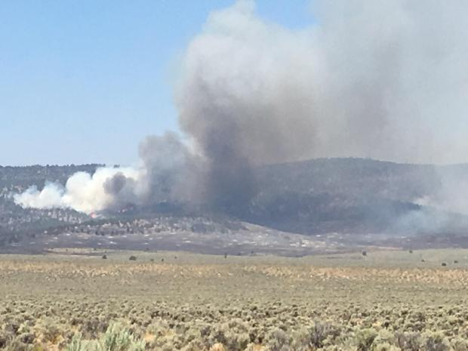

Figure C-2. South end of the Cinder Butte Fire on August 4. Source: Inciweb

**August 9-17**

The Type 3 team handled the remaining suppression damage repair and demobilization of firefighting resources between August 9 and 12. After that, a Type 4 incident commander managed continuing patrol of the fire through a warmer, drier, windier period to make sure of no additional flare-ups within the fire perimeter that could threaten the final containment lines. On August 17, the fire was declared 100% contained.

Along with destroying four minor structures, causing the evacuation of 8 people, damaging powerlines, disrupting traffic on U. S. Highways 20 and 395, and burning in four grazing allotments, the fire affected approximately 1,062 acres of the 12 Mile PAC (priority habitat) and 50,984 acres of general habitat for greater sage-grouse.

**Significance**

These three fires illustrate the importance of rapid responses to protect sage-grouse habitat and the role of RFPAs in that rapid response. The Ana Fire burned in the Picture Rocks PAC, which is small and isolated from other PACs with a declining sage-grouse population at risk of extirpation. Spring lek surveys in 2017 found only seven male birds in this PAC. Loss of habitat to wildfires, given the decades-long recovery times, places this particular population at even greater risk of loss. The Hawk Fire burned in a previously unburned portion of Cow Lakes PAC. Both sage-grouse habitat and populations are in decline in this PAC largely due to the combination of wildfires and invasive annual grasses. Rapid response by the Jordan Valley RFPA likely was a factor in avoiding further significant losses of habitat.

Over the course of the summer six wildfires in Oregon burned in priority habitat for sage-grouse (Folly Farms, Picture Rock, Cow Lakes, Louse Canyon, and 12 Mile PACs) and nine fires affected general habitat. Some of the wildfire impacts in southeastern Oregon include:

* 1,575 acres of Sagebrush Focal Area burned
* 8,311 acres of sage-grouse Priority Habitat Management Area burned
* 80,562 acres of sage-grouse General Habitat Management Area burned
* 121 miles of fence lost
* 31 allotments impacted
* 40 grazing permitees affected
* Approximately 5,217 animal unit months of forage unavailable until recovery objectives are met.

Greater sage-grouse are considered an umbrella species for many other sagebrush obligate species, such as pygmy rabbit, pronghorn antelope, and several species of birds and reptiles. Loss of sage-grouse habitat affects habitat availability for these other sagebrush obligate species as well. A sagebrush obligate species is one that requires sagebrush to meet all or part of it’s habitat needs, such as habitat for breeding, hiding cover, winter cover, and/or food.