## Appendix E: Blue Mountains (Bear Butte and Desolation Fires)

### Introduction

The Blue Mountains area was unusually quiet this year. Two significant fires are outlined below.

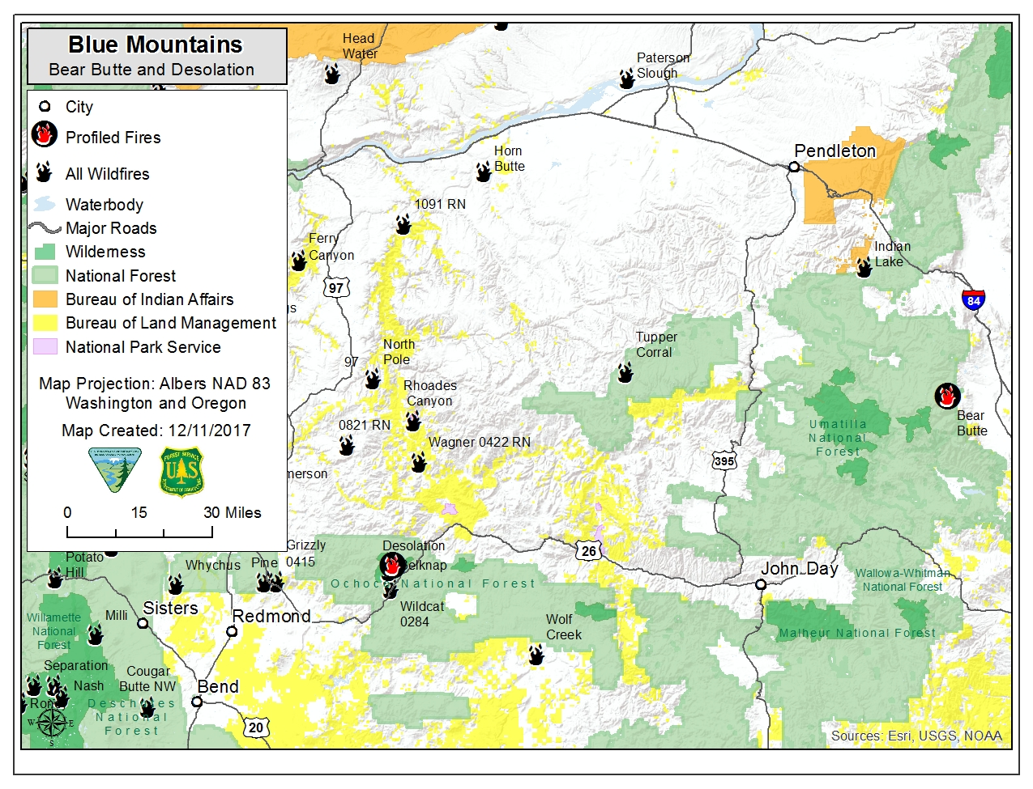

### Bear Butte Fire

|  |  |
| --- | --- |
| Date of Ignition | 8/4/2017 |
| Cause | Unknown |
| Containment | Controlled Oct. 2, Out November 8 |
| Land Ownership at Ignition Point | Wallowa-Whitman National Forest |
| Preparedness Level at Time of Ignition | National: PL 3  Regional: PL 4 |
| Fire Size | 499 Acres |
| Estimated Cost | $6,5000,000 |
| Land Jurisdictions Affected | National Forest |
| Resources at Incident Peak | Personnel 165: Crews: 6; Engines: 5; Water Tenders: 2; Helicopter: 2; Heavy Equipment: 2 |
| Injuries |  |
| Structures Destroyed | 0 |
| Cooperators | Forest Service, Oregon Department of Forestry, Baker County, Union County, Grant County |

**August 4**

The Bear Butte Fire was reported on the afternoon of August 4 and due to the fire spread and intensity, it became immediately managed as a Type 3 incident. Fire behavior in the initial burn period was observed as short crown runs with long-range spotting and group torching. A full suppression strategy was chosen as the fire was in close proximity to Anthony Lakes Ski Resort, 25 residences and cabins, campgrounds and powerline infrastructure. The fire was burning in high elevation closed timber with thick timber litter understory. High temperatures, low relative humidity and erratic east winds were all influencing fire behavior. The rapid fire spread and lack of aerial and ground resources available prompted a quick evacuation of the campgrounds and summer homes in the immediate fire area. Approximately 50 people were evacuated in the first burn period. A Type 2 team was ordered the first day of the incident.

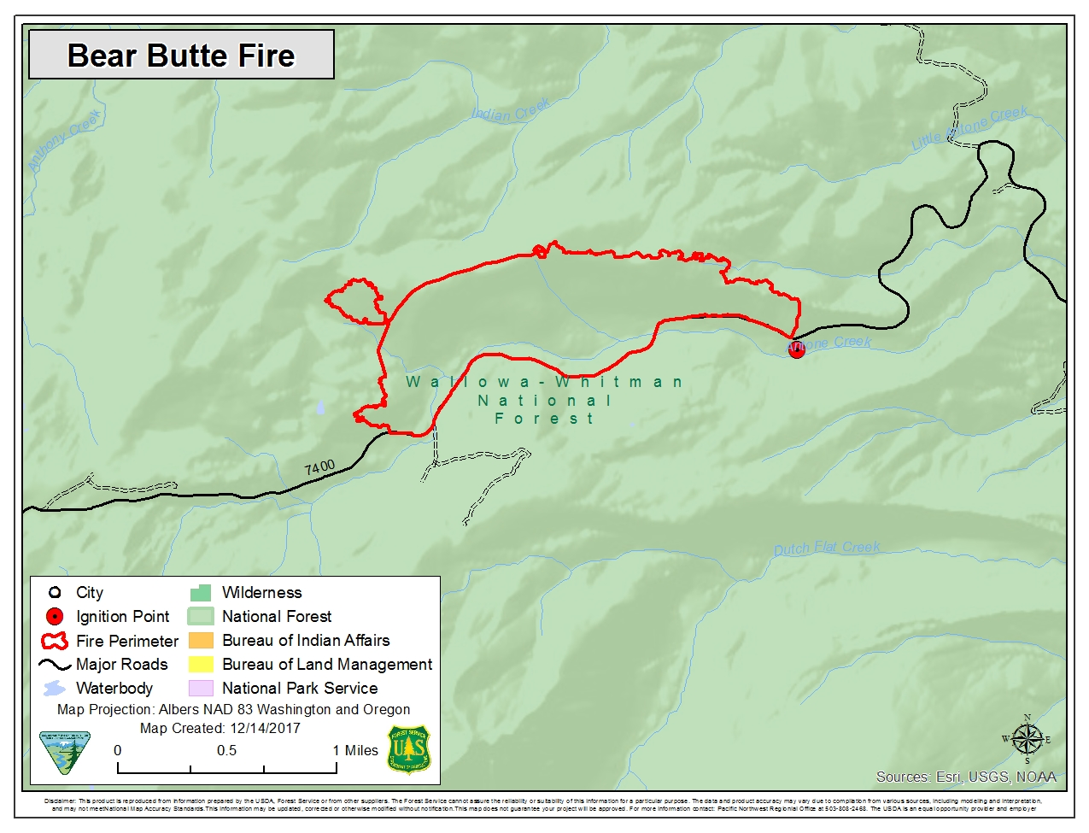**August 5**

The fire size on August 5 was estimated at 350 acres and had no containment. This incident was surrounded by high values and still had the potential to spread in any direction. Due to the threats, Level 1 evacuations were ordered for the Floodwater Flats, Anthony Lakes Highway, and Anthony Lakes Ski Resort. North West Team 9 arrived and was in briefed.

**August 6- August 11**

With an influx of resources to assist fire managers (including line overhead and aircraft), the fire was successfully held at 499 acres. Firefighters constructed direct fireline with the use of dozers and hand crews to catch the fire. The weather also became milder and assisted firefighters with more moderate fire behavior that allowed for the use the direct fireline strategy.

**August 12- August 24**

On August 12, Level 1 evacuations for the Flood Water Flat, Anthony Lakes Ski Resort, and Anthony Lakes Highways were lifted. The fire was showing minimal fire behavior and was 85% contained. Mop-up efforts continued on the incident through a transition back to the local unit on August 14 and the fire was called 100 percent contained on August 24. Bear Butte Fire was continually mopped up and rehabilitated in areas where deemed necessary for the next three months. It was called controlled on October 2 and called out on November 8.

**Significance**

Bear Butte Fire was the only large fire to be assigned an incident management team in North East Oregon during the 2017 fire season. During a record fire year in the region and with a shortage of resources regionally and nationally, this fire was held at a minimal size while threatening valuable resources.

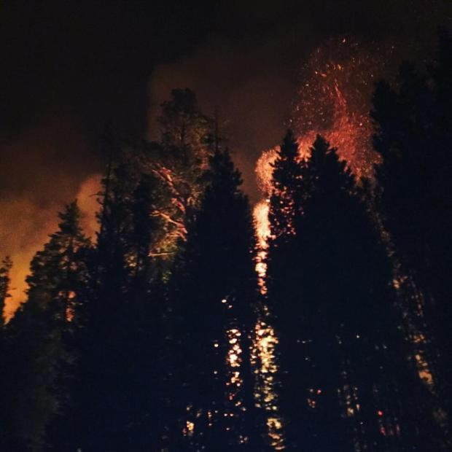

Figure XX. Fire behavior during Initial Attack, September 4 (Bear Butte Fire)

## Desolation Fire

|  |  |
| --- | --- |
| Date of Ignition | September 9, 2017 |
| Cause | Lightning |
| Land Status at Fire Origin | Ochoco National Forest |
| Preparedness Level at Time of Ignition | National: PL 5  Regional: PL 5 |
| Fire Size | 4,635 acres |
| Estimated Cost | $1,500,000 |
| Land Jurisdictions Affected | National Forest |
| Maximum Resources Assigned | 220 Personnel; 7 Crews; 12 Engines; 5 Water Tenders; 4 Helicopter; 1 Heavy Equipment |
| Structures Destroyed | 0 |
| Cooperators | Forest Service, Bureau of Land Management, Oregon Department of Forestry |

**September 9-12, 2017**

The Desolation Fire started in the Mill Creek Wilderness, about 20 miles northeast of Prineville, Oregon near the intersection of the East Fork of Mill Creek and Desolation Canyon. Due to safety concerns related to snags and steep terrain, no ground resources were initially assigned to the fire, and aircraft were used to drop water and check its growth, while obtaining better size estimates. On day three, strong wind gusts out of the northwest fanned the fire, pushing it south out of the wilderness toward private structures along Highway 26, including the 53 acre site of the Ochoco Christian Conference Center (formerly Mount Bachelor Academy), and prompting Level 2 evacuation notices for another 27 residences in the Marks Creek area along Hwy 26 between mileposts 45-50. The fire was estimated at 2,000 acres.

**September 13, 2017**

A Type 3 Central Oregon Incident Management Team took command of the fire, focusing on a confine and contain strategy and keeping the fire north of the highway. Five airtankers were utilized, supporting ground resources by slowing the fire's progress and cooling actively burning flanks. Challenges remained with heavy fuel, warm temperatures and afternoon winds. A structure protection group began working to secure private residences in the area, and 75 firefighters were on scene, with six additional 20-person crews arriving.

**September 14-16, 2017**

The Desolation fire stayed within planned containment lines through gusty winds as firefighters worked through the day and into the night to keep the fire north of Highway 26 and protect adjacent private residences. Crook County lowered the evacuation notice for homes in the Mark’s Creek area to a Level 1 (Get Ready).

Firefighters continued prepping the northern containment line along Forest Road 27 with feller bunchers and other heavy equipment to form a “catcher’s mitt” should the fire grow toward the northeast. Crews also removed fuels around Whistler Campground and Bingham Springs Trailhead and around private property near the highway. The fire was mainly a ground fire, burning through dead and down timber and shrubs within the 2000 Hash Rock Fire scar. On September 16, Central Oregon experienced wetting rain, with some snow falling on the Desolation fire, helping reduce fire activity and clear smoke from area wildfires.



