## Appendix J: Using Science and Technology to Inform Decisions

### Introduction

Development of new technology has taken fire modeling from paper to geospatial layers of natural, cultural, and infrastructure resource complexities. The advent of LANDFIRE, a program that provides a series of data layers for vegetation, greatly facilitated the development of a number of fire behavior, smoke dispersion, and fire effects tools used to support decisions made during and after a wildfire.

### Wildland Fire Decision Support System (WFDSS)

The Wildland Fire Decision Support System represents the current state-of-the-art technology that calculates fire behavior, such as rate-of-spread, flame length, and fire spread potential. WFDSS also serves to document the incident goals and objectives and tracks fire management and agency administrator decisions.

Most recently, WFDSS has added links to near real-time geospatial information stored in the WILDCAD dispatching system. This link allows fire managers to incorporate topographic maps and provides a web-based common operating picture to multiple levels of management simultaneously.

WFDSS has four levels of geospatial fire behavior projections:

* Basic Fire Behavior – estimates fire behavior based on weather and fuel moisture inputs and analyzes potential fire behavior like flame length, crown fire potential, and fine fuel moisture variance.
* Short-Term Fire Behavior – depicts fire spread pathways and arrival time of a fire over a period of hours using wind and fuel moisture inputs to estimate the rate of spread.
* Near-Term Fire Behavior – estimates fire spread and fire behavior using weather and wind data over a period of three to seven days to determine potential growth given the weather forecast for that period.
* Fire Spread Probability, or FSPro – produces multiple simulations of fire spread using weather and long-term climate records. The analyst can adjust spotting potential, use terrain to modify windspeed and direction, and alter fuel models to better reflect actual conditions.

Each time the fire behavior analyst updates a WFDSS run, a new risk assessment can be prepared, allowing the decision-maker and the incident management team to see how risk is changing over time on a given fire. The relative risk rating evaluates values at risk and their proximity to the fire along with other social and political concerns, hazards posed by fuel conditions, expected fire behavior, the potential for fire growth, seasonal barriers to fire spread, and current seasonal severity relative to a “normal” fire season.

Lastly, WDFSS creates a recommended incident organization based on the relative risk rating, the difficulty in implementing the course of action described, and social-political concerns related to the fire, such as mixed ownerships. The result is a recommended incident organization, such as a Type 2 or Type 1 incident management team.

### Smoke Forecasting

The fire managers and air quality regulators now have access to a number of smoke modeling tools to assess expected smoke production, transport, and dispersion in near-real time. To help incident management teams, fire agencies, and the public make use of these new tools, we now have Air Resource Advisors.

Air Resource Advisors have technical expertise in air quality monitoring, smoke modeling, pollutant health thresholds, and communicating smoke risks and potential mitigation measures. When dispatched to a wildfire, their specific tasks include:

* Providing, installing, and operating air quality monitors and interpreting the resulting data for fire camps and communities as needed,
* Summarizing information about current air quality conditions, comparing them to national health thresholds and communicating those findings to partner agencies and the public,
* Using and interpreting national smoke models and running fire specific models to provide forecasts of future air quality impacts,
* Assisting Safety Officers and others in addressing firefighter impacts from smoke,
* Advising on how to reduce risks and mitigate smoke exposure of the public and firefighters,
* Supporting incident management teams in public meetings and in media such as Inciweb, AirNow, and smoke blogs, and
* Coordinating with public health agencies and air quality regulators to address their concerns about smoke impacts on the public.

In 2017, Air Resource Advisors were used on the Diamond Creek Fire, central Washington Fires Support, Eagle Creek Fire, Whitewater Fire, east Cascades fires, Blanket Creek Fire, North Umpqua and High Cascades Complexes, Chetco Bar Fire, and the Miller Complex. A typical smoke outlook produced by an Air Resource Advisor describes the current fire activity, expected smoke impacts, and the expected Air Quality Index for nearby communities. Because of the duration of the fires where Air Resource Advisors were used, most fires had several advisors over the summer and sometimes two advisors were assigned. For example, the Blanket Creek Fire had a total of five Air Resource Advisors with overlapping advisors between August 20 and September 3.

### Risk Management and Assistance Teams (RMAT)

In 2017, the Forest Service began testing the use of Risk Management Assistance Teams to help managers, cooperators, and the public better understand the risks posed by large and complex fires. A Forest Supervisor or District Ranger typically requests an RMAT when they need help in determining priorities between several fires or are unsure of the best approach to use on an individual fire. Using a risk assessment, the team identifies the locations and lists of values that warrant protection from fire and then uses FSPro in WFDSS to estimate the probability that the fire will reach the locations of those values. RMAT findings can be used by a local unit, area command, multiagency command, geographic coordination center, or agency to prioritize fires when firefighting resources become scarce.

RMATs in the Pacific Northwest used the 2017 draft Quantitative Risk Assessment product to inform a variety of analyses concerning long-duration fires and complex fires. The Quantitative Risk Assessment product was developed last winter and spring by refining the LANDFIRE fuels layer, identifying the high value resources and assets, developing expected changes in value should a fire reach the identified resource or asset, and ranking the relative importance of the results.

Assets can include residences, communication sites, transmission and distribution lines, railroads, major roads such as interstates and state highways, developed and dispersed recreation sites, ski areas, historical structures, seed orchards, and mills. High-valued resources can include commercial timber, municipal watersheds, federally threatened or endangered species habitat, and sensitive species habitat.

In 2017, the Forest Service established three RMATs nationally. Each team consists of a line officer with experience in dealing with large fires, a fire management officer, an operations/risk management specialist such as an Operations Section Chief or a Strategic Operational Planner, a local fire behavior specialist, and two long-term fire analysts. The team can create a number of products, depending on the needs and questions concerning an individual fire or fire complex:

* Conditional Net Value Change (cNVC) Map(s) – given fuels and expected fire behavior, a map or series of maps of the expected benefits and losses for designated high value resources and assets.
* Fire Behavior Analysis – uses fire behavior modules within WFDSS to characterize expected fire behavior and spread and use additional tools to assess potential threats to values and natural resources and to evaluate mop-up hazards in the fire area.
* Exceedence Probability (EP) Curves – compares the expected losses or benefits from a group of fires to help set priorities.
* Estimated Firefighter Evacuation Time Map – models the shortest ground transportation time in hours from any given point to a hospital. The travel time estimate begins from the moment a litter is lifted off the ground and travel begins. Does not include the time needed to prepare the injured person for evacuation or acquire the needed transportation. It estimates walking speeds as adjusted for slope and vegetation type and driving speed based on the types of roads traveled.
* Mop-up Hazard Rating Map – identifies where vegetation types and slope steepness align to create potentially hazardous conditions for firefighters during mop-up. Incident management teams and decision-makers can combine this map with infrared imagery of hotspots and areas of intense heat to prioritize areas for mop-up and avoid areas that are rated as largely unsafe or have little need for mop-up.
* Suppression Difficulty Index (SDI) Map – identifies areas with high exposure to unsafe conditions and little ability to mitigate those safety risks, taking into account potential fire behavior, access, fireline production rates, and the availability of fuel breaks created by natural features or by fuels treatments.
* Potential Control Location (PCL) Map – depicts where the landscape is highly suitable or generally not suitable for stopping the fire by identifying potential control features. It assumes that the firefighting effort is consistent with past fires in the area.
* Tree Mortality Map – identifies areas with high levels of tree mortality and, therefore, increased firefighter exposure to snags. This product also supports the Suppression Difficulty Index, Potential Control Location, and Mop-up Hazard analysis.
* Incident Timeline Graph – provides a visual depiction of the size, costs, number of personnel, percent contained and remaining to be contained, fire danger, strategies used, relative risk assessment level, organizational needs assessment level, assigned team type, structures threated and destroyed, and decision status. This product can be used to brief incoming incident management teams and as a tracking tool over the life of the fire.
* Incident Resource Use Graph – a supplement to the Incident Timeline Graph, this graph depicts the amount and type of firefighting resources assigned to the incident as well as the costs and fire size as reported on the ICS-209 form.
* Aviation Use Summary Package – summarizes and maps aviation actions on the fire such as retardant and water drops from airtankers and helitankers, the exposure of aviation assets to safety hazards over time, and the number and type of aircraft assigned to the fire each day.

Some or all of the above products are used to develop a trade-off analysis where different potential firefighting strategies are evaluated against firefighter safety, public safety, and the values at risk from the fire. The RMAT uses standardized tables to develop scores for how well each alternative course of action meets the fire management objectives and protects firefighter and public safety, as well as scoring the likelihood of success and the social and political concerns with a given course of action.

In 2017, RMATs were used by MAC Support and the Willamette, Umpqua, Rogue River-Siskiyou, and Okanogan-Wenatchee National Forests. For MAC Support, the RMAT evaluated 65 fires on the Umpqua, Willamette, Deschutes, and Ochoco National Forests in mid-August and developed Exceedence Probability Curves. The team grouped the fires into seven clusters to evaluate the expected net loss or benefit.

This analysis indicates that the northern Umpqua (UPF North) and the Willamette (WIF North and WIF South) most likely to see the highest net loss over the next seven days in the absence of any suppression action (Figure K-1). The southern Umpqua (UPF South) and southern Rogue River-Siskiyou (RSF South) were expected to see mild to moderate loss, while the northern Rogue River-Siskiyou (RSF North) could see a mild loss in the absence of any suppression action. Further, the expected loss on the northern Rogue River-Siskiyou expected losses were half those expected for the southern Umpqua and southern Rogue River-Siskiyou. The Deschutes and Ochoco National Forests (DEF/OCF) were expected to see a net resource benefit from the two fires assessed (Milli and Belknap). As a result, the recommended priority for firefighting resources was:

1. Umpqua National Forest North
2. Willamette National Forest South
3. Willamette National Forest North
4. Umpqua National Forest South/Rogue River-Siskiyou South
5. Rogue River-Siskiyou North
6. Deschutes/Ochoco National Forests



Figure K-1. Exceedance probability curves provided to NW MAC for fires in the Oregon Cascades.

On the various National Forests, the team conducted trade-off analyses of selected fires and complexes to aid in selecting which strategy to use, help the incident management team prioritize resource use, and to help the Rogue River-Siskiyou and Umpqua National Forests align their strategies for several fires along their common boundary.

### “Habitat” for Fire

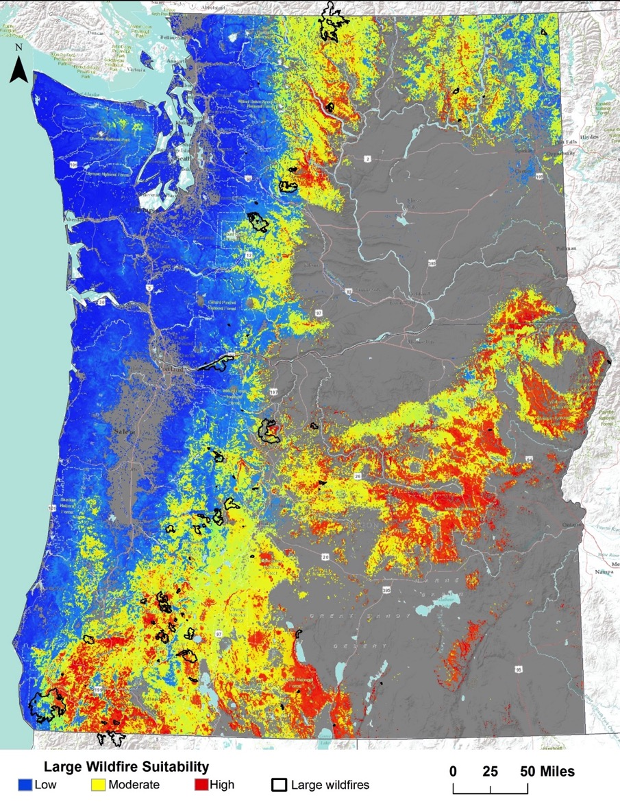Although not widely used, scientists in the Northwest have developed an experimental product that maps the “habitat” for large forest fires based on measures of climate during the main fire season, topography, distance from roads, historical lightning ignitions, and solar radiation (Figure K-2). The model assumes that burnable fuels are highly likely to be present, so are not included. The resulting map depicts probabilities that an area would support the development of a large forest fire.

Figure K-2. Map of the “habitat” for large fires in forests. Warmer colors indicate a higher probability of a large fire developing while cooler colors indicate a lower probability. Lower probability areas can still support large fire growth under extreme conditions.

For example, the Chetco Bar Fire started in a high probability area and largely stayed within the area of warmer colors through the early part of the fire (Figure K-2). Once the Chetco Effect wind developed, it pushed the fire into a lower probability area. After the wind subsided, the fire continued to spread in the warmer colors, including light blue areas but showed little spread in the cooler areas until the next wind event.

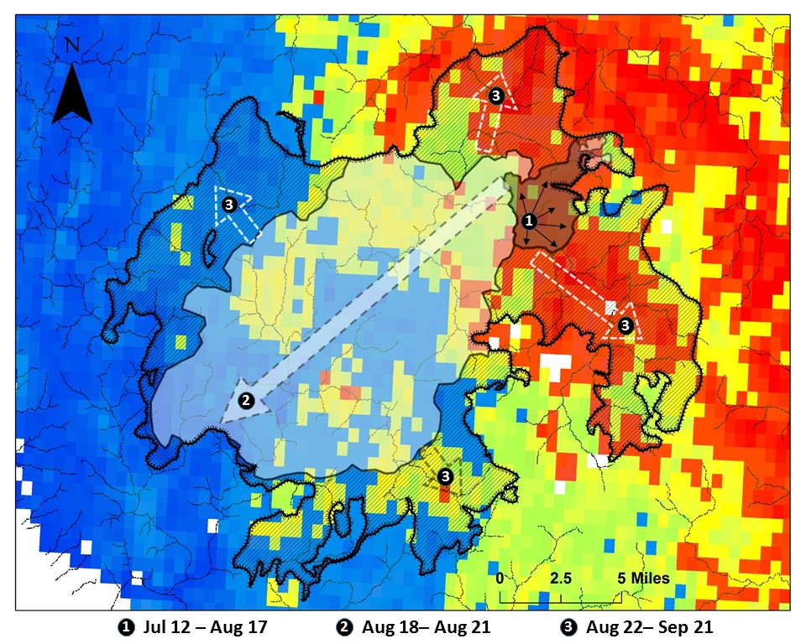

Figure K-2. Map of the Chetco Bar Fire spread events in the context of the “habitat” for large fires. The main spread event into the lower probability area occurred during the Chetco Effect wind event.

### Infrared Mapping

Infrared, or thermal, mapping is widely used to track wildfire growth and identify heat across a fire. Infrared technology has advanced greatly in recent years. The National Interagency Fire Center in Boise manages the National Infrared Operations Unit. The unit is made up of aircraft, thermal imaging cameras, infrared interpreters, and geographic information systems. The aircraft fly over several fires, usually at night, and download the imagery to the interpreters who convert the data into maps firefighting teams can use to develop or update daily plans for managing the fire as well as tracking the size of the fire.

In 2017, two of the three aircraft normally available to the national infrared program were unavailable, resulting in the use of other sources to gather infrared data. Unmanned Aircraft Systems were one source on some fires (see below). The military also provided some infrared mapping services. In August, two RC-26 “Metroliner” aircraft were stationed in the Northwest (Figure K-3A), one from the Washington Air National Guard which flew out of Fairchild Air Force Base in Spokane and one from the Arizona Air National Guard which flew out of Mahlon Sweet Airport in Eugene. These aircraft largely flew at night to detect new fires, map existing fires, and provide live video downlinks to fire managers as requested, known as Distributed Real-Time Infrared, or DRTI. This capability lead to the nickname “DRTI Bird.” In September, a UH-72 Lakota helicopter from the Oregon Army National Guard provided daytime infrared mapping services (Figure K-3B).

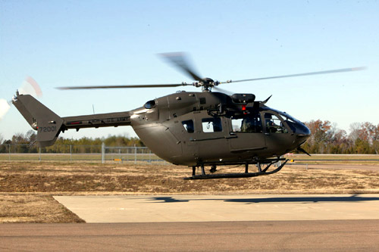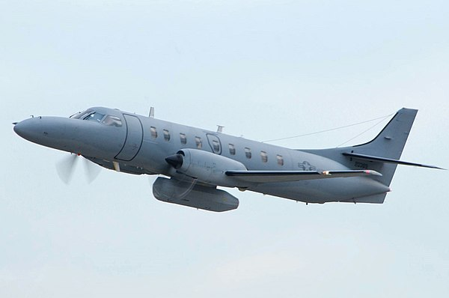

A

B

Figure K-3. RC-26 Metroliner (A) and UH-72 Lakota (B) used for infrared mapping in 2017.