VII. Appendix L: Expanded Outreach

Fire Prevention and Incident Management Teams expanded efforts to outreach to to Spanish-speaking visitors and residents. In the last four years, the regional fire prevention efforts have worked with cooperators and agency personnel to create and disseminate a variety of fire prevention, education, emergency evacuation, and specific campaign materials.

This year, IMTs worked with agency personnel and local community members to produce Spanish-language updates on active incidents. Spanish translations of daily updates, community meeting presentations and evacuation information (Ready-Set-Go) were produced at Chetco Bar, Eagle Creek, Indian Creek, Norse Peak, Uno Peak and at the SW Oregon Joint Information Center. Some of these materials were posted and further accessed on the national Inciweb site.

Additional materials were revised in several languages for the Matsutake Mushroom harvest community in south Central Oregon.

*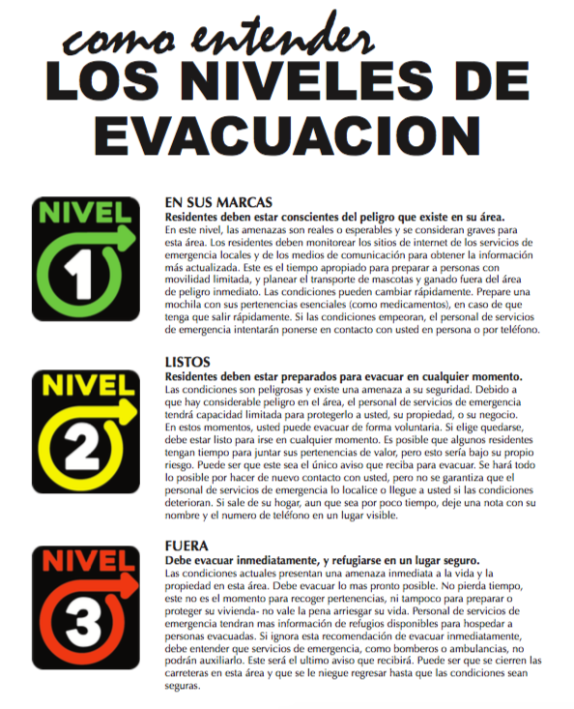Left: Evacuation Levels in Spanish*