**La Grande Airtanker Base 2017**

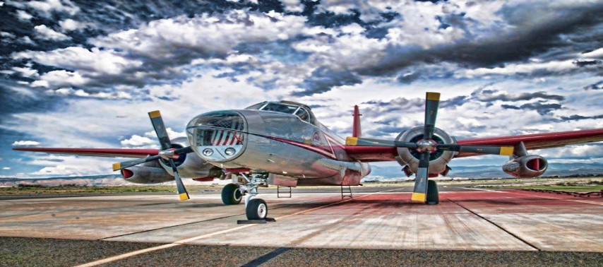

**Mission statement:**

Our mission is to support wildland fire suppression efforts in the Pacific North West. We accomplish this, by providing safe, efficient and cost effective direction and operational guidance to Aerial Fire Fighting resources while on the ground at the LGD ATB. The LGD ATB provides contracted air tankers and fire retardant services to the USDA Forest Service and its cooperators in Eastern Oregon, Washington, and Western Idaho.

**Personnel :**

**Griffith Williams – ATBM / MXMS(t) /** **RAMP/** **FWPT /** **RTCM**

**Darci Drinkwater–** **ATIM /** **RADO/ RAMP(t)** /**FWPT /** **ATBM(t)**

**Russell Hurst – ATBM / MXMS / RAMP / FWPT / RTCM**

**Carter Wells – ATBM / MXMS / RAMP /** **FWPT/ RTCM**

**Gary Riedmiller – ODF SEATs Manager**

**Chelsie Houck - ATIM / RADO/ FWPT /** **RTCM(t)**

**Silas Turner –** **RAMP /** **FWPT/** **RTCM**

**Maddie Turner-FWPT /** **RTCM (t)**

**Miguel Estudillo- FWPT(t) /** **RTCM (t)**

**Brianna Carollo-** **FWPT(t) / RTCM (t)**

**Jake Evers-** **FWPT(t) / RTCM (t)**

**Operational Timeframe for 2017**

Base open for fire support – June 14, 2017

Base closed for fire support – October 21, 2017

**First load;**

On July 02, T-05 and T-844 flew the first four loads from La Grande Air Tanker Base to the Silver Dollar, WA-SPD-166.

**Biggest Days;**

July 29, two heavy air tankers and two SEATs flew 12 loads for 25,845 gallons.

August 4, six heavy air tankers and two seats flew 47 loads for 73,243 gallons.

**Last load;**

On September 13, T869 and T870 flew the last loads of the season to the Indian Ridge, OR-WWF-1031.

**La Grande Air Tanker Accomplishments:**

This was LGD ATB 25th season without an accident or incident with heavy Air Tankers, SEATS or light fixed wing planes. The La Grande Air Tanker Base hosted two Oregon Department Forestry contract SEATs, T869 and T870 for a 75 day contract. La Grande Air Tanker base provided retardant services and support personnel for safe, fast and efficient loading. ODF funded the SEATs and provided a SEMG. This was very successful partnership for all agencies with in the BMIDC foot print.

**Activity Summary for 2017**

196 missions on 53 different fires flown from La Grande Air Tanker Base. We supported fires with retardant with 129 SEAT loads and 67 Large Air Tanker loads. This is a force-account base so there are no retardant contract cost.

**Retardant flown from La Grande Air Tanker Base Comparison SEATs to LATs s.**

Retardant Costs to Incident LATs and SEATs: $ **589,976.10**

**TOTAL Gallons 283,834**

SEAT Flight time Costs to Incidents: 114.7 hrs. $ **340,983.09**

LATs Flight time Costs to Incidents: 60.64 hrs. **$ 524,365.14**

12 LATs worked from La Grande ATB this season:

T-02, T-05, T-06, T-10, T-40, T-101, T-132, T-142, T-162, T-163, T-164 and T-166.

67 loads = 191,964 gallons of retardant

LAT retardant cost = $403,124.50

Landing Fees to Incident: **$ 6,019.50**

SEATS

6 SEATs worked from La Grande ATB this season:

T-822, T-835, T-854, T-869, T-844, T-870

129 loads = 91,870 gallons of retardant

SEAT retardant cost = $192,927

**Total cost to Incident: $ 1,466,444.41**

**Fire Retardant Use by Agency for 2016**

**FS-R6 FS-Other BLM ODF DNR BIA IDL Total Gallons**

**149,058 8,157 38,152 37,648 18,320 6,482 26,017 283,834**

**LAQA Program Participation For 2017**

We are firm believers in the LAQA program and follow the guides issued by MTDC fully. Thirteen samples were submitted from La Grande Air Tanker Base. Two base opening samples, nine truck order samples and two base closing samples. All results were good. The product wintered well and we are getting what we pay for.